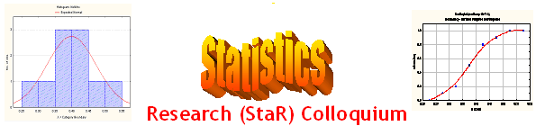
Seminar

Dept of Mathematical Sciences
King Fahd University of Petroleum and Minerals

Presenter | Dr. Anwar H. Joarder  Dept of Mathematical Sciences, KFUPM
Title | Some Insights into Statistical Independence
Topic & (Level) | Statistics Education  (Methodological, Educational)
Audience | All KFUPM community are cordially Invited
Date | Tuesday, Oct 10, 2006
Time | 1:00 PM
Location | Building 5, Smart Classroom # 203

Abstract

Statistical independence are not usually understood well by students in the service courses. Many do not see any connection between the definition and the conclusion. In this talk we argue that it is better understood using a contingency table. We also argue that it is important to understand the degree of dependence. The identity established by Joarder and Al-Sabah (2003) provides exact amount of dependence between the events. Some other pedagogical notions will be highlighted.

.

Ramadan Mubarak

