ICS 103-55 Lab Quiz#03 Key

The cross-product of two 1D-arrays x and y of the same size is defined as:
Cross-product = $\sum_{i=0}^{\text{size}−1}{x_{i}}∗y_{i}$
Write a complete C program that contains:
- The main function
- A function of type void called crossProduct

The main function:
- Declares and initializes a double array x with the following values:
5.0, 2.0, 7.0, 3.0, 8.0, 4.0, 3.5
- Prompts for and reads 7 values in a double array y of size 7
- Passes the two arrays x and y and the array size to the function crossProduct together with parameters that will return the cross-product and the number of corresponding array elements that are equal.
- Displays the value of cross-product and the number of corresponding array elements that are equal.

The function crossProduct:
- Calculates and returns the cross product.
- Counts and returns the number of corresponding array elements that are equal.
NOTE: PARTIAL GRADE WILL BE GIVEN IF YOU SOLVE THE PROBLEM WITHOUT USING THE crossProduct FUNCTION.
Sample run of the program:
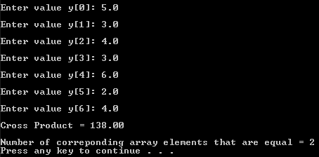

#include <stdio.h>
#include <stdlib.h>
#define SIZE 7

void crossProduct(double x[], double y[], int size,
double* product, int* count);

int main(void){
double x[] = {5.0, 2.0, 7.0, 3.0, 8.0, 4.0, 3.5};
double y[SIZE], product;
int count, k;

for(k = 0; k < SIZE; k++){
printf("\nEnter value y[%d]: ", k);
scanf("%lf", &y[k]);
}

crossProduct(x, y, SIZE, &product, &count);

printf("\nCross Product = %0.2f\n", product);
printf("\nNumber of correponding array elements that are equal = %d\n", count);

system("pause");

return 0;
}

void crossProduct(double x[], double y[], int size,
double* product, int* count){
int k;
*product = 0;
*count = 0;
for(k = 0; k < size; k++){
*product += x[k] * y[k];

if(x[k] == y[k])
*count = *count + 1;
}
}

