King Fahd University of Petroleum and Minerals
Information & Computer Science Department
ICS 101 – Computer Programming
Summer Semester 2008 (073)

Lab # 1 (INTRODUCTION)

Objective:
- How to use Windows, Microsoft Developer Studio Fortran PowerStation 4.0

Scope:
The student should know the following:
- Logon and Logoff
- Launch and Close an application
- Microsoft Developer Studio Integrated Environment
- Edit, Compile and Run Fortran programs

Discussion:
1. To run Microsoft Developer Studio Fortran PowerStation 4.0, click the followings:
Start → All Programs → Fortran PowerStation 4.0 → Microsoft Developer Studio

The following screen will appear:
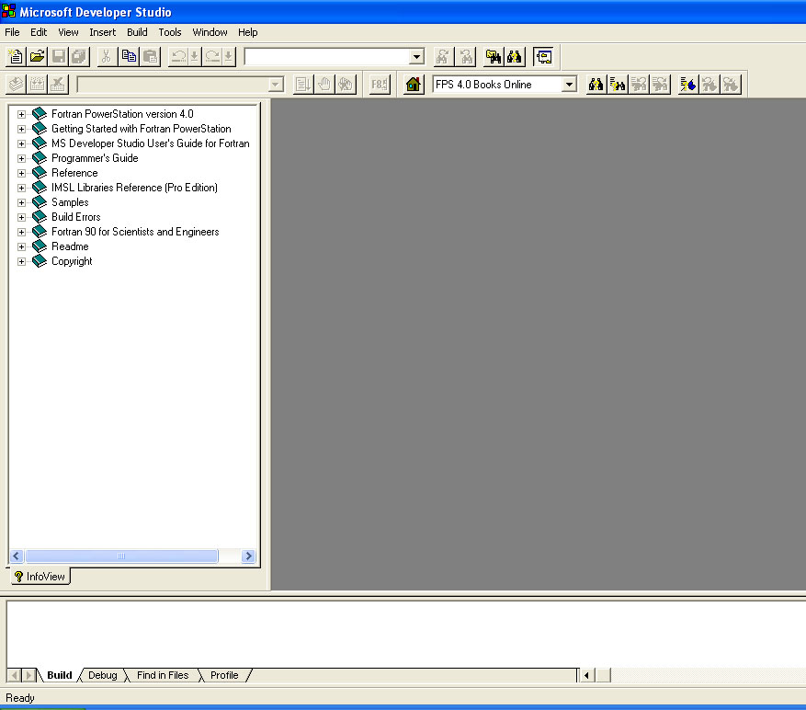

2. Then, click the menu File → New:
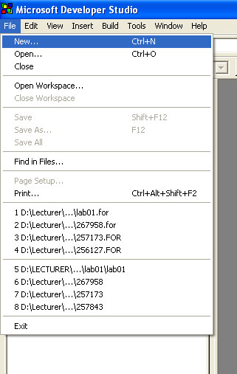

The following dialog box will appear:
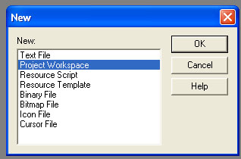

3. Select Project Workspace, and click OK button.

The following dialog box will appear:
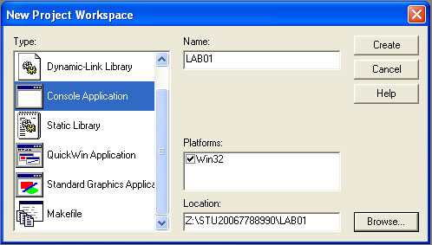

4. Set the Location to your directory (e.g. Z:\STU2006778899).
5. Set the Project name (e.g. Lab01)
6. Then click the button Create.
7. Then select the menu File → New:
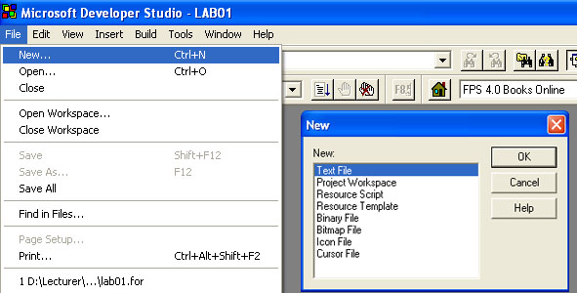

8. Select Text File and then click the button OK.
9. Now you will find text editor.
10. Select the menu File → Save As.
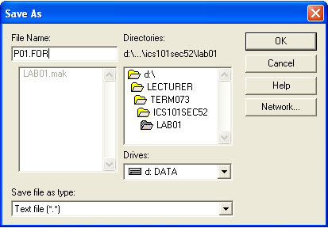

11. Write the filename with the extension FOR. (e.g P01.FOR). Remember that the extension FOR is very important.

12. Press the button OK.

13. In the active window, type in the following program starting after the green line (Column 7). Note: 10 is before the green line.
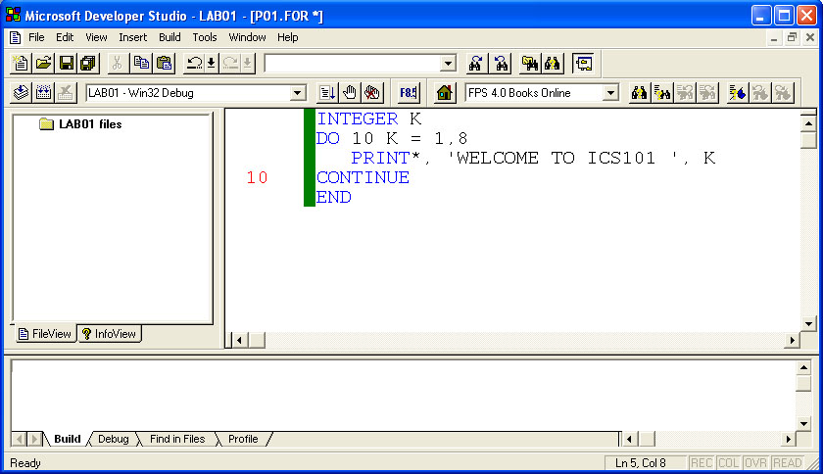

14. Select the menu BUILD → Compile. If the following dialog box appears,
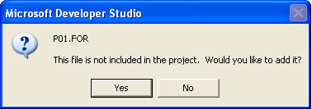
, click the Yes button.

15. To build your Fortran-program, select the menu Build → Build.
16. To execute the final program, select the menu Build → Execute.

ERROR HANDLING:
1. In the previous program, change the PRINT statement in the third line to PRI
2. Save the program
3. Compile it
4. Now your program will show the following error message:
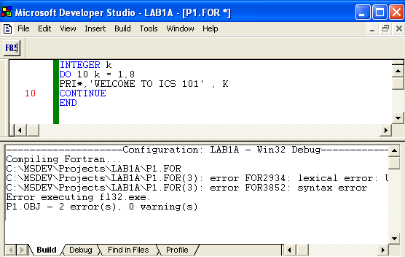

5. This means there is an error in Line 3 of your program. Press F4 to see the first error, the FORTRAN System now shows your program with the line having the error shown in Blue color. Press F4 to go to next error and so on.

6. Correct the error(s). Compile, build and execute your program again.

Exercise:
- Create a new project.
- Add a new FORTRAN file into the project.
- Save it with a name (e.g. P2.FOR)
- In the active window, type in the following program starting after the green line.

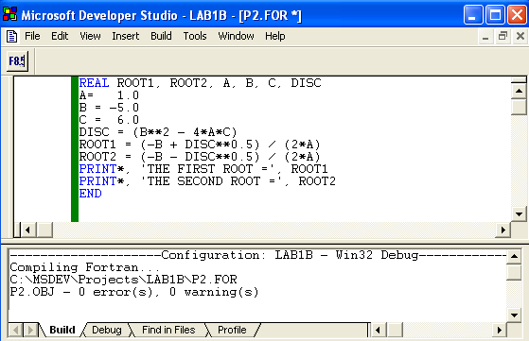

- Compile, Build, and Execute the program

