ICS436 – System and Network Administration
Lab Assignment – LAB 1
Installing Fedora Core 4

Introduction
In this lab we will be installing Fedora Core 4 as a virtual machine using VMware. Since the expertise in this class varies widely, this lab will guide you through the basic installation. Unless specific directions are listed for a particular section of the installation, the actual configuration of the system is left to your discretion. In your notebook, be sure to document every configuration at each step; for example, the mount point for each partition, sizes of partitions, package settings, etc. Your notes should be detailed enough to allow someone else to exactly follow your installation steps.

Reference Material
- Fedora Core 4 Installation Guide, http://fedora.redhat.com/docs/fedora-install-guide-en/fc4/Linux Installation HOWTO
- Fedora Core 4 Installation Guide, http://stanton-finley.net/fedora_core_4_installation_notes.html
- EasyVMX, http://www.easyvmx.com

Procedure

Setting Up the Virtual Machine
We will perform the lab work on virtual machines using VMware. If you are using VMware Player (which is installed in LAB 335), you need to create:
- virtual macine configuration file
- virtual disk

To create them in this manual we use EasyVMX (http://www.easyvmx.com). In the home page (Figure 1) there are three flavors available: (1) easyvmx, (2) Super Simple, and (3) Expert Form.
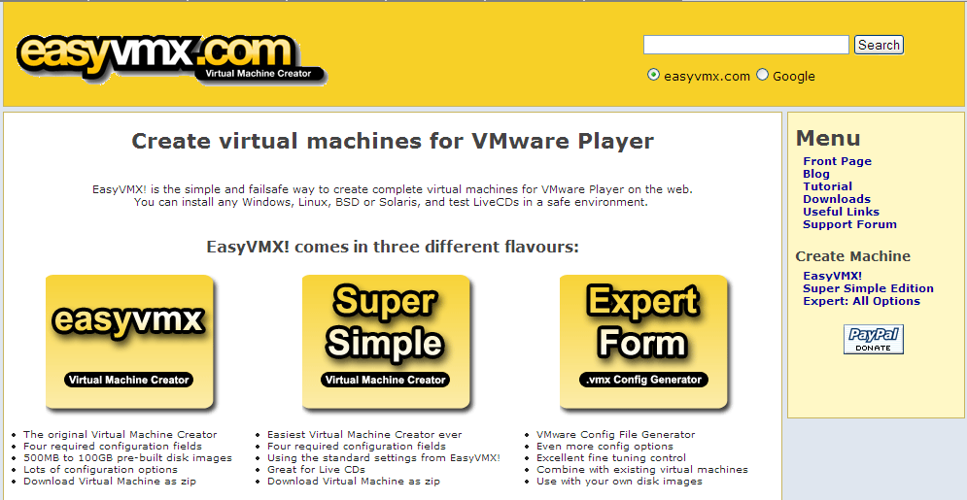
Figure 1. EasyVMX website (http://www.easyvmx.com).

Choose the first flavor (easyvmx) and a configuration page will be shown (Figure 2).

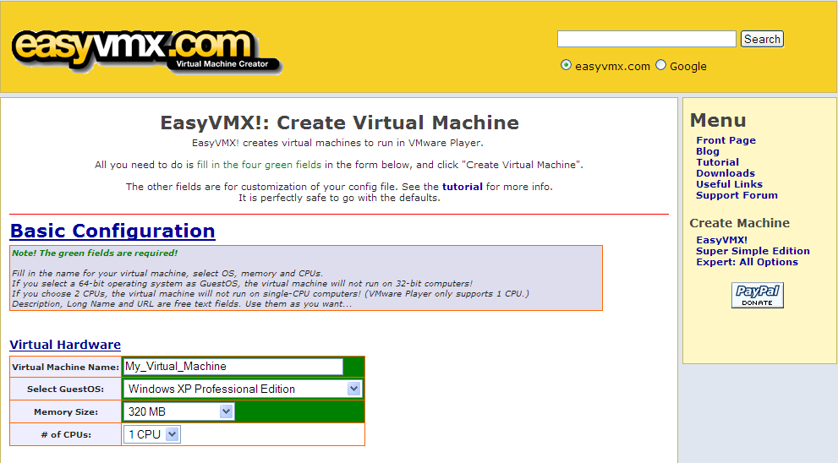
Figure 2. easyvmx configuration page (http://www.easyvmx.com/easyvmx.shtml).

Fill in the following information (unspecified ones are left to your choice):
- GuestOS: Redhat Linux
- Memory Size: 128 MB
- # of CPU: 1 CPU
- Disk #1 Size: 4 GB

Then click Create Virtual Machine button in the end of the page and a download page will be shown (Figure 3).
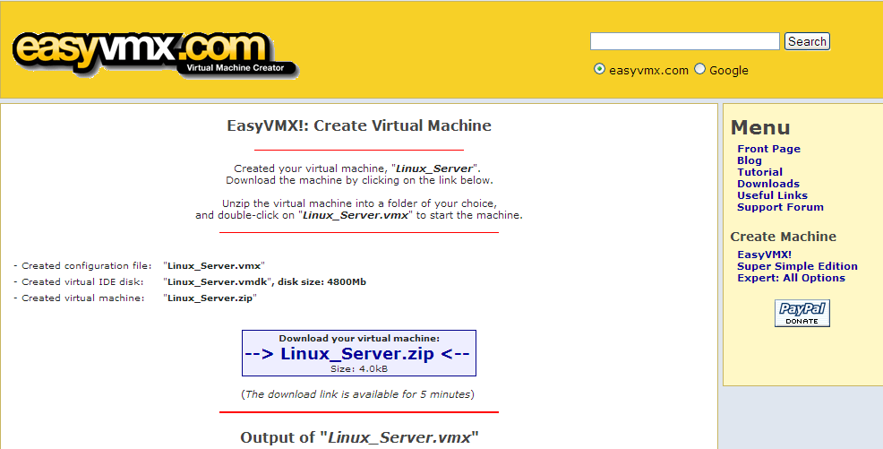
Figure 3. Download page.

Download the file and extract it in your external hard drive. Insert the Fedora Core 4 DVD in the DVD drive and double-click the vmx file to start the virtual machine. The installation procedure will be started.

Installation Procedure
The procedure is shown in Figure 4 - Figure 22 as follows:
- in the boot screen, press Enter
- in the installation welcome screen, click Next
- in the language selection screen, click Next
- in the keyboard configuration screen, click Next
- in the installation type screen, choose Server and click Next
- in the disk partitioning screen, click Next
- in the partition warning screen, click Yes
- in the partition removal screen, click Next
- in the partitioning removal warning screen, click Yes
- in the disk setup screen, click Next
- in the boot loader screen, click Next
- in the network configuration screen, click Next
- in the firewall configuration screen, click Next
- in the time zone selection screen, choose Asia/Riyadh
- in the root password screen, enter the root password (min. 6 characters) and confirm it, click Next
- in the package group selection screen, click Next
- in the about to install screen, click Next
- in the installation status screen, wait while files are installed
- in the installation complete screen, take out the DVD and click Reboot
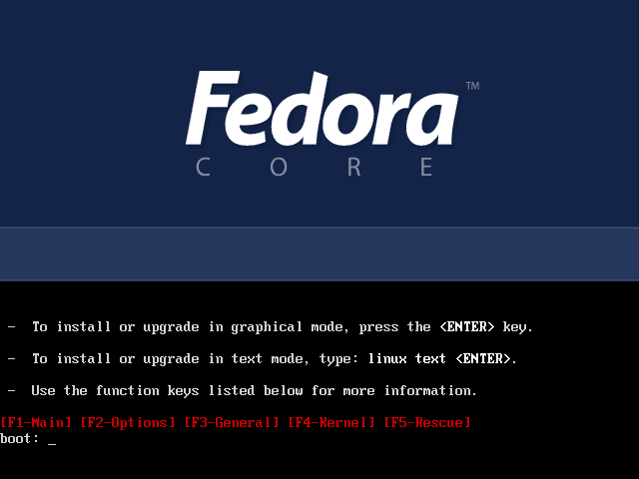
Figure 4. Fedora Core boot screen.
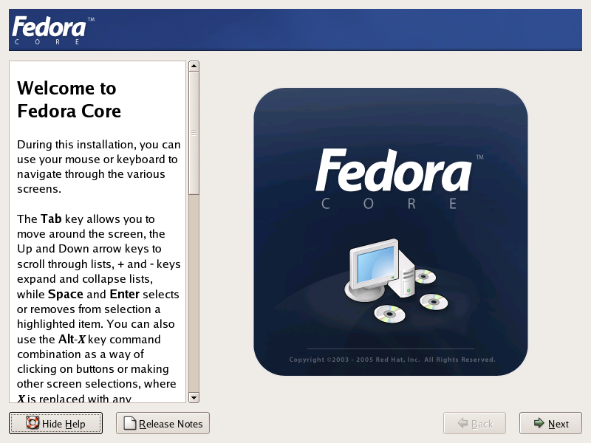
Figure 5. Fedora Core installation welcome screen.

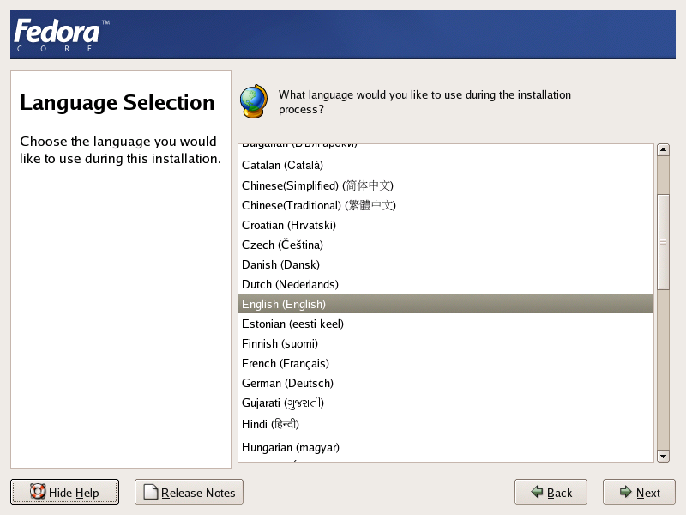
Figure 6. Language selection screen.

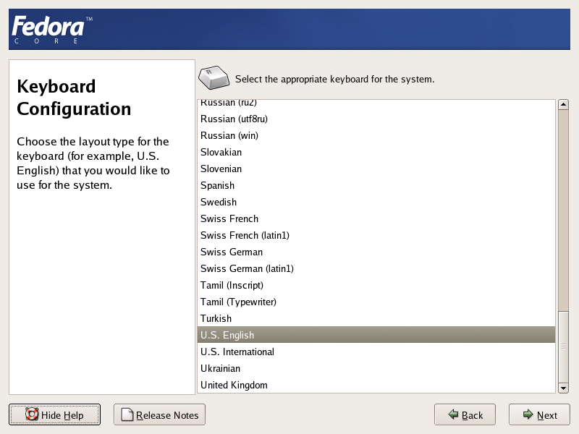
Figure 7. Keyboard configuration screen.

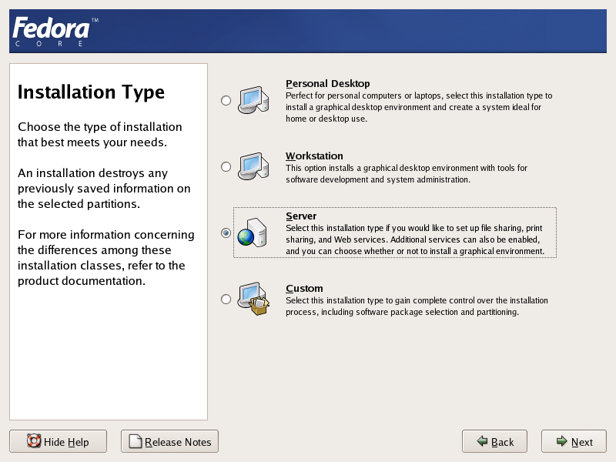
Figure 8. Installation type screen.

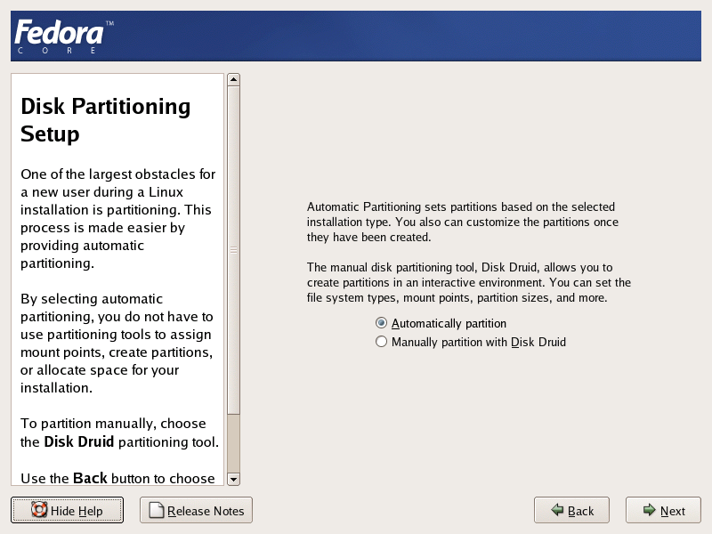
Figure 9. Disk partitioning screen.

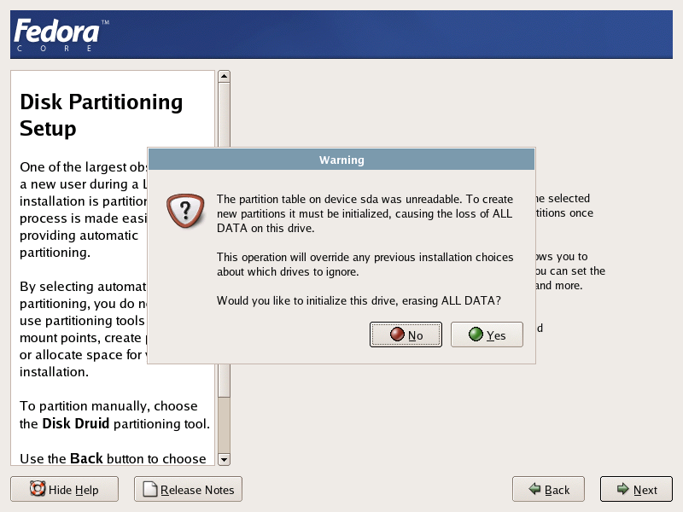
Figure 10. Partition warning screen.

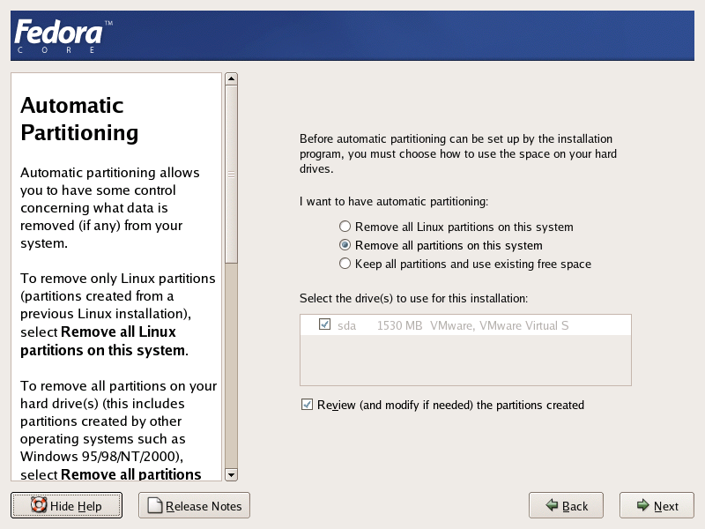
Figure 11. Partition removal screen.

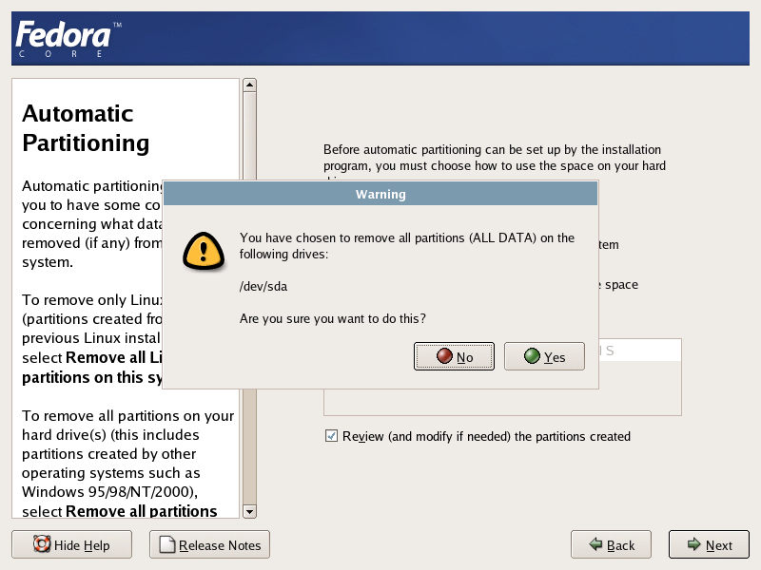
Figure 12. Partitioning removal warning screen.

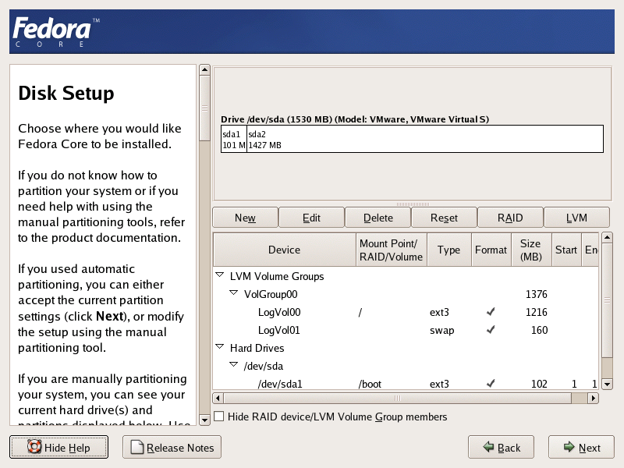
Figure 13. Disk setup screen.

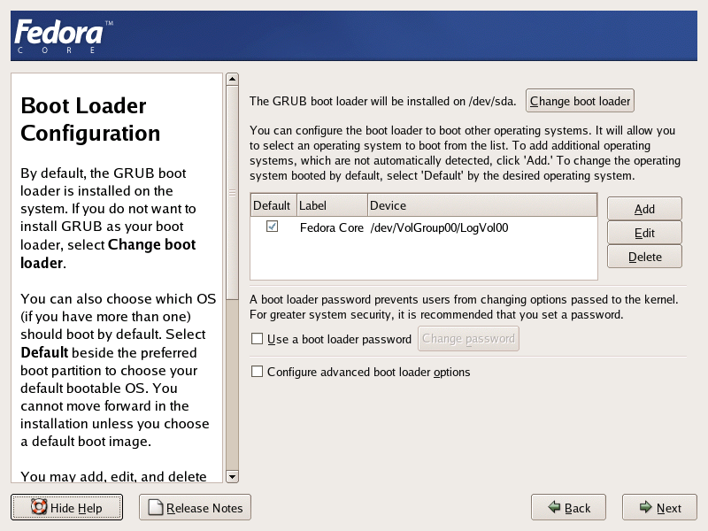
Figure 14. Boot loader screen.

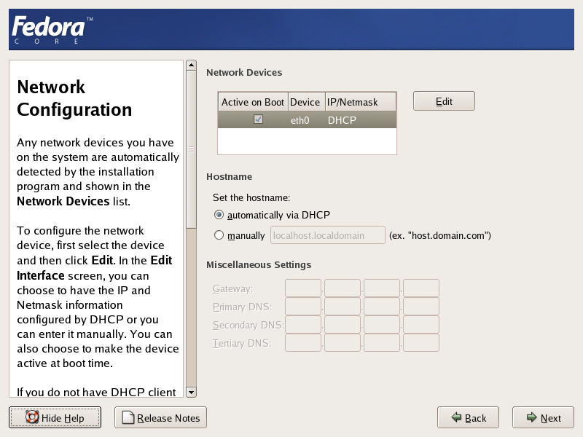
Figure 15. Network configuration screen.

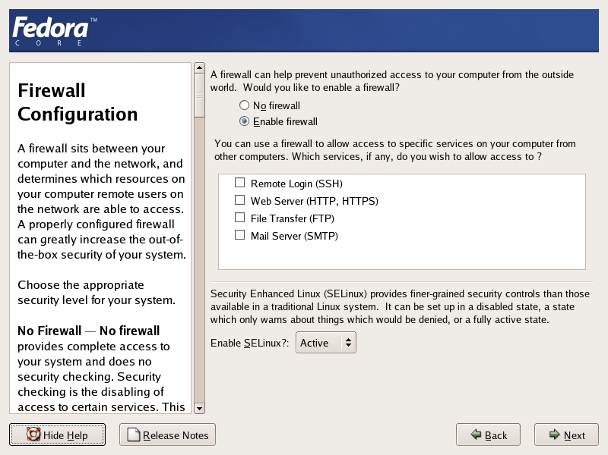
Figure 16. Firewall configuration screen.

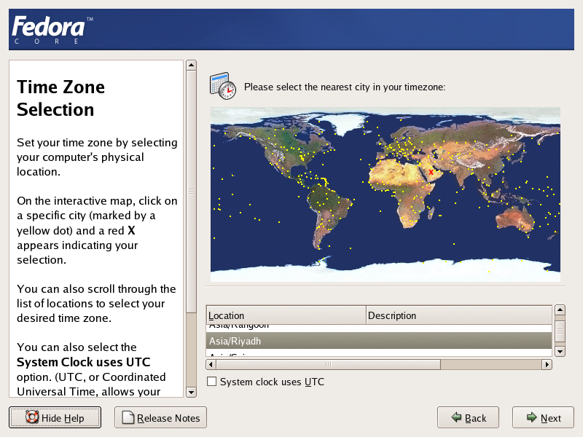
Figure 17. Time zone selection screen.

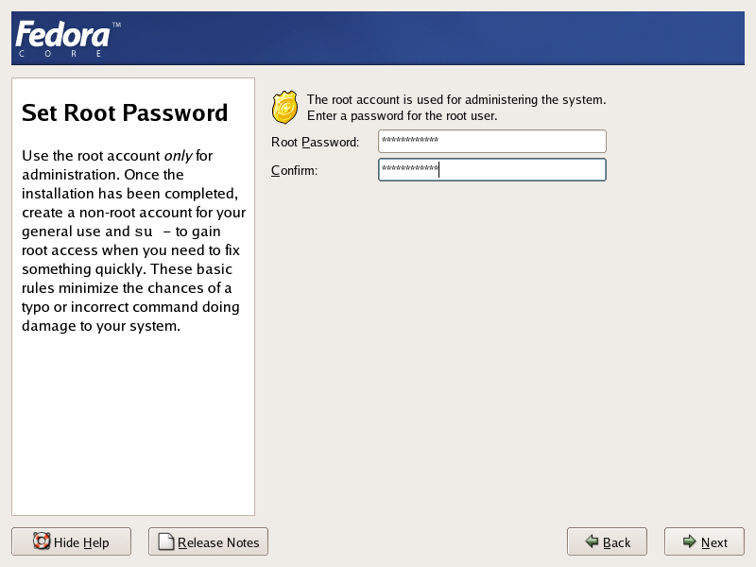
Figure 18. Root password screen.

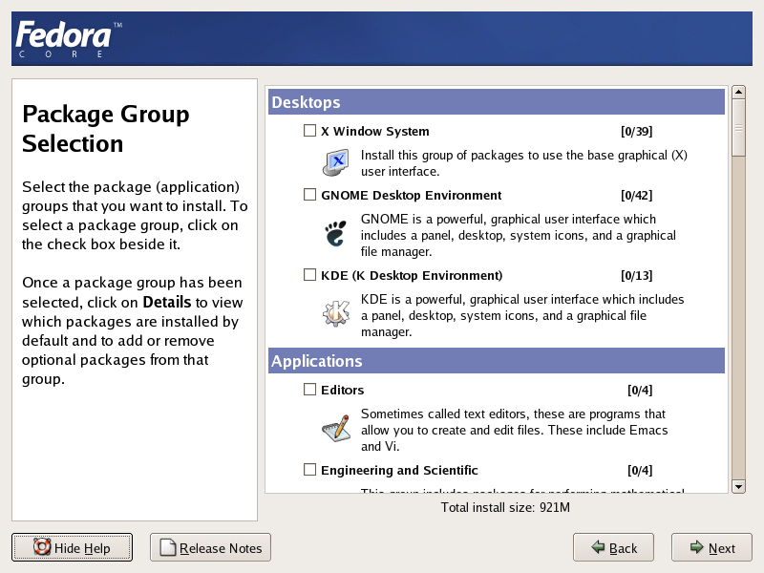
Figure 19. Package group selection screen.

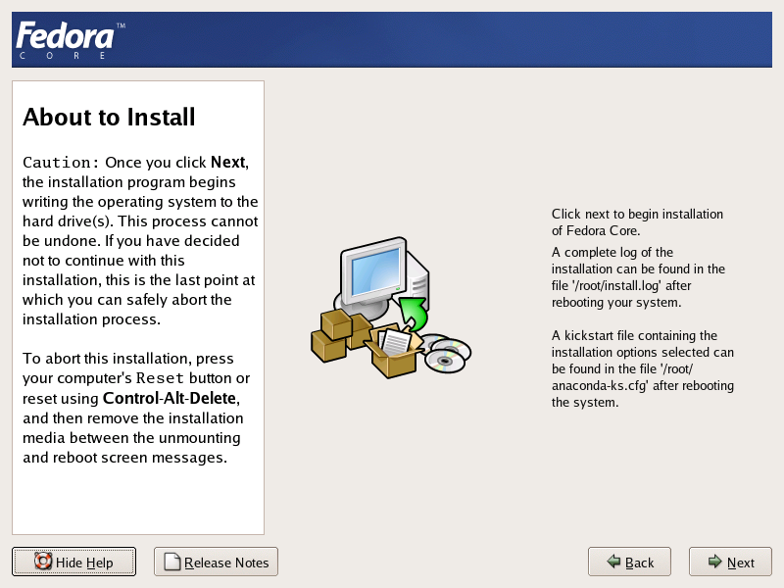
Figure 20. About to install screen.

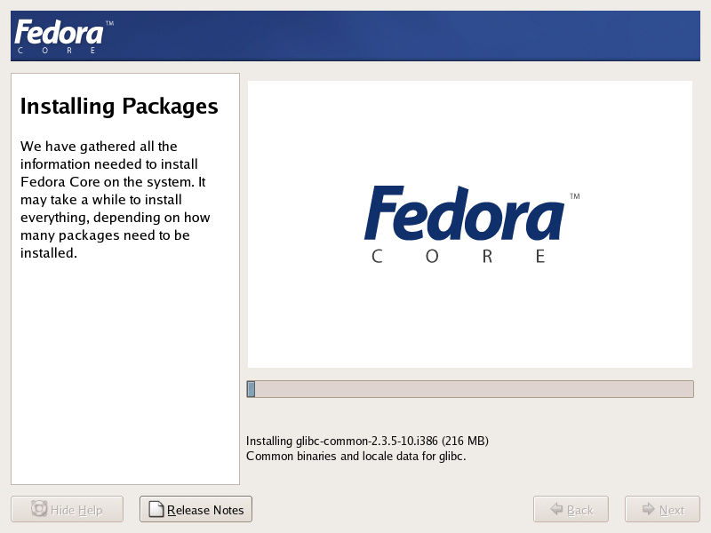
Figure 21. Installation status screen.

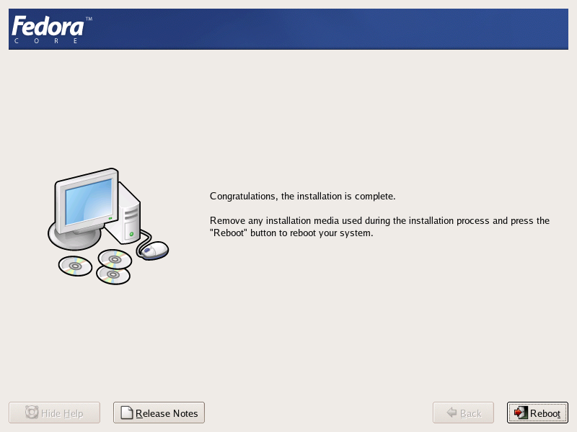
Figure 22. Installation complete screen.

Lab Report
For the lab report, give an overview of how your installation went along with a list of the initial configuration from your notebook. List any problems you had, and their solutions. Also, answer the following questions:
- What was the purpose of putting /boot in the first location of the hard drive and forcing it to be a primary partition?
- Explain why different partitions are used for different sections of the filesystem. Why isn’t a single large partition used for everything? Are there any drawbacks to this method?
- How do the partitions /dev/hda1 and /dev/hda5 differ, besides having different numbers? What is the critical difference between the two? Be specific.
- If the disk type is IDE, the disk you installed Fedora Core on is /dev/hda. What would /dev/hdd correspond to?
- Why don’t you want to use root as the regular login on your machine?
- Explain why shadow passwords should be enabled.
- What in particular would you like to learn about system administration? Your response will help us to guide the topics of future labs if we are able to accommodate your interests.

