ICS 103: Computer Programming in C
Fall Semester 2009-20010 (Term-091)
Lab #6: Data Files

Objective:

By the end of this lab, students should know how to use data files for input and output.

Data Files:

When dealing with a large amount of data, it may be more convenient to read inputs and produce outputs, to and from files, rather than manually typing in inputs and printing outputs to the screen, which may be difficult or inconvenient in the processing of large amounts of data.
The process of using data files for input/output involves four steps as follows:
1- Declare variables of type FILE to represent the files
FILE *infile, //pointer variable for the input file
*outfile; //pointer variable for the output file

2- Open the files for reading/writing using the fopen function.
infile = fopen("data.txt", "r");
outfile = fopen(“result.txt", “w");

Note: fopen returns NULL if the input file is not found.
In dealing with files, it is always a good practice to verify if the file has been opened sucessfully before proceeding for read/write operations. This is because reading/writing on file which is not opened sucessfully would results in run time error, causing the program to be terminated abnormally.
The follwing staements handle the file not found case by terminating the program in case the input file is not opened succesfully.

if (infile==NULL)
{ printf(“file not found”);
Exit (1);
}
The basic modes for dealing with files are:
"r" | Open for reading
"r+" | Open for reading and writing
"w" | Open for writing and create the file if it does not exist. If the file exists then make it blank.
"w+" | Open for reading and writing and create the file if it does not exist. If the file exists then make it blank.
"a" | Open for appending (writing at the end of file) and create the file if it does not exist.
"a+" | Open for reading and appending and create the file if it does not exist.
The only modes that will be used in this course are "r" and "w". The others are just mentioned for your information.
3- Read/write from/to the files using the fscanf and fprintf functions.
miles = fscanf(infile,"%lf",&miles);
Note: fscanf returns EOF if it encounters end of file.
fprintf(outfile,"That equals %.2f kilometers.\n",kms);
4- Close the files after processing the data using the fclose function.
fclose(infile);
fclose(outfile);

When you are finished using a file you must always close it. If you do not close a file, then some of the data might not be written to it.

Example 1:

#include <stdio.h>
#define KMS_PER_MILE 1.609

int main(void)
{ double kms, miles;
FILE *infile, *outfile;

infile = fopen("data.txt","r");
outfile = fopen("result.txt","w");

fscanf(infile, "%lf", &miles);
fprintf(outfile, "The distance in miles is %.2f.\n", miles);

kms = KMS_PER_MILE * miles;

fprintf(outfile, "That equals %.2f kilometers.\n", kms);
fclose(infile);
fclose(outfile);
return (0);
}

Example 2:

The example shown below handles the case of EOF (End_Of_File) controlled loop. It reads the text of the same program and displays it on the screen. As you see, the program reads the text character by character. Since we don’t know how many characters are in the file, we use EOF controlled loop to read the whole text. Copy this program and save it as example2.cpp, then run it and you will see the whole program displayed on the screen.

#include <stdio.h>
int main ()
{ FILE *in;
in=fopen("example2.cpp","r");
int status;
char ch;
status=fscanf(in,"%c",&ch);
while(status!=EOF)
{ printf("%c",ch);
status=fscanf(in,"%c",&ch);
}
fclose(in);
return 0;
}

Example 3:

This example compute the sum and average score of a class quiz. The quiz scores are read from an input file “scores.txt”.

#include <stdio.h>
int main (void)
{ FILE *infile;
double score, sum=0, average;
int count=0, input_status;

infile = fopen("scores.txt", "r");
input_status = fscanf(infile, "%lf", &score);
while (input_status != EOF)
{ printf("%f\n ", score);
sum += score;
count++;
input_status = fscanf(infile, "%lf", &score);
}
average = sum / count;
printf("\nSum of the scores is %f\n", sum);
printf("Average score is %.2f\n", average);
fclose(infile);
return 0;
}

Values to be used in input file “scores.txt”
10.0
6.8 9.5
9.7 7.7
3.6 5.7 8.1
7.3 6.8

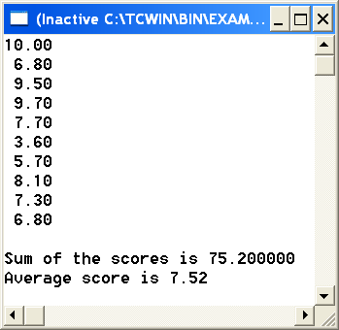

Exercises:
You need to use EOF controlled loop in all exercises.
Exercise 1:

Write a program that reads a file “data.txt” shown below character by character. It then displays the number of digits, small letters, capital letters, and other characters as shown in the output of the program.

Note: The digits are represented internally by integer numbers forming an interval with increasing numbers from ‘0’ to ‘9’. Thus any digit belongs to the interval [‘0’,’9’]. Don’t use the codes in the condition checking; use the characters themselves. The same applies for letters i.e. a small letter belongs to the interval [‘a’,’z’], and a capital letter belongs to the interval [‘A’,’Z’]. If you don’t take care of checking new line character, you will get 13 for the number of other characters.

Input File
kadFak%^&5453
as*(){}765
129(*&aBgKM

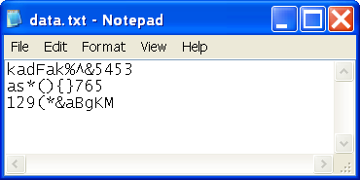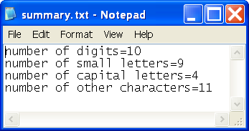

Exercise 2:
The file, scores.txt, contains an unknown number of data records for students in a certain section. Each data record (line in the “grades.txt” file) consists of two values, ID# and scores of a student.
Write a program that first scan through the file to compute the average score of the students, then scan through the file the second time to distribute the students into two files, good.txt containing those students whose score is greater or equal to the average, and poor.txt, containing those students who scored less than the average.

Hint: In this exercise, you need to read the content of the file “scores.txt” twice. The first time to get the average, and the second time to compare the scores with the average and distribute them into 2 files. After the first reading the reading pointer reaches the end of the file. Now you have 2 options to start reading from the beginning of the file; either close the file, then open it again or call rewind function as follows:
rewind (fileAddress) ;
fileAddress represents the FILE variable name used in fopen for “scores.txt” file.

Input file
206527 44.24
208530 75.38
207135 85.61
205241 91.51
204324 50.61
203357 68.28
202117 57.11

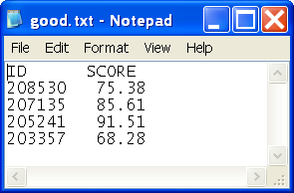 | 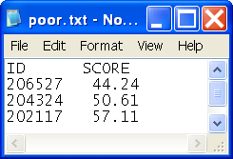

Exercise 3:
Using the same, scores.txt file of exercise 2, write a program that reads the data from this file and assigns a letter grade to each student based on the following grading policy. Your result should be stored in a file, grades.txt, which should have three columns, ID#, Score and Letter Grade. Display score with two digits after decimal point.
Note: Since the ID# is outside the range for int, use double for ID#. But when you write to the file, write the ID# with 0 digits after decimal point. Each call to fscanf should read 2 values (ID# and score).

Score | Grade
score>= 90 | A
80<= score <90 | B
65<=score<80 | C
50<=score<65 | D
score<50 | F

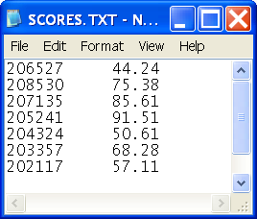 | 