ICS 103 – Computer Programming in C
Spring Semester 2010 (092)
Lab # 5: Repetition

Objective:

Learn the Repetition Structures by covering the following loops:
- while loop
- for loop
- do-while loop

Loops are basically means to do a task multiple times, without actually writing the repeated statements over and over again.

The format of a while loop is as follows:

while (condition)
{ statements;
}

If the block of statements to be repeated is one, then the brackets { } are not required.
The condition is evaluated, and if it is true, the code within the block is executed. This repeats until the condition becomes false. We can think of a while loop as a repeating if statement.

The for-loop is another type of loop which allows for initialization and iteration control. Its format is:

for(initialization; condition; update)
{ statements;
}

The initialization part is executed first followed by the condition. If the condition is true, the code within the block is executed. Once at the end of the loop, we go to update, then evaluate condition. If the condition is true the statements are executed again and so on. Note that the execution part is executed only one time when the for loop starts.
A for-loop can be converted easily into a while-loop. The for-loop and while-loop are pre-test loops (i.e., the iteration is executed based on the condition being true). Thus, we can have zero iteration in case the condition is false at the beginning.

A do-while loop is the third type of loop. Its format is:

do
{ statements;
}
while (condition);

The do-while is useful for things that we want to perform at least once because here the loop is executed at least one time, because the condition is evaluated at the end and not at the beginning as in the case of for and while loops. Don’t forget to include the semi-colon after the condition of while.

Counting Loops

We can have counting loops in case we know in advance how many iterations we will perform. We can use while or for loops for such cases. The following is an example of a counting loop for displaying the alphabet.

#include <stdio.h>
int main(void)
{ char ch;
for (ch='A';ch<='Z';ch++)
{ printf("%c\t",ch);
if((ch-'A'+1)%6==0) //prints 6 characters per line
printf("\n");
}
return 0;
}

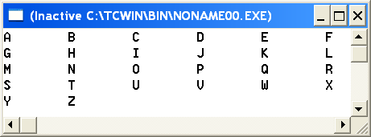

You can change the above example to a while loop.

Sentinel-Controlled Loops

In case the number of iterations is not known in advance, then we use a sentinel-controlled loop. In this case the signal to end the loop will come from the input. Here is an example of a sentinel-controlled loop. The program reads in positive numbers and finds their sum. When 0 is input, the loop will stop.

#include <stdio.h>
int main()
{ double num, sum ;
sum=0.0;
printf("Enter a value (0 to quit) >");
scanf("%lf",&num);
while (num !=0)
{ sum += num;
printf("Enter a value (0 to quit) >");
scanf("%lf",&num);
}
printf("sum = %f\n", sum);
return 0;
}

A do-while can be used in a menu driven program. The example shown below will continue running as long as the user did not enter the number 5.

#include <stdio.h>
void menu();
int main()
{ int choice;
do
{ menu();
printf("Enter your choice >");
scanf("%d",&choice);
// Here come the statements to do
// the different tasks
} while (choice != 5);
return 0;
}

void menu()
{ printf("1-division\n");
printf("2-addition\n");
printf("3-multiplication\n");
printf("4-division\n");
printf("5-Exit\n");
}

A do-while can also be used to validate an input as indicated in the example below.

#include <stdio.h>
int main()
{ int n;
do
{ printf ("Enter an integer number in [10,100] interval >");
scanf("%d",&n);
if (n<10 || n>100)
printf("Sorry wrong input, try again\n");
} while (n<10 || n>100);
printf("Now your input is correct");
return 0;
}

We can have one or more loops defined inside another loop. These are called nested loops. The example shown below uses a nested loop to compute the sum of integer numbers from 1 to 10.

#include <stdio.h>
int main()
{ int sum,i,j;
for(i=1;i<=10;i++)
{ sum=1;
printf("1");
for(j=2;j<=i;j++)
{ sum=sum+j;
printf("+%d",j);
}
printf("=%d\n",sum);
}
return 0;
}

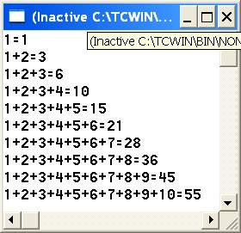

Exercise :1

Using while loop, write a program to reverse an integer number typed by the user. Use remainder and division by 10.

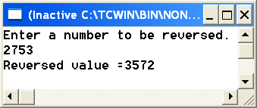

Exercise :2

Using nested for loop, write a program to print the following pattern on the screen.

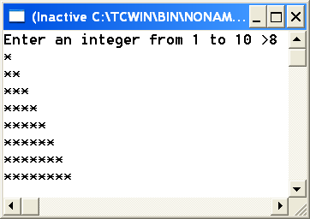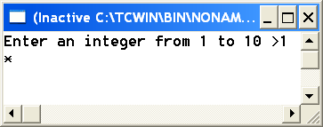

Exercise :3
Using sentinel controlled loop (while or for loop), write a program that reads a radius from the user and displays the area and circumference of a circle. This task is repeated until the user types 0.

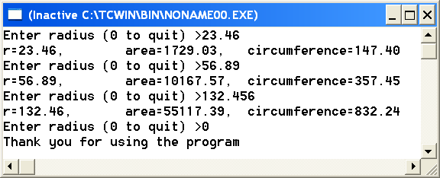

Exercise:4
Using do-while, Write a program to check that the user has typed a letter. The program will not stop until the user types a small or capital letter. Sample runs are shown below.
Note: Use getchar() to skip the new line character after reading each character.

