ICS 103: Computer Programming in C
Spring semester 2009-2010(092)
Lab 3: Mathematical Expressions

Objective:

Learn how to use operators, expressions and math functions.

Arithmetic Operators:

To solve most programming problems, you will need to write arithmetic expressions that manipulate type int and double data. In C language, these are the basic arithmetic operators: addition (+), subtraction (-), multiplication (*), division (/), and remainder (%).
- If the operands are of different types, the type with less precession will be converted to the one with more precession, then the operation will be performed. The precision order is char, int, long, float, double.
- Division between two integer numbers results in an integer result (for example, 5/2 gives 2 not 2.5).
- The division by zero is undefined. Either you get a compilation warning or a run time error.
- The remainder operator % is related to the division. This operator will give the remainder produced by dividing the two integer numbers ( 5 % 2 = 1). Therefore, this operator is not used with double values. If one of the operands or both are double, you will get an error message from the compiler saying: Illegal use of floating point.

Arithmetic Expressions:

Arithmetic expressions contain a combination of the arithmetic operations including brackets:
x = z – (a + b / 2) + w * -y
To evaluate the expression, the following rules are applied in the order specified:

1. ( ) expression within parentheses, innermost parenthesized expression evaluated first.
2. +, - unary operators (plus and minus sign).
3. *, /, % multiplication, division and remainder are evaluated from left to right.
4. +, - addition and subtraction are evaluated from left to right.

For the above expression (Assume a=10, b=5, w=3.5, y=11.2, z =7.3), the evaluation goes like: b/2 = 5/2 = 2; (a+b/2) = 10+2 = 12; −y = −11.2; w*−y = 3.5 * −11.2 = −39.2.
Finally, we have z = 7.3 − 12 + (−39.2) = −4.7 − 39.2 = −43.9. Thus, x (assume x is double) becomes −43.9.

Mathematical Functions:
To do some advanced mathematical functions in C, you need to include the header file math.h that defines various algebraic functions. Here are some frequently used functions:

pow(x,y) x^{y} pow(5,3) = 5³ = 125
sqrt(x) (x > 0) sqrt(4) = = 2
log(x) ln x (x > 0) log(5) = 1.6094
log10(x) (x > 0) log10(5) = 0.698970
exp(x) e^{x} exp(2) = 7.3891
sin(x) sin x (x in radian) sin(90) = 0.893997
cos(x) cos x (x in radian) cos(90) = -0.448074
tan(x) tan x (x in radian) tan(90) = -1.9952
asin(x) sin⁻¹ x ( x in [-1,1]) asin (0) = 0
acos(x) cos⁻¹ x (x in [-1,1]) acos(0) = 1.570796
atan(x) tan⁻¹ x atan(0) = 0

Note that the above functions have input arguments of type double and return result of type double.

Example

Write a program that reads the lengths of two sides of a triangle and the angle between them and calculates the length of the third side using the following formula:

#include <stdio.h>
#include <math.h>
#define PI 3.1456
int main()
{ double side1, side2,side3,angle; // use meaningful names for your variables
printf("Enter side1 >");
scanf("%lf",&side1);
printf("Enter side2 >");
scanf("%lf",&side2);
printf("Enter angle in degrees >");
scanf("%lf",&angle);
angle=angle/180*PI; // convert angle to radians
side3=sqrt(side1*side1+side2*side2-2*side1*side2*cos(angle));
//or side3=sqrt(pow(side1,2)+pow(side2,2)-2*side1*side2*cos(angle));
printf("side3= %.2f",side3);
return 0;
}

Run the example above for some simple known rectangles (equilateral, isosceles, or right angle triangle)

Exercises:

Exercise 1:

Write a program that reads radius and height of a cylinder and computes its volume and surface area. The surface area is the surface of the 2 circular bases and the surface of the lateral side.
$\text{volume}=π r^{2}h$ $\text{surface} \text{area}=2πr r h+2π r^{2}$
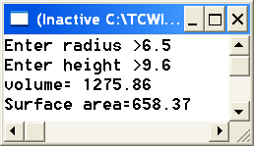

Exercise 2:

Consider the sample problem as example 1 but now the program reads the height and surface area and finds and prints the radius.
Note: Here you will be solving a quadratic equation
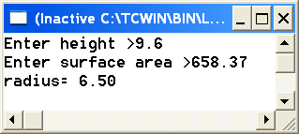

Exercise 3:

Write a program that reads the amount of change and finds the minimum number of bills represented by the change. Assume that the bills available are 1, 5, 10, and 50 riyals.
Hint: Use remainder and integer division.
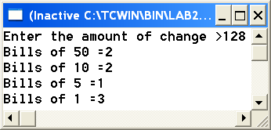

Evaluation:
Your grade will depend on your active participation and seriousness during the lab.

