ICS 103: Computer Programming in C
Spring semester 2009-2010(092)
Lab 2: Data Types

Objective:

Learn about Basic data types in C and how to use them in Problem Solving

Basic Data types in C :

The following table shows the basic data types in C.

Data Type | C Keyword | Bytes | Range | Placeholder  (printf) | Placeholder  (scanf)
Character | char | 1 | (–128 - 127) (0 - 255) | %c | %c
Integer | int | 4 | –2,147,483,648 to 2,147,483,647 | %d | %d
Floating Point | float | 4 | 3.4E-38 to  3.4 E38 | %f | %f
Double precision floating point. | double | 8 | 1.7e–308 to 1.7e+308 | %f | %lf

Notes:

1. C also defines the following modifiers that can be used to modify the memory allocated to the types above as well as the range of possible values:
- short
- long
- signed
- unsigned

For example, short int (or simply short) reduces the size allocated to integers to 2 bytes with a rage of
–32,768 to 32,767.

The default for char and int is signed – meaning the values are distributed between negative and positive values. unsigned char will allocate all the possible range to positive values (0 to 255).

2. The standard C specification (ANSI C) does not actually specify a fixed range or memory for these types. All it says is something like this:
short int <= int <= long int
float <= double <= long double

What this means is that a short int has less amount of storage (bytes) than an int and int has less strorage than a long int. Thus, the above ranges are actually machine and implementation dependent. The following example will print the actual size allocated based on our computer:

/* Displays the number of bytes used to store each type */
#include <stdio.h>

int main(void) {
printf("the size of char is %d bytes\n", sizeof(char));
printf("the size of short is %d bytes\n", sizeof(short));
printf("the size of int is %d bytes\n", sizeof(int));
printf("the size of long is %d bytes\n", sizeof(long));
printf("the size of float is %d bytes\n", sizeof(float));
printf("the size of double is %d bytes\n", sizeof(double));
printf("the size of long double is %d bytes\n", sizeof(long double));
return 0;
}
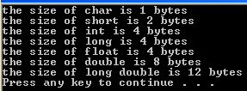

3. As can be seen from the table above, characters are actually represented in C as integer values. Each character is represented by its ASCII code (e.g A = 65. B=66, etc). The table at the end of this document shows the printable ASCII characters and their corresponding ASCII code.

Printing a char variable using “%c” will print the character but printing it with “%d” will print the ASCII code. Similarly, printing an integer variable with “%c” will also print the character provided the value is within the range of characters. The following example demonstrates this.

/* Shows the relationship between char and int types */
#include <stdio.h>

int main(void) {
char c='A';
int code=65;
printf("the ascii value of %c is %d\n", c, c);
printf("prints %c using its ASCII value\n", code);
return 0;
}
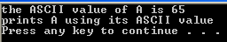

Tasks:

1) Write a program that reads the radius of the circle inscribed inside the square and based on that it will print the values of red and yellow areas respectively.

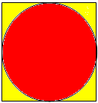

Print the values with 2 digits after decimal point. Define the value of π (3.1416) as a constant.
A sample run of your program gives the following:

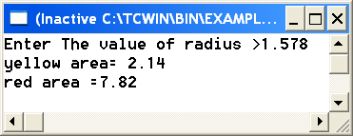

2) Write a program that computes a salary of a part time employee based on :\
- number of days worked.
- number of hours per day assuming that he worked the same hours every day.
- the hourly wage.
Choose the right type for each variable.

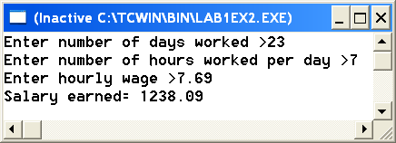

3) Write a program that reads the initials (2 ) of a person. Then, it will print a message informing him a bout his age after 5 years. The printed message should look as shown below.

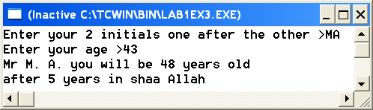

ASCII Table

This table lists the ASCII characters and their decimal, octal and hexadecimal numbers. Characters which appear as names in parentheses (e.g., (nl)) are non-printing characters. A table of the common non-printing characters appears after this table.

Char Dec Oct Hex | Char Dec Oct Hex | Char Dec Oct Hex | Char Dec Oct Hex
-------------------------------------------------------------------------------------
(nul) 0 0000 0x00 | (sp) 32 0040 0x20 | @ 64 0100 0x40 | ` 96 0140 0x60
(soh) 1 0001 0x01 | ! 33 0041 0x21 | A 65 0101 0x41 | a 97 0141 0x61
(stx) 2 0002 0x02 | " 34 0042 0x22 | B 66 0102 0x42 | b 98 0142 0x62
(etx) 3 0003 0x03 | # 35 0043 0x23 | C 67 0103 0x43 | c 99 0143 0x63
(eot) 4 0004 0x04 | $ 36 0044 0x24 | D 68 0104 0x44 | d 100 0144 0x64
(enq) 5 0005 0x05 | % 37 0045 0x25 | E 69 0105 0x45 | e 101 0145 0x65
(ack) 6 0006 0x06 | & 38 0046 0x26 | F 70 0106 0x46 | f 102 0146 0x66
(bel) 7 0007 0x07 | ' 39 0047 0x27 | G 71 0107 0x47 | g 103 0147 0x67
(bs) 8 0010 0x08 | ( 40 0050 0x28 | H 72 0110 0x48 | h 104 0150 0x68
(ht) 9 0011 0x09 | ) 41 0051 0x29 | I 73 0111 0x49 | i 105 0151 0x69
(nl) 10 0012 0x0a | * 42 0052 0x2a | J 74 0112 0x4a | j 106 0152 0x6a
(vt) 11 0013 0x0b | + 43 0053 0x2b | K 75 0113 0x4b | k 107 0153 0x6b
(np) 12 0014 0x0c | , 44 0054 0x2c | L 76 0114 0x4c | l 108 0154 0x6c
(cr) 13 0015 0x0d | - 45 0055 0x2d | M 77 0115 0x4d | m 109 0155 0x6d
(so) 14 0016 0x0e | . 46 0056 0x2e | N 78 0116 0x4e | n 110 0156 0x6e
(si) 15 0017 0x0f | / 47 0057 0x2f | O 79 0117 0x4f | o 111 0157 0x6f
(dle) 16 0020 0x10 | 0 48 0060 0x30 | P 80 0120 0x50 | p 112 0160 0x70
(dc1) 17 0021 0x11 | 1 49 0061 0x31 | Q 81 0121 0x51 | q 113 0161 0x71
(dc2) 18 0022 0x12 | 2 50 0062 0x32 | R 82 0122 0x52 | r 114 0162 0x72
(dc3) 19 0023 0x13 | 3 51 0063 0x33 | S 83 0123 0x53 | s 115 0163 0x73
(dc4) 20 0024 0x14 | 4 52 0064 0x34 | T 84 0124 0x54 | t 116 0164 0x74
(nak) 21 0025 0x15 | 5 53 0065 0x35 | U 85 0125 0x55 | u 117 0165 0x75
(syn) 22 0026 0x16 | 6 54 0066 0x36 | V 86 0126 0x56 | v 118 0166 0x76
(etb) 23 0027 0x17 | 7 55 0067 0x37 | W 87 0127 0x57 | w 119 0167 0x77
(can) 24 0030 0x18 | 8 56 0070 0x38 | X 88 0130 0x58 | x 120 0170 0x78
(em) 25 0031 0x19 | 9 57 0071 0x39 | Y 89 0131 0x59 | y 121 0171 0x79
(sub) 26 0032 0x1a | : 58 0072 0x3a | Z 90 0132 0x5a | z 122 0172 0x7a
(esc) 27 0033 0x1b | ; 59 0073 0x3b | [ 91 0133 0x5b | { 123 0173 0x7b
(fs) 28 0034 0x1c | < 60 0074 0x3c | \ 92 0134 0x5c | | 124 0174 0x7c
(gs) 29 0035 0x1d | = 61 0075 0x3d | ] 93 0135 0x5d | } 125 0175 0x7d
(rs) 30 0036 0x1e | > 62 0076 0x3e | ^ 94 0136 0x5e | ~ 126 0176 0x7e
(us) 31 0037 0x1f | ? 63 0077 0x3f | _ 95 0137 0x5f | (del) 127 0177 0x7f

ASCII Name | Description | C Escape Sequence
nul | null byte | \0
bel | bell character | \a
bs | backspace | \b
ht | horizontal tab | \t
np | formfeed | \f
nl | newline | \n
cr | carriage return | \r
vt | vertical tab
esc | escape
sp | space

