ICS 103: Computer Programming in C
Fall Semester 2010-2011 (Term 2010-1)

Lab 1: Introduction

Objective:

- Learn the basic components of a C program.
- Learn the compilation process.
- Learn how to use Windows and Dev C++.
- Learn how to write & run C programs.
A C-program:
A typical structure of a C program consists of the following:
- Preprocessor Directives that always begin with # (e.g. #include <stdio.h>)
The two most frequent directives are #include and #define.

#include: This directive is used to include header files that have the definition of functions used in the program like prinf function which is defined in stdio.h file.

Note:

#include <file> instructs the compiler to look for file where system include files are held; #include "file" instructs the compiler to look for file in the current directory where the program is run from.

#define: This directive is used to define numeric or string constants. It is a macro-substitution facility. For example, if we have the statement

#define PI 3.14

Then all subsequent occurrences of the identifier PI will be replaced by the value 3.14 when the program is compiled.
- Functions
A function is a block (group) of statements that makes a specific kind of processing.
Every C program has a main() function. The execution starts from main().
- Variables / identifiers
These are used to store data in a program. You must declare a variable before you use it.
Here is the general structure of a C program.

preprocessor directives  main function heading  { declarations;  executable statements;  } | #include <stdio.h>  int main(void)  { int num = 50;  printf(“The number \t Square of number\n”);  printf(“\t %d \t\t\t %d\n”, num, num*num);  return 0;  }

Compilation Process:
Source File
Compiler
Error message
Object File
Successful
Linker
Other Object Files
Executable File

Unsuccessful

Writing, Compiling and Executing a program:
  - Launch DevC++.
  - From the File menu: File → New Source File.
  - From the File menu: File → Save As, browse to your working folder, create
a folder named Lab1 (unless it is there) and then save the file giving it a proper name, like Program1.c
  - Type your program in the editor window; save it.
  - To compile your program, from Execute menu choose Compile (Execute → Compile). If there are errors, you must fix them before going on to the next step
  - If Compile is successful, you can run (execute) the program through Execute → Run

The screen for DevC++ while writing your first program should look as the following figure.

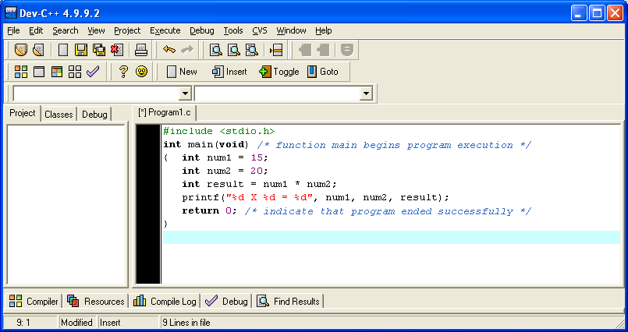
Sample C Programs:
Program 1: Compute the multiplication of two integer numbers
#include <stdio.h>
int main(void) // function main begins program execution
{ int num1 = 15;
int num2 = 20;
int result = num1 * num2;
printf(“%d X %d = %d”, num1, num2, result);
system("pause"); // Use this to prevent output screen from closing
return 0; // indicate that program ended successfully
}

Program 2: Convert from Celsius to Fahrenheit
Note: The program below produces a compile-time error. Why?
#include <stdio.h>
int main()
{ /* Tf=32+9/5*Tc */
int celsius = 70;
int fahr = 1.8 * Celsius+32;
printf("Fahrenheit: %d\tCelsius: %d\n", fahr,celsius);
getchar(); // to keep the console window opened
return 0;
}
Program 3: Read an integer number and print it and its square

#include <stdio.h>
int main(void)
{ int num;
printf("Enter an integer number:\n");
scanf("%d",&num);
printf("The square of %d is %d", num, num*num);
system("pause"); // To prevent closing of console window
return 0;
}

Sample Run
Enter an integer number:
5 <Enter> ⇐ User input
The square of 5 is 25

Lab work:

Launch DevC++ in your computer and run the above programs.

Exercise (to be graded at the start of next lab):

Write a C-program that reads a real number (with fractional part); the program should then print the number, its square and its square root.

Sample Run
Enter a real number:
16.4 <Enter> ⇐ User input
The square of 16.4 is 268.96
The square root of 16.4 is 4.049691

