بسم الله الرحمن الرحيم
COURSE SYLLABUS

TEXT BOOK: Handouts and all related publications

INSTRUCTOR: Dr. Mustafa M. Hariri

Week Subjects

1 Introduction and definitions

2 The Arabian Shield (Characteristics, works done, Evolution, and rock units)

3 The Arabian Shield (The plutonic and layered rock units)

4, 5 The Arabian Shield (tectonism, Najd fault systems, and Theories on Arabian Shield evolution)

- Geological history and economic importance for the Arabian Shield)

MAJOR EXAM # 1
- Phanerozoic Rocks (background, and tectonic events)

8&9 General characteristics of the sedimentary rocks north, east and west of the Arabian Shield)

10 Tertiary intrusions and the sedimentary section of Saudi Arabia

- Characteristics of sedimentary section of Saudi Arabia

MAJOR EXAM # 2

12&13 Hydrocarbon accumulation in Saudi Arabia

- Tectonstratigraphic provinces

15&16 Salt diaprism, geological features of the Arabian Plate and
stratigraphic control

Grade Distributions
15 Attendance
12.5 First Major Exam
12.5 Second Major Exam
10 Term paper
15 Quizzes
5 Field Report
30 Final Exam
100 Total

Contacts:

Dr. Mustafa M. Hariri

e-mail: mmhariri@kfupm.edu.sa

Office No: 3/100 Phone No: 2620

P O Box 5070 KFUPM, 31261, Dhahran

Home Page: http://users.kfupm.edu.sa/ES/mmhariri/
Earth Sciences Page: http://www.kfupm.edu.sa/es/
http://bb.kfupm.edu.sa

Important Sites:
http://www.dgsonline.org/
http://www.sgs.org.sa/
http://www.aqd.nps.gov/grd/tour/
http://www.saudiaramco.com/cgi-bin/bvsm/home.jsp

PART I

THE ARABIAN SHIELD

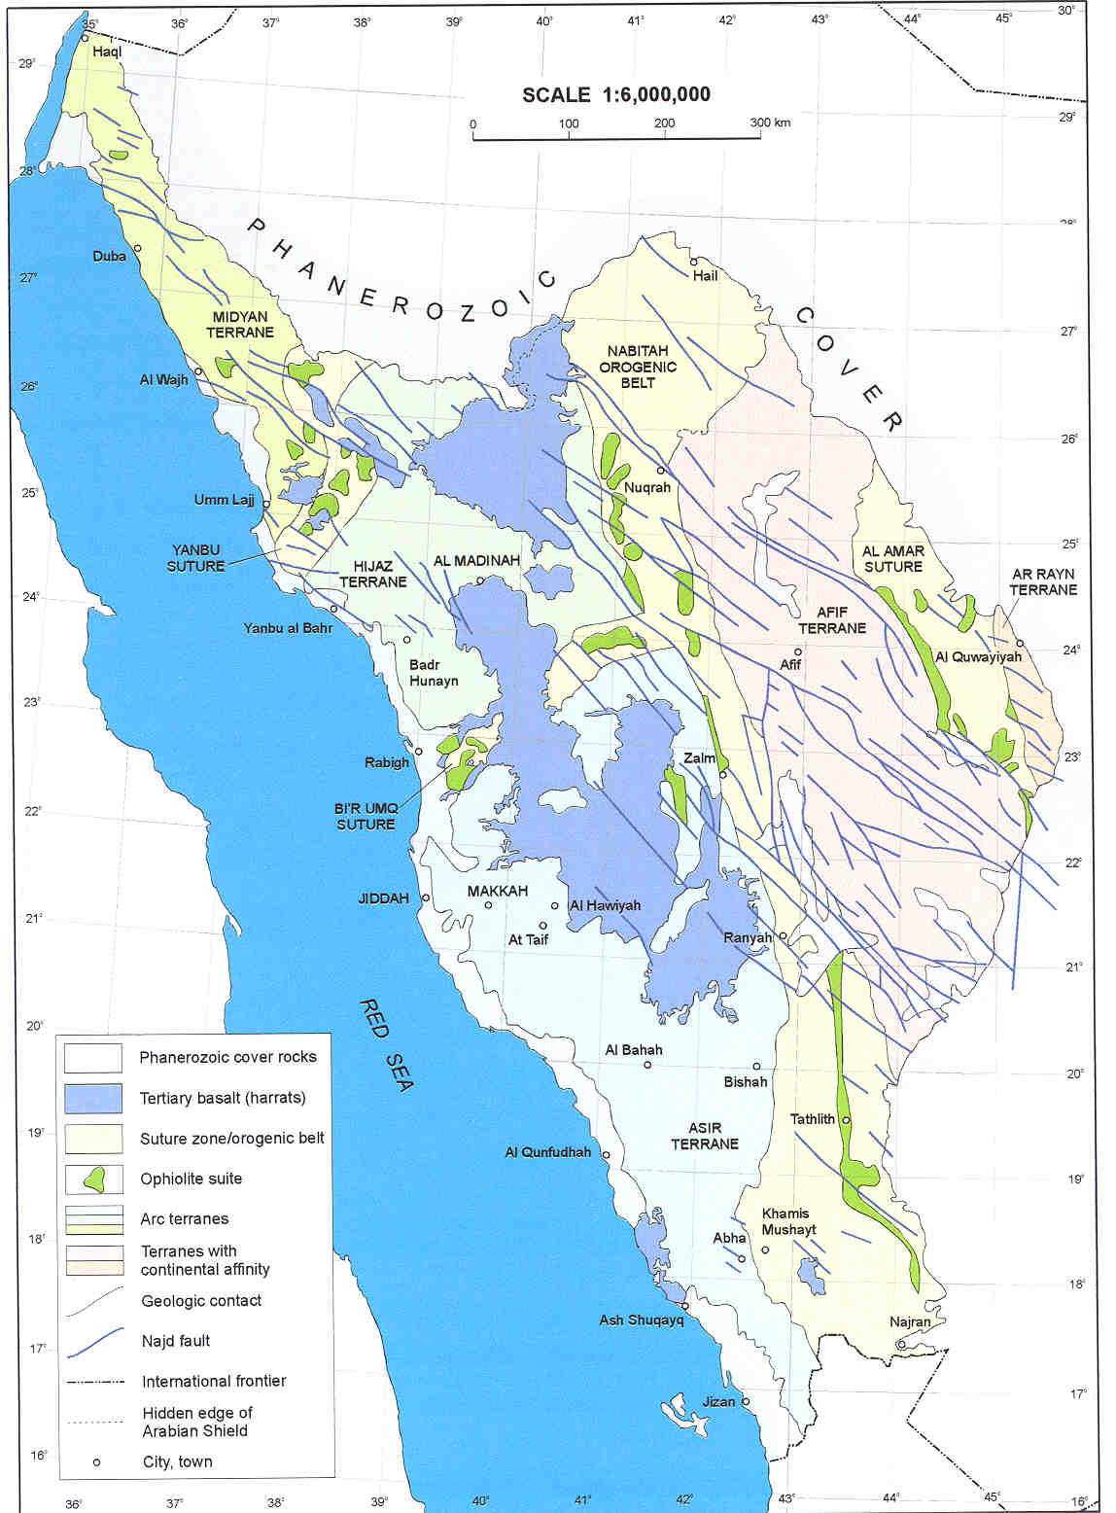

INTRODUCTION
The area of Saudi Arabia is about 2.25 million Km². Majority of this area is covered by deserts. Deserts cover the middle and east part of the country. Mountains are exposed in the west, south and North West parts.
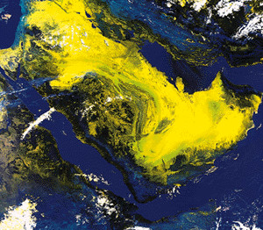

Geology of Saudi Arabia

The geology of Saudi Arabia is made up of two parts;

- Igneous and Metamorphic
Form 1/3 of the area and exposed in the west, north west and southwest

- Sedimentary cover
Form 2/3 of the area and covers the north and east parts.

THE ARABIAN SHIELD
Is the basement igneous and metamorphic Precambrian rocks that exposed in the west, northwest and southwest parts of the Arabian Peninsula.
The Arabian Shield is narrow in the north and south.
In the north the width is about 50-100 km
and in the south the width is about 200 km.
In the middle the width reaches its maximum about 700 km

Characteristics:

- The age of the Arabian Shield ranges between (400 -1000 million year). Some may also date to 1600 million year.

- The Arabian Shield is a segment of the Nubian Shield which has been separated in the Early Tertiary by the formation of the Red Sea.

- Rock units of the Arabian Shield were subjected to many deformation and metamorphic processes that change most of their characteristics.

Works conducted in the Arabian Shield:

Works performed on the Arabian Shield goes back to more than 30-35 years, and included the following:
- Mapping in regional and local scale 1:250,000.
- Detailed mapping for some areas to scale of 1:50,000 and 1:10,000.
- Rock analysis (in both Chemical and Petrographic methods) to determine: Age, Magmatic affinity, Tectonic settings, and Mineral resources.

The studies indicated the following:

- The Arabian Shield is made up of number of group of stratigraphic rock units that include:
Volcanic and Sedimentary meta-volcanic and meta-sediments

- These rocks have been subjected to a number of regional orogenies which associated by intrusions. The intrusions are of different shapes, compositions, deformational tectonic. The rocks also subjected to metamorphism and crystallization that produced meta-sediments.

Evolution of the Arabian Shield:

Events took place and affected the Arabian Shield can be summarized in the following:

- Formation of groups of stratigraphic successions that include both sedimentary and volcanic rocks.

- These rock units subjected to a number of tectonic deformations in both local and regional scales.

- The deformations were associated with the intrusion of plutonic rocks that have different shape and composition.

- These intrusions were also associated with strong tectonic deformations and metamorphism and crystallization that ended forming meta-sediments and meta-volcanics

Rock units of the Arabian Shield:

Based on the above formation stages the Arabian Shield is made up of:
1) Stratified Rocks that deposited as strata (layered) and include all layered rocks such as:

- Volcano-clastics
- Sedimentary
The sedimentary rocks are composed of sediments derived from plutonic and volcanic rocks and includes Conglomerate, Breccia, Sandstone, Greywacke, Limestone, Chert.

2) Plutonic Intrusions:
- Intrusions
- Dikes
These rocks range in composition from mafic to felsic.
3) Volcanic rocks:
- Lava Flows
- Volcano-clastics either deposited in basin under water or on land.

Definitions

GROUP: The formal lithostratigraphic unit next in rank above formation. A group includes two or more associated formations.

FORMATION: A body of rock strata that consists dominantly of a certain lithologic type or combination of types. formations may be combined into groups or subdivided into members.

MEMBER: A lithostratgraphic unit of subordinate rank, comprising some specially developed part of formation

TIME UNITS | TIME ROCK UNITS | ROCK UNITS
EON  ERA  PERIOD  EPOCH  AGE  CHRONE | EONTHEM  ERATHEM  SYSTEM  SERIES  STAGE  SUBSTAGE | SUPER GROUP  (OR COMPLEX)  GROUPS  FORMATIONS  MEMBERS  BEDS  LAMENA
Early- Middle- Late | Lower- Middle- Upper

Classifications of the layered rocks in the Arabian Shield:

1) Brown and Jackson 1960:
First to study the volcanic and sedimentary succession of the Arabian shield. They divided the rocks units into:
- Gneissic belts of granitic and dioritic compositions
- Surrounded by metamorphic schist
Ablah, Fatma formations and Shammar rhyolite
Rocks that are 1000-700 my
Halaban Andesite
Rocks that are older than 1000 my
Lith Complex, Hali schist, Baish greenstone,

2) Schemidt wt al 1973:
The Arabian Shield composed of
Murdamah and Ablah
Unconformity
Jeddah and Halaban
* Less than 1000 my
Hali, Baish & Baha groups
Unconformity
* Older than 1000 my
Old basic (Khamis Mushayt gneiss)
The Main Three classifications of the Arabian Shield are:

3) Greenwood et al 1976 (USGS):
This division is for the southern part of Arabian Shield
- Based on detail geological studies for the southern part of the Arabian Shield.
- Suggests that the Arabian Shield formed initially as oceanic crust and island arcs where volcanic tholeiite (basalt characterized by the presence of clinopyroxene and orthopyroxene and calcic plagioclase).
- These volcanic followed by the layered strata and finally they were metamorphosed and cratonized.

4) Delfour 1983 (BRGM):
This division is for the middle and northern part of the Arabian Shield
- Based on the studies that carried out on the middle and northern part of the Shield
- Suggested that the Arabian Shield is made up of continental crust that has been crystallized and reformed
- This continental crust has a base of older basement and all the rock units followed later

5) Johnson et al 1983:
Grouped the two previous classifications in a third one
- Based on the correlation and comparison of the other two
classifications and connect all this with the new studies on the Arabian Shield.

The Plutonic rocks of the Arabian Shield

- The plutonic rocks cover large areas of the Arabian Shield.

- They range in composition from basic (peridotite, dunite, gabbro)
to intermediate (diorite, tonalite) to acidic (granite)

- The vary in size and shape from dikes, and sills to ( reach in diameter 10’s Km)

Plutonic rocks classification according to age:
Synkinematic (the old intrusions)
Late-kinematic (intermediate intrusions)
Post-kinematic (late intrusions)

Syn-kinematics :
- Age 700-900 my
- Form as Batholiths and they the roots of later intrusions.
- They include of the early formed rocks units.
- Their composition generally is Calc-Alkalic
5) Rock units (Diorite and Trondjhomite)

Late-kinematics:
- Age 620-700 my
- Undeformed
- Calc-alkalic in composition
- Mostly porphyritic and banded
- Rock units (Admellite and Monzonite)

Post-kinematics:
- Age 620-560 my
- Less distribution in the Arabian Shield
- Smaller body (Laccoliths)
- They have ring, elliptical and circular shapes
- They range in composition from alkaline to peralkaline
- Rock units (red granite and syenite)

South Part's Classification of the Arabian Shield

The Basement geology of the southern part of the Arabian Shield
By Greenwood et al 1976 (USGS):

HIJAZ TECTONIC CYCLE (1065-550 my)
NAJD FAULT SYSTEM (550-500 my)
Jubaylah (sedimentary)
(650-550 my)
Shammar (volcanic)
Murdamah (sedimentary)
(850-650 my)
Halban (volcanic)
Ablah (sedimentary)
(1165-850 my)
Jeddah (volcanic)
Bahah (sedimentary)
Baish (volcanic)

North & Middle Parts' Classification of the Shield

The Basement geology of the northern and middle part of the Arabian Shield By Delfour 1983 (BRGM):

NAJD TECTONIC CYCLE (880-520 my)

(610-520 my)
Jibalah (sedimentary)
(690-610 my)
Shammar (volcanic)
Murdamah (sedimentary)
(800-690 my)
Hulayfah (volcanic)

ASIR TECTONIC CYCLE (1200-880 my)

(880-800 my)
Ured (Sedimentary & Ophiolite)

(1000 my)
Ajal (Schist, Amphibolite, quartzite)

(>1000-1000 my)
Older basement (orthogneiss & Granite)

TECTONISM IN THE SOUTHERN PART OF THE SHIELD
Najd (500 my) Jubaylah Group Wrench faults (Najd
fault systems) left lateral
in the NW direction

Shammar (530 my) Shammar Group Subsidence

Bishah (550 my) Murdmah Group Metamorphism to
greenschist, Folding, and
Faulting in the N direction

Yafikh (650 my) Halaban Group Metamorphism to
greenschist, Folding, and Faulting in the N direction

Ranyah (750 my) Ablah Group Metamorphism to
greenschist, Folding, and Faulting in the N-NE and
local metamorphism to amphibolite

Aqiq (850 my) Jeddah Group Metamorphism to
greenschist, Folding, and
Faulting in the N-S Direction

TECTONISM IN THE NORTHERN PART OF THE SHIELD
Ash Shabah (530 my) Jubaylah Group Wrench faults left lateral
(Najd fault system) NW direction

Ar Rimah (610 my) Shmmar Group Metamorphism to
greenschist, Folding and Faulting N-S direction

Ar Raqabah (690 my) Hylayfah Group Metamorphism to
greenschist, Folding and Faulting N-S direction

Tuluha (800 my) Urd Group Metamorphism to
greenschist, Folding and Faulting N-S direction

Asir (1000 my) Ajal Group Amphibolite schist

NAJD FAULT SYSTEM

General information:
- Large size faults form in a belt has a width of 300 km and a length of 1100 km.
- They cut the Arabian Shield from south-east to the north-west
- They trend north-west
- No mountains building deformation and no regional metamorphism were associated with this faults system. Therefore, it is named as a system and not tectonic cycle.

Location:
Starts from the south-eastern part of the Arabian Shield to the north-western part in the direction of the gulf of Aqaba. The system also exposed in the northern part of the eastern desert and Synia desert of the Nubian Shield.

Age:
The Najd faults system took place after the Hijaz tectonic cycle. Its age is between 630 my and 530 my. It considers to be the latest tectonic event in the formation of the Arabian Shield. It may be formed due to the east-west stress regime.

Type:
The faults in Najd faults system are left lateral (Wrench) Strike-slip type. Displacement within these faults varies from one fault to another. It ranges between 2-25 km and in some places it reaches 40 km. Maximum displacement is in the middle of the large faults and less displacement at the ends of the faults.
The vertical displacement is also important within these faults as Jibalah Group deposited in basins within these faults.
Najd Faults system form in a group in en echelon form distance between each group and the other is about 70 km.

Intrusions associated with Najd Fault system:
Granitic, dioritic and gabbroic bodies and dikes present within the Najd faults system. These intrusions intruded in the time of faulting, and may be the faults system facilitated in the formation of these intrusions.
The age of the intrusions ranges between 580-530 my.

Secondary faults:
Secondary faults associated with Najd faults system they may have same trends or different trends. These faults formed by later movements and has affect even on the Paleozoic rocks covering the Arabian Shield especially in the southeastern part of the Shield.

The OPHIOLITE BELTS IN THE ARABIAN SHIELD

There are about six disconnected belts of ultramafic and mafic rocks parallel to the general trend of the rock units and tectonism (faults and folds) in the Shield.

Four of these belts are trending N-S and they are as follows:
- Al-Amar-Idsas belt
- Jabal Humayyan-Jabal Sabhah belt
- Al-Bijadiyah-Halban belt
- Al-Hulayfah-Hamdah-Nabitah belt

The other two belts are trending E-NE and include the following:
- Jabal Ess-Jabal Al-Wask belt
- Bir Umq-Jabal Thurwah belt

- These belts vary in length and width and constituents from one place to another. However, they share the general geological characteristics.

- In addition to these belts there are some other localities in the Arabian Shield were Mafic and Ultramafic rocks present. Examples of these localities are:
- The serpentine rocks in the northern and the south-western parts of the Shield.

- The ultramafic belts in the Shield were subjected to deformations and there rocks also affected by metamorphism to greenschist and amphibolite facies.

- These belts characterized by tectonic contact with the surrounding rock units. Base of these belts is mainly serpentine which has inclusions of tectonic mafic and ultramafic rocks and hosted melange rocks.

- In many places the border of these ophiolite belts are affected by later tectonic deformation and changes due to hydrothermal solutions as in Al-Amar Idsas belt where the contact has changed to fault contact and the serpentine rocks have altered to along the fault to carbono-silicate and carbontized rocks. These carbontized rocks are difficult to differentiate from sedimentary carbonate.

- Alteration of serpentinite to carbonitized and to talc is very predominant in many places within these belts, especially where deformation and tectonism took place.

- All these ophiolite belts were cut by Najd Faults system, and this can be noticed from the displacements within the belts.

- These ultramafic and mafic belts have generally the characteristics of ophiolites. However, the tectonic deformation and metamorphism in the Shield have destroy these characteristics except in Jabal Ess on the Amar-Idsas belt.

EVOLUTION AND FORMATION OF THE SHIELD

- To understand the evolution processes of the Arabian Shield, the evolution of the surrounding Shields is also need to be understood. The nearest Shield to the Arabian Shield is the Nubian Shield. The two shields were attached to each other and separated by the Red Sea in the Tertiary.

- The Red Sea starts spreading in the Tertiary and continues spreading in the rate of 1.5 to 2 cm a year. The direction of spreading is East-West.

Theories on the Arabian Shield evolution:

1) Island Arcs theory:
The Arabian Shield developed as a result of collision more than one Island Arcs. These Island Arcs formed in oceanic crust (Al Shanti and Mitchel 1976; Greenwood et al. 1976; Bakor et al. 1976; Frisch and Al Shanti 1977; Gass 1977, 1981; Schmidt et al 1979 and Camp 1984)

2) Continental crust theory:
The Arabian Shield developed as tectonic deformation from magmatic activities, or sof continesilicrust or b(Delfoure 1981; Hepworth 1979; Garson and Shalabi 1976; and Kemp et al 1982)

3) Suture zones and Microplates theory:
The Arabian Shield formed by microplates that have sutured to each others. These plates are of oceanic and continental affinities (Kroner 1983; Vail 1983; Camp 1984; Stoeser et al. 1984)

- This theory answers many questions that rise by the other two theories.

- It also explains the distribution of the five geological provinces of the Shield.

- The theory divided the Arabian Shield into five microplates (terranes):
- Asir terrane (Arc)
- Hijaz terrane (Arc)
- Midyan terrane (Arc)
- Afif terrane (Continental)
- Ar Rayn terrane (Continental)

- These terranes are separated from each other by four suture zones:
- Yanbu suture between Hijaz and Midyan terranes
- Bir Umq suture between Asir and Hijaz terranes
- Nabitah suture between Afif and Hijaz and Asir terranes
- Al Amar suture between Ar Rayn and Afif terranes

In Summary:

- The Arabian Shield can be subdivided tectonically into five microplates and may be more.

- Three of these five terranes (microplates) are formed as intraoceanic island arc terranes (Asir, Hijaz, and Midyan). These terranes form the western part of the Arabian Shield.

- The other two terranes are Afif and Ar Rayn. Both of these terranes are of continental affinities.

- These terranes are separated by four suture zones (Yanbu, Bir Umq, Nabitah and Al- Amar)

- The suture zones are made up of ophiolites

The following section is taking from (Johnson, 1998)
- The Precambrian rocks (Arabian Shield) contain most of the Saudi Arabia’s known metal deposits, such as gold, silver, copper, zinc, iron, and magnesium (Johnson, 1998).

- Since its creation, the Arabian plate moved northeast away from Egypt and Sudan, north away from Somalia, and rotated counterclockwise about a point in the vicinity of the Gulf of Suez (Johnson, 1998)

- Such movement is accommodated by Compression and strike-slip displacement along the Bitlis and Zagros zones, where the Arabian plate collides with and subducts beneath the Eurasain plate, and by strike-slip displacement along the Dead Sea transform

- At the present time, the northern part of the Arabian plate moves northwest, with respect to the Eurasian plate, at a rate of 20 mm/y

- Two types of earthquake activities are present within the Arabian Plate:
- Weak to moderate earthquake activities in regions of extension South, South-western, and Southeastern margins of the Arabian Plate

- Strong earthquake activities are present in regions of compression
Northerly and Northeasterly margins

- Overall the Arabian Peninsula has moved as much as 350 km away from Africa

- Seismic refraction survey in southeastern Saudi Arabia indicates the following:
- The Arabian-plate lithosphere generally consists of two layers each has a thickness of about 20 km
- The MOHO is about 40-45 km below the surface separating the continental crust form upper mantel.
- The upper layer is made up of deformed Precambrian rocks with vast amount of granitic rocks
- The deeper layer is mainly mafic in composition and contains fragments of deeper crustal material brought to the surface by Cenozoic volcanic eruption in several places in the western part of the Arabian plate

Geological history of the Arabian Shield:

- The rocks of the Shield represent one of the best exposed and largest assemblages of Neoproterozoic rocks in the word.
- These rocks are divided into separate crustal units or suspect terranes
- The terranes believed to have distinct unique geologic histories.

Historical Evolution:

Many of the Neoproterozoic rocks accumulated in oceanic environments (island arcs, oceanic plateaux, and mid-ocean ridges)

- This ocean lay on the margins of Rodinia (global super-continent that existed during the early Neoproterozoic.

- Rodinia began to break up about 750 my

- Rifted segments of super-continent reassembled by the end of Neoproterozoic forming a new super-continent of Gondwana
- In this process, the basement rocks of Saudi Arabia, northeast Africa and along strike in Mozambique belt, were caught between western and eastern segments of Gondwana

- As the segments came together, forming a belt of folded, thrusted, and metamorphosed agglomerated terranes and reworked older rocks

- At the end of this process, additional volcanic and sedimentary rocks were deposited in marine and continental environments, and a vast amount of plutonic rock was intruded into and beneath the deformed volcanic and sedimentary rocks

- Sutures between the constituent terranes of the Arabian shield and the northeast Africa part are marked by
a] Serpentinite b] thrusts c] brittle-ductile shear zones

- These faults and shear zones coincides with zones of significant
changes in gravity, magnetic, structural, and isotopic characteristics

- These Neoproterozoic rocks crop out in Oman and appear to extend beneath the Phanerozoic cover.

ECONOMIC IMPORTANCE OF THE SHIELD

This part is taking chiefly from the Mineral Resources Of Saudi Arabia (1994)

- The Kingdom of Saudi Arabia has a large variety of metallic and non-metallic mineral resources

- These resources range in size and value from occurrences of limited potential to deposits large enough to sustain profitable exploitation

(Occurrences, Prospects, Deposits, Ore, and Ore body)
Occurrence: Any occurrences of an economic mineral
Prospect: Any occurrence that has been drilled or prospected
Deposit: Any substantial body of mineral
Ore : A mineral that occurs in such quantity and grade as to make extraction profitable
Orebody: A deposit that can be mined profitably at current time

- Most metallic minerals are located in the Proterozoic rocks of the Arabian Shield exposed in the western part of the Kingdom.

- Industrial minerals are also located in the Arabian Shield but they are more common in the Phanerozoic sedimentary rocks that flank the Shield in the eastern and northern parts and underlie the Red Sea plain

- Examples of the metallic, nonmetallic and industrial minerals in the Shield are:
Au, Ag, Cu, Pb, Zn, Ni, Hg, Mo, Cr, talc, gypsum, kaolin, Fe, Mn, Asbestos, Mica, S, Ornamental stones, Sn, W, Th, U, Nb, F,REE & Ba

PART II

THE SEDIMENTRAY COVER

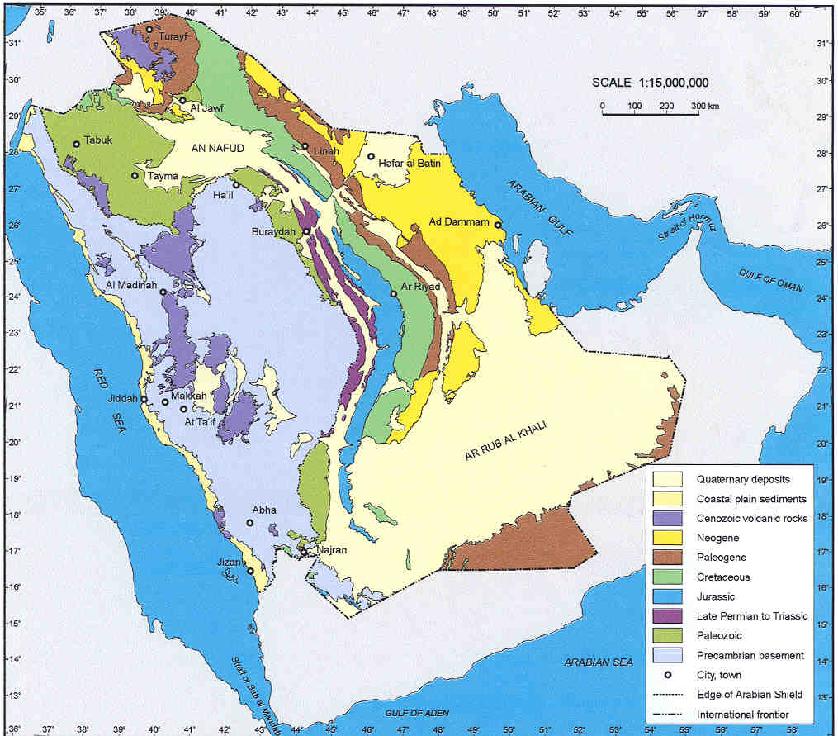

THE PHANEROZOIC ROCKS
Sedimentary formations

General Background:

- The crystalline basement of the Arabian Shield has not been completely stable since the its formation in the Precambrian.

- Due to the plate movements during the history of Gondwana and other parts of the world the Arabian Shield was affected by:
1) Strike-slip faulting and rifting, forming GRABENS
- Uplift and subsidence, forming DOMES, BASINS, ARCHES
and TROUGHS

- The effects of this deformation are reflected in:
The crest of Hail Arch is about 4 km above the trough of An-
Nafud basin

The easternmost part of the Arabian plate are depressed
beneath more than 10 km of sedimentary rocks

The crystalline rocks in the western part of the plate are
elevated by as much as 3 km above sea level along the Red
Sea escarpment

Basement rocks are vertically displaced as much as 3 km on
buried faults beneath central Arabia

The southeastern margin of the plate has been overthrust by
slices of ocean floor

- The present-day Arabian Shield is exposed because of uplift along the Hail arch and Red Sea arch (Johnson, 1998)

- The Phanerozoic sedimentary in the Arabian Plate began with the deposition of calstic rocks and later evaporates in the above mentioned grabens or pull-apart basins (in Oman and eastern Arabia).

- The formation of salt basins (Infracambrain-Cambrian) in the eastern part of the Arabian plate together with local structures and basement horst blocks make an excellent condition for oil traps.

Tectonic events:

During the Early Paleozoic:
Central Arabia was a stable subsiding passive margin flanking Gondwana.
Shallow-marine, fluvial, sandstone, siltstone, and shale were deposited on low-relief erosion surface formed on the Precambrian basement

During the Late Ordovician-Early Silurian:
-The depositional cycle interrupted by polar glaciation
-Arabia at this time was within 30 of the south pole
- Sea level rise and fall caused regression and transgression of the ocean
floor a round Gondwana

Devonian:
-The passive margin of Gondwana in Arabia became active because of the
Hercynian orogenic activity
- Central Arabian underwent uplift and tilting
-The regional uplifting during Devonian is reflected in the development
of the Central Arabian arch, where the Devonian sedimentary rocks are
absent.

- Earlier deposits were depressed in fault basins or eroded across generally north-trending horst blocks resulting in an irregular topography preserved beneath the Unayzah-Khuff unconformity.
- This resulting in the initiation of structures that eventually controlled the location of Paleozoic-hosted oil fields in central Arabia.

Late Carboniferous:
Unayzah formation calstic rocks, which constitute major oil reservoirs where they overlie appropriate Hercynian structures, mark the resumption of sedimentation in the Late Carboniferous.

Permian:
Deposition of the Khuff formation which represents the earliest major carbonate unit in Arabia, followed, concurrent with rifting and Gondwana breakup in the Zagros region.

Mesozoic:
-The Mesozoic geologic history of the Arabian plate is marked by the
formation of structural highs and lows.
- In central Arabia, regional extension caused by continued breakup of
Gondwana and rifting along the Zagros belt resulted in the Triassic reactivation of Hercynian structures and syn-sedimentary thinning of Triassic deposits over growth faults.
- Reactivated basement structures, present in Saudi Arabia in the form of Mesozoic anticlinal highs trending N-S. These highs affected the younger sedimentation, particularly during the Upper Cretaceous causing anticlinal drape folds and helping to create the Mesozoic oil fields of Saudi Arabia

-The reservoir rocks are Jurassic and Cretaceous, into which Jurassic hydrocarbons migrated during the Tertiary.

In Middle Jurassic and Early Cretaceous:
The axial region of central Arabian arch underwent inversion and became a basin and

In the Late Cretaceous:
The arch reformed again as a result of uplift in southern Arabia and continued subsidence to north.

During the Middle Cretaceous:
Concurrent with the opening of the Atlantic, Neo-Tethys closed and the African-Arabian and Eurasian plates converged.

Tectonic events within the Arabian Shield and Red Sea

Carboniferous - Initial subsidence in Gulf of Suez

Triassic & Jurassic - General epeirogenic uplift in northern Red Sea

Cretaceous - Subsidence in southern Red Sea

Paleocene - Initial subsidence along the Red Sea

Oligocene- Initial rifting in Red Sea Graben (41-36 m.y)

Miocene & Pliocene- Major subsidence in Red Sea Graben; rifting
during the last 5 m.y

The Phanerozoic rocks (sedimentary formations) of Saudi Arabia are found in two parts within the Arabian Plate:

- East and North of the Arabian Shield

- Within the Arabian Shield and the Red Sea area

- Sedimentary cover rocks in the east and north of the Arabian Plate range in age from Cambrian to Quaternary. They reach a thickness of about 5500 m.

- Some of these sediments deposited as outliers of older rocks as erosional remnants on marginal parts of the Arabian Shield.

- In the north of the Shield rocks are mainly Paleozoic sedimentary rocks.

- Tertiary strata occur in the Sirhan-Tyrayf basin.

- Tertiary to Quaternary strata overlie Precambrian and Phanerozoic rocks between the Shield and the Red Sea coast and along the valleys leading down to the coast.

- Tertiary to Quaternary alluvium and alluvium form thin veneers on the Shield itself and vast deserts, such as the Ar Rub al Khali and An Nafud, to the east and north of the Shield.

SEDIMENTARY ROCKS EAST OF

THE ARABIAN SHIELD

- The sedimentary rocks are bordering the east of the Shield.

- They crop out in a great curving belt and form a series of essentially
parallel west-facing escarpments, each with a resistant limestone cap.

- Exposures are abundant and many rock units can be traced without
significant interruption for hundreds of kilometers.

- Beds reflecting buried basement configuration dip gently and uniformly away from the escarpment region into the Arabian Gulf and Ar Rub al Khali.
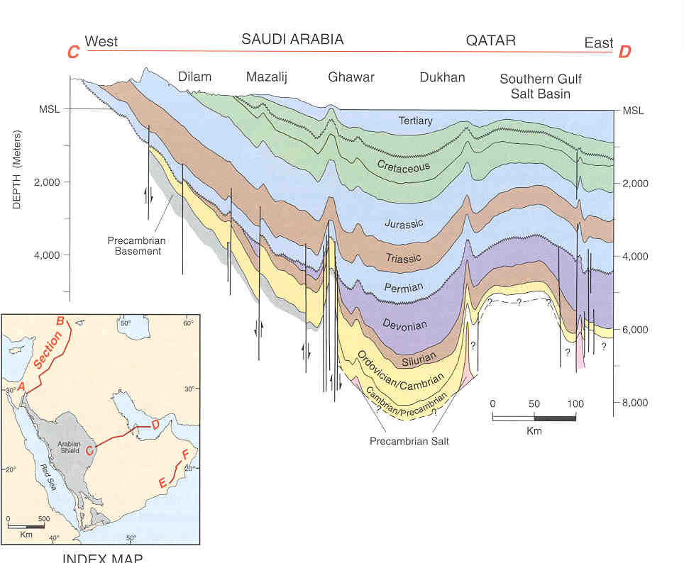

Lithological Characteristics of the Paleozoic rocks

( East of the Shield):
  - Lower Paleozoic rocks east of the Shield consist of alternating non-marine and marine units
  - They are dominantly clastic but with some thin carbonate beds in the upper most part
  - The stratigarphically lowest rocks have been correlated with rocks of Cambrian age in Jordan but have not themselves yielded any Cambrian fossils.
  - The higher sequences conation fossils such as brachiopods and
  - Graptolites, which indicate the age of Early Ordovician, Silurian, and Early Devonian.
  - Upper Permian and Upper Triassic rocks unconformably overlie the Lower Paleozoic rocks in the central escarpment. These rocks composed also of alternating non-marine and marine units, dominantly clastic, but with thick calcareous at the base and in the middle.

Lithological Characteristics of the Mesozoic rocks

(East of the Shield):

Geologic time | Rock types
Early to Middle Jurassic | Marine shale and interbedded carbonate in central Saudi Arabia  Graded into sandstone to the south and north
Late Jurassic and Early Cretaceous | Mostly carbonate with alternation of evaporites
Early Cretaceous | Dominantly coarsely clastic with thin basal carbonate
Upper Cretaceous | Dominantly carbonate

Lithological Characteristics of the Cenozoic rock

(East of the Shield)

- Oligocene is missing east of the shield

- The Eocene carbonate is succeeded by Miocene and Pliocene sandy limestone and sandstone

Tertiary sediments (East of the Shield)

- Small, widely scattered, isolated patches of late Tertiary gravel occur east of the Shield and are mostly well-rounded white quartz pebbles usually poorly sorted with some limestone pebbles. These grovels may represent remnants of channel deposits laid down by Tertiary rivers

- Small outleir of sandy marl, sandy limestone in central part of Ar Rub al Khali

- Marine beaches along the Arabian Gulf Coast of sand and coquina terraces 1 to 2 m above the main high tide level.

- Young bedded deposits of Gypsum at several localities.

Quaternary sediments (East of the Shield)

- Terraces of limestone and quartz gravels

- Gravel blankets covering Ad dibdibah plain (broad and flat) flanking Al-Batin and extending from south of Trans-Arabian pipeline into Iraq and Kuwait. This sheet represents the residue of vast flood of rock debris derived from the basement complex and funneling out through the wadi Ar Rimah and Al-batin channel systems.

- Sabkhas are Coastal and inland flats built up by deposition of silt, clay, and muddy sand in shallow but extensive depressions. They are commonly saturated with brine and salt. Most are located about 60 km off the shoreline, some are located far in land.

- Half of Phanerozoic sedimentary rocks in the East and North is blanketed by eolian sand (Ar Rubi-Al-Khali contains probably the largest continuous body of sand in the world, covering about = 600,000 km²). They are in the form of: Sand Oceans in dunes, longitudinal sand sheets divided by Sabkhas. Various forms of narrow sand ridges and dune chains and sand mountains reach 50-300 m above the substratum.

SEDIMENTARY ROCKS NORTH OF

THE ARABIAN SHIELD
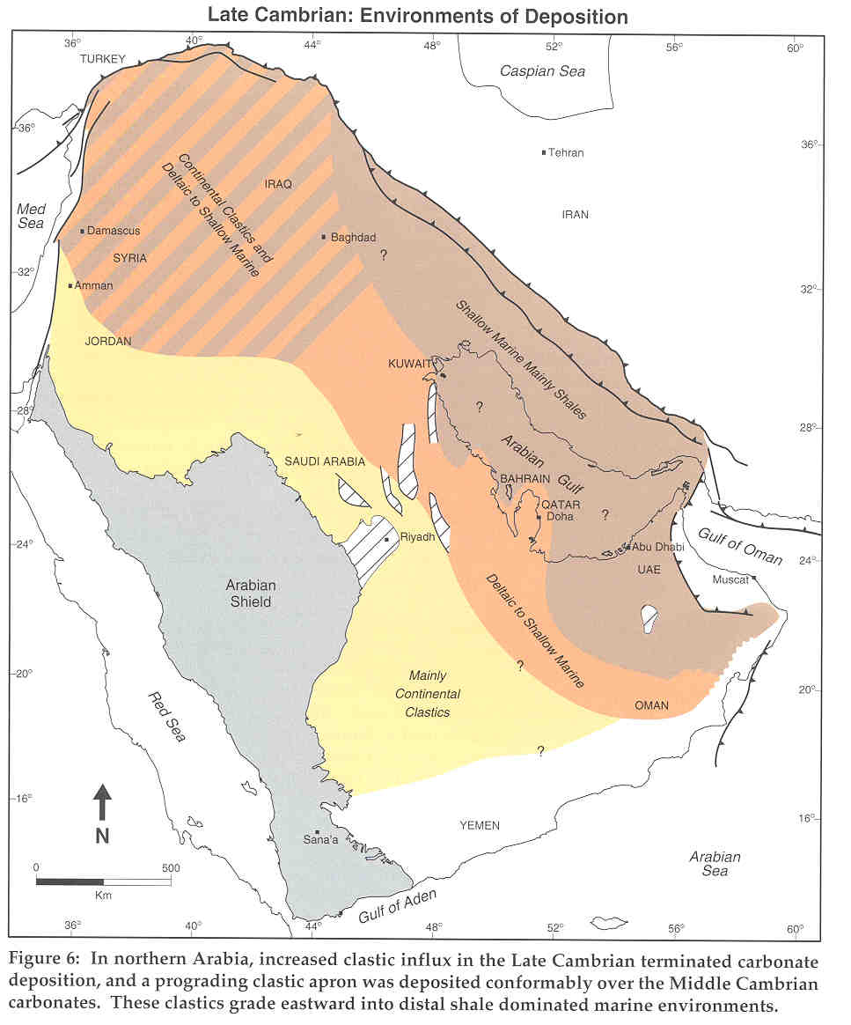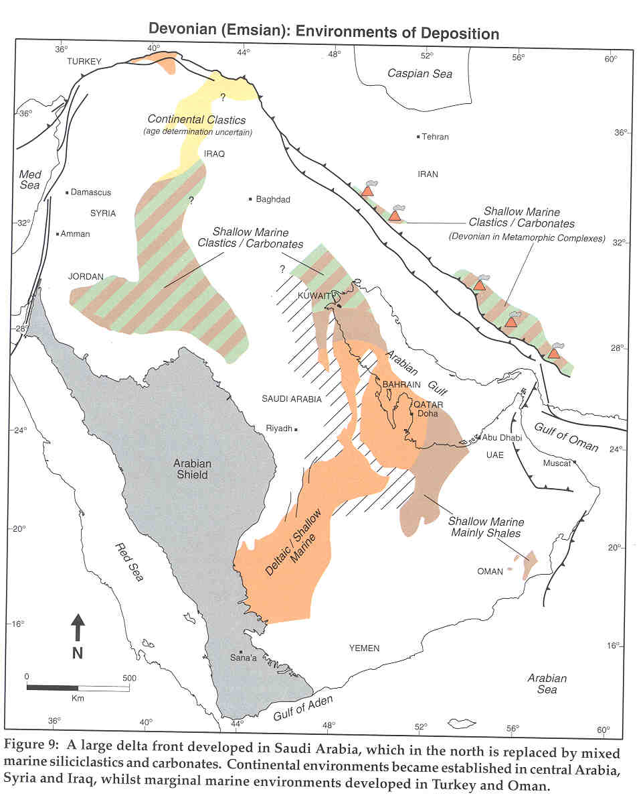

Lower Devonian and Older Paleozoic
Form a gently curving arc parallel the north edge of the Shield and disappear eastward beneath An Nafud.

Upper Cretaceous to Tertiary
Sirhan Turayf Basin formations unconformably lie above these rocks. This Basin begins west of the crest of buried structural ridge (Hail arch), where the Aruma formation dips gently westward below Hibr formation

Quaternary Silt, and gravel

Miocene and Pliocene Sandstone, marl and Limestone

Paleocene & Eocene Hibr formation

Upper Cretaceous Aruma formation

Aruma formation
Ranges in thickness from 18-30 m in the upper part it is sandy or argillaceous limestone that is phosphatic in places and in the lower part contains beds of sandstone and shale that are partly phospatic

At the top of Aruma formation and conformably lies the Hibr formation

Hibr formation
Is a zone of sandy phosphorite with beds of limestone, chert and shale.

The Hibr formation is divided into three members:
Upper Limestone and partly phosphatic chert

Middle Phosphate member (Chert and Phosphate)

Lower Chert and laminated argillaceous and sandy Limestone

As-Sahin plain is covered with sheet gravel that include basalt pebbles may derived from the Al Harrah lava field (extends from the Jordanian border).

SEDIMENTARY ROCKS ALONG

THE RED SEA COAST

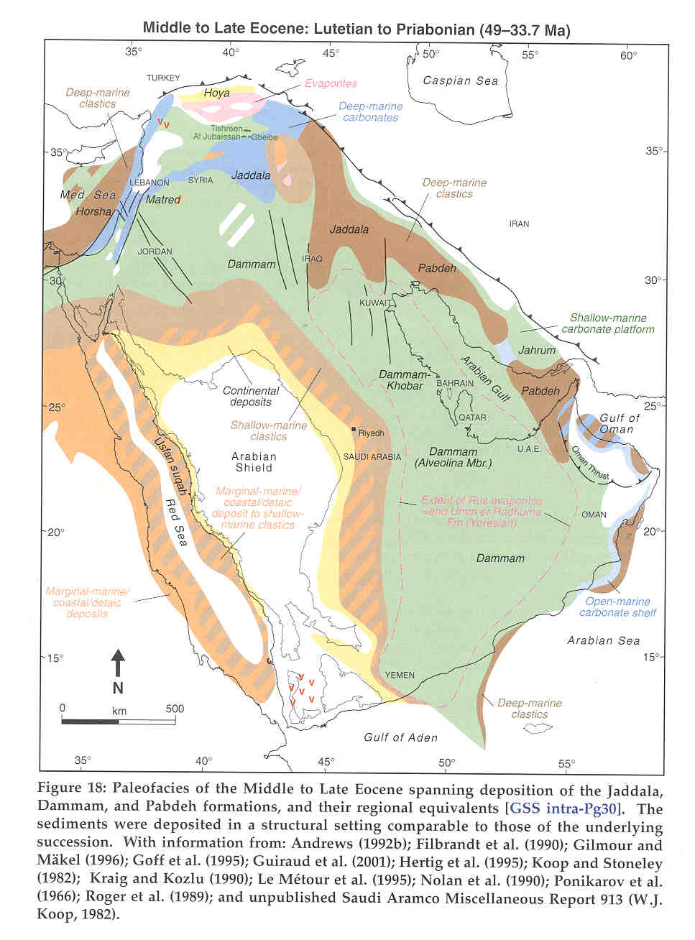
Sedimentary rocks along the Red Sea Coast

Jurassic
Khums Sandstone form outliers southwest of the Shield Upper Phanerozoic to Lower Tertiary along the coastal strip

Upper Cretaceous ( Maastrichtian)
Usfan formation north of Jeddah represents the southernmost limit of Late Cretaceous transgression from Mediterranean

Late Cretaceous sediments above the Precambrian basement
In the middle northern part along the coastal (revealed by drilling in Wadi Azlam). These sediments include clay and sandstone, gypsum, sandy marlstone, siltstone, red shale, and argillaceous sandstone, overlain by gravel, sand, and silt, and covered in places by eolain sand. Limestone is also present and some beds are fossiliferous.

Northwest-trending faults that were active before and during sedimentation cut these deposits and created a graben with a total vertical movement of as much as 800 m along its eastern edge

Cenozoic formations
Between the Gulf of Aqaba and Yanbu al Bahr the following sequence
Miocene Conglomerate, reef limestone, marl, and gypsum
Oligocene Sequence of conglomerate, arkose, sandstone, and argillite
Pliocene-Pleistocene Calcareous deposits
Oligocene Raghama formation in the coastal plain north of divided into :
Upper Miocene to Pliocene reef limestone, evaporate, sandstone, and conglomerate

Middle transgressive marine origin sediments coarse to fine sedimentary rocks, clays , reef limestone, marls and evaporites and intraforamtional breccia
Lower Detrital sediments and some carbonate

Between Yanbu al Bahr and Jeddah the following:
Eocene uppermost Shumaysi formation and
Miocene evaporates crop out discontinuously along the Red Sea coast

Shumaysi (Eocene) formation composed of sandstone, shale, siltstone, tuff, and basaltic andesite.

Southern part of the coastal plain of the Red Sea:

Early to Middle Tertiary (possibly deformed when Miocene gabbros were being intruded along the Red Sea margin):

The Baid formation in the Al-Qunfudhah quadrangle:
Consists of conglomerate, sandstone, limestone, chert, and basalt (possibly fresh water origin no fossils).
In Manjamah quadrangle, the formation consists of tuffaceous siltstone, argillaceous material includes volcanic glass, plagioclase, and magnetite fragments

Pliocene:
The Bathan formation in the Al Lith quadrangle:
Consists of terrigenous boulder, and pebble conglomerate and coarse grain sandstone. The formation is moderately tilted toward the Red Sea.
In the Manjamah quadrangle, the formation is made up of polymict conglomerate containing sub-angular to sub-rounded clasts of metavolcanic, metasedimenatry, and other metamorphic rocks and plutonic rocks.

The coastal plains:
Pediment and derived deposits consist of boulder-and cobble-sized near the steep zones and of gravel, sand and silt into flat area. These materials cover vast areas at the landward edge of the coastal plains.

Sand and gravel form the floors of all main wadis and their tributaries. These deposits are sub-angular to well rounded, unstratified to well stratified, and commonly cross bedded and filling channels.

Flood plains:
Silt and fine grained sand and clay as much as 4 m thick layers covering the extensive flood plains and along major wadis.

Banks of calcareous and terrigenous muds occur in shallow water along the coast, and reefs consisting of different type of coral, gastropods, brachiopods, and plelecypods are still building by living organisms.

Islands off the coast are made up of :
Fine to coarse-grained carbonate sand, composed of broken shells, coral reef fragments and subordinate amounts of eolian silt, resting on coral reef and surrounded by mud banks that are exposed at low tide.

Sabkhahs:
Occur on the inland side of the coastal banks and coral reefs and are composed of brown and white saline silt.

Tertiary Intrusions:
Dike system extends through the western part of the Arabian Shield from the Yemen border to the Gulf Aqaba. They are gabbro, diorite, and hypabyssal intrusive rocks. The age of these rocks range between 19-27 m.y. They reach 300 m in width and tend to branch and anastomose. Some can be traced to several kilometers. They are coarse grained in the middle and chilled and fined at the edges.
These dikes give rise to north-northwest trending aeromagnetic lineaments.

Tertiary and Quaternary Volcanic:

Volcanic activity associated with the evolution of the Red Sea continued from Oligocene- to historic time's locations of these volcanic rocks.
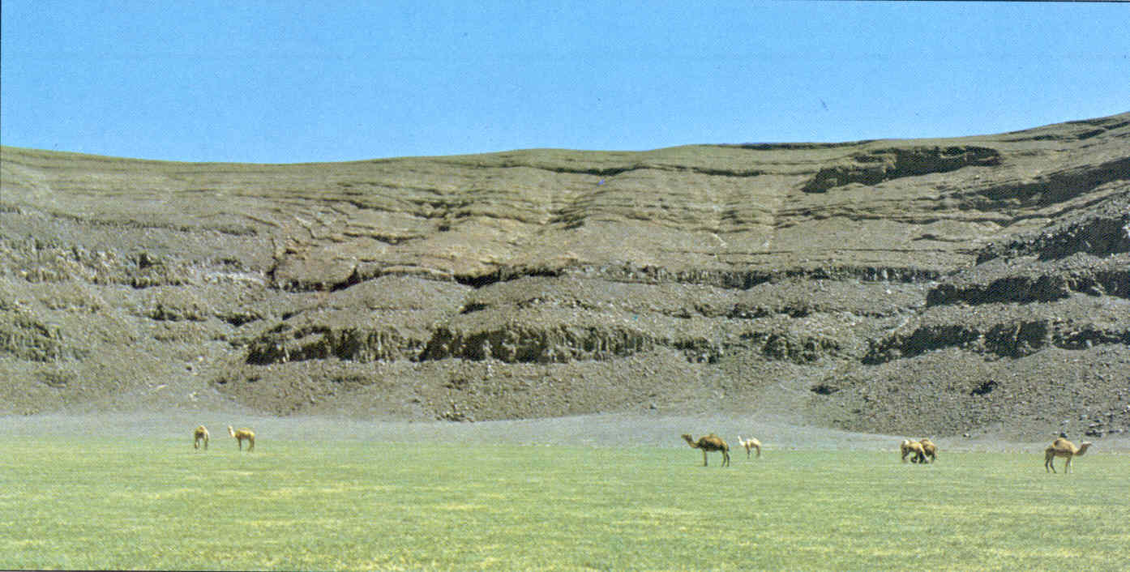
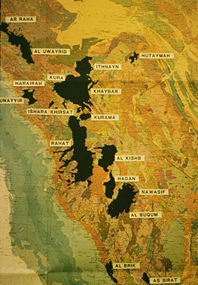
AGE:
- Example of the oldest is occupy the crest of monocline flexure at As Sirat (about 580 m in thickness and dates to around 25 m.y) late Oligocene.
- Example of youngest is Wadi Amq (18/41D) 2.2 m.y (Late Pliocene) and Quaternary times and basaltic volcanism is in historic times in Al-Madinah area in the north of the Shield.
TYPES AND ROCKS:
Basalt flows cover large areas of the western part of the Shield form plateaus or harrats with surface composed of angular lava blocks about 40 cm. in diameter.
The flow rocks are commonly vesicular columnar basalt overlaying loosely consolidated tephra beds in places. Flow rocks and tephra are underlain in some areas by Precambrian rocks, and in other areas by alluvium, including gravel, gypsum, and limestone. Lava tongues follow existing drainage channels in many places.
Many large cinder cones range up to 2.5 km in diameter and rise above the general level of the lava up to 300 m. Some preserved as bowel shape but other are partly eroded.

Many of the cones have been cut to bases by lava flowing from more or less circular feeder pipes, and many cut by radiating feeder dikes.
In some places the flows form only thin veneer laying above the Precambrian basement, and in some places the volcanic successions reach 500-1000m.

The magma appears to have been extruded mainly from north-trending fissures, and have emanated from depths that were probably reaching 60-100 km. Some differentiated from shallower depths.

TERTIARY SPREADING, UPLIFTING:
Seafloor spreading in the Red Sea began 5-6 m.y., although an earlier episode of spreading may have occurred 15-25 m.y.

Intrusion of the magma along the spreading axes created the oceanic crust southern Red Sea and formed hot springs in some other areas.

In the Northern part of the Red Sea the floor may be a mixture of rifted continental crust and newly formed oceanic crust. Syn- and Post-rift sedimentary rocks, including evaporites, flank the spreading axis in the Red Sea and underlie the Red Sea coastal plain (Tihama).

Processes related to spreading caused:
- Uplift of the southwestern and southeastern margin of the Arabia and Hadramaut (2500-3300 m) above sea inland from Red Sea and Gulf of Aden.
- The Red Sea margin of southern Saudi Arabia has undergone 2.5-4 km uplift in the last 13.8 m.y.
- End-Cretaceous-Tertiary events in the southeastern part of the Arabian plate include
- oblique obduction of the Masirah ophiolite (Paleocene) onto the Arabian continent
- rift-shoulder uplift and
- normal faulting of coastal southern Oman and eastern Yemen
This episode of uplift caused development of the Gulf of Aden collapse structures, fractures parallel and oblique to the general trend of the gulf, and the southern flanks of the Mesozoic Hadramaut arches.

SEDIMENTARY SECTION OF SAUDI ARABIA

The sedimentary section of Saudi Arabia exposed above the Precambrian and falls into eight major divisions:

Cambrian through Carboniferous
Saq, Al-Qassim, Sarah, Al-Qalibah, Al-Tawaeel, Al-Jouf, Al-Jobah, and Unizah
Dominantly coarse clastic rocks with some thin carbonate beds in the uppermost part

Upper Permian through Upper Triassic

Khuf, Sudair, Al-Jilh, and Manjour
Alternating non marine-marine units, dominantly clastic but with thick calcareous sections at the base and in the middle

Lower and Middle Jurassic
Marrat, Dhruma, and Twaiq Mountain
In central Arabia marine shale interbeded with carbonate grades to sandstone in the northern and southern parts

Upper Jurassic and early Lower Cretaceous

Hanifah, Jubailah, Arab, Hith, Sulaiy, and Yamamah
Mostly carbonate but with alternating evaporate normal marine cyclic deposits near end of Jurassic

Late Lower Cretaceous

Buwaib and Biyadh
Dominantly coarse clastic rocks with thin basal Carbonate unit

Middle Cretaceous
Wasia (in the north Skaka)
Dominantly coarse clastic rocks

Upper Cretaceous to Eocene

Aruma, Umm er Radhumah, Rus, and Dammam
Carbonate units but in subsurface lower Eocene includes evaporite section.
Miocene and Pliocene

Hadrukh, Al-Dam, Al-Hofuf, and Al-Kharj
Clastic rocks dominantly sandy limestone and sandstone

Lithological Characteristics of the Phanerozoic Eon
(After Z. Al-Naggar)

PHANEROZOIC EON  Oman Orogeny 65 m.y. | Cenozoic Era | Cainogene  Mesogene  Paleogene | Regressive (the pluvial period in the region the last great Ice Age)  Shallow marine transgressive phase  Shallow marine transgressive phase  Orogenic / main phase with repeated transgression and regression and numerous syn-sedimentary structures  Transgressive phase (the second largest marine transgression in the region)  Oscillatory phase  Permian Regressive  Carboniferous Phase with a  Devonian Carboniferous  -Permian  Glaciations  And local  transgression  only in late  Permian  Silurian Transgressive  phase  Ordovician (Interrupted by  Regression And  Cambrian Glaciations  during Late  Ordovician)
PHANEROZOIC EON  Oman Orogeny 65 m.y. | Mesozoic Era | Cretaceous  Jurassic  Triassic
PHANEROZOIC EON  Oman Orogeny 65 m.y. | Paleozoic Era | Late Paleozoic  Early Paleozoic

Characteristics of the Early Paleozoic lithological units

(Cambrian, Ordovician, and Silurian)

- A transgressive phase depositing mainly clastic, carbonates and marls depending on the depth of the sea. Marl being in the deepest part of the basin (sea).

- It was a phase of periodic instability leading to alternating shallow and deep-water facies.

- This instability culminated in a Late Ordovician early Silurian glaciations (coming from north Africa)

- It also culminated in a post (Late) Silurian tectonic episode that separated the Early Paleozoic from the Late Paleozoic rocks by major break

- The alternation of deep and shallow water facies has provided excellent opportunities for both hydrocarbon and ground water accumulations

Characteristics of the Late Paleozoic lithological units

(Devonian, Carboniferous, and Permian)

- It was generally a phase of marine regression except for the Late Permian which extensive phase of marine transgression.

- A very pronounced glacial phase affected the whole region (as part of the Southern Hemisphere) during late Carboniferous-early Permian time.
This glacial phase was coming from the south- southwest and it did not exceed the southern 1/3 of the Arabian plate

- Most of the rock units representing this span of time in the Middle East is dominated by clastic deposits (sandstone, siltstone, shales, tills, and tillites .. etc) mostly of continental origin(either eolion, fresh water or glacial) with minor intercalating tongues and lagoonal, littoral or even shallow marine origin at the peripheries of the Arabian plate.

- Such condition have made the Late Paleozoic sequence in the Middle east an ideal sequence for hydrocarbon accumulation, coal deposits, ground water storages, clay deposits accumulation and many other economical values
e.g. Oil accumulation in Unizah formation in Houtat Bani Tameem field.
Oil and Gas fields in Algeria and Libya and Coal deposits in Sinai Peninsula.

- Due to the fact that the Late Permian transgression in the Middle East was proceeded by a long history of marine regression and erosion, Permian rocks display one of the most pronounce cases of over stepping in the Middle East

Characteristics of Khuff Formation
(Late Paleozoic, Permian)
a] It is represented all over the Middle East and it is carbonate.

b] Represents a transgression phase

c] Characterized by unify lithology

d] It is mainly shallow shelf carbonates in some places shale and gypsum intraculation.

e] One of the most important gas trapper in the region

f] I t overlies different rock units of different ages include basement complex, which makes it a good important gas trapper in the region, especially in Qatar dome north of Qatar.

g] Khuff rock types are carbonate and dolomitized carbonate (which develops the secondary porosity because the Mg ion smaller than Ca ion). This makes the Khuff rock units a good reservoir for gas and oil particular because it is capped with shale and overlying rocks of different ages even the basement complex.

Characteristics of Permo-Triassic Rocks

- Outcrop in the form of clastic patches (Sudair Formation) protected by the overlying Jillh Formation or adhering to the underlying Khuff limestone for a length of 850 km.

- Thickness of the patches range between 116-200m

Characteristics of Jurassic Rocks

- The second largest transgression in the Middle East.

- Most of the oil reservoirs are found in calcarenite. Calcarenite increases from base to top.

- Excellent source rocks 1200->3000 m of extremely richly fossiliferous carbonates rich in organic content.

- Easy migration towards the east and north following the general dip in the region.

- Excellent reservoirs in the form of calcarenite and clacarentic limestone beds that increase steadily from the base of each formation towards its top and from the base of the group to the Arab Formation where it reaches its maximum thickness.

- Excellent traps in the form of a large number of swells (e.g. the Ghawar structure)

- Excellent cap rocks in the form of the Hith anhydrite and salt.

- Excellent basins which did act as ideal kitchen for the generation of oil.

- Excellent lateral entrapment (stratigraphic traps) due to the lateral change into lime-mud towards the East and North.

Characteristics of Cretaceous Rocks

- Early and Middle Cretaceous limestone, dolomite, calcarnite transgression phase include (Suliy, Yamamh, and Buwaib)

- Middle Cretaceous (Biyadh and Wasia) clastic sandstone, channel fill conglomerate and shale. Intervene with Shuibah Formation slight transgression during the beginning of the Middle Cretaceous.

- Late Cretaceous (Aruma Formation) major transgression.

- Good potential of ground water especially in Wasia and Aruma

- Accommodate the major Shuibah field (gas, and oil)

Characteristics of Tertiary and Quaternary Rocks
(Paleocene, Eocene, Miocene, Pliocene, and Pleistocene)

Include the following Formations:
Umm Er Radhuma, Um Er Rus, Al-Dammam, Al-Hadrukh, Al-Dam, Al-Hafouf, Al-Kharj, and Surficial deposits
- The upper Cretaceous is characterized by dominantly shallow-water carbonates blanket the area, and deeper water shale and limestone come in distance from the basin margin

- The Paleocene characterized by transgression and resulted in a thick limestone and basinal marls. Carbonates alone being exposed along the landward edges of the outcrop.

- The Early Eocene witnessed the introduction of persistent and widespread evaporite precipitation. Anhydrite in considerable thickness was deposited in the Rub al Khali basin, across Qatar, the western Arabian Gulf and northeastern Arabia and continued on into Kuwait and southern Iraq.

- Invasion of fresher sea water in the middle Eocene brought about widespread deposition of carbonates.

- Widespread emergence of the Arabian platform in middle Eocene reduced the Tethys to relic sea probably as it is now. Since then emergence has persisted and continental conditions have obtained over Saudi Arabia.

- In middle Miocene time minor intermittent flooding. The Miocene sequence in Arabia probably represents in effect a thin wedge of lacustrine, fluvial, and coastal plain deposits peripheral to the main area of subsidence in Iran, and Iraq where evaporite-forming conditions prevailed.

- Dammam Formation accommodates the Khobar and Alat acquifers (Al-Khobar is extensively used in Al-Qatif, Al-Khobar, Dhahran, and Al-Hasa). Alat is used in RasTanura, and An Nuayriyah.

- Houfuf Formation characterizes by great Arial extent over which gravel deposits of this unit and interior equivalent are found. Probably at the end of Dam there was a general tilting of the Arabian foreland and a rapid erosion which furnished the gravel incorporated in the Hofouf.

- Kharj rocks are normally lacustrine limestone with associated bedded gypsum and gravel.

HYDROCARBON ACCUMULATION IN SAUDI ARABIA
- The structural pattern of the Arabian Peninsula include four basic tectonic zones:
a] Arabian Shield-Cratonic, Precambrian rocks

b] Stable shelf- gently dipping Paleozoic, Mesozoic and Older
Cenozoic strata forming around the north and east of the Shield

c] Unstable shelf-very gently dipping Phanerozoic sediments, underlain by tensional block faulting trending generally north-south.

d ] Zone of Maginal Troughs lies in northeast Iraq, south of Iran and northern margin of the Arabian Gulf.

- The fifth zone is zone of Allochnthonous Nappes in the Oman Mountains representing an island arc, abducted in the Late Cretaceous

- All major Saudi Arabian oil fields occur in the Unstable Shelf

- Major oil field anticlines developed through the movement of basement blocks as indicated for Ghawar.

- In the Arabian Gulf, diapirism from thick Upper Proterozoic-Lower Cambrian salt contributed to the anticlines growth.

- This diapirism probably triggered by deep basement fractures.

SEDIMENTARY AREAS OF THE ARABIAN PLATE

- Stable Shelf (around the margins of the Arabian Shield)

- Unstable Shelf (affected by basement tectonism further out from the Shield)

The Stable Shelf has no significant hydrocarbon occurrences because of:
- the relative thinness of the stratigraphic section and
- the absence of the tectonic elements needed to produce fold traps

Sixteen sedimentary basins in Arabia (Unstable Shelf)

The major basins are:

- Rub Al kahli Basin
- Northern Arabian Gulf Basin
- Eastern Arabian Gulf Basin
- Western Arabian Gulf Basin
- Dibdibba Basin
- Sirhan-Turayf Basin
- Red Sea Basin

The largest Basin in the Unstable Shelf area of Arabia is the Rub Al Khali Basin. However, the greater thickness and continuity of sedimentary sequence indicate that the depth to potential Pre-Mesozoic reservoirs is often excessive or below the oil window.

In the northern part of the Rub Al Khali Basin, in the eastern Arabian Gulf the occurrence of numerous salt diapirs has caused the upcoming of the starigraphic sequence and the formation of multiple, stacked oil pools in giant structures.
The major productive sedimentary basins of the Arabian Plate are the Eastern Arabian Gulf Salt Basin and the Western Arabian Gulf Salt Basin

Factors controlling the formation of hydrocarbon
in the Arabian Plate

- Continued role of tectonic reactivation of basement faults and diapirism causing:
a ] shallow marine, porous calcarenitic to oolitic carbonates to
accumulate.
b ] periodic further shallowing by which suitable evaporate seals
were formed

2) The effect of the Lower Cambrian salt diaprisim is fundamental and causes the uplift of large oil and gas structures

- The presence of carbonate strata, from Permian through to mid-Tertiary which allowed free fluid movement through their many fractures.

- Associations of evaporate, mainly anhydrite or gypsum and some time rock salt making widely distributed and impermeable seals, especially in the Late Jurassic and Miocene. The evaporates appear cyclically inter-bedded between extensive carbonate formations.

- Glacial or fluvio-glacial deposits occurring in the Late Carboniferous and Ordovician that contain high permeability.

- Abundance of rich source rocks and the presence of shale source rocks as well as reservoir sandstones within the clastic sequence

The Tectonostratigraphic Provinces within
the Arabian Plate

Basement Uplift Province:
North trending basement uplifts produce giant anticlines, northeast of Saudi Arabia. They form within most of the platform area onshore northeast Saudi Arabia. The province consists of lower clastic supercycle unconformably overlain by a carbonate supercycle. Sediments thinning and becoming coarser and more permeable over anticilinal crests
Examples of reservoirs formed within this province are Ghawar and Khurais

Deep Seated Salt Dome Province:
Underlying the Phanerozoic sequence throughout most of the northern Arabian Gulf up to 1500m of Late Proterozoic-Lower Cambrian Hormuz Salt Series occurs at depth of 9000m
Overburden, salt buoyancy, and basement faulting acting to provide relief, produce salt-flowage anticlines.
This area includes most major oil field anticline of offshore Saudi Arabia such as Khafji, Safaniya, Berri, and Manifa. It also includes the anticlinal field of Dukhan, Bahrain.

Salt Diapir and Neogene Folds Province:
It extends through the eastern Arabian Gulf, and southern Iran. Left-lateral
strike-slip faults in the basement allow the deep-seated Hormuz Salt to appear as prominent salt piercements.

Pliocene Folding Province of the Zagros Ranges:
Row of anticlines have been formed by compressional- folding in Late Pliocene without the influence of deep seated salt. This includes an area from Bushehr into Kurdestan.

Allochthonous Nappes Province:
Applies to the obducted mafic and ultramafic rocks of the Oman Mountains.

IMPORTANCE OF SALT DIAPIRISM

The influence of the thick Late Precambrian or Early Cambrian Hormuz Salt Series are so significant that its basinal extent is of major importance to oil and gas exploration because of:

It occupies three main depositional basins;
a] Western Gulf Salt Basin (covering all of offshore Saudi Arabia
and much of onshore Saudi Arabia)

b] Underlying Abqaiq and even Jawb Field, Eastern Gulf Basin in the offshore of U.A.E.

c] Southeast Iran and the Oman Salt Basin (extends from Dhofar to the edge of the Oman Mountains at Fahud and Yibal)

The main Zagros Reverse Fault evidently formed the northeast edge of Hormuz Series salt deposition and is an old Precambrian fault line. Domal structures show that the Northern Gulf Salt Basin extends into the onshore coastal Saudi Arabia and into Dibdibbah Trough.

The Hormuz appears to have taken advantage of the basement block faulting to produce domal structures as in Bahrain, the Dammam Dome and long salt-wall structures like Dukhan, Safaniya, and Khafji

Broad structural features are indicated as positive gravity trends related to the basement for Saudi Arabia, Kuwait, and Oman, while the Dammam Dome, Bahrain Anticline and Dukhan Field show as relative negative features.

AGE AND STYLES OF PETROLEUM STRUCTURES

a] The north-south elongated anticlines related to basement faulting in Saudi Arabia, the Neutral Zone, and Qatar.

b] Domal structures over deep-Cambrian salt Diapirs as in the northern Arabian Gulf offshore, Saudi Arabia, Kuwait, and Bahrain, and the fields in the eastern Arabian Gulf in most onshore and all offshore Abu Dhabi and all Oman. Many of these start growth as early as Permian and mostly since Jurassic.

c ] The compressional, linear, box fold anticlines of Iraq and southern Iran, trend generally northwest-southeast began to form at the end of the Cenomanian, but were highly folded and fractured during the Pliocene mountain building.

THE DISTINCTIVE GEOLOGICAL FEATURES
OF THE ARABIAN PLATE

Presence of Sedimentary Basins
More than 16 basins are present within the Arabian Plate and distributed through vast sedimentary areas (see above section of Basins).

Characteristics of Sedimentation and Stratification:
a] Distinctive extensive lateral persistence of many formation over a distance of up to several thousands kilometers
example: the extension of the Eocene Dammam Formation
from south Saudi Arabia (Dhofar) to Iraq and Syria about 2500 km with thickness of 100-150m (Blanket lithosome)
other example: Umm er Radhama, Aruma, Wasia, Hith and
Arab Formations
b] Lateral changes in lithofacies from SW to NW
example: Wasia group changes from inter-bedded sandstone
and shales in the Arabian platform to massive limestone Sarvak Formation South of Iran

c] Eustatic (Sea Level changes)
The two major reservoir sequences in the Arabian Peninsula
- Upper Jurassic Arab Formation
- Mid-Cretaceous Wasia Group
Both are characterized by repetitive or cyclic stratification, due to transgression and regression and enclosed evaporite seals. This is due to eustatic Sea Level changes

Variation in the Stratigraphic Sequence
The stratigraphic sequences in the Arabian plate vary both in thickness and rock types from one place to the other

Presence of Unconfomrities
The stratigraphic sequences of the Arabian Plate contain many unconformities. These unconformities are very important in oil and gas exploration.

The importance of unconformities is due to:

A] Bed above unconformities often coarse and has good Permeability. Beds beneath unconformities may conation solution features which make them suitable reservoirs and enhanced porosity.

B] Dolomitization may take place beneath the unconformity and produce subconformity reservoirs

C] The weathered material within unconformity itself may becomes reservoir

D] Unconformities generally truncate underlying porous and permeable beds, while the beds above the unconformity may be impermeable, creating subconformity traps

E] Irregular erosional surfaces of an old unconformity can lead to
channels and strike valleys filled by permeable sand, which overlain in turn by impermeable clay or shales producing supraunconformity, paleogeomorphic traps.

F] Unconformities of regional extent tend to truncate older formations of varying age and structure with the possibilities of older source rocks and pre-unconformity traps.

Stratigraphic Control on Oil and Gas Accumulations
in Saudi Arabia

- Thickness of Sedimentary Sequence:

In Saudi Arabia the thickness of sedimentary section ranges from 4500 m to 14,000 m. General trend of thickening away from the interior homocline, in both NE and E. The possibility for oil and gas discovery seems remote where the sequence is less than 3500 m thick.

- Seals or Caperocks:

The presence of impermeable seals is very important. The most significant of these seals are:

the extensive, evaporates of the Hith anhydrite at the top of the upper Jurassic. It serves as a seal to the underlying, Arab formation carbonates. Anhydrites within the Jilh Formation n subsurface act as the seal for gas at ain Dar and to the west of the Summan Plateau.

Shales seals are also great important especially with regard to the Mid-Cretaceous Wasia Group. In Kuwait the very permeable Burgan sandstone reservoir is capped by a thin seal of Ahmadi shale. The same situation is present in the supergiant Safaniyah and Khafji fields.

Interlayer dense carbonates, limestone,
Also act to form seals as in the almost continuous ascending limestone sequence from the top of Marrat Formation through the Dhurma and Jubila Formations.

Dolomitization
Usually dolomitization associated with volume reduction which increases the porosity and Permeability. But some time dolomitiztion of carbonate grains may continue without leaching, so that an interlocking crystal develops and forming impermeable seal. Example of such is in Khuff Formation where, cap of gas reservoirs in both Bahrain and Dammam Dome is present with some anhydrites.

Pressure solution surfaces or stylolites.
They reduce and tight intervals between porous. Example of such seal is present in Thamama Group limestone (Abu Dhabi) and may be Shaybah (Saudi Arabia).

Tar seals are unusual in Saudi Arabia.

- Reservoir Rocks:

The sedimentary sequence of Saudi Arabia characterized by the presence of multiple, stacked reservoirs characterized by well-sorted, medium to coarse-grained calcareous or arenaceous sands.
These reservoir rocks are present mainly in the Mesozoic and Permian part of the stratigraphic section.
They characterized by effective porosity and excellent permeability, and some time secondary porosity.
Example of reservoir rocks is the sand-size carbonate grindstones and dolomites of Arab-D reservoir. This reservoir is best developed where calcarenite is greater than 25%. Other examples Arab-C, Wasia Group, and Khuff Formation.

4) Source Rocks:

Example of the source rocks for oil in the upper Jurassic reservoirs of Arab Formation are the source facies dark gray to black, organic rich, carbonate silts of the Tuwaiq Mountain and Hanifa Formations, where oil generated and has migrated upwards through fractures in 300 m tight carbonates and passed around the evaporate caprocks of the Arab members to be most completely sealed by thick anhydrites of Hith Formation.

Oil within the upper Fadhili reservoir, below the Tuwaiq Mountain Formation may have migrated down, while oil of Middle Jurassic Lower Fadhili, Sharar and Faridah may have been derived from source rocks within the more argillaceous Lower Dhruma Formation.

Source rocks for the Middle Cretaceous reservoirs are proposed to have
originated in Jurassic source rocks and to have migrated vertically along fractures.

Although the possible source rocks for Jurassic and Middle Cretaceous rocks of Arabia can be explained, it is more difficult to explain the huge gas reserves and oil contained in the Permian Khuff and Dalan Formations. Because these Formations rest on a widespread unconformity with truncated older Paleozoic beds below. However the Berwath Formation Shales are possibly the source-rock and also the dark Shales within Jouf Formation. Moreover the Silurian Shales such as Qusaiba shale may be of regional significance as source rocks in the Arabian Peninsula.

