Water Wars

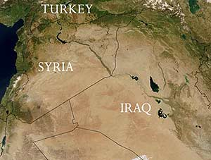
The British Foreign Office has identified water as one of the most likely causes of future conflicts in Central Asia. And in other places, it is already a live issue triggering conflict. Most of the world's major rivers run through several countries, and most have no treaties to control who takes what water. So the downstream countries are always vulnerable.
Turkey has in the past threatened to use its dams to hold back the River Euphrates from Iraq and Syria. In Africa, Egypt has warned that it will wage war on any country that takes water from the Nile without its agreement. India has been in dispute with Pakistan over the Indus and with Bangladesh over the Ganges.
And take the Middle East. During the 1967 Six Day War, Israel took control of the River Jordan. And since then it has also refused to let Palestinians sink new boreholes in the West Bank. It says this policy is necessary to protect the water reserves, which are already being overused. That is true. But the reality is that Israeli settlers in their hilltop compounds on the West Bank have swimming pools and sprinklers on their lawns, while down below, their Palestinian neighbours go thirsty.
Typical is Madama, a small Palestinian village overlooked by an Israeli settlement on the hill. Its main source of water is a single well situated high on the hillside, not far from the boundary of the settlement. Not long before my visit, some settlers had deliberately poisoned the well by dumping used baby nappies into it. And they shot at villagers and Oxfam aid workers who went to clean it out.
I met one poor farmer who told me he spent three hours every day leading his donkey to collect water from a nearby village, for his nine children and five farm animals.
Of course, virtue is not all on one side here. The Israeli settlers have real fears about their neighbours coming too close to their settlement. But peace will not come nearer while there are such grievances over something as basic as access to water

