- Consider the circuit shown in Figure 1, in which the diodes are assumed to be ideal. Are the input u and the output y linearly related? Is it true that a linear system must consist of only linear components?
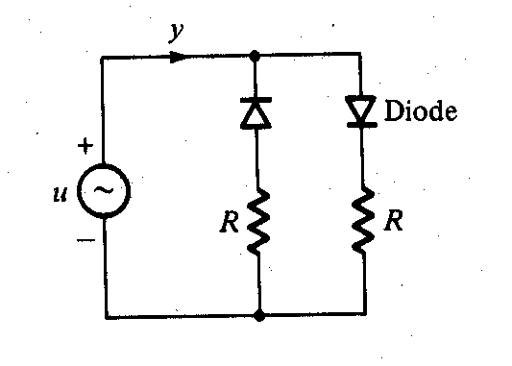

Figure 1

- Consider the multivariable feedback system shown in Figure 2. Find the transfer function H(s)
$$\left[\begin{matrix}e(s) \\ y(s)\end{matrix}\right]=H(s)\left[\begin{matrix}r(s) \\ d(s)\end{matrix}\right]$$
d
+
C(s)
G(s)
r + e + u y
_

Figure 2

- Problem 2.3 of Text
- Problem 2.18 of Text (Only the part that deals with Fig. 2.25).
- Determine whether the discrete-time system of Figure 3 is linear when a = 2, c = 0.5 and m = 4.

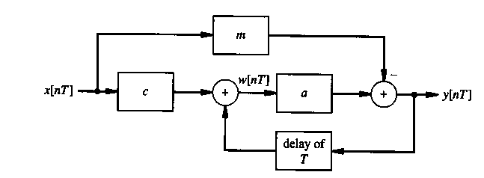
Figure 3

