King Fahd University of Petroleum & Minerals
Electrical Engineering Department
EE418: Satellite Communications
In Class Group Work
Digital Modulation for Satellite Communications
Developed by Dr. Ali Muqaibel
Names (Group):

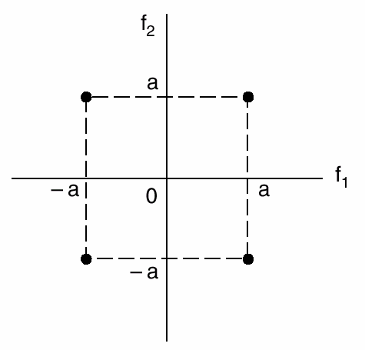
A signal constellation diagram is shown in the figure. Let the basis functions be as follows:
where
- 00
- 01

- What type of modulation is being used (ASK, PSK, or FSK)? Why?

- 10
11

- Build (sketch) the block diagram for correlators based coherent receiver.
- Let a=1, If at the output of the two correlators are as follows
Out of correlator with | 0.92 | -0.5 | 0.3  - t
Out of correlator with | -0.7 | -0.2 | 2

What is the received sequence of bits? Show how you get the answer?

d) Let a=1, Assuming that all decisions where correct in the previous question. Which one of the three symbols was exposed to the largest amount of noise (Show how you find the answer)? How much is this noise energy?

e) Re-draw the previous constellation diagram and re-assign the bits to the constellation points in a better way. Justify your answer?

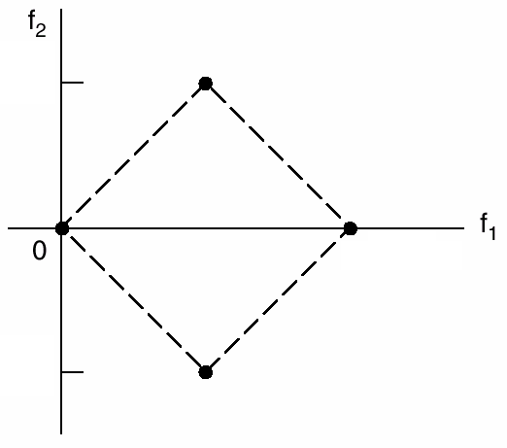
f) A new constellation diagram is shown. Assign the bits and find the values of x and y as function of a such that the new constellation diagram exhibit the same probability of error as the original diagram.
x

y
-x

g) On the new constellation diagram (part f), draw the decision boundaries.

h) Calculate the average energy per bit for the original constellation diagram and for the diagram introduced in part (f). Which one of the two constellations do you prefer? Justify your answer.

i) Show that the two basis functions are orthogonal. (show all details)

________________________________________________________________________
Good Luck, Dr. Ali Muqaibel

