A. Introduction
Three phase transformers are used throughout industry to change values of three-phase voltage and current. Since three-phase power is the most common way in which power is produced, transmitted, and used, an understanding of how three phase transformer connections are made is essential. In this section it will discuss different types of three phase transformers connections.
A three-phase transformer is constructed by winding three single-phase transformers on a single core. These transformers are put into an enclosure, which is then filled with dielectric oil. The dielectric oil performs several functions. Since it is a dielectric, a nonconductor of electricity, it provides electrical insulation between the windings and the case. It is also used to help provide cooling and to prevent the formation of moisture, which can deteriorate the winding insulation.

B. Three-Phase Transformer Connections
There are only 4 possible transformer combinations:
● Delta-to-Delta - use: industrial applications
● Delta to Wye – use: most common; commercial and industrial
● Wye to Delta – use: high voltage transmissions
● Wye-to-Wye – use: rare, don’t use causes harmonics and balancing problems.

a) Y/Y Connection

A Y/Y connection for the primary and secondary windings of a three-phase transformer is shown in the figure below. The line-to-line voltage on each side of the three-phase transformer is √3 times the nominal voltage of the single-phase transformer. The main advantage of Y/Y connection is that we have access to the neutral terminal on each side and it can be grounded if desired. Without grounding the neutral terminals, the Y/Y operation satisfactory only when the three-phase load is balanced. The electrical insulation is stressed only to about 58% of the line voltage in a Y-connected transformer.(4:225)
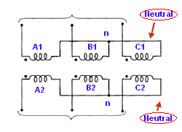
Figure (1) Y/Y connected three-phase transformer

b) Y/Δ Connection

This connection as shown in figure below is very suitable for step-down applications. The secondary winding current is about 58% of the load current. On the primary side the voltages are from line to neutral, whereas the voltages are from line to line on the secondary side. Therefore, the voltage and the current in the primary are out of ohase with the voltage and the current in the secondary. In a Y/Δ connection the distortion in the waveform of the induced voltages is not as drastic as it is in a Y/Y-connected transformer when the neutral is not connected to the ground the reason is that the distorted currents in the primary give rise to a circulating current in the Δ-connected secondary.(4:256)
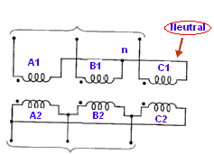
Figure (2) Y/ Δ connected three-phase transformer

c) Δ/Y Connection

This connection as shown in figure below is proper for a step-up application. However, this connection is now being exploited to satisfy the requirements of both three-phase and the single-phase loads. In this case, we use a four-wire secondary. The single-phase loads are taken care of by the three line-to-neutral circuits. An attempt is invariably made to distribute the single-phase loads almost equally among three-phases.(4:256)
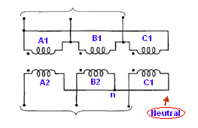
Figure (3) Δ/Y connected three-phase transformer

d) Δ/Δ Connection

as shown below the three transformers with the primary and secondary windings connected as Δ/Δ. The line-to-line voltage on either side is equal to the corresponding phase voltage. Therefore, this arrangement is useful when the voltages are not very high. The advantage of this connection is that even under unbalanced loads the three-phase load voltages remain substantially equal. This disadvantage of Δ/Δ connection is the absence of a neutral terminal on either side. Another drawback is that the electrical insulation is stressed to the line voltage. Therefore, a Δ-connection winding requires more expensive insulation than a Y-connected winding for the same power rating.(4:255)
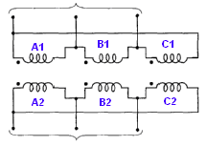
Figure (4) Δ/Δ connected three-phase transformer

C. Analysis of three-phase Transformer

Under steady-state conditions, a single three-phase transformer operates exactly the same way as three single-phase transformers connected together. Therefore, in our discussion that follows we assume that we have three identical single-phase transformers connected to form a three-phase transformer.(4:257)

D. Electrical Characteristics
Transformers in the trade are either autotransformers (non isolating) or isolation transformers. The main difference between the two is that isolating transformers protect the load from any problems associated with the supply voltage. These are ideally suited for loads that are finicky to voltage spikes and dips, or there is a concern for damage to expensive electronic components.
Speaking of protection, the majority of transformers have inherent protection for the secondary through a fuse or thermal link. The fuse may or may not be easily replaceable. When installing transformers, if there is any doubt, at the least install secondary fusing to protect the transformer and/or load on the transformer. It is also recommended to install primary line side fusing for maximum protection.
There are three basic configurations of transformers used in the trade. Primary voltages are typically AC (alternating current), while the secondary voltage might be AC or DC (direct current).

a) Step down transformers
This is used where a lower voltage is required to supply a load or control voltage. Example: A unit has a 230-volt supply, and the control circuit requires 24 volts. A unit has 600-volt supply and a damper motor requires 120 volts.

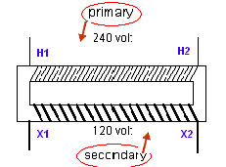
Figure (5) step down transformer

b) Step up transformers
Rarely seen in the trade but is sometimes used, it is used where a higher voltage is required. Example: Unit supply voltage is 120 volts and a crankcase heater requires a 230-volt supply.
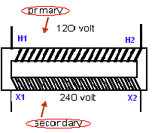
Figure (6) step up transformer

c) Isolation transformers
Another transformer that is sometimes used is Isolation transformer, which has the same primary and secondary voltages. They are used to protect the secondary load from supply voltage irregularities. Note that isolation transformers are also available in step up and step down configurations.
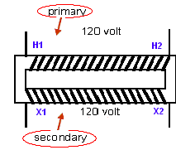
Figure (7) isolation transformer

E. How transformers work

A basic transformer consists of two sets of coils or windings. Each set of windings is simply an inductor. AC voltage is applied to one of the windings, called the primary winding. The other winding, called the secondary winding, is positioned in close proximity to the primary winding, but is electrically isolated from it.
The alternating current that flows through the primary winding establishes a time-varying magnetic flux, some of which links to the secondary winding and induces a voltage across it. The magnitude of this voltage is proportional to the ratio of the number of turns on the primary winding to the number of turns on the secondary winding. This is known as the “turns ratio.”
To maximize flux linkage with the secondary circuit, an iron core is often used to provide a low-reluctance path for the magnetic flux. The polarity of the windings describes the direction in which the coils were wound onto the core. Polarity determines whether the flux produced by one winding is additive or subtractive with respect to the flux produced by another winding. A basic two-winding transformer is shown in the Figure below.

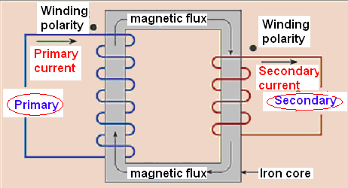

Figure (8) how transformer work

F. Transformer Construction
The simple elements of a transformer consist of two coils having mutual inductance and a laminated steel core. The two coils are insulated from each other and the steel core. Other necessary parts are some suitable container for assembled core and windings; a suitable medium for insulating the core and its windings from its container; suitable bushings (either of porcelain, oil filled or capacitor type) for insulating and bringing out the terminals of windings from the tank.
In all type of transformers, the core is constructed of transformer sheet steel laminations assembled to provide a continuous magnetic path with a minimum of air gap included. The steel used is of high silicon content, some times heat treated to produce a high permeability and low hysteresis loss at the usual operating flux densities. Laminating the core minimizes the eddy current loss, the laminations being insulated from each other by a light coat of core-plate varnish or by an oxide layer on the surface. The thickness of lamination varies from 0.35mm for a frequency of 50 Hz to 0.5 mm for a frequency of 25 Hz. The core laminations (in the form of strips) are joined.
The joints in the alternate layers are staggered in order to avoid the presence of narrow gaps right through the cross-section of the core. Such staggered joints are said to be ‘Imprecated’. Constructional distinguished from each other merely by the manner in which the primary and secondary coils are placed around the laminated core. The two types are known as:
1) Core Type;
2) Shell Type;

In the so-called core type transformers, the windings surround a considerable part of the core. Where as shell type transformer, the core surrounds a considerable part of the windings.
In the simplified diagram for the core type transformers, the primary and secondary windings are shown located on the opposite legs of the core, but in actual construction, these are always interleaved to reduce leakage flux. As shown in the figure, half the primary and half the secondary windings have been placed side by side or concentrically on each limb, not primary on one limp and the secondary on the other. In both core and shell type transformers, the individual laminations are cut in the form of long strips of L’s, E’s and I’s. In order to avoid high reluctance at the joints where the laminations are butted against each other, the alternate layers are stacked differently to eliminate these joints.

- Core-type transformer
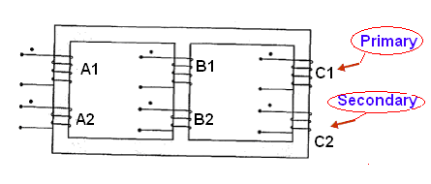
Figure (9) core type transformer
The coils are form-wound and are of cylindrical type. The general form of these coils may be circular or oval or rectangular. In small size core-type transformers, a simple rectangular core is used with cylindrical coils, which are either circular or rectangular in form. But for large size core-type transformers, round or circular coils are used which are so wound as to fit over a cruciform core section. The circular coils are used in most of the core-type transformers because of their mechanical strength. Such coils are wound in helical layers with different layers insulated from each other by paper, cloth, or cooling ducts. Since the low voltage (LV) winding is easiest to insulate, it is placed nearest to the core.

Because of lamination and insulation, the net or effective core area is reduced, due allowance for which has to be made. It is found that in general, the reduction in core cross-sectional area due to the presence of paper, etc. is of the order of 10% approx.

Rectangular cores with rectangular cylindrical coils can be used for small size core-type transformers. For large size transformers, circular cylindrical coils are preferred. Obviously, a considerable amount of useful space is wasted. A common improvement on square-core is to employ cruciform core which demands at least two sizes of core strips. For very large transformers, further core stepping is done which not only gives high space factor but also results in reduced length of the mean turn and consequent I²R loss.

- Shell-type transformers
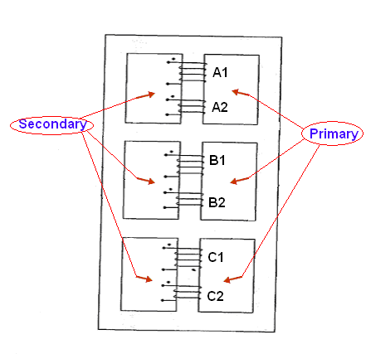
Figure (10) shell type transformer
The coils are form wound but are multilayer disc type usually wound in the form of pancakes. The different layers of such multilayer discs are insulated from each other by paper. The complete winding consists of stacked discs with insulation space between the coils, the spaces forming horizontal and cooling ducts.
It may be pointed out that cores and coils of transformers must be provided with rigid mechanical bracing in order to prevent movement and possible insulation damage. Good bracing reduces vibration and the objectionable noise _ a humming sound _ during operation.
The spiral _core transformer employs the newest development in core construction. The core is assembled of a continuous strip or ribbon of transformer steel wound in the form of a circular or elliptical cylinder. Such construction allows the core flux to follow the grain of the iron. Cold _ rolled steel of high silicon content enables the designer to use considerably higher operating flux densities with lower loss per kg. The use of higher flux density reduces the weight per KVA. Hence, the advantages of such construction are

- A relatively more rigid core
- Lesser weight and size per kVA rating
- Lower iron losses at higher operating flux densities
- Lower cost of manufacture.

G. Mathematical Working of a Transformer
An alternating voltage applied to primary circuit P circulates an alternating current through P and this current produces an alternating flux in the steel core. If the whole of the flux produced by P passes through secondary circuit S, the emf induced in each turn is the same for P and S. Hence, if N₁ and N₂ be the number-of turns on P and S respectively,

Total em. induced in S = N₂ x emf. per turn = N₂
Total emf. induced in P = N₁ x emf. per turn = N₁

When the secondary is on open circuit, its terminal voltage is the same as the induced emf. The primary current is then very small, so that the applied voltage V₁ is practically equal and opposite to the emf. induced in P. Hence:
V2 = N₂
V1 = N₁

Since the full-load efficiency of a transformer is nearly 100 percent,
I₁V_{1 x} primary power factor = I₂ V₂ x secondary power factor.
But the primary and secondary power factors at full load are nearly equal,
I₁ / I₂ = V₂ /V₁

An alternative and more illuminating method of deriving the relationship between the primary and secondary currents is based upon a comparison of the primary and secondary ampere-turns. When the secondary is on open circuit, the primary current is such that the primary ampere-turns are just sufficient to produce the flux necessary to induce an emf. that is practically equal and opposite to the applied voltage. This magnetizing current is usually about 3- 5 per cent of the full-load primary current.
When a load is connected across the secondary terminals, the secondary current by Lenz’s Law produces a demagnetizing effect. Consequently the flux and the emf induced in the primary are reduced slightly. But this small change can increase the difference between the applied voltage and the emf. induced in the primary from, say, 0.05 pet cent to, say, 1 per cent, in which case the new primary current would be 20 times the no-load current.
The demagnetizing ampere-turns of the secondary are thus nearly neutralized by the increase in the primary ampere-turns; and since the primary ampere-turns on no load are very small compared with the full-load ampere-turns,
Full-load primary ampere-turns = full-load secondary ampere-turns,

I₁ = N₂ = V₂
I₂ ₌ N₁ ₌ V₁

It will be seen that the magnetic flux forms the connecting link between the primary and secondary circuits and that any variation of the secondary current is accompanied by a small variation of the flux and therefore of the emf. induced in the primary, thereby enabling the primary current to vary approximately proportionally to the secondary current. This balance of primary and secondary ampere-turns is an important relationship wherever transformer action occurs.

CONCLUSION
.
Three phase transformers are important equipments in power systems and power plants. When a three-phase transformer is energized, the inrush current due to flux saturation causes a stress impact to the transformer. As a result, the differential relays are applied to design the protective system of a three-phase transformer. This protective system can distinguish inrush current from fault current.

Transformer differential relaying remains the preferred protection for power transformers. It provides the fastest fault protection, with excellent security. Unfortunately, transformer differential relays can be challenging to properly configure and install.

REFERENCES

- Criss, John and Larry Lawhead. "Using Transformer Differential Relay Iop Characteristics to Measure Near Trip Conditions." IEEE (1996) : 103- 108.

- Yamayee, Ziz. A. and Juan L. Bala, Electromechanical Energy Devices and Power Systems, Gonzaga University, 1994, 64-109.

- Gebert, Kenneth L and Edwards, Kenneth R . Transformers principles and applications. Chicago: American Technical Society, 1974.

- Guru, Bhag S and Huseyin R. Electric Machinery and Transformers. New York: Oxford University Press, 2001.

- Richardson, Donald V. Handbook of Rotating Electric Machinery. Virgina : Reston Publishing Company.

- Seitlinger, Walter. "Phase Shifting Transformers." VA TECH Transmission and Distribution, 2001 : 1- 7..

- Ernest Mendrela, Transformers, www.ee.lsu.edu/mendrela/EE3410ElMechEnergyConv.pdf

- Three Phase, www.du.edu/~jcalvert/tech/threeph.htm

- Inside Transformers, www.du.edu/~jcalvert/tech/transfor.htm

APPENDIX A

A. Commonly used symbols for different types of transformers

