The Reactive Power, Does It Important For Us

I. INTRODUCTION
A. DEFINITION OF REACTIVE POWER

Almost all power transported or consumed in alternating current (AC) networks. AC systems supply or consume two kind of power: real power and reactive power .Real power accomplishes useful work while reactive power supports the voltage that must be controlled for system reliability.
For AC systems voltage and current pulsate at the system frequency. Although AC voltage and current pulsate at same frequency, they peak at different time power is the algebraic product of voltage and current. Real power is the average of power over cycle and measured by volt-amperes or watt. The portion of power with zero average value called reactive power measured in volt-amperes reactive or vars.
The total power is called the apparent power (symbolized by the capital letter S) and measured by volt-amperes or VA. To describe the reactive power , imagine a person on trampoline , The person real power goes into moving horizontally across trampoline as it bounces , the effort the person expend to keep standing(represent reactive power Q ) during bouncing result no net forward motion(represent real power P) , but it's necessary to walk on trampoline . The motion from trampoline always perpendicular to the direction the person is walking. So that the direction between P and Q 90 degree Out of phase.

II. Measuring reactive power
The amount and complexity of household electrical equipment has increased tremendously over the last few years. Electronic ballast lighting, computer monitors and air conditioners are welcome additions to our homes but come with additional burdens. One of these is on the electricity grid, as these appliances generate more signal harmonics.
This change in the end-consumer profile is a disadvantage for energy distributors which bill energy based only on active power. With the application of non-linear loads to power lines the active energy no longer represents the total energy delivered. As a response to improve billing, the measurement of reactive energy is gaining interest. For example, Italy’s leading energy distributor has decided to install more than 20 million household energy meters with active and reactive power measurements.
This growing interest in measuring reactive energy leads to the question: What method should an energy meter designer implement to accurately measure the reactive energy?
Although today’s electronic digital signal processing (DSP) enables reactive energy measurements to be closer to the theoretical value, there is no consensus in the field of energy metering on the methods of measurement. This article aims to explain and compare the three main methods in use, namely the Power Triangle, the Time Delay and Low-pass Filter.
A. System requirements
Electromechanical meters have set a precedent in reactive energy billing. Although they are bandwidth limited and cannot take into account harmonics of the line frequency, they are supported by the international standard for alternating current static var-hour meters for reactive energy (IEC-1268). The standard defines reactive energy measurements at the fundamental line frequency, which implies that it is not mandatory to include harmonics. It also specifies additional testing conditions to check the robustness of the measurements against the third harmonic, the dc offset in the current input, and the line frequency variation. The various reactive power measurement methods presented in this paper are evaluated against these critical tests of the IEC-1268 (Table 1).
B. Reactive power theory
The reactive power is defined in the IEEE Standard Dictionary 100-1996 under the energy “magner” as:
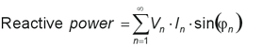(1)
where Vn and In are respectively the voltage and current rms values of the nth harmonics of the line frequency, and jn is the phase difference between the voltage and the current nth harmonics. A convention is also adopted stating that the reactive energy should be positive when the current is leading the voltage (inductive load).
In an electrical system containing purely sinusoidal voltage and current waveforms at a fixed frequency, the measurement of reactive power is easy and can be accomplished using several methods without errors. However, in the presence of non-sinusoidal waveforms, the energy contained in the harmonics causes measurement errors.
According to the Fourier theorem any periodic waveform can be written as a sum of sin and cosine waves. As energy meters deal with periodic signals at the line frequency both current and voltage inputs of a single phase meter can be described by:
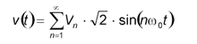(2)
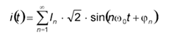(3)
where Vn, In and jn are defined as in Equation 1.
C. Active power
The average active power is defined as:
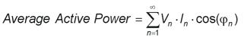(4)
The implementation of the active power measurement is relatively easy and is done accurately in most energy meters in the field.
D. Apparent power
The apparent power is the maximum real power that can be delivered to a load. As Vrms and Irms are the effective voltage and current delivered to the load,
Apparent power = V_{rms} • I_{rms} (5)
The correct implementation of the apparent energy measurement is bound by the accuracy of the rms measurements.
E. Reactive power calculation
As explained above, different methods can be used to calculate the reactive power. The theoretical definition of the reactive power is difficult to implement in an electronic system at a reasonable cost. It requires a dedicated DSP to process the Hilbert transform necessary to get a constant phase shift of 90° at each frequency. Several solutions have been developed to overcome this limitation. They can be categorized in three groups:
1- Method 1: Power triangle
The Power triangle method is based on the assumption that the three energies, apparent, active and reactive, form a right-angle triangle as shown in Figure 1. The reactive power can
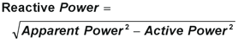(6)
then be processed by estimating the active and apparent energies and applying:
Although this method gives excellent results with pure sinusoidal waveforms, noticeable errors appear in presence of harmonics (Table 1).
2- Method 2: Time delay
A time delay is introduced to shift one of the waveforms by 90° at the fundamental frequency and multiply the two waveforms:
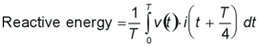(7)
where T is the period of the fundamental. In an electronic DSP system, this method can be implemented by delaying the samples of one input by the number of samples representing a quarter-cycle of the fundamental frequency (Fline) (Figure 2)
This method presents drawbacks if the line frequency changes and the number of samples no longer represents a quarter-cycle of the fundamental frequency. Significant errors are then introduced to the results (Table 1).
3- Method 3: Low-pass filter
A constant 90° phase shift over frequency with an attenuation of 20 dB/decade is introduced. This solution, which has been implemented by Analog Devices, can be realized with a single pole low-pass filter on one channel input (Figure 3). If the cut-off frequency of the low-pass filter is much lower than the fundamental frequency, this solution provides a 90° phase shift at any frequency higher than the fundamental frequency. It also attenuates these frequencies by 20 dB/decade (Figure 4).
Similarly to method 2, this solution is susceptible to variations of the line frequency. However, a dynamic compensation of the gain attenuation with the line frequency can be achieved by evaluating the line period of the signal (Table 1).
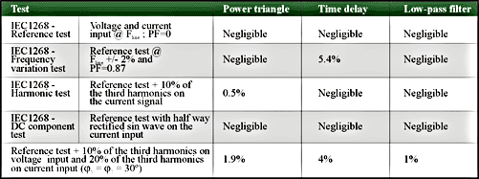
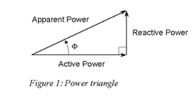

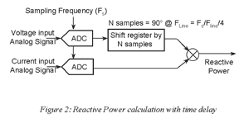

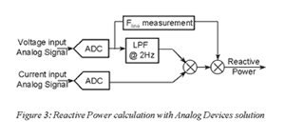

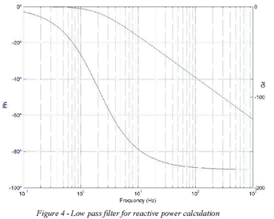

Recent advances in technology have increased consumer demand for electrical products that offer convenience and entertainment in the modern home. With these advances have come increased burdens on utilities that transmit electricity and on consumers that pay for its use. A portion of this burden is due to reactive power.

If you were to compare the amount of electricity flowing into your home (i.e. apparent power) with that which performs productive work (i.e. real power) you would see that there is a difference. Known as reactive power, this additional energy is needed to energize motor windings and similar type loads in your home. Reactive power is returned to the electric grid as the windings de-energize, but is quickly needed again since motor windings must be re-energized 120 times per second. Reactive power does no real work, (e.g. turning a fan blade) but provides the magnetizing energy so that real work can be done.
III. NEEDS OF REACTIVE POWER
Voltage control in an electrical power system is important for proper operation for electrical power equipment to prevent damage such as overheating of generators and motors, to reduce transmission losses and to maintain the ability of the system to withstand and prevent voltage collapse. In general terms, decreasing reactive power causing voltage to fall while increasing it causing voltage to rise. A voltage collapse occurs when the system try to serve much more load than the voltage can support.
When reactive power supply lower voltage, as voltage drops current must increase to maintain power supplied, causing system to consume more reactive power and the voltage drops further . If the current increase too much, transmission lines go off line, overloading other lines and potentially causing cascading failures. If the voltage drops too low, some generators will disconnect automatically to protect themselves. Voltage collapse occurs when an increase in load or less generation or transmission facilities causes dropping voltage, which causes a further reduction in reactive power from capacitor and line charging, and still there further voltage reductions. If voltage reduction continues, these will cause additional elements to trip, leading further reduction in voltage and loss of the load. The result in these entire progressive and uncontrollable declines in voltage is that the system unable to provide the reactive power required supplying the reactive power demands.
Reactive power needs are determined in the planning process, which is a part of engineering, part economics and part judgment. The engineering analysis requires running large, complex mathematical computer models of the electric system. The economical part required putting costs into models to determine how to achieve an efficient, reliable system. The judgment arises due to the large number of modeling choices, expert assumption and approximations that often are necessary.
A. Reactive power blackouts
Insufficient reactive power leading to voltage collapse has been a causal factor in major blackouts in the worldwide. Voltage collapse occurred in United States in the blackout of July 2, 1996, and August10, 1996 on the West Coast. Voltage collapse also factored in blackouts of December 19, 1978, in France; July 23, 1987, in Tokyo; March 13, 1989, in Québec; August 28, 2003, in London; September 28, 2003, in Sweden and Denmark; and September 28, 2003, in Italy.
While August 14, 2003, blackout in the United States and Canada was not due to a voltage collapse as that term has traditionally used by power system engineers, the task force final report said that" Insufficient reactive power was an issue in the blackout" and the report also "overestimation of dynamics reactive output of system generation " as common factor among major outages in the United States. Due to difficulties modeling dynamic generators output, the amount of dynamic reactive output from generators has been less than expected, worsening voltage problems and resultant power outages

V. PROBLEMS OF REACTIVE POWER
Though reactive power is needed to run many electrical devices, it can cause harmful effects on your appliances and other motorized loads, as well as your electrical infrastructure. Since the current flowing through your electrical system is higher than that necessary to do the required work, excess power dissipates in the form of heat as the reactive current flows through resistive components like wires, switches and transformers. Keep in mind that whenever energy is expended, you pay. It makes no difference whether the energy is expended in the form of heat or useful work.

We can determine how much reactive power your electrical devices use by measuring their power factor, the ratio between real power and true power. A power factor of 1 (i.e. 100%) ideally means that all electrical power is applied towards real work. Homes typically have overall power factors in the range of 70% to 85%, depending upon which appliances may be running. Newer homes with the latest in energy efficient appliances can have an overall power factor in the nineties.

The typical residential power meter only reads real power, i.e. what you would have with a power factor of 100%. While most electric companies do not charge residences directly for reactive power, it’s a common misconception to say that reactive power correction has no economic benefit. To begin with, electric companies correct for power factor around industrial complexes, or they will request the offending customer to do so at his expense, or they will charge more for reactive power. Clearly electric companies benefit from power factor correction, since transmission lines carrying the additional (reactive) current to heavily industrialized areas costs them money. Many people overlook the benefits that power factor correction can offer the typical home in comparison to the savings and other benefits that businesses with large inductive loads can expect.
.

Most importantly, you pay for reactive power in the form of energy losses created by the reactive current flowing in your home. These losses are in the form of heat and cannot be returned to the grid. Hence you pay. The fewer kilowatts expended in the home, whether from heat dissipation or not, the lower the electric bill. Since power factor correction reduces the energy losses, you save.

As stated earlier, electric companies correct for power factor around industrial complexes, or they will request the offending customer to do so, or they will charge for reactive power. They’re not worried about residential service because the impact on their distribution grid is not as severe as in heavily industrialized areas. However, it is true that power factor correction assists the electric company by reducing demand for electricity, thereby allowing them to satisfy service needs elsewhere. But who cares? Power factor correction lowers your electric bill by reducing the number of kilowatts expended, and without it your electric bill will be higher, guaranteed.

We’ve encountered this with other electric companies and have been successful in getting each of them to issue a retraction. Electric companies do vary greatly and many show no interest in deviating from their standard marketing strategy by acknowledging proven energy saving products. Keep in mind that promoting REAL energy savings to all their customers would devastate their bottom line.

Power factor correction will not raise your electric bill or do harm to your electrical devices. The technology has been successfully applied throughout industry for years. When sized properly, power factor correction will enhance the electrical efficiency and longevity of inductive loads. Power factor correction can have adverse side effects (e.g. harmonics) on sensitive industrialized equipment if not handled by knowledgeable, experienced professionals. Power factor correction on residential dwellings is limited to the capacity of the electrical panel (200 amp max) and does not over compensate household inductive loads. By increasing the efficiency of electrical systems, energy demand and its environmental impact is lessened

Conclusion
Efficient completion is a way to achieve efficiency and reduce costs to consumers. Efficient competition is difficult to achieve. Due to innovation and technological progress, the optimal industry structure and mode of regulation may not need to change. As regulated markets move from franchised monopolies toward completion, Regulation needs to move from direct price regulation to market rules. Competitive markets required competitive market design.
Put difficulties, efficient market design does not just happen spontaneously. It is the result of a process that includes full discussion, learning and informed judgment by all affective and responsible parties.

