King Fahd University of Petroleum and Minerals
Department of Electrical Engineering

EE 306: Electromechanical Devices

Second Semester 2005 (042)

Term Project:

DC Machines

Student Name: Hatem Al-Ghannam

Student ID #: 214265

Prepared For: Dr. Shwehdi, Mohamed H

TABLE OF CONTENT

INTRODUCTION 1
BACKGROUND INFORMATION 1
I. DC MOTORS 1
A. General Information 1
B. Construction 2
C. DC Motor Operation 3
D. DC Motor Equivalent circuit 4
II. DC GENERATORS 4
A. General Information 4
B. Construction 4
C. How DC Generator Works 4
D. DC Generator Operation 5
E. DC Generator Equivalent circuit 6
CONCLUSION 7
REFRENCES 8

INTRODUCTION

Electric Motors and Generators, group of devices used to convert mechanical energy into electrical energy, or electrical energy into mechanical energy, by electromagnetic means. A machine that converts mechanical energy into electrical energy is called a generator, alternator, or dynamo, and a machine that converts electrical energy into mechanical energy is called a motor. In this report we will take a brief look about DC motors and generators.

BACKGROUND INFORMATION

Two related physical principles underlie the operation of generators and motors. The first is the principle of electromagnetic induction discovered by the British scientist Michael Faraday in 1831. If a conductor is moved through a magnetic field, or if the strength of a stationary conducting loop is made to vary, a current is set up or induced in the conductor. The converse of this principle is that of electromagnetic reaction, first observed by the French physicist André Marie Ampere in 1820. If a current is passed through a conductor located in a magnetic field, the field exerts a mechanical force on it.

The simplest of all dynamoelectric machines is the disk dynamo developed by Faraday. It consists of a copper disk mounted so that part of the disk, from the center to the edge, is between the poles of a horseshoe magnet. When the disk is rotated, a current is induced between the center of the disk and its edge by the action of the field of the magnet. The disk can be made to operate as a motor by applying a voltage between the edge of the disk and its center, causing the disk to rotate because of the force produced by magnetic reaction.

The magnetic field of a permanent magnet is strong enough to operate only a small practical dynamo or motor. As a result, for large machines, electromagnets are employed. Both motors and generators consist of two basic units, the field, which is the electromagnet with its coils, and the armature, the structure that supports the conductors, which cut the magnetic field and carry the induced current in a generator or the exciting current in a motor. The armature is usually a laminated soft-iron core around which conducting wires are wound in coils.

I. DC MOTORS

A. General Information

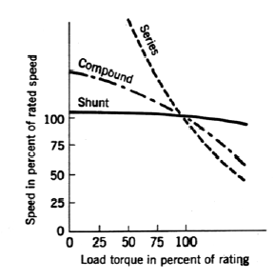
A DC motor is used to drive a mechanical load. In this lab, a separately excited DC generator provides the load. The load on the motor is adjusted by varying the generator field current. By increasing the field current of the DC generator, the load on the DC motor increases and thus the armature current increases. In general, DC motors are characterized by their torque-speed curves as shown in Figure 9.1. Since the measuring equipment for shaft torque is not available in the lab it is necessary to use alternative means of characterizing the DC motor. One alternative is to plot shaft speed versus armature current since torque is directly proportional to the armature current( $T=K_{a}φ_{d}I_{a}$) with a constant field current supplied to the motor. Shaft speed is also a function of the field current in a DC motor while maintaining a constant armature voltage($E_{a}=K_{a}φ_{d}ω$ ) as field current is directly proportional to the direct axis flux produced in the machine.

B. Construction

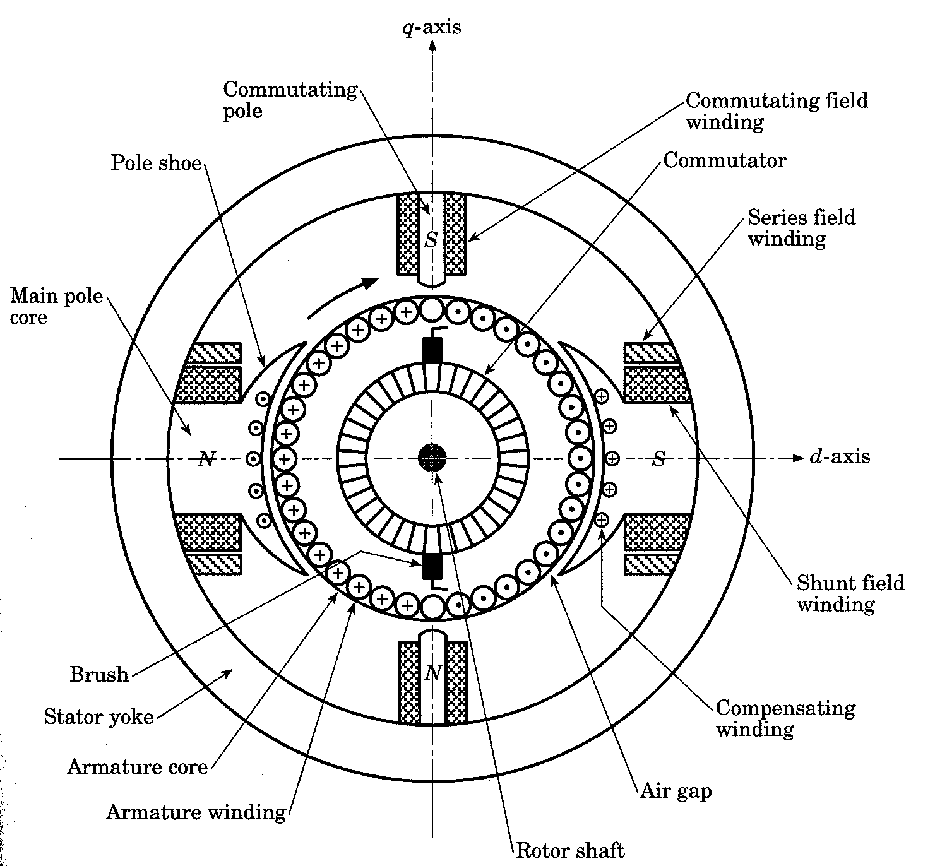
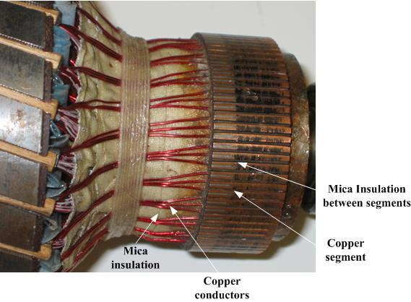
The stator of the dc motor has poles, which are excited by dc current to produce magnetic fields. In the neutral zone, in the middle between the poles, commutating poles are placed to reduce sparking of the commutator. The commutating poles are supplied by dc current. Compensating windings are mounted on the main poles. These short-circuited windings damp rotor oscillations. The poles are mounted on an iron core that provides a closed magnetic circuit. The motor housing supports the iron core, the brushes and the bearings. The rotor has a ring-shaped laminated iron core with slots. Coils with several turns are placed in the slots. The distance between the two legs of the coil is about 180 electric degrees. The coils are connected in series through the commutator segments. The ends of each coil are connected to a commutator segment. The commutator consists of insulated copper segments mounted on an insulated tube. Two brushes are pressed to the commutator to permit current flow. The brushes are placed in the neutral zone, where the magnetic field is close to zero, to reduce arcing. The rotor has a ring-shaped laminated iron core with slots. The commutator consists of insulated copper segments mounted on an insulated tube. Two brushes are pressed to the commutator to permit current flow. The brushes are placed in the neutral zone, where the magnetic field is close to zero, to reduce arcing. The commutator switches the current from one rotor coil to the adjacent coil, the switching requires the interruption of the coil current. The sudden interruption of an inductive current generates high voltages. The high voltage produces flashover and arcing between the commutator segment and the brush.

C. DC Motor Operation

In a dc motor, the stator poles are supplied by dc excitation current, which produces a dc magnetic field. The rotor is supplied by dc current through the brushes, commutator and coils. The interaction of the magnetic field and rotor current generates a force that drives the motor. The magnetic field lines enter into the rotor from the north pole (N) and exit toward the south pole (S). The poles generate a magnetic field that is perpendicular to the current carrying conductors. The interaction between the field and the current produces a Lorentz force; the force is perpendicular to both the magnetic field and conductor. The generated force turns the rotor until the coil reaches the neutral point between the poles. At this point, the magnetic field becomes practically zero together with the force. However, inertia drives the motor beyond the neutral zone where the direction of the magnetic field reverses. To avoid the reversal of the force direction, the commutator changes the current direction, which maintains the counterclockwise rotation. Before reaching the neutral zone, the current enters in segment 1 and exits from segment 2. Therefore, current enters the coil end at slot a and exits from slot b during this stage. After passing the neutral zone, the current enters segment 2 and exits from segment 1, this reverses the current direction through the rotor coil, when the coil passes the neutral zone. The result of this current reversal is the maintenance of the rotation.
(a) Rotor current flow from segment 1 to 2 (slot a to b)

(b) Rotor current flow from segment 2 to 1 (slot b to a)

D. DC Motor Equivalent circuit
The following figures show the equivalent circuit of a separately excited dc motor. Equivalent circuit is similar to the generator only the current directions are different. The operation equations are:
Armature voltage equation
$V_{\text{dc}}=E_{\text{am}}+I_{\text{am}} R_{a}+V_{\text{brush}}$

$ω=2 π n_{m}$The induced voltage and motor speed vs angular frequency
$E_{\text{am}}=K_{m} I_{f} ω$

$K_{m} I_{f} ω=E_{\text{am}}=V_{\text{dc}}−I_{\text{am}} R_{m}$The combination of the equations results in

$P_{\text{out}}=E_{\text{am}} I_{\text{am}}$$T=\frac{P_{\text{out}}}{ω}=K_{m} I_{\text{am}} I_{f}$The current is calculated from this equation. The output power and torque are:

II. DC GENERATORS

A. General Information

Most common electrical appliances (e.g., electric light-bulbs and electric heating elements) work fine on ac electrical power. However, there are some situations in which dc power is preferable. For instance, small electric motors (e.g., those which power food mixers and vacuum cleaners) work very well on ac electricity, but very large electric motors (e.g., those which power subway trains) generally work much better on dc electricity. Let us investigate how dc electricity can be generated.

B. Construction

The construction of the DC Generator is the same like the DC Motor. So you can refer to that part to see the construction.

C. How DC Generator Works

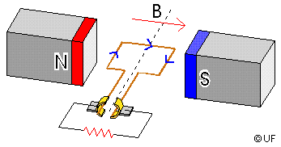
If an armature revolves between two stationary field poles, the current in the armature moves in one direction during half of each revolution and in the other direction during the other half. To produce a steady flow of unidirectional, or direct, current from such a device, it is necessary to provide a means of reversing the current flow outside the generator once during each revolution. In older machines this reversal is accomplished by means of a commutator, a split metal ring mounted on the shaft of the armature. The two halves of the ring are insulated from each other and serve as the terminals of the armature coil. Fixed brushes of metal or carbon are held against the commutator as it revolves, connecting the coil electrically to external wires. As the armature turns, each brush is in contact alternately with the halves of the commutator, changing position at the moment when the current in the armature coil reverses its direction. Thus there is a flow of unidirectional current in the outside circuit to which the generator is connected. DC generators are usually operated at fairly low voltages to avoid the sparking between brushes and commutator that occurs at high voltage. The highest potential commonly developed by such generators is 1500 V. In some newer machines this reversal is accomplished using power electronic devices, for example, diode rectifiers.

D. DC Generator Operation

The N-S poles produce a dc magnetic field and the rotor coil turns in this field. A turbine or other machine drives the rotor. The conductors in the slots cut the magnetic flux lines, which induce voltage in the rotor coils. The coil has two sides: one is placed in slot a, the other in slot b. In Figure a, the conductors in slot a are cutting the field lines entering into the rotor from the north pole, the conductors in slot b are cutting the field lines exiting from the rotor to the south pole. The cutting of the field lines generates voltage in the conductors. The voltages generated in the two sides of the coil are added. The induced voltage is connected to the generator terminals through the commutator and brushes. In Figure a, the induced voltage in b is positive, and in a is negative. The positive terminal is connected to commutator segment 2 and to the conductors in slot b. The negative terminal is connected to segment 1 and to the conductors in slot a. When the coil passes the neutral zone:
(a) Rotor current flow from segment 1 to 2 (slot a to b)
- Conductors in slot a are then moving toward the south pole and cut flux lines exiting from the rotor
- Conductors in slot b cut the flux lines entering the in slot b.

This changes the polarity of the induced voltage in the coil. The voltage induced in a is now positive, and in b is negative. The simultaneously the commutator reverses its terminals, which assures that the output voltage (Vdc) polarity is unchanged. In Figure b:
(b) Rotor current flow from segment 2 to 1 (slot b to a)
- The positive terminal is connected to commutator segment 1 and to the conductors in slot a.
- The negative terminal is connected to segment 2 and to the conductors in slot b.

E. DC Generator Equivalent circuit

The magnetic field produced by the stator poles induces a voltage in the rotor (or armature) coils when the generator is rotated. This induced voltage is represented by a voltage source. The stator coil has resistance, which is connected in series. The pole flux is produced by the DC excitation/field current, which is magnetically coupled to the rotor. The field circuit has resistance and a source. The voltage drop on the brushes represented by a battery. The following figure equivalent circuit of a separately excited dc generator.

The magnetic field produced by the stator poles induces a voltage in the rotor (or armature) coils when the generator is rotated. The dc field current of the poles generates a magnetic flux. The flux is proportional with the field current if the iron core is not saturated:
$Φ_{\text{ag}} = K_{1} I_{f}$

The rotor conductors cut the field lines that generate voltage in the coils.
$E_{\text{ag}} = 2 N_{r} B ℓ_{g} v$

The motor speed and flux equations are :
$v=ω \frac{D_{g}}{2}$$Φ_{\text{ag}}=B ℓ_{g} D_{g}$

The combination of the three equation results the induced voltage equation:
$E_{\text{ag}}=2 N_{r}B ℓ_{g}v=2 N_{r}B ℓ_{g} \left(ω \frac{D_{g}}{2}\right)=N_{r} \left(B ℓ_{g} D_{g}\right) ω=N_{r} Φ_{\text{ag}} ω$

$E_{\text{ag}}=N_{r} Φ_{\text{ag}} ω=N_{r} K_{1} I_{f} ω=K_{m} I_{f} ω$•The equation is simplified.
When the generator is loaded, the load current produces a voltage drop on the rotor winding resistance. In addition, there is a more or less constant 1–3 V voltage drop on the brushes. These two voltage drops reduce the terminal voltage of the generator. The terminal voltage is;
$E_{\text{ag}}=V_{\text{dc}}+I_{\text{ag}} R_{a}+V_{\text{brush}}$

CONCLUSION

In this study and search of this power technology we found that it is not used widely because of its cost comparing with AC machine and I hope that this power technology will be developed and used very commonly in the future.

REFRENCES

- Microsoft Encyclopedia Encarta 2004
- http://www.eas.asu.edu/~karady/360_stuff/Lectures/Lecture%2024%20360_Chapter_8_DC%20Motors.ppt
- http://www.ee.nuigalway.ie/subjects/ee302/lectures/L8%20DC%20Motors%202.pdf
- http://www.usace.army.mil/inet/usace-docs/armytm/tm5-692-2/chap19VOL-2.pdf
- http://www.faculty.uaf.edu/ffrww/ee303/Fall2001/Labs/e303lab9.pdf
- http://www.tpub.com/neets/book5/15.htm
- http://zone.ni.com/devzone/devzoneweb.nsf/Opendoc?openagent&24C5C7AF05B36E208625681E0072BE75
- http://farside.ph.utexas.edu/teaching/302l/lectures/node75.html

