Introduction and History:

An electric generator is a device used to convert mechanical energy into electrical energy.
The generator is based on the principle of electromagnetic induction discovered in 1831 by Michael Faraday. Faraday discovered that if an electric conductor, like a copper wire, is moved through a magnetic field, electric current will flow in the conductor. So the mechanical energy of the moving wire is converted into the electric energy of the current that flows in the wire.
To change the Simple Generator into a direct-current generator, we have to do the following:
1. The current must be made to move in only one direction.
2. The current must be conducted from the rotating loop of wire

Generator components
A DC generator consist of the following components
Rotor:
In its simplest form, the rotor consists of a single loop of wire made to rotate within a magnetic field. In practice, the rotor usually consists of several coils of wire wound on an armature.
Armature:
The armature is a cylinder of laminated iron mounted on an axle. The axle is carried in bearings mounted in the external structure of the generator. Torque is applied to the axle to make the rotor spin.
Coil:
Each coil usually consists of many turns of copper wire wound on the armature. The two ends of each coil are connected either to two slip rings (AC) or two opposite bars of a split-ring commutator (DC).
Stator:
The stator is the fixed part of the generator that supplies the magnetic field in which the coils rotate. It may consist of two permanent magnets with opposite poles facing and shaped to fit around the rotor. Alternatively, the magnetic field may be provided by two electromagnets.
Field electromagnets:
Each electromagnet consists of a coil of many turns of copper wire wound on a soft iron core. The electromagnets are wound, mounted and shaped in such a way that opposite poles face each other and wrap around the rotor.
Brushes:
The brushes are carbon blocks that maintain contact with the ends of the coils via the slip rings (AC) or the split-ring commutator (DC), and conduct electric current from the coils to the external circuit.

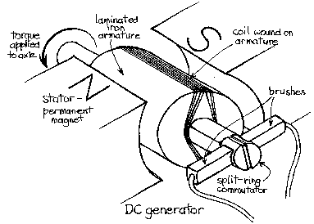

How DC Generators Work:

The commutator rotates with the loop of wire just as the slip rings do with the rotor of an AC generator. Each half of the commutator ring is called a commutator segment and is insulated from the other half. Each end of the rotating loop of wire is connected to a commutator segment. Two carbon brushes connected to the outside circuit rest against the rotating commutator. One brush conducts the current out of the generator, and the other brush feeds it in. The commutator is designed so that, no matter how the current in the loop alternates, the commutator segment containing the outward-going current is always against the "out" brush at the proper time. The armature in a large DC generator has many coils of wire and commutator segments. Because of the commutator, engineers have found it necessary to have the armature serve as the rotor(the rotating part of an apparatus) and the field structure as the stator (a stationary portion enclosing rotating parts). Which is the inverse of an AC Generator.

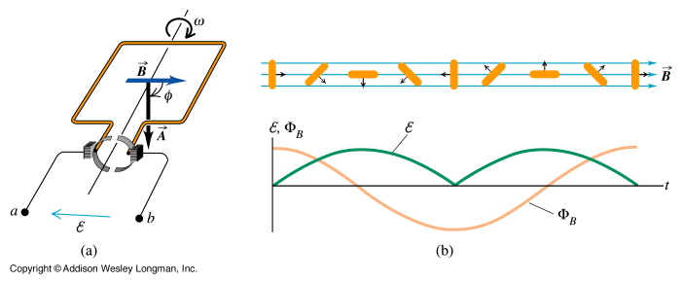

Types of DC Generators:

In some DC generators, the direct current needed for the electromagnets that make up the field structure comes from an outside source, just as it does in most AC generators. These DC generators are called separately excited generators. Many other DC generators use part of the direct current they produce to operate their own electromagnets. These generators are called self-excited generators. A self-excited DC generator depends on residual magnetism--that is, a small amount of magnetism remains in the electromagnets after the generator is shut off. Without this residual magnetism, it would be impossible to start a self-excited generator once it had stopped.
The direct current needed for a self-excited generator's electromagnets can be drawn from its armature by means of three different connections: Shunt, Series and Compound, a combination of shunt and series connections.
The type of generator used for a certain task depends on the amount of voltage control required. For example, a DC generator used to charge a battery needs only simple voltage control. It might be a shunt generator.
A DC generator that supplies electricity for a passenger elevator needs more complicated voltage control. It would be a separately excited generator.

Uses of DC Generators:

Many DC generators are driven by AC motors in combinations called motor-generator sets. This is one way of changing alternating current to direct current. Factories that do electroplating and those that produce aluminum, chlorine, and some other industrial materials need large amounts of direct current and use DC generators. So do locomotives and ships driven by diesel-electric motors. Because commutators are complex and costly, many DC generators are being replaced by AC generators combined with electronic rectifiers. Rectifiers are devices that let current flow in one direction only. They permit use of simpler, more rugged AC generators, even when DC is required.

King Fahd University of Petroleum & Minerals

Electrical Engineering Department

Electromechanical Devices
EE-306

EE Term Project

“Direct Current Generator”

Done by

Mohammed Al-Jindan ID# 205134

Table of Content

Introduction and history 1
Generator components 2
How DC Generators work 3
Types of DC generator 5

Uses of DC generator 6

Conclusion 7

Conclusion:
The invention of the DC generator made our life easy. But the fact that the commutators are complex and cost a lot of money, a lot of DC generators have been replaced by a modified AC generators which is more economical. The modification to the AC generator is done by adding Rectifiers that makes the current flow in one direction only as I mentioned before. I hope that more studies will be carried out in the future to reduce the cost of the commutators therefore reduce the cost of the DC generator.

References:

- Electromechanical Energy Devices and Power systems, Yamayee and Bala
- http://www.micro.magnet.fsu.edu/electromag/java/generator/dc.html
- http://www.cbe.ab.ca/b858/dept/sci/teacher/zubot/Phys30notes/DCgenerator/DCgenerator.htm\
- http://www.physics.sjsu.edu/facstaff/becker/physics51/generator.htm
- http://www.hsc_csu_edu_au-physics-core-motors-2696-generatorDC_gif.htm

