The Features of The New Technologies Used For Electric Generator

Prepared for
Dr.shwaihdi

EE 304
Electromechanical Energy Devices And Power
Systems

By

Abdullah Habib Al-Hulaimi

ID # 214917

Mechanical Engineering Department

TABLE OF CONTENTS

INTRODUCTION…………………………………………………….…1

I. BACKGROUND……………………………………………………...2

A. Old Types dc generators

B. New Types of dc generators

II. AlQURRAH POWER PLANT GENERATORS …………………3

A. System Overview

B. Major Components

III. FEATURES OF NEW DC GENRATOR…………….…………..4

A. Improving Safety

B. Characteristics

C. Small Calculations & theories

CONCLUSION……………………………………………….….……6

REFERENCES………………………………………………..………7

ii

BACKGROUND
Primary I thanks Allah for the help to complete our work properly .Secondary I thank my mother and father for there pray for me. a lot of thanks to Dr.SHWEHDI ,MOHAMED who guides us to complete our work .and I do not forget every body who helped me specially secceco engineers .

Abstract

The report discusses the features of the new technologies used for dc generators . The report begins with an introduction. This is followed by discussing the old types of dc generators and the types. Then, the new materials and components and the new systems are discussed in the new technologies used for improving DC generators . After that, the report discusses how to improve safety and the characteristics of DC generators in the features of the new plants. Finally, the report ends with a conclusion.

INTRODUCTION

The function of the Main Generator is to convert the rotational mechanical energy of the steam-driven Main Turbine into electrical energy for supply to plant electrical equipment and distribution to the power grid . One of the most important devices in all types of power plants which are used for increasing the derived energy to the people . Because of the importance of electricity, there are many new technologies that have been used to improve the function of generators . These new technologies have added many new features for generators. As a result, the energy that these generators offer for usage is better than any other device . For this reason, I propose to write the report
The specific purpose of the report will be to discuss the technologies that have been used for improving electric generators. Also, some attention will be paid for discussing the features of the new types of electric generators. The report is important for every one. However, lay readers will find it suitable for them.
The report begins with an introduction. This is followed by discussing the old types of electric generators and the types of new electric generators in the background. Then, the new materials and components and the new systems are discussed in the new technologies used for improving electric generators. After that, the report discusses how to improve safety and the characteristics of a electric generators in the features of the new power plant. Finally, the report ends with a conclusion.

I. BACKGROUND

There are two important points that will show the importance of the new types of electric generators. The first one is the old types of electric generators and their limitations and the second one is the types of new electric generators. These two points are explained before the main part of the report.

A. Old Types of Electric Generators

There are many old types of electric generators. Some of these old types were totally replaced by the new ones because of their limitations and some of them have been developed to be more efficient. One of their limitation is the smoke
coming from the stack is exhaust from 50-year-old electric generators. These were installed between 1948 and 1954, and there was a law passed that any generators installed before 1977 were not required to have scrubbers on them. This means that these generators are pouring out pure unfiltered pollution into the air. This is blowing over shopping centers, residential areas, schools, and the hospital, and can cause many health problems .another limitation is It is my belief that this pollution is not only going to cause acid rain, but is also contributing to our droughts. If pollution causes the temperature to rise, how can clouds form since they need cool air for condensation? Iao Valley, the source of much of the island’s water supply, is right in the path of this pollution. My opinion is that the water cycle in IaoValley and the West Maui mountains is being damaged by the pollution from this power plant. This system is still in use because of the many developments that have been made for it. 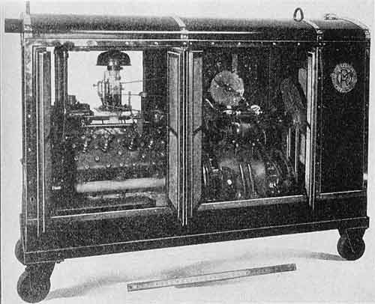
Interior view, 40-kw, old gas-electric generator set

B. Types of Electric Generator

The Generator system objectives differ from one power plant to another according to the types of energy. This is because each type requires different type of arrangement because they differ in their sizes, speeds and other things.

II. Al-QURRAH POWER PLANT GENERATORS

A. System Overview
The Main Generator converts the rotational mechanical energy developed by the steam-driven Main Turbine into electrical energy. It is classified as an outdoor, hydrogen inner-cooled, horizontally mounted, cylindrical rotor, rotating field generator. The generator has a continuous output capacity of 735,200 kVA with a 0.85 lagging power factor. The generator output is at 20kV and 60 Hz. The generator rotor is directly coupled to the No. 2 low pressure turbine. The generator rotor is supplied with DC current to produce a magnetic field in the rotor. This DC current is provided from the excitation system which consists of a brushless exciter and a permanent magnet generator, both directly coupled to the generator rotor. (1)
As the generator rotor's magnetic field cuts the stator winding, an EMF is induced in the stator. This voltage, and the resulting current constitute the electrical output of the generator. The generator terminal voltage is determined by the strength of the magnetic field in the rotor, which is controlled by the amount of current supplied by the exciter. The Exciter and Automatic Voltage Regulator (AVR) System is used to adjust and control the amount of excitation provided to the Main Generator Field. Details of the operation of the Exciter and the AVR are contained in SD-27, Exciter and Automatic Voltage Regulator System. (1)
The Main Generator stator contains three sets of windings. A separate current is developed in each set of windings. Since the windings in the stator are arranged 120º apart, the alternating current (and the voltage) induced in these three windings are 120º out of phase. Thus the generator is called a three phase generator. (1)
The electrical output of the generator is "collected" at the three generator terminals. One end of each stator winding is connected to a porcelain-insulated lead bushing mounted in a lead box on the bottom of the generator. The other ends of the windings are connected together and grounded through a disconnect switch and the primary winding of the neutral transformer. The generator output terminals are connected to the generator transformer through the isolated phase bus ducts.
general info
Manufacturer: Mitsubishi Heavy Industries
Rated Speed: 3600 rpm
Number of Phases: 3
Frequency: 60 Hz
Number of Poles: 2 poles
Voltage Output (nominal): 2 0 kV
Hydrogen Gas Pressure: 4.0 barg
Apparent Power Output: 735,200 kVA
True Power Output: 625,000 kW
Rated Current Output: 21,223 amps
Power Factor: 0.85
Excitation Voltage: 550 VDC
Hydrogen Gas Volume: 120 m³

B. MAJOR COMPONENTS (1)

Because of the importance of electricity, there are many new technologies that have been added to improve the performance of generator systems. The generator is constructed of three major components:
o Generator Frame
o Stator
o Rotor

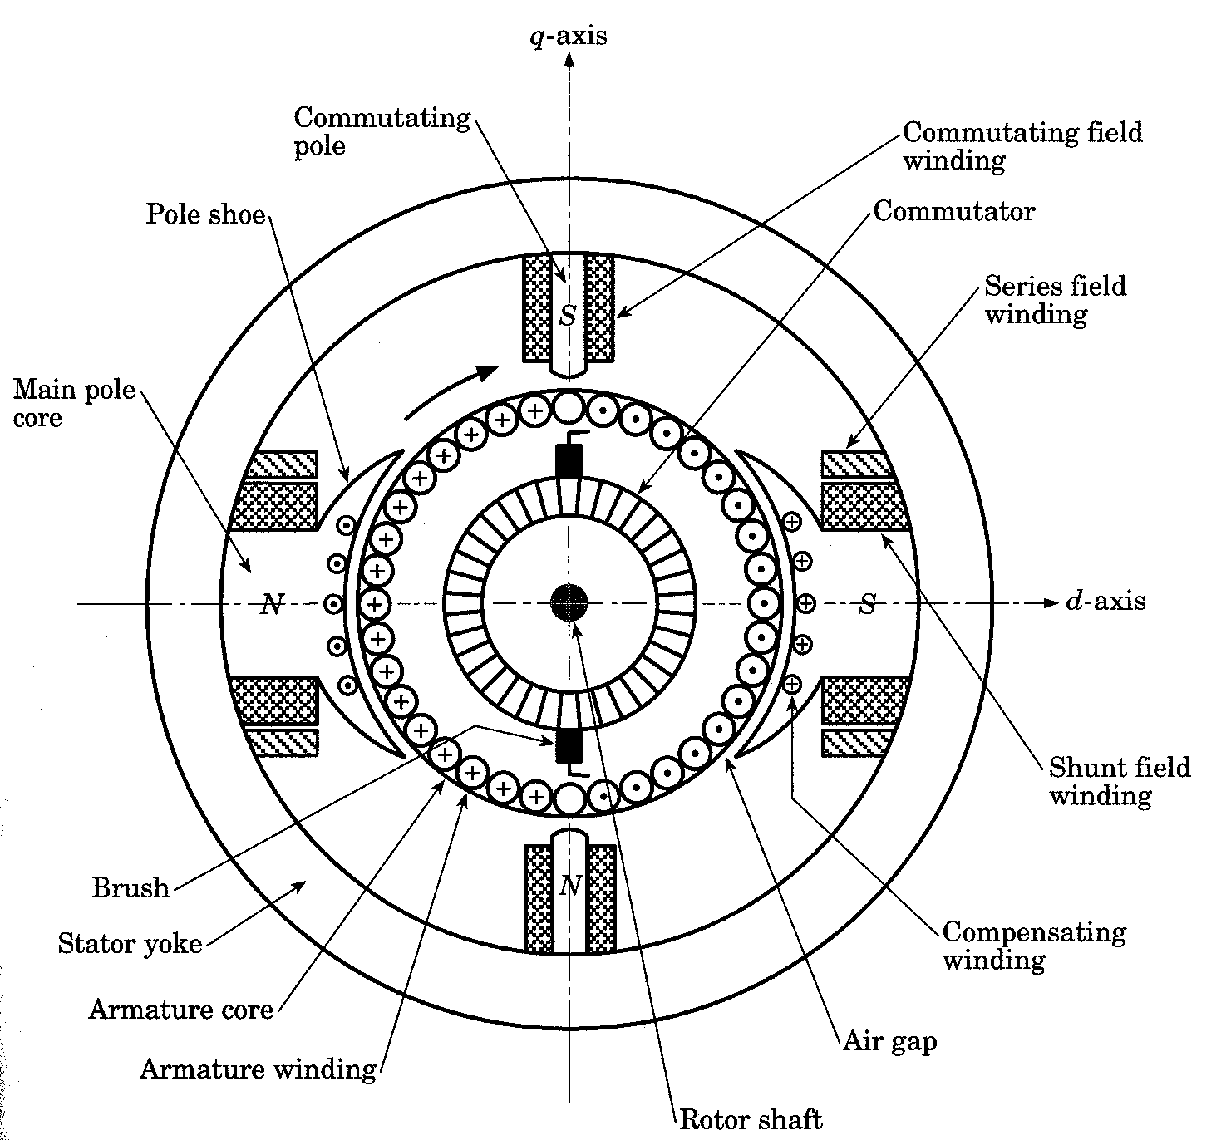
Fig 1 General arrangement of a dc generator

*Generator Frame
The primary function of the generator frame is to support the stator core, the gland seal and bearing bracket assemblies, the lead box, and the hydrogen coolers. Secondly, it provides containment for the hydrogen cooling gas. (1)

, the frame is constructed of frame rings and an outer shell. The frame transfers the weight of all its components into the foundation seating plates through a frame foot, which extends the entire length of the frame. The generator has shims installed between the generator frame feet and the seating plates to provide for alignment to the turbine shaft. This installation method ensures a minimum of vibration. To minimize problems associated with thermal expansion of the generator width, axial anchors are placed in the frame foot and in the seating plates. To provide similar protection for the frame's longitudinal (length) dimension, transverse anchors secure the bearing brackets on each end of the generator. (1)

*Rotor
The purpose of the rotor is to receive the DC excitation current from the exciter, create a magnetic field that rotates with the rotor, and subsequently induce current flow in the stator, which results in the generation of electrical power.

Fig 2 Rotor

The rotor is coupled directly to the No. 2 low pressure turbine. The rotor shaft is made from a solid steel forging. It is constructed with winding slots, end-turn ventilation slots, pole faces, bearing journals, and provisions for installation of internal excitation leads as shown in Figure 3. It has two pole faces spaced 180 degrees apart which allow the magnetic field to leave and enter the rotor body. The relationship and orientation of the magnetic field relative to the rotor and stator are illustrated in Figure 4.

The rotor windings are created from U-shaped bars placed together (concave to concave) to form a rectangular conductor with a hollow center. The windings are installed in slots in the rotor to provide a path for the flow of hydrogen through their centers and facilitate inner coil cooling. Wedges are inserted over the top of the slots to secure the windings and guard against movement(1)
caused by centrifugal forces. Each wedge has holes bored in the center portion to discharge the hydrogen gas into the gap between the rotor and stator.

*Stator
The function of the stator is to produce electrical power induced by the rotating magnetic field of the rotor crossing the stationary conductors in the stator windings. This electrical power is fed to the grid through the generator transformer.

The stator consists of laminated steel plates (core) with windings (coils) wrapped around them. The cores are high-permeability (low reluctance to magnetic flux), low-loss, silicon steel laminations which are insulated on both sides. The insulated laminations reduce losses caused by eddy currents (circulating currents causing heat which represents wasted electrical energy). Additionally, the hydrogen cooling gas is circulated through the axial ventilation passages of the stator to carry away the heat generated in the core by the induced current, as well as the heat caused by eddy currents. The laminations are bolted together to form an essentially solid tubular cylinder. The core is shielded from axial magnetic flux disturbance at the ends by the installation of magnetic end shields clamped on the outside. Equally spaced slots are formed which run the entire length of the inner surface of the stator tube. The slots are deep enough to contain two separately wound coil sections. Figure 4 illustrates an end view of the stator and rotor. The stacked "Xs" in the figure represent the windings embedded in the slots of the stator. (1)

The coils embedded in the slots of the stator are insulated from the stator core and from each other. They are supported to resist any movement which might damage their insulation or interfere with the rotation of the rotor.

The stator core assembly is connected to the generator frame with flexible elements/supports. Flexible supports are used to reduce the amount of vibration transmitted to the generator frame and its foundation.

The stator is wound to produce three separate sets of windings. The windings are arranged so as to produce an electrical output in each set of windings that differs in alternating current and voltage phase of the adjacent winding by 120º. The ends of each winding (phase) are connected to the lead bushings located at the bottom rear of the generator housing. Three of the bushings (one from each end of each winding) are electrically connected together to form the neutral bus of the generator. The other three lead bushings are connected to the isolated phase bus which conducts the output of each generator phase to the generator transformer and the unit transformer. (1)

III. FEATURES OF GENERATOR

A. Improving Safety

To protect yourself, your family and your property read and follow the safety instructions contained in every generator operations manual.
1. Make certain that you size your generator properly. See our sizing page for help by clicking the following link;
2. ALWAYS use a transfer switch when generator is connected to home circuit breaker panel!
3. Installation of an emergency generator, disconnect and/or transfer switch gear MUST be performed by a qualified electrical contractor.
Do NOT attempt to install these devices to your electrical panel, it is EXTREMELY DANGEROUS!!! NOT a do-it-yourself job!
4. ALWAYS check and follow State, Local, National Fire and Electric Codes.
5. NEVER run an electric generator inside a building, especially in a building attached to a dwelling. It is AGAINST ALL FIRE / SAFETY CODES!
6. NEVER store a generator near a gas water heater or furnace!
7. A generator should never be operated at maximum power output for more than 30 minutes. ( See number 1 above )
8. ALWAYS store Gasoline in approved containers only!
9. NEVER fuel an electric generator when the generator is running!
10. EXTINGUISH all flames or cigarettes when handling Gasoline! ( See number 6 above )
11. ALWAYS insure proper ventillation, and air flow around the generator. Never operate the unit in a confined area.
12. ALWAYS have a fully charged, approved Fire Extinguisher located near the generator!
13. ALWAYS properly disconnect from your utility service BEFORE starting your backup generator! ( See number 2 above )
14. ALWAYS store fuel containers out of the reach of children!
15. ALWAYS use grounded extension cords with sufficient wire gauge for the application.
16. ALWAYS check extension cords for exposed wires and frayed shielding, REPLACE if damaged.
17. NEVER remove or tamper with safety devices, they are there to protect you and your property!
18. NEVER attempt to repair an electric generator, only a qualified serviceman should perform repairs!
19. Many engine parts are very HOT during operation, severe burns may result if touched! KEEP children AWAY from generators at all times!
20. ALWAYS operate generator on level and secure ground surfaces.
21. NEVER operate generator in an enclosed compartment! (3)

B. Performance Characteristics of Generators
1. No-load characteristics

*Voltage buildup in Shunt Generator
Shunt generators have a distinct advantage over separately excited dc generators in that no external power supply is required for the field circuit.
The voltage buildup in a dc shunt generator depends on the presence of a residual flux in the poles of the generator. When the generator first starts to turn, an internal voltage will be generated which is given by
EA = K_res!:
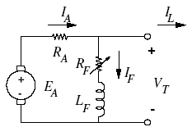
This voltage appears at the terminals of the generator. But when this voltage appears at the terminals, it causes a current to flow in the generator’s field coil. Note that there is no load connected to the terminals, hence the field current IF is only current caused by the voltage EA. This field current produces a magneto motive force in the poles, which increases the flux in them. The increase in flux causes an increase in EA and so on.
This process can be modeled mathematically using a differential equation. Since the internal voltage EA, the flux _ in the machine and the field current IF change while the voltage is building up,
these quantities should be treated as time-varying variables:
EA = EA(t); _ = _(t); IF = IF (t):
At no-load, the transient behavior of a shunt generator is described by the equations:
EA = VT + RAIA
IA = IF + IL = IF
VT = RF IF + NF
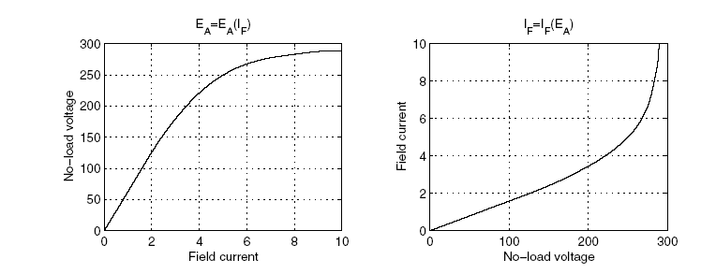

2. Terminal characteristic of a DC shunt generator

The steady-state operation of a loaded generator is described by the equations:
EA = VT + IARA
VT = RF IF
IA = IL + IF :
From these equations,
RAIL = EA _ (RA + RF )IF
That is, the RAIL is the voltage gap between the no load voltage and the voltage drop across RA and
RF caused by the field current IF ; see the graph below. (4)

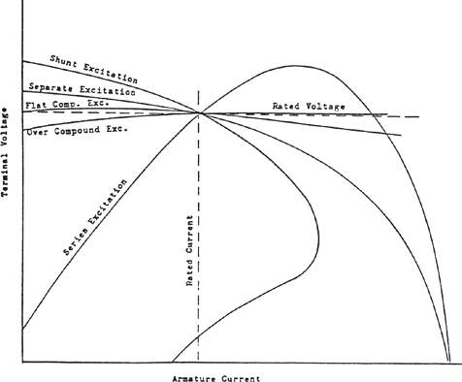

Calculations
- power factor = cos(Phi) = cos 31=0.85 "lagging"
- efficiency= Po\Pin
- Open circuit test
- short circuit test
5.voltage regulation=[(Vnl-Vfl)\Vfl]*100

CONCLUSION

generators are one of the most important tools in all types of producing electric tools . Because of that, many new technologies have been developed for generators to improve their function.

On the other hand , this report gave us the chance to communicate with other exported people .

REFERENCES

1 “Saudi Electric company manual book ”

2. “http://amasci.com/miscon/whatis.html”

3. “http://www.findarticles.com.”

4. “http://www.state.hi.us/

5. “http://www.generatorsofli.com/Flash_how_it_works.html

6. “http://mauiwater.org/min000619ph.html

