CHAPTER ONE:
INTRODUCTION

1. INTRODUCTION
1.1 Grounding:
The use of electricity brings with it an electric shock hazard for humans and animals, particularly in the case of defective electrical apparatus. In electricity supply systems it is therefore a common practice to connect the system to ground at suitable points. Thus in the event of fault, sufficient current will flow through and operate the protection system, which rapidly isolates the faulty circuit. It is therefore required that the connection to ground to be of sufficiently low resistance.
It is essential to mention here that the terms "ground" and "earth" can't quite be used interchangeably. The proper reference ground may sometimes be the earth it self, but most often, with small apparatus, it is its metallic frame or grounding conductor. The potential of this ground conductor may be quite different from zero.
Grounding is of major importance in our efforts to increase the reliability of the supply service, as it helps to provide stability of voltage conditions, preventing excessive voltage peaks during disturbances. Grounding is also a measure of protection against lightning. For protection of power and substations from lightning strokes, surge arresters are often used which are provided with a low earth resistance connection to enable the large currents encountered to be effectively discharged to the general mass of the earth. Depending on its main purpose, the ground is termed either a power system ground or a safety ground.

1.2 Safety and Ground:
1.2.1 Basic problem:
In principle, a safe grounding design has the following two objectives:
- To provide means to carry electric currents into the earth under normal and fault conditions without exceeding any operating and equipment limits or adversely affecting continuity of service.
- To assure that a person in the vicinity of grounded facilities is not exposed to the danger of critical electric shock.

A practical approach to safe grounding thus concerns and strives for controlling the interaction of two grounding systems, as follows:
- The intentional ground, consisting of ground electrodes buried at some depth below the earth's surface.
- The accidental ground, temporarily established by a person exposed to a potential gradient in the vicinity of a grounded facility.

People often assume that any grounded object can be safely touched. A low substation ground resistance is not, in itself, a guarantee of safety. There is no simple relation between the resistance of the ground system as a whole and the maximum shock current to which a person might be exposed. Therefore, a substation of relatively low ground resistance may be dangerous, while another substation with very high resistance may be safe or can be made safe by careful design. For instance, if a substation is supplied from an overhead line with no shield or neutral wire, a low grid resistance is important. Most or all of the total ground fault current enters the earth causing an often steep rise of the local ground potential. If a shield wire, neutral wire, gas-insulated bus, or underground cable feeder, etc., is used, a part of the fault current returns through this metallic path directly to the source. Since this metallic link provides a low impedance parallel path to the return circuit, the rise of local ground potential is ultimately of lesser magnitude. In either case, the effect of that portion of fault current that enters the earth within the substation area should be further analyzed. If the geometry, location of ground electrodes, local soil characteristics, and other factors contribute to an excessive potential gradient at the earth's surface, the grounding system may be inadequate despite its capacity to carry the fault current in magnitudes and durations permitted by protective relays.

1.2.2 Conditions of danger:
During typical ground fault conditions, the flow of current to earth will produce potential gradients within and around a substation. Unless proper precautions are taken in design, the maximum potential gradients along the earth's surface may be of sufficient magnitude during ground fault conditions to endanger a person in the area. Moreover, dangerous voltages may develop between grounded structures or equipment frames and the nearby earth.

The circumstances that make electric shock accidents possible are as follows:
a) Relatively high fault current to ground in relation to the area of ground system and its resistance to remote earth.
b) Soil resistivity and distribution of ground currents such that high potential gradients may occur at points at the earth's surface.
c) Presence of an individual at such a point, time, and position that the body is bridging two points of high potential difference.
d) Absence of sufficient contact resistance or other series resistance to limit current through the body to a safe value under circumstances a through c.
e) Duration of the fault and body contact, and hence, of the flow of current through a human body for a sufficient time to cause harm at the given current intensity.

The relative infrequency of accidents is due largely to the low probability of coincidence of all the unfavorable conditions listed above.

1.2.3 Range of tolerable current:
Effects of an electric current passing through the vital parts of a human body depend on the duration, magnitude, and frequency of this current. The most dangerous consequence of such an exposure is a heart condition known as ventricular fibrillation, resulting in immediate arrest of blood circulation.
1. Effect of frequency:
Humans are very vulnerable to the effects of electric current at frequencies of 50 Hz or 60 Hz. Currents of approximately 0.1 A can be lethal. Research indicates that the human body can tolerate a slightly higher 25 Hz current and approximately five times higher direct current. At frequencies of 3000-10 000 Hz, even higher currents can be tolerated. In some cases the human body is able to tolerate very high currents due to lightning surges. The International Electrotechnical Commission provides curves for the tolerable body current as a function of frequency and for capacitive discharge currents.
Information regarding special problems of dc grounding is contained in the 1957 report of the AIEE Substations Committee.
2. Effect of magnitude and duration
The most common physiological effects of electric current on the body, stated in order of increasing current magnitude, are threshold perception, muscular contraction, unconsciousness, fibrillation of the heart, respiratory nerve blockage, and burning.
Current of 1 mA is generally recognized as the threshold of perception; that is, the current magnitude at which a person is just able to detect a slight tingling sensation in his hands or fingertips caused by the passing current.
Currents of 1-6 mA, often termed let-go currents, though unpleasant to sustain, generally do not impair the ability of a person holding an energized object to control his muscles and release it. In the 9-25 mA range, currents may be painful and can make it difficult or impossible to release energized objects grasped by the hand. For still higher currents muscular contractions could make breathing difficult. These effects are not permanent and disappear when the current is interrupted, unless the contraction is very severe and breathing is stopped for minutes rather than seconds. Yet even such cases often respond to resuscitation. It is not until current magnitudes in the range of 60-100 mA are reached that ventricular fibrillation, stoppage of the heart, or inhibition of respiration might occur and cause injury or death. A person trained in cardiopulmonary resuscitation (CPR) should administer CPR until the victim can be treated at a medical facility.

CHAPTER TWO:
GROUNDING SYSTEM

2. GROUNDING SYSTEM
2.1 Resistance of Grounding System:
The value of resistance to ground of an electrode system is the resistance between the electrode system and another "infinitely large" electrode in the ground at infinite spacing. The soil resistivity is a deterministic factor in evaluating the ground resistance. It is an electrophysical property. The soil resistivity depends on the type of soil (Table 1), its moisture content, and dissolved salts. There are effects of grain size and its distribution and effects of temperature and pressure.
Type of soil | Resistivity  (Ω.m)
Loam, garden | 5-50
Clay | 8-50
Sand and gravel | 60-100
Sandstone | 10-500
Rocks | 200-10,000
Table 1:
(Typical Values of Resistivity of Some Soils)

Homogeneous soil is seldom met, particularly when large areas are involved. In most cases there are several layers of different soils. For nonhomogeneous soils, an apparent resistivity is defined for an equivalent homogeneous soil, representing the prevailing resistivity values from a certain depth downward. The moisture content of the soil reduces its resistivity (Fig. 1).
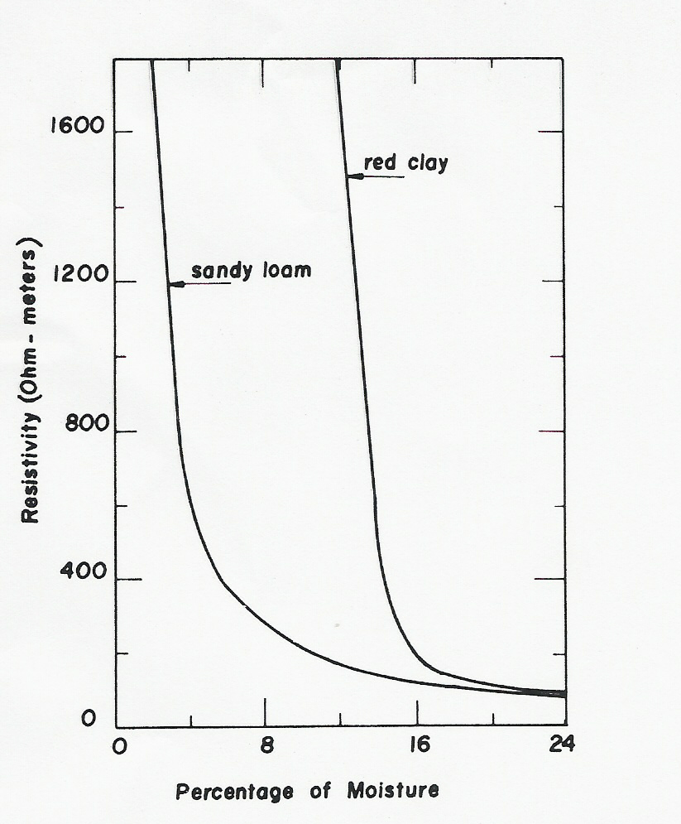
Figure 1:
(Variation of soil resistivity with its moisture content)

As the moisture content varies with the seasons, the resistivity varies accordingly. The grounding system should therefore be installed nearest to the permanent water level, if possible, to minimize the effect of seasonal variations on soil resistivity. As water resistivity has a large temperature coefficient, the soil resistivity increases as the temperature is decreased, with a discontinuity at the freezing point.
The resistivity of soil depends on the amount of salts dissolved in its moisture. A small quantity of dissolved salts can reduce the resistivity very remarkably. Different salts have different effects on the soil resistivity, which explains why the resistivities of apparently similar soils from different locations vary considerably (Fig. 2).
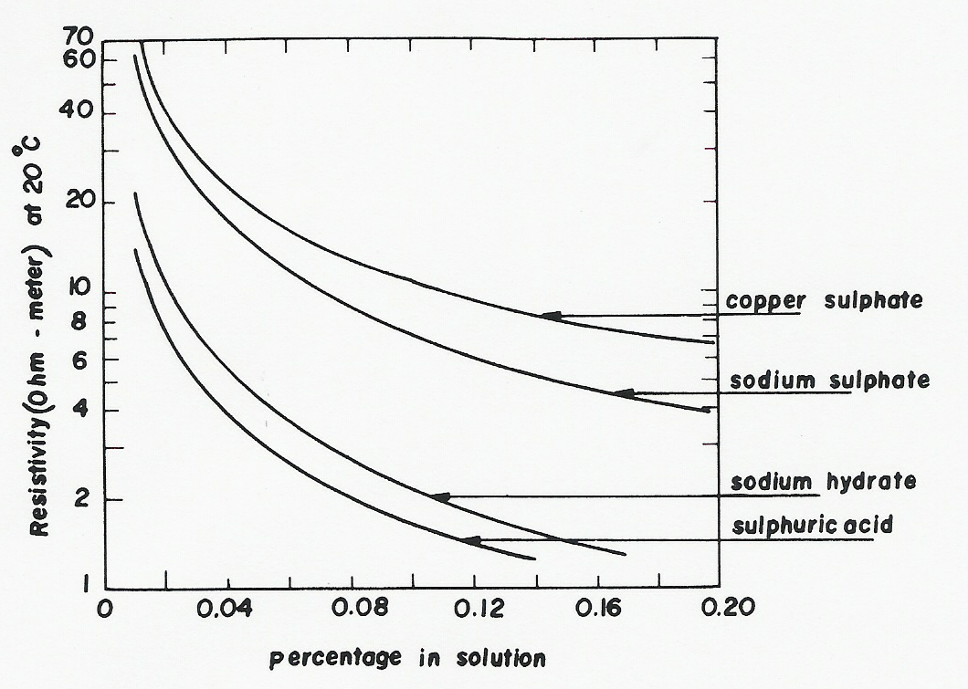
Figure 2:
(Resistivities of different solutions)
Soil resistivity is one of the most important factors in selecting a ground bed location. The number of anodes required, the length and diameter of the backfill column, the voltage rating of the rectifier and power cost are all influenced by soil resistivity. In general, the lowest and most uniform soil resistivity location with relation to depth should be utilized for a deep ground bed site.

2.1.1 Resistance of a Grounding Point Electrode:
The simplest possible electrode is the hemisphere (Fig. 3). The ground resistance of this electrode is made up of the sum of the resistances of an infinite number of thin hemispherical shells of soil. If a current I flows into the ground through this hemispherical electrode, it will flow away uniformly in all directions, through a series of concentric hemispherical shells. Considering each individual shell with a radius x and a thickness dx, the total resistance
R up to a large radius r1 would be:
$$R=\int_{r}^{r1}{\frac{ρ\text{dx}}{2{πx}^{2}}}=\frac{ρ}{2π}(\frac{1}{r}−\frac{1}{r1})$$
where ρ is the resistivity
as r1→ ∞
$$R_{∞}=\frac{ρ}{2πr}$$

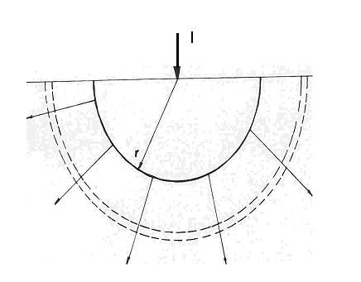
Figure 3:
(current entering ground through a hemispherical electrode)

The general equation becomes:
$$R=\frac{ρ}{2πc}$$
c: is the electrostatic capacitance of the electrode combined with its image above the surface of the earth. This relation is applicable to any shape of electrode.

2.1.2 Resistance of Driven Rods:
The driven rod is one of the simplest and most economical form of electrodes. Its ground resistance could be calculated:
- If its shape is approximated to that of an ellipsoid of revolution having a major axis equal to twice the rod's length and a minor axis equal to its diameter d.
then
$$R=\frac{ρ}{2πℓ}\text{ln}\frac{4ℓ}{d}$$

- If the rod is taken as cylindrical with a hemispherical end, the analytical relation for R takes the form the following equation:
$$R=\frac{ρ}{2πℓ}\text{ln}\frac{2ℓ}{d}$$

- If the rod is assumed as carrying current uniformly along its length, the formula becomes:
$$R=\frac{ρ}{2πℓ}[\text{ln}(\frac{8ℓ}{d})−1]$$

The resistance of a single rod is in general not sufficiently low, and it is necessary to use a number of rods connected in parallel..

$$η=\frac{\text{resis}\text{tan}\text{ceofelectrode}}{n}$$

where,
η: screening coefficient,
n: resistance of n electrodes in parallel,

usually η listed in tables obtained by calculations and measurements since it is difficult to obtains.

2.1.3 Grounding Grids:
Using interconnected ground grids will help for obtaining a low ground resistance at high voltage substations.
A typical grid system for a substation:
- Comprise 4/0 bare
- Solid copper conductors
- Buried at a depth of from 30 to 60 cm
- Spaced in a grid pattern of about 3 to 10 m.
- At each junction, the conductors are securely bonded together.

The ground conductor size is made to avoid fusing:
$$A=\text{If}\sqrt{\frac{\text{76}t}{\text{ln}\frac{\text{234}+\text{Tm}}{\text{234}+\text{Ta}}}}$$

Where:
Iƒ: is fault current,
A: cross section in mm²,
t: fault duration,
Tm: maximum allowable temperature,
Ta: ambient temperature,

Resistance to ground determines the maximum potential rise of the grounding system during the fault:
$$R=\frac{ρ}{L}(\text{ln}\frac{2L}{\sqrt{\text{dh}}}+K1\frac{L}{\sqrt{A}}−K2)$$
Where:
L: total length of all conductors
A: total area of grid
d: grid conductor diameter
K1&K2: factors of length-to-width ratio of the area

2.2 Impulse Impedance of Grounding System:
The importance of Impulse Impedance of grounding system comes form the need of determination of performance of it while discharging impulse current under abnormal conditions.
2.2.1 Performance of Driven Rods:
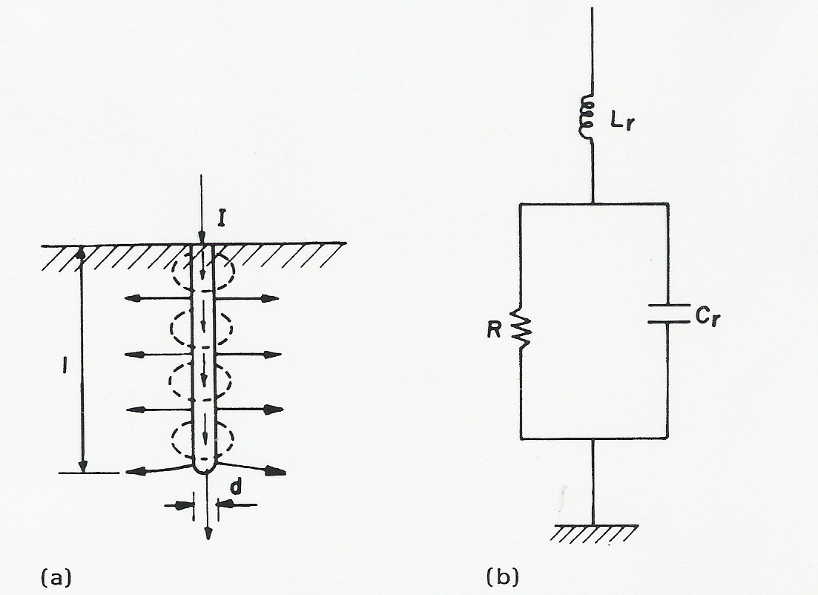
Figure 4:
(a-Impulse current spreading from driven rod and its magnetic field . b-Equivalent circuit for a driven rod under impulse)

As shown in figure 4 above the current (I) gets into the rod electrode and from there diffuses into the ground. In addition to its resistivity, the soil has a dielectric constant εr. When the electrode voltage changes with time, there will be a conductive current in addition to a capacitive current.
$$C=\frac{εrℓ}{\text{18}\text{ln}(\frac{4ℓ}{d})}×{\text{10}}^{−9}$$
The inductance of the rod where the current is most concentrated:
$$L=2ℓ\text{ln}\frac{4ℓ}{d}×{\text{10}}^{−7}$$
The ground will draw a considerable capacitive current in addition to its conductive current at high frequencies. The total current flows through the self-inductance of the electrode. At low frequencies the inductance and capacitance can be safely neglected, whereas at extremely high frequencies a distributed network would represent the ground.

2.2.2 Performance of Grounding Grids:
Ground wires of considerable length are usually buried as counterpoises along transmission lines or near high-voltage substations for lightning protection. The usual transmission -line circuit of distributed constants can represent a buried wire.
The distributed resistance to ground:
- Deeply buried wire:
$$R=\frac{ρ}{2π}\text{ln}\frac{4ℓ}{d}$$
- Near able buried wire:
$R=\frac{ρ}{π}\text{ln}\frac{4ℓ}{d}$
The impulse impedance of a buried ground wire:
$$Z=\sqrt{R(r+{\text{SL}}_{d}})$$
Where:
r: metallic resistance of the wire per meter
Ld: distributed inductance per meter
In case of a grounding grid its equivalent circuit is analyzed in response to the applied impulse current. The circuit parameters could be estimated knowing the dimensions of the grid. To account for the impulse current, however, flowing off each conductor along its length, its effective inductance is reduced to one-third the steady-state value.
Naturally, the impulse impedance is initially higher than the power-frequency impedance, but decreases with time to the steady state value at a rate depending on the circuit and wave parameters.

CHAPTER THREE:
DESIGN OF GROUNDING SYSTEM IN SUBSTATIONS

3. DESIGN OF GROUNDING SYSTEM:
This design according to IEEE standard dated at 2000.
3.1 Design Criteria:
There are two main design goals to be achieved by any substation ground system under normal as well as fault conditions. These goals are:
- To provide means to dissipate electric currents into the earth without exceeding any operating and equipment limits.
- To assure that a person in the vicinity of grounded facilities is not exposed to the danger of critical electric shock.

It is possible for transferred potentials to exceed the GPR of the substation during fault conditions. The design procedure described here is based on assuring safety from dangerous step and touch voltages within, and immediately outside, the substation fenced area. Because the mesh voltage is usually the worst possible touch voltage inside the substation (excluding transferred potentials), the mesh voltage will be used as the basis of this design procedure.
Step voltages are inherently less dangerous than mesh voltages. If, however, safety within the grounded area is achieved with the assistance of a high resistivity surface layer (surface material), which does not extend outside the fence, then step voltages may be dangerous. In any event, the computed step voltages should be compared with the permissible step voltage after a grid has been designed that satisfies the touch voltage criterion.
For equally spaced ground grids, the mesh voltage will increase along meshes from the center to the corner of the grid. The rate of this increase will depend on the size of the grid, number and location of ground rods, spacing of parallel conductors, diameter and depth of the conductors, and the resistivity profile of the soil. In a computer study of three typical grounding grids in uniform soil resistivity, the data shown in Table 2 were obtained. These grids were all symmetrically shaped square grids with no ground rods and equal parallel conductor spacing. The corner Em was computed at the center of the corner mesh. The actual worst case Em occurs slightly off-center (toward the corner of the grid), but is only slightly higher than the Em at the center of the mesh.

Grid number | Number of meshes | Em corner/center
1 | 10x10 | 2.71
2 | 20x20 | 5.55
3 | 30 x 30 | 8.85
Table 2
(Typical ratio of corner-to-corner mesh voltage)

As indicated in Table 2, the corner mesh voltage is generally much higher than that in the center mesh. This will be true unless the grid is unsymmetrical (has projections, is L-shaped, etc.), has ground rods located on or near the perimeter, or has extremely nonuniform conductor spacings. Thus, in the equations for the mesh voltage Em, only the mesh voltage at the center of the corner mesh is used as the basis of the design procedure. Analysis based on computer programs, may use this approximate corner mesh voltage, the actual corner mesh voltage, or the actual worst-case touch voltage found anywhere within the grounded area as the basis of the design procedure. In either case, the initial criterion for a safe design is to limit the computed mesh or touch voltage to below the tolerable touch voltage.
Unless otherwise specified, the remainder of the guide will use the term mesh voltage (Em) to mean the touch voltage at the center of the corner mesh. However, the mesh voltage may not be the worst-case touch voltage if ground rods are located near the perimeter, or if the mesh spacing near the perimeter is small. In these cases, the touch voltage at the corner of the grid may exceed the corner mesh voltage.

3.2 Critical parameters:
The following site-dependent parameters have been found to have substantial impact on the grid design:
- Maximum grid current IG,
- Fault duration tr,
- Shock duration ts
- Soil resistivity ρ,
- Surface material resistivity (ρs),
- Grid geometry;

Several parameters define the geometry of the grid, but the area of the grounding system, the conductor spacing, and the depth of the ground grid have the most impact on the mesh voltage, while parameters such as the conductor diameter and the thickness of the surfacing material have less impact.

3.2.1 Maximum grid current (lG):
The evaluation of the maximum design value of ground fault current that flows through the Substation Grounding grid into the earth IG. In determining the maximum current IG, consideration should be given to the resistance of the ground grid, division of the ground fault current between the alternate return paths and the grid, and the decrement factor.

3.2.2 Fault duration (tf) and shock duration (ts):
The fault duration and shock duration are normally assumed equal, unless the fault duration is the sum of successive shocks. The selection of tf should reflect fast clearing time for transmission substations and slow clearing times for distribution and industrial substations. The choices tf and ts should result in the most pessimistic combination of fault current decrement factor and allowable body current. Typical values for tf and ts range from 0.25 s to 1.0 s.

3.2.3 Soil resistivity (ρ)
The grid resistance and the voltage gradients within a substation are directly dependent on the soil resistivity. Because in reality soil resistivity will vary horizontally as well as vertically, sufficient data must be gathered for a substation yard.
Because the equations for Em and Es assume uniform soil resistivity, the equations can employ only a single value for the resistivity.

3.2.4 Resistivity of surface layer (ρs):
A layer of surface material helps in limiting the body current by adding resistance to the equivalent body resistance.

3.2.5 Grid geometry:
In general, the limitations on the physical parameters of a ground grid are based on economics and the physical limitations of the installation of the grid. The economic limitation is obvious. It is impractical to install a copper plate grounding system. Typical conductor spacings range from 3 m to 15 m, while typical grid depths range from 0.5 m to 1.5 m. For the typical conductors ranging from 2/0 AWG (67 mm²) to 500 kcmil (253 mm²), the conductor diameter has negligible effect on the mesh voltage. The area of the grounding system is the single most important geometrical factor in determining the resistance of the grid. The larger the area grounded, the lower the grid resistance and, thus, the lower the GPR.

3.3 Index of design parameters:
Symbol | Description
ρ | Soil resistivity, Ω.m
ρs | Surface layer resistivity, Ω.m
3Io | Symmetrical fault current in substation for conductor sizing, A
A | Total area enclosed by ground grid, m²
Cs | Surface layer derating factor
d | Diameter of grid conductor, m
D | Spacing between parallel conductors, m
Df | Decrement factor for determining IG
Dm | Maximum distance between any two points on the grid, m
Em | Mesh voltage at the center of the corner mesh for the simplified method, V
Es | Step voltage between a point above the outer corner of the grid and a point 1 m diagonally outside the grid for the simplified method, V
Estep50 | Tolerable step voltage for human with 50 kg body weight, V
Estep70 | Tolerable step voltage for human with 70 kg body weight, V
Etouch50 | Tolerable touch voltage for human with 50 kg body weight, V
Etouch70 | Tolerable touch voltage for human with 70 kg body weight, V
h | Depth of ground grid conductors, m
hs | Surface layer thickness, m
IG | Maximum grid current that flows between ground grid and surrounding earth (including dc offset), A
Ig | Symmetrical grid current, A
K | Reflection factor between different resistivities
Kh | Corrective weighting factor that emphasizes the effects of grid depth, simplified method
Ki | Correction factor for grid geometry, simplified method
Kii | Corrective weighting factor that adjusts for the effects of inner conductors on the corner mesh, simplified method
Km | Spacing factor for mesh voltage, simplified method
Ks | Spacing factor for step voltage, simplified method
Lc | Total length of grid conductor, m
LM | Effective length of Lc + LR for mesh voltage, m
LR | Total length of ground rods, m
Lr | Length of ground rod at each location, m
LS | Effective length of Lc + LR for step voltage, m
LT | Total effective length of grounding system conductor, including grid and ground rods, m
Lx | Maximum length of grid conductor in x direction, m
Ly | Maximum length of grid conductors in y direction, m
n | Geometric factor composed of factors na, nb, nc, and nd
nR | Number of rods placed in area A
Rg | Resistance of grounding system, Ω
Sf | Fault current division factor (split factor)
tc | Duration of fault current for sizing ground conductor, s
tf | Duration of fault current for determining decrement factor, s
ts | Duration of shock for determining allowable body current, s
Table 3:
(index of design parameters)

3.4 Design procedure:
The following describes each step of the procedure:
Step 1: The property map and general location plan of the substation should provide good estimates of the area to be grounded. A soil resistivity test, will determine the soil resistivity profile and the soil model needed (that is, uniform or two-layer model).

Step 2: The conductor size. The fault current 3Io should be the maximum expected future fault current that will be conducted by any conductor in the grounding system, and the time, tc, should reflect the maximum possible clearing time (including backup).

Step 3: The tolerable touch and step voltages are determined. The choice of time, ts, is based on the judgment of the design engineer.

Step 4: The preliminary design should include a conductor loop surrounding the entire grounded area, plus adequate cross conductors to provide convenient access for equipment grounds, etc. The initial estimates of conductor spacing and ground rod locations should be based on the current IG and the area being grounded.

Step 5: Estimates of the preliminary resistance of the grounding system in uniform soil can be determined. For the final design, more accurate estimates of the resistance may be desired. Computer analysis based on modeling the components of the grounding system in detail can compute the resistance with a high degree of accuracy, assuming the soil model is chosen correctly.

Step 6: The current IG is determined. To prevent overdesign of the grounding system, only that portion of the total fault current, 3Io that flows through the grid to remote earth should be used in designing the grid. The current IG should, however, reflect the worst fault type and location, the decrement factor, and any future system expansion.

Step 7: If the GPR of the preliminary design is below the tolerable touch voltage, no further analysis is necessary. Only additional conductor required to provide access to equipment grounds is necessary.

Step 8: The calculation of the mesh and step voltages for the grid as designed can be done by the approximate analysis techniques for uniform soil, or by the more accurate computer analysis techniques. Further discussion of the calculations are reserved for those sections.
Step 9: If the computed mesh voltage is below the tolerable touch voltage, the design may be complete (see Step 10). If the computed mesh voltage is greater than the tolerable touch voltage, the preliminary design should be revised (see Step 11).

Step 10: If both the computed touch and step voltages are below the tolerable voltages, the design needs only the refinements required to provide access to equipment grounds. If not, the preliminary design must be revised (see Step 11).

Step 11: If either the step or touch tolerable limits are exceeded, revision of the grid design is required. These revisions may include smaller conductor spacings, additional ground rods, etc. More discussion on the revision of the grid design to satisfy the step and touch voltage limits is given.

Step 12: After satisfying the step and touch voltage requirements, additional grid and ground rods may be required. The additional grid conductors may be required if the grid design does not include conductors near equipment to be grounded. Additional ground rods may be required at the base of surge arresters, transformer neutrals, etc. The final design should also be reviewed to eliminate hazards due to transferred potential and hazards associated with special areas of concern.

CHAPTER FOUR:

CASE STUDY

4.1 Step-By-Step Formulas for Calculating Substation Grounding:

- Soil Resistivity:
1. Sum the apparent resistivity (Ω-m) of the same point for all tests then calculate their average as follows:
$ρ_{A}=\frac{\sum_{k=1}^{k}{\left(\text{Apparent resistivities of point number A}\right)}}{k}$,
Where,
k is the number of tests
Similarly for all other points.
2. The soil resistivity ρ can be computed as follows:
$ρ=\frac{\sum_{j=1}^{j}{\left(ρ_{j}\right)}}{j}$,
Where,
J: is the number of points.

- Grounding Conductor Size:
1. Calculate the cross sectional area (mm²) of the conductor as follows:
$A_{{\text{mm}}^{2}}=I_{f}\sqrt{\frac{t_{c}\text{.}α_{r}\text{.}ρ_{r}\text{.}{\text{10}}^{4}}{\frac{\text{TCAP}}{\text{1n}\left[1+\left(\frac{T_{m}−T_{a}}{K_{o}+T_{a}}\right)\right]}}}$

2. Evaluate the diameter (m) of the conductor as follows:
$d=\sqrt{\frac{4×{\text{10}}^{−6}×A_{{\text{mm}}^{2}}}{π}}$

- Tolerable Step Voltage:
The step voltage (E_{step}) in volts can be calculated as follows:
$E_{\text{step}}=\frac{(\text{1000}+6×C_{S}×ρ_{S})×0\text{.}\text{116}}{\sqrt{t_{s}}}$
Where,
C_{S} the surface layer factor is given by
$C_{S}=1−0\text{.}\text{09}\left[\frac{1−\left(ρ/ρ_{S}\right)}{2×h_{S}+0\text{.}\text{09}}\right]$

- Tolerable Touch Voltage:
The tolerable touch voltage (E_{touch}) in volts is:
$E_{\text{touch}}=\frac{(\text{1000}+1\text{.}5×C_{S}×ρ_{S})×0\text{.}\text{116}}{\sqrt{t_{s}}}$

- Calculation of Grid Resistance:
The substation ground resistance (R_{g}) in ohm
$R_{g}=ρ×\left[\frac{1}{L_{T}}+\frac{1}{\sqrt{\text{20}A}}\left(1+\frac{1}{1+h×\sqrt{\text{20}/A}}\right)\right]$
Where,
L_{T} the total buried length of conductors in m is calculated as follows:
L_{T} = L_{C} + L_{R}
Where
L_{C} the total length of grid conductor in meters
L_{C} =$2×\left(\frac{L}{D}+1\right)×L+4×L$
Where
L_{R} = TGR × L_{r}
The total number of ground rods (TGR),
TGR = $\frac{4×L}{\text{SGR}}+4×\text{nt}$

- Calculation of Maximum Step Voltage:
Maximum step voltage (E_{S}) in volts,
$E_{S}=\frac{ρ×K_{S}×K_{i}×I_{G}}{L_{S}}$
Where,
The step voltage spacing factor (K_{S}) is:
$K_{S}=\frac{1}{π}\left[\frac{1}{2×h}+\frac{1}{D+h}+\frac{1}{D}\left(1−0\text{.}5^{n−2}\right)\right]$
Where,
The corrective factor accounting for grid geometry (K_{i}) is:
K_{i} = 0.644 + 0.148 × n
The maximum grid current in A (I_{G}) is:
I_{G} = 0.7 × I_{f}
The effective buried conductor length in (L_{S}) m:
L_{S} =0.75 × L_{C} + 0.85 × L_{R}

- Calculation of Maximum Step Voltage:
The mesh voltage (E_{m}) in volts is:
$E_{m}=\frac{ρ×K_{m}×K_{i}×I_{G}}{L_{M}}$
Where,
The geometrical factor (K_{m})
$$K_{m}=\frac{1}{2π}\left[\text{ln}\left(\frac{D^{2}}{\text{16}×h×d}+\frac{{\left(D+2h\right)}^{2}}{8×D×d}−\frac{h}{4×d}\right)+\left(\frac{K_{\text{ii}}}{K_{h}}×\text{ln}\left(\frac{8}{π\left(2n−1\right)}\right)\right)\right]$$
The corrective weighting factor is:
K_{h} = $=\sqrt{1+\left(h/h_{o}\right)}{\text{ , h}}_{o}=\text{1 m }(\text{reference depth of grid})$
The effective number of parallel conductors in a given grid n:
n = n_{a} × n_{b} × n_{c} × n_{d}
= $\frac{2×L_{C}}{L_{p}}$ × 1× 1 × 1 = $\frac{2×L_{C}}{L_{p}}$
Where,
The effective buried length (L_{M}) in m is:
$$L_{M}=L_{C}+\left[1\text{.}\text{55}+1\text{.}\text{22}\left(\frac{L_{r}}{\sqrt{L_{X}^{2}+L_{Y}^{2}}}\right)\right]×L_{R}$$

Constant | Value
Resistivity of Surface Layer ρ_{s} (Ω-m) | 3000
Time of Current Flow T_{c} (sec) | 1
Length of each ground rod L_{r} (m) | 2.5
Duration of Shock T_{s} (sec) | 0.5
Maximum (fusing) temperature Tm (˚C) | 1083
Thermal Capacity Factor TCAP J/(cm³. ˚C) | 3.422
Thermal Coefficient of resistivity at T_{r} α_{r} (1/˚C) | 0.00393
Resistivity of Ground conductor ρ_{r} at T_{r} (μ) | 1.7241
Table 4: Design Constants (according to SEC)

4.2 CALCULATION PROCEDURE:
According to:
SEC-ERB ENGINEERING STANDARDS SES-P-119.10 (2001), IEEE Std 80 – 2000 and IEEE Std 81 – 83.
4.2.1 Determine Soil Resistivity :

The soil resistivity calculation is done by averaging the apparent resistivity point wise as follows:
First a simple table of the soil resistivity tests is shown below:
POINT NUMBER | TEST # 1 | TEST # 2 | TEST # 3 | TEST # 4 | TEST # 5 | AVERAGE IN  Ω-m
POINT NUMBER | Apparent resistivity | Apparent resistivity | Apparent resistivity | Apparent resistivity | Apparent resistivity | AVERAGE IN  Ω-m
1. | 9.0 | 16.5 | 40.5 | 30.0 | 33.0 | 25.8
2. | 4.2 | 6.6 | 12.0 | 8.1 | 6.9 | 7.56
3. | 2.6 | 1.5 | 1.8 | 1.1 | 1.7 | 1.74
4. | 3.2 | 1.5 | 1.7 | 1.5 | 1.4 | 1.86
5. | 3.8 | 2.0 | 2.3 | 1.7 | 1.7 | 2.3
6. |  |  | 2.9 |  | 1.8 | 2.35
7. |  |  | 3.8 |  |  | 3.8
Table 5: soil resistivity test

Next the average of each point is as follows:
$$ρ_{1}=\frac{9\text{.}0+\text{16}\text{.}5+\text{40}\text{.}5+\text{30}\text{.}0+\text{33}\text{.}0}{5}=\text{25}\text{.}8Ω\text{-m}$$
$$ρ_{2}=\frac{4\text{.}2+6\text{.}6+\text{12}\text{.}0+8\text{.}1+6\text{.}9}{5}=7\text{.}\text{56}Ω\text{-m}$$
$$ρ_{3}=\frac{2\text{.}6+1\text{.}5+1\text{.}8+1\text{.}1+1\text{.}7}{5}=1\text{.}\text{74}Ω\text{-m}$$
$$ρ_{4}=\frac{3\text{.}2+1\text{.}5+1\text{.}7+1\text{.}5+1\text{.}4}{5}=1\text{.}\text{86}Ω\text{-m}$$
$$ρ_{5}=\frac{3\text{.}8+2\text{.}0+2\text{.}3+1\text{.}7+1\text{.}7}{5}=2\text{.}3Ω\text{-m}$$
$$ρ_{6}=\frac{2\text{.}9+1\text{.}8}{2}=2\text{.}\text{35}Ω\text{-m}$$
$$ρ_{7}=\frac{3\text{.}8}{1}=3\text{.}8Ω\text{-m}$$
The average of each point is written in table # 1 above.
Next the soil resistivity ρ is calculated as follows:
$$ρ=\frac{\text{25}\text{.}8+7\text{.}\text{56}+1\text{.}\text{74}+1\text{.}\text{86}+2\text{.}3+2\text{.}\text{35}+3\text{.}8}{7}=6\text{.}\text{487}Ω\text{-m}$$

4.2.2 Grounding Conductor Size :

Per (Eq.10-13) of SES-P-119.10,

$$A_{{\text{mm}}^{2}}=I_{f}\sqrt{\frac{t_{c}\text{.}α_{r}\text{.}ρ_{r}\text{.}{\text{10}}^{4}}{\frac{\text{TCAP}}{\text{1n}\left[1+\left(\frac{T_{m}−T_{a}}{K_{o}+T_{a}}\right)\right]}}}$$
$$=\text{40000}×\sqrt{\frac{\frac{1×\text{.}\text{00393}×1\text{.}\text{7241}×{\text{10}}^{−6}×{\text{10}}^{4}}{3\text{.}\text{422}}}{\text{ln}\left[1+\left(\frac{\text{1083}−\text{50}}{\text{234}+\text{50}}\right)\right]}}=\text{143}\text{.}{\text{7028 mm}}^{2}$$
The nearest higher size as per Table 10-2 of SES-P-119.10 is 240mm².
Hence the selected conductor size for substation ground grid=240mm²
Therefore,
d = Diameter of the grid conductor in meter
= $\sqrt{\frac{4×{\text{10}}^{−6}×A_{{\text{mm}}^{2}}}{π}}=\sqrt{\frac{4×{\text{10}}^{−6}\text{240}}{π}}=0\text{.}\text{01748}\text{ m}$

4.2.3 Tolerable Step and Touch Voltages :

Per SES-P-119.10
Due to the asphalt surface layer, which is a high resistivity material, the shallow depth of the asphalt precludes the assumption of uniform resistivity in the vertical direction. C_{S} (Surface layer derating factor) can be considered as a corrective factor to compute the effective resistance and it is given as an empirical equation.

Surface layer derating factor,
$$\begin{aligned}C_{S}=1−0\text{.}\text{09}\left[\frac{1−\left(ρ/ρ_{S}\right)}{2×h_{S}+0\text{.}\text{09}}\right] \left(\text{Eq}\text{.}\text{ 10-5}\right) \\ 1−0\text{.}\text{09}\left[\frac{1−\left(6\text{.}\text{487}/\text{3000}\right)}{2×0\text{.}1+0\text{.}\text{09}}\right]=0\text{.}\text{6903}\end{aligned}$$

Tolerable Step Voltage,
$$E_{\text{step}}=\frac{(\text{1000}+6×C_{S}×ρ_{S})×0\text{.}\text{116}}{\sqrt{t_{s}}} (\text{Eq}\text{.}\text{ 10}−3)$$
Where:
t_{s} Shock duration in sec., which ranges from 0.5-1.0 sec. For SEC-ERB applications, it shall be taken as 0.5 sec.
$$E_{\text{step}}=\frac{(\text{1000}+6×0\text{.}\text{6903}×\text{3000})×0\text{.}\text{116}}{\sqrt{0\text{.}5}}=\text{2202}\text{.}5\text{ V}$$

Tolerable Touch Voltage,
$$\begin{aligned}E_{\text{touch}}=\frac{(\text{1000}+1\text{.}5×C_{S}×ρ_{S})×0\text{.}\text{116}}{\sqrt{t_{s}}} (\text{Eq}\text{.}\text{ 10}−4) \\ \frac{(\text{1000}+1\text{.}5×0\text{.}\text{6903}×\text{3000})×0\text{.}\text{116}}{\sqrt{0\text{.}5}}=\text{673}\text{.}\text{66}\text{ V}\end{aligned}$$

4.2.4 Calculation of Grid Resistance :

$$R_{g}=ρ×\left[\frac{1}{L_{T}}+\frac{1}{\sqrt{\text{20}A}}\left(1+\frac{1}{1+h×\sqrt{\text{20}/A}}\right)\right] (\text{Eq}\text{.}\text{ 10-12})$$
Where
R_{g} = Substation ground resistance in ohm
ρ = Average ground Resistivity in ohm-m
The total buried length of conductors in m
L_{T} = L_{C} + L_{R}
Where
L_{C} = Total length of grid conductor in meters
= $2×\left(\frac{L}{D}+1\right)×L+4×L$
Where
L = Dimension of the substation in m. According to SEC-ERB standard in article 8.2.1 it states that “the grounding grid shall encompass all of the area within the fence, and shall extend at least 1.5 meters outside the substation fence on all sides (if space permits) including all gates in any position (open or closed)”.
Therefore,
L = dimension of substation + 2 × 1.5
= 80 + 3 = 83 m
Therefore,
L_{C} = $2×\left(\frac{\text{83}}{\text{15}}+1\right)×\text{83}+4×\text{83}=\text{1416}\text{.}\text{533}\text{ m}$
L_{R} = Total length of ground rods in meters. As per SEC-ERB standard the ground rod length shall be 2.5 m
Therefore,
L_{R} = TGR × L_{r}
Where, the total number of ground rods,
In this case study,
TGR = $\frac{4×L}{\text{SGR}}+4×\text{nt}$
Where,
SGR = is the spacing between periphery ground rods in m,
nt = is the number of transformers in the substation, each transformer has 4 ground rods one for equipment grounding, two for the surge arrestors and one for neutral-grounding.
For the case study,
SGR = 5 m
nt = 3

TGR = $\frac{4×\text{83}}{5}+4×3=\text{78}\text{.}4$
Since TGR is the number of ground rods it takes only an integer value,
Therefore,
TGR = 78
L_{r} = The standard length of each ground rod = 2.5 m
L_{R} = 78 × 2.5 = 195 m
Consequently,
L_{T} = L_{C} + L_{R} = 1416.533 + 195 = 1611.533 m
Hence,
The area occupied by the ground grid (including the walkway which adds 1.5 m around the periphery) in m²
A = L × L = 83 × 83 = 6889 m²
Where,
h = Depth of grid in meters excluding asphalt covering. According to SES-P-119.10 article 8.2.3 “grounding grid shall be buried at a depth ranging from 0.5 to 1.5 m below final ground grade (excluding asphalt layer)”.
In the case study,
h = 0.5 m
Therefore,
$$\begin{aligned}R_{g}=6\text{.}\text{487}\left[\frac{1}{\text{1611}\text{.}\text{533}}+\frac{1}{\sqrt{\text{20}×\text{6889}}}\left(1+\frac{1}{1+0\text{.}5\sqrt{\text{20}/\text{6889}}}\right)\right] \\ 0\text{.}\text{0385}Ω\end{aligned}$$

4.2.5 Calculation of Maximum Mesh and Step Voltages :

Mesh voltage (E_{m}),
$E_{m}=\frac{ρ×K_{m}×K_{i}×I_{G}}{L_{M}} (\text{Eq}\text{.}\text{ 10-8})$,
Where,
K_{m} = The geometrical factor,
$\begin{aligned}K_{m}=\frac{1}{2π}\left[\text{ln}\left(\frac{D^{2}}{\text{16}×h×d}+\frac{{\left(D+2h\right)}^{2}}{8×D×d}−\frac{h}{4×d}\right)+\left(\frac{K_{\text{ii}}}{K_{h}}×\text{ln}\left(\frac{8}{π\left(2n−1\right)}\right)\right)\right] \\ \left(\text{Eq}\text{.}\text{ 10}\text{.}9\right)\end{aligned}$Where,
D = Spacing between parallel conductors in meters, according to SES-P-119.10 article 8.2.4 “the grounding grid conductors shall preferably be laid, as far as possible, at reasonably uniform spacing. Depending on site conditions, typical spacing of the main conductors generally ranges between 3 meters to 15 meters. Grid spacing shall be halved around the perimeter of the grid to reduce periphery voltage gradients”.
Therefore D initially is,
D = 15 m
d = 0.01748 m
h = depth of ground grid conductors in meters
= 0.5 m
K_{ii} = Corrective weighting factor that adjusts the effect of inner conductors in the corner mesh. As per SES-P-119.10 “K_{ii} = 1 for grids with ground rods along the perimeter, or for grids with ground rods in the grid corners, as well as both along the perimeter and throughout the grid area”.
= 1

Or, as per SES-P-119.10 “for grids with no ground rods or grids with only a few ground rods, none located in the corner or on the perimeter”.
K_{ii} = $\frac{1}{{\left(2×n\right)}^{\left(2/n\right)}}$

In this case study, since there are ground rods in the perimeter
Therefore,
K_{ii} = 1
Where,
K_{h} = Corrective weighting factor that emphasizes the effects of a grid depth and is given as follows:
$\begin{aligned}=\sqrt{1+\left(h/h_{o}\right)}{\text{ , h}}_{o}=\text{1 m }(\text{reference depth of grid}) \\ \sqrt{1+\left(0\text{.}5/1\right)}=1\text{.}\text{225}\end{aligned}$
n = effective number of parallel conductors in a given grid
n = n_{a} × n_{b} × n_{c} × n_{d}
where,
n_{a} = $\frac{2×L_{C}}{L_{p}}$
Where,
L_{C} = 1416.533 m
L_{p} = peripheral length of the grid in m
= 4 × L = 4 × 83 = 332 m
Therefore,
n_{a} = $\frac{2×\text{1416}\text{.}\text{533}}{\text{332}}=8\text{.}\text{533}$
Since n_{a} can only be an integer therefore the value has to be rounded down
Therefore,
n_{a} = 8
n_{b} = n_{c} = n_{d} = 1 (for square grids)
Therefore,
n = 8 × 1 × 1 × 1 = 8
$$\begin{aligned}K_{m}=\frac{1}{2π}\left\{\text{ln}\left(\frac{{\text{15}}^{2}}{\text{16}×0\text{.}5×0\text{.}\text{01748}}+\frac{{\left(\text{15}+2×0\text{.}5\right)}^{2}}{8×\text{15}×0\text{.}\text{01748}}−\frac{0\text{.}5}{4×0\text{.}\text{01748}}\right)\right. \\ \left. +\left(\frac{1}{1\text{.}\text{225}}×\text{ln}\left(\frac{8}{π\left(2×8−1\right)}\right)\right)\right\} \\ 0\text{.}\text{9556}\end{aligned}$$
Where,
K_{i} = Corrective factor accounting for grid geometry
= 0.644 + 0.148 × n
= 0.644 + 0.148 × 8 = 1.828
I_{G} = Maximum grid current in A
= S_{f} × D_{f} × I_{f}
Where,
S_{f} = Current division factor. As per SES-P-119.10 “It relates the magnitude of fault current to that of its portion flowing between the grounding grid and surrounding ground. For SEC-ERB application, the minimum value of this factor shall be taken as 0.7”.
S_{f} = 0.7
D_{f} = Decrement factor. As per SES-P-119.10 “for SEC-ERB system with minimum shock duration of 0.5 sec, value of D_{f} shall be 1”.
D_{f} = 1
I_{f} = Is the fault current
In this case study it is given as
= 40,000 A
Therefore,
I_{G} = 0.7 × 1 × 40,000 = 28000 A
Where,
L_{M} = Effective buried length in m
= $L_{C}+\left[1\text{.}\text{55}+1\text{.}\text{22}\left(\frac{L_{r}}{\sqrt{L_{X}^{2}+L_{Y}^{2}}}\right)\right]×L_{R}$
Where,
L_{X} = maximum length of the grid in the X-direction in m
L_{Y} = maximum length of the grid in the Y-direction in m
In this case study, the substation grid is a square.
Therefore,
L_{X} = L_{Y} = L = 83 m
Hence,
L_{M} = $\text{1416}\text{.}\text{533}+\left[1\text{.}\text{55}+1\text{.}\text{22}\left(\frac{2\text{.}5}{\sqrt{2×{\text{83}}^{2}}}\right)\right]×\text{195}=\text{1723}\text{.}\text{85}\text{ m}$
Therefore,
$$E_{m}=\frac{6\text{.}\text{487}×0\text{.}\text{9556}×1\text{.}\text{828}×\text{28000}}{\text{1723}\text{.}\text{85}}=\text{184}\text{.}0\text{ V}$$
Step Voltage (E_{S}),
$$E_{S}=\frac{ρ×K_{S}×K_{i}×I_{G}}{L_{S}} (\text{Eq}\text{.}\text{ 10-10})$$
Where,
K_{S} = Step voltage spacing factor
= $\frac{1}{π}\left[\frac{1}{2×h}+\frac{1}{D+h}+\frac{1}{D}\left(1−0\text{.}5^{n−2}\right)\right] (\text{Eq}\text{.}\text{ 10-11})$
= $\frac{1}{π}\left[\frac{1}{2×0\text{.}5}+\frac{1}{\text{15}+0\text{.}5}+\frac{1}{\text{15}}\left(1−0\text{.}5^{8−2}\right)\right]=0\text{.}\text{359}$
Where the effective buried conductor length in meter:
L_{S} = 0.75 × L_{C} + 0.85 × L_{R}
= 0.75 × 1416.533 + 0.85 × 195 = 1228.15 m
Therefore,
$$E_{S}=\frac{6\text{.}\text{487}×0\text{.}\text{359}×1\text{.}\text{828}×\text{28000}}{\text{1228}\text{.}\text{15}}=\text{97}\text{.}0\text{ V}$$

- The value of the mesh voltage is less than the tolerable touch voltage
(E_{m} = 184 V < E_{touch} = 673.66 V)
- The value of the step voltage is less than the tolerable step voltage
(E_{S} = 97.0 V < E_{step} = 2202.5 V)
Therefore the grounding grid sizing is OK.

4.3 Design Procedure Using Excel Program:
This procedure has been used in SEC, which is the fastest way for design.

4.3.1 Procedure:
- Entering the apparent resistivities getting from the several test.

READING NUMBER | TEST# 1 | TEST# 2 | TEST# 3 | TEST# 4 | TEST# 5
1 | 9.0 | 16.5 | 40.5 | 30.0 | 33.0
2 | 4.2 | 6.6 | 12.0 | 8.1 | 6.9 |  | PLEASE ENTER THE
3 | 2.6 | 1.5 | 1.8 | 1.1 | 1.7
4 | 3.2 | 1.5 | 1.7 | 1.5 | 1.4 |  | SOIL RESISTIVITY
5 | 3.8 | 2.0 | 2.3 | 1.7 | 1.7
6 | 0.0 | 0.0 | 2.9 | 0.0 | 1.8 |  | MEASUREMENTS IN THE
7 | 0.0 | 0.0 | 3.8 | 0.0 | 0.0
8 | 0.0 | 0.0 | 0.0 | 0.0 | 0.0 |  | TABLE SHOWN
9 | 0.0 | 0.0 | 0.0 | 0.0 | 0.0
10 | 0.0 | 0.0 | 0.0 | 0.0 | 0.0
11 | 0.0 | 0.0 | 0.0 | 0.0 | 0.0
12 | 0.0 | 0.0 | 0.0 | 0.0 | 0.0
13 | 0.0 | 0.0 | 0.0 | 0.0 | 0.0
14 | 0.0 | 0.0 | 0.0 | 0.0 | 0.0
15 | 0.0 | 0.0 | 0.0 | 0.0 | 0.0
Table 6: data of soil resistivities

- Taking the average of the tests will get:

Reading Number | Average
1 | 25.800
2 | 7.560
3 | 1.740
4 | 1.860
5 | 2.300
6 | 2.350
7 | 3.800
8 | 0
9 | 0
10 | 0
11 | 0
12 | 0
13 | 0
14 | 0
15 | 0
Total | 6.487
Table 7: the average of tests

- Entering the standard values and calculated value.
Design Procedure for Single Layer
Square Substation Grounding
DESIGN DATA |  |  |  |  |  | VALUES
Soil Resistivity ρ (Ω-m) |  |  |  |  |  | 6.48714286
Symmetrical (RMS) Ground fault current If (A) |  |  |  |  |  | 40000
Ambient Temperature Ta (˚C) |  |  |  |  |  | 40
Reference temperature for materail constants Tr (˚C) |  |  |  |  |  | 20
Thickness of Surface Layer hs (m) |  |  |  |  |  | 0.1
Substation Dimension L (m) |  |  |  |  |  | 83
Spacing Between Periphery Ground Rods SGR (m) |  |  |  |  |  | 5
Spacing Between Parallel Conductors D (m) |  |  |  |  |  | 15
Corrective Weighting Factor Kii |  |  |  |  |  | Y
Depth of Burial of Earth Grid h (m) |  |  |  |  |  | 0.5
Table 8: some standard values

CONSTANTS | VALUES
Resistivity of Surface | 3000
Layer ρs (Ω-m) | 3000
Time of Current | 1
Flow Tc (sec) | 1
Length of each | 2.5
ground rod Lr (m) | 2.5
Duration of | 0.5
Shock Ts (sec) | 0.5
Maximum (fusing) | 1083
Temperature Tm (˚C) | 1083
Thermal Capacity | 3.422
Factor TCAP J/(cm³. ˚C) | 3.422
Thermal Coefficient | 0.00393
of resistivity at Tr αr (1/˚C) | 0.00393
Resistivity of Ground | 1.7241
conductor ρr at Tr (μ) | 1.7241
Table 9: constants

4. Now when we write equations to calculate the wanted value according to the location of the data. As shown in the figure below.
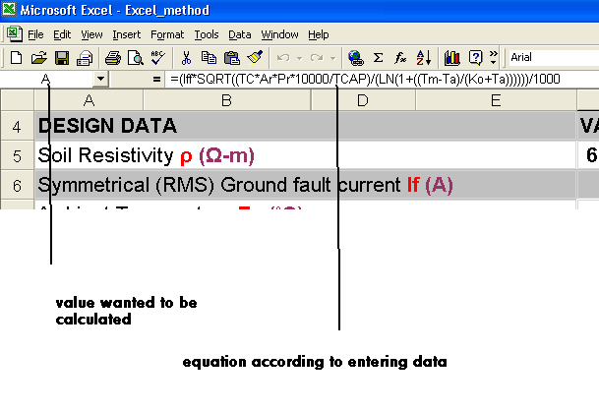
Figure 5: Procedure of calculation

So the output data will be

CALCULATED DATA |  | VALUES
Conductor size A (mm²) | Calculated | 142.112046
The next higher standard value is (mm²) | Standard | 240
Corrective weighting factor Kh |  | 1.22474487
Diameter of conductor d (m) |  | 0.01747726
Surface layer resistivity Derating factor Cs |  | 0.69032626
Effective number of parallel conductors n |  | 8
Corrective weighting factor Kii |  | 1
Tolerable touch voltage Etouch (V) |  | 673.661063
Estep (V) |  | 2202.49793
Total Length of grid conductor Lc (m) |  | 1416.53333
Total number of ground rods TGR |  | 78
Total Length of ground rods LR (m) |  | 195
Total Buried length of conductors LT (m) |  | 1611.53333
Effective buried length Lm (m) |  | 1723.85022
Ground Resistance Rg (Ω) |  | 0.03852044
Maximum grid current IG (A) |  | 28000
Ground Potential Rise GPR (V) |  | 1078.57236
Spacing Factor for Mesh Voltage Km |  | 0.95521894
Ko (˚C) |  | 234.452926
Peripheral Length of Grid Lp (m) |  | 332
Corrective factor for grid geometry Ki |  | 1.828
Mesh Voltage Em (V) |  | 183.98867
Effective buried conductor length Ls (m) |  | 1228.15
Step voltage spacing factor Ks |  | 0.35959036
Step voltage Es (V) |  | 97.2174693
Table 10: output

5. After that we compare it with limits as shown below

RESULT:
 |  | exact |  |  |  | Approx.
Em (v) |  | 183.9886702 |  |  |  | 184 |  |  | < | Etouch (v) |  |  | 673.6611 |  |  |  | ACCEPTED
Es (v) |  | 97.21746931 |  |  |  | 97.22 |  |  | < | Estep (v) |  |  | 2202.498 |  |  |  | ACCEPTED |  |  |  |  | DESIGN ACCEPTED
Rg (ohm) |  | 0.038520442 |  |  |  | 0.039 |  |  | < | Rmax (ohm) |  |  | 1 |  |  |  | ACCEPTED
Table 11: Result

Conclusion:
In this project Substation Grounding Design and Performance is been done with case study. The Design is according to SEC and IEEE standards. Constants values and procedure of design are taken form SEC. New program is been used in this project conserve time for design. Excel program is been used in SEC designation that is used here. Design calculations are estimated form constants.

6. References: -

- “IEEE guide for safety in AC Substation Grounding”, ANSI/IEEE Std.80, 1986.
- Haldev Thapar, Victor Gerex, and Vijay Singh. “Ret active Ground Resistance of the human Feet in High Voltage Switchyards”. January 1993
- WWW.ERICO.COM. “Grounding Resistance or impedance”. 2001
- J.E.T. Villas, J.A.A. Case Grande, D. Mukhedkar, and Vasco S. da Costa.”The Grounding Grid Design of the Baeea Do peixe Substation using a Two Layer Soil Model”. October 1988.
- J.E.T. Villas, F.C. Maia, D. Mukhedkar, and Vasco. Da Costa. “Computation of Electric Field Using Ground Grid Performance Equations “. 1986.
- IEEE Std 80-2000
- PJM TSDS Technical Requirements. “Substation Bus Configuration and Substation Design Requirements”. 20-05-2002.
- G.YU, J. MA, and F.P. Dawaalibi. “Computation of Return Current through Neutral Wires in Grounding System Analysis”.
- SEC-ERB ENGINEERING STANDARD, SES-P-119.10

