CHAPTER 3
LEAKAGE CURRENTS

3.1 leakage currents on polluted high voltage insulators
Measurements of leakage currents under real field conditions are presented and the various parameters o the phenomenon are investigated. The measurements were performed on the Greek island of Crete’s power distribution system. The Cretan island power network suffers considerable marine pollution, as it is mainly constructed near the coast and is exposed to constant, prevailing north winds causing dust deposits. An online recording system has been installed on the insulators of the 150 kV network in order to monitor the leakage currents on the polluted insulators. Based on the measurements, physical interpretations are attempted.

The measuring system set-up
The measuring arrangement is shown schematically in figure 1. A metal strap is placed around the insulator near its grounded end. A leakage current sensor is installed on the grounded support of the insulator as close as possible to the grounded end of the insulator. The sensor (figure 2) is a high accuracy Hall effect current transducer. One end of the sensor’s input is connected to the strap while the other end is earthed. Any leakage current flowing on the surface of the insulator will, therefore, be shunted through the sensor to the ground. The sensor works on the principle of magnetic compensation. The use of the Hall effect sensor ensures galvanic isolation of 6 kV between the current input and the output of the sensor. The input impedance of the sensor is negligible.

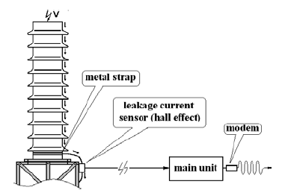
Figure 3.1 The measuring system.
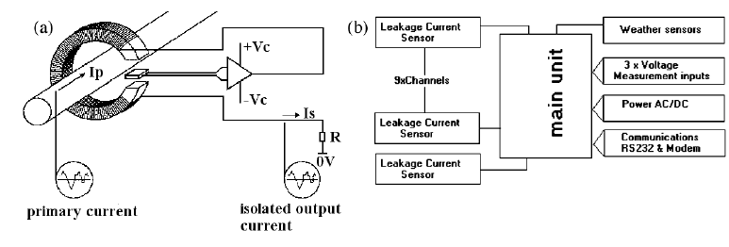
Figure 3.2 (a) Simplified diagram of the Hall effect current transducer (sensor). (b) Schematic diagram of the recording system. Leakage current and meteorological parameters are recorded.

The output of the sensor is directed to the main unit of the recorder. This unit incorporates an analogue-to-digital (A/D) converter and a microprocessor data acquisition system, specially designed to record the leakage current activity on nine different insulators.
The unit is also equipped with 3 voltage inputs in order to record the three phase to ground voltages through appropriate voltage transformers, 160 kV to 120 KV. Since meteorological conditions, such as humidity, temperature, etc play a role in the development of the phenomenon; the recording system is additionally equipped with weather sensors for recording humidity, temperature, wind-speed and rainfall.
Results
Figure 3 presents a snapshot of the leakage current waveforms in a 140 ms time window. The value of the leakage current i (t) (mA) and the corresponding phase to neutral voltage v(t) (kV) are indicated on the left and right axes respectively. It is noted that pulses (both positive and negative) of variable amplitude that appear at a random time represent the leakage current, and the constant amplitude sine waveforms represent the corresponding voltage. The measurements were performed on 29 May 2000 at 6:03:45 am under the following conditions: temperature = 23 .C, pollution = 0.1 mg cm-2, relative humidity = 80% and wind speed = 0.1 m s-1.

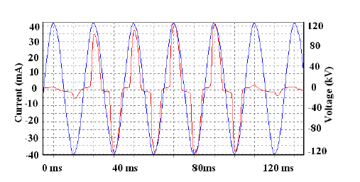
Figure 3.3 Leakage current pulses and the corresponding voltage
waveforms, of an insulator (which supports a bus bar), installed in a
150 kV substations.

Figure 3.4(a) provides a magnification of figure 3 showing a single 50 Hz period, where the leakage current waveform is clearly indicated. Figure 3.4(b) presents a time-averaged plot extracted by eliminating time fromi (t) and v(t) measurements presented in figure 3.4(a).

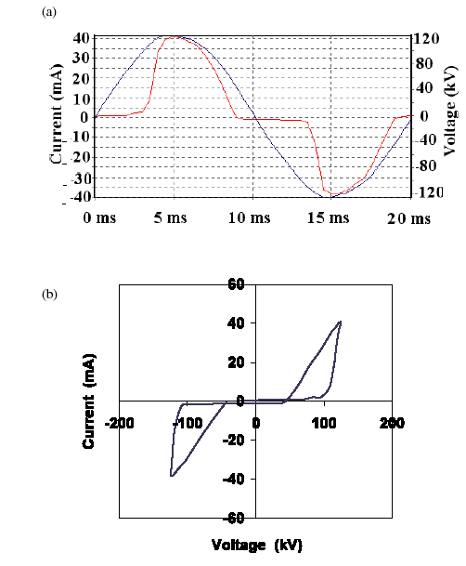
Figure 3.4 (a) Typical waveforms of the leakage current and the
voltage during a single 50 Hz period.
(b) Time-averaged plot

Additional measurements for comparison are presented in figures 3.5, showing leakage current waveforms in 120 ms time windows. The measurements were recorded in different timeframes under different conditions as follows.

(i) Figure 3.5(a): 01 April 2001, 11:27:04 pm, temperature = 18 .C, pollution = 0.07 mg cm-2, relative humidity = 76%, and wind speed = 0.3 m s-1.

(ii) Figure 3.5(b): 03 May 2000, 10:15:40 pm, temperature = 19 .C, pollution = 0.16 mg cm-2, relative humidity = 85%, and wind speed = 0.2 m s-1.

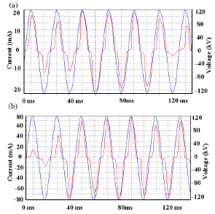
Figure 3.5 Leakage current pulses and the corresponding voltage waveforms of a post insulator installed in a 150 kV substation.

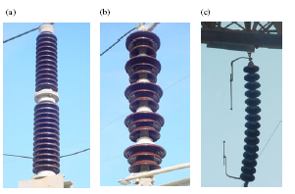
Figure 3.6 the different insulator types under test.

The study of leakage currents on insulators suffering pollution under real physical conditions can give reliable data with which to work. Such experimental results show evidence that the leakage current on common porcelain insulators exhibits non-linear behavior. Current transport was studied by exploring time-averaged i–v plots. From the results presented and the above discussion it is clear that significant, wide leakage current pulses appear well after the voltage has reached a considerable level. These show remarkable similarity and repeatability in their main characteristics. Current pulse annihilation comes at a voltage level lower than that required for conduction initiation. The argument proposed, that ionization processes and avalanche mechanisms are responsible for the phenomena, appears to be valid. Disability action initiating leakage current hysteresis effects was also detected via the i–v characteristics plotted. These phenomena can be attributed to the conductivity fluctuations caused by the varying non uniform electric field on the polluted insulators.

3.2 Leakage Current Characteristics Caused by Contaminated Distribution Insulators
Contamination-caused insulator breakdown is a leading cause of fair weather failures in distribution systems. Research on transmission insulators found that most contamination related outages occur during clear, calm weather conditions, late at night or early in the morning. Since the wetting and contamination mechanisms at the distribution level are the same, similar trends in outages are expected. Failures are initiated as leakage current flowing over a wet contaminated surface . The pollution region is composed of both airborne contaminants (salt, dust, etc.) and moisture. Wind is the mechanism by which contaminants are deposited on the insulator surface. Contamination levels can continue to grow over time unless abated by natural cleaning mechanisms, like rain or heavy dew.

Sea spray and condensation are the two main mechanisms by which insulators can become wet during clear weather conditions. Water condenses on the insulator when the insulator surface cools below the dew point temperature. This behavior is most likely to occur late at night or early in the morning. The combination of contamination and moisture creates a polluted surface on which leakage currents can self extinguish, continue sporadically or become destructive high-current flashovers.

A test setup was developed which permits various degrees of polluted insulators to be studied in the field by using a fog chamber. The fog chamber allows natural atmospheric conditions to be replicated. In particular, condensation resulting from the cooling of an insulator’s surface below the dew point temperature can be simulated.

Experimental Setup

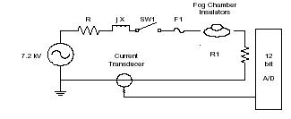
Fig. 3.7 Circuit Model of Experimental Setup

The experiments were performed at Texas A&M University's Downed Conductor Test Facility. A feeder from the local utility’s 12.5 kV multi-grounded wye distribution system serves this facility. The feeder serves approximately two megawatts of residential, light commercial and oil field load. The test facility is approximately 3.2 electrical kilometers from the substation and the available bolted single phase fault current is approximately 2200 A. The experiment was performed on an unloaded single-phase lateral tapped off the distribution feeder.

Fig. 1 is the circuit model for the experiment. SW1 is a switch that is used to energize the system. When closed it provides 7.2 kV RMS to the insulators being tested. R and jX represent the resistance and reactance of the distribution line feeding the circuit. These components can be neglected because the circuit's other impedance, R1, has a much larger magnitude. The pin of each insulator is connected in series and tied to R1, a 500 W current-limiting resistance. In the event of a flashover, it will limit the fault current to 14.4 amps. This protects the recording equipment from damaging high current faults. It should be noted that when very small currents flow, the effect on the voltage appearing across the insulators is negligible. For example, if 250 mA of current flows, the voltage is only reduced from 7200 V to 7200 - 500(.250) = 7075 V, or a 1.7% reduction.

Protection is also provided for the resistors by F1, a type 2T fuse. It offers protection to the resistors by limiting the duration of flashover current. Flashover current with a magnitude of 14.4 amps will cause the fuse to operate in approximately one second. This offers ample protection for R1 against the heat being generated during a flashover. The next component in the circuit model is the current transducer. Its function is to convert the leakage current flowing across the polluted insulators into a voltage signal for recording purposes. The current transducer has a frequency range of 5 Hz to 15 MHz, and a 0.1 V/A per turn gain. During these experiments four turns were placed through the current transducer, giving an effective gain of 0.4 V/A.

Data Acquisition
A 12-bit data acquisition system is used to digitally record leakage current signals at a rate of 3840 Hz which corresponds to 64 samples per 60 Hz cycle. Amplification is performed prior to A/D conversion in order to scale signals to gain optimal resolution by using the full range of the A/D converter. Large gains improve the time-domain resolution of small signals but will saturate the A/D converter with large signals. Small gains improve the resolution of large signals but cause small signals to have poor resolution. As stated in the Experimental Setup, surface contamination and salinity are varied, causing the leakage current to have a large dynamic range.

3.3 Calculation Of Specific Creepage Path:

Typical creepage values for either cap and pin insulator string or post insulators at 132 KV under heavy pollution, classification IV, would be determined as follow:

Nominal voltage 132 KV rms
Rated voltage 145 KV rms
Maximum rated voltage phase to phase
Creepage
Test creepage distance 145 KV * 31 mm/KV = 4495 mm

Table 3.1 guided for selection of insulators creepage distance to suit polluted condition
Pollution level | Minimum nominal specific creepage distance ( mm/ KV)
Light | 16
Medium | 20
Heavy | 25
Very | 31

Formation manufacture details:

Typical substation insulator 80 KN minimum failing load
Creepage 330 mm
Spacing distance 127 mm

Number of insulators required to provide 4495 mm creepage using cap and pin porcelain string insulators = 4495/ 330 = 13.6. therefore the minimum total number of insulators per string would be 14. in this case failure of one unit would reduce the creepage distance to 4165 mm, equivalent to an effective value of 28.7 mm/KV @ 145 KV rated voltage. However, at the nominal system voltage of 132 KV the design value is maintained at 13.5mm/KV.Minimum length of suspension insulator string = 14 * 127 = 1778 mm.
Alternatively, 15 insulators per string could be specified in order to maintain the recommended creepage distance at 145 KV-rated voltage under a one insulator shed failure condition. This allows full overhead line operation between normal line maintenance outage at the expense of increased overall string length of 1905 mm.

3.4 Current Leakage Measurement (Device)
Electrical Safety compact instrument suitable for leakage current measurement, for Typical and functional test according to Low Voltage Directive.

• MODELS up to 500VA (LK500MN) or up to 2000VA (LK2000MN);
• INCLUDED “MD” CIRCUIT according to:
- EN60335-1,
- EN60950,
- EN60601-1;
• INSULATION TRANSFORMER
INCLUDED;
• measurement of the Leakage current toward Ground, cover and Patient, with 1st fail test,.....

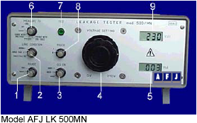
Figure 3.8

Front Panel Description:
1. Measuring range switch: 1mA, 10mA;
2. 1st FAIL test condition selector;
3. leakage current measuring filter selector;
4. EUT supply voltage rotary knob;
5. measured leakage current display;
6. leakage current path selector;
7. 100mA fuse test push button;
8. “A” or “B” phase selector;
9. EUT supply voltage display.

The REAR PANEL carries:
• EUT connection plugs ( Schuko ): Phase A, Phase B, Ground;
• EUT connection plugs ( Banana ): Phase A, Phase B, Ground;
• standard power chord plug;
• slow blow general protection fuse;
• fast blow leakage current protection fuse.

TECHNICAL DATA
EUT power supply section
Test voltage: 0 ÷ 270 Vac, 50Hz by set by manual internal variac
Power rating mod. LK2000 External 2700VA Insulation transformer
Test voltage readout: 3 digit LCD display, 1V resolution
Measurement: True RMS
Voltage readout accuracy: ±(1% + 2digit ) (**)
Max Load current: 1.9Aac, mod. LK500
10Aac, mod LK2000

Leakage current section:
Ranges: 1mA, f.s. 1.999 mA ( True RMS )
10mA, f.s. 19.99 mA (True RMS )
Readout: 3 ½ digit LCD display
Voltage readout accuracy (50 Hz): ±(1% + 3digit ) for measurement > 30µA
EUT connection EUT Power supply: Schuko Plug and Laboratory sockets
Chassis, Patient: Laboratory sockets

Self test: Measuring circuit check push button

Measuring circuit protection: 100mA Quick fuse

EUT Protection: 2.5Aac fuse, mod LK500
16Aac magneto-thermal switch

PHYSICAL DATA
