INTRODUCTIN

Circuit breakers are switching devices which according to the American National Standards Association (ANSI) C37.100 [1] are defined as:" A mechanical device capable of making, carrying for a specific time and breaking currents under specified abnormal circuit conditions such as those of short circuit." Circuit breakers have been developed for the protection of electrical circuits and small-sized electrical equipment and provide excellent protection against overloads and short-circuit.
High voltage circuit breakers (including breakers rated at intermediate voltage) are used for service on circuits with voltage ratings higher than 600 volts. Standard voltage ratings for these circuit breakers are from 4,160 to 765,000 volts and three-phase interrupting ratings of 50,000 to 50,000,000 kVA.
In the early stages of electrical system development, the major portion of high-voltage circuit breakers was oil circuit breakers. However, magnetic and compressed-air type air circuit breakers have been developed and are in use today. The magnetic air circuit breaker is rated up to 750,000 kVA at 13,800 volts. This type of circuit breaker interrupts in air between two separable contacts with the aid of magnetic blowout coils. As the current-carrying contacts separate during a fault condition, the arc is drawn out horizontally and transferred to a set of arcing contacts. Simultaneously, the blowout coil provides a magnetic field to draw the arc upward into the arc chutes. The arc, aided by the blowout coil magnetic field and thermal effects, accelerates upward into the arc chute, where it is elongated and divided into many small segments. The construction of this type of circuit breaker is similar to that of a large air circuit breaker used for low-voltage applications, except that they are all electrically operated. Compressed-air circuit breakers, or air-blast circuit breakers, depend on a stream of compressed air directed toward the separable contacts of the breaker to interrupt the arc formed when the breaker is opened. Air-blast circuit breakers have recently been developed for use in extra high-voltage applications with standard ratings up to 765,000 volts. Oil circuit breakers (OCBs) are circuit breakers that have their contacts immersed in oil. Current interruption takes place in oil which cools the arc developed and thereby quenches the arc. The poles of small oil circuit breakers can be placed in one oil tank; however, the large high-voltage circuit breakers have each pole in a separate oil tank. The oil tanks in oil circuit breakers are normally sealed. The electrical connections between the contacts and external circuits are made through porcelain bushings.
As the operating voltage and the short circuit capacities of the power systems have continued to increase, high power circuit breakers have evolved trying to keep pace with the growth of the electric power systems. To achieve current interruption some of the early circuit breaker designs simply relied on stretching the arc across a pair of contacts in air. Later, arc chute structures, including some with magnetic blow-out coils were incorporated, while other devices used a liquid medium, including water but more generally oil as the interrupting medium.

- CIRCUIT BREAKER BEHAVIOR

The performance of protection, distribution and storage devices significantly affects both the reliability and safety of the DC power system. Voltage excursions caused by an over-current instance can cause electronic equipment to malfunction due to over-voltage, and disrupt service due to under-voltage. Poor discrimination between protection devices can cause upstream device operation, resulting in major interruption to service. The rapid advancement of both computing power and analogue circuit simulation programs derived from SPICE software provides a relatively user-friendly environment for over-current protection design and analysis. This is advantageous as telecommunications power distribution systems are often large and complex, and developing an equivalent circuit model for a power system is not a trivial task.

- DC Circuit Breaker Designs

The circuit breaker design which will yield the shortest interruption time can be obtained by holding a constant maximum voltage across the load inductance. Since the D.C. source is usually small compared to the maximum recovery voltage, the recovery voltage is approximately the voltage across the breaker when it opens. The resulting current can be described by
i (t) = - (Vmax / L) t + Io A (1)
If the breaker voltage is held constant at maximum, the decay of current will be constant and yield the shortest interruption time. Because the current is decaying linearly an expression for a time variable resistance which would result in shortest turn off times is
R (t) = Vmax / (Io – (Vmax / L )t ) Ω (2)
And a plot of this function is shown in Figure 1 for
Io = 15A, Vmax = 200 V, and L = 5mh.

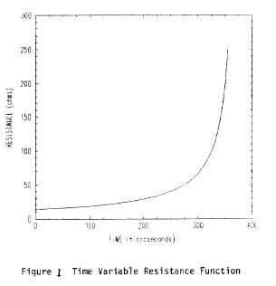

In application, since a continuous switching of an infinite number of resistors is not possible, it is desirable to know how well a set of switched resistors approximates this response. A breaker can be designed in which the recovery voltage can be adjusted by switching a second resistor into the circuit. The new value of resistance is calculated to bring the value of the dump resistor back to the optimum value on the curve in Fig.1 and is dependent on the switching time.
Calculating the optimum switching time is a four-dimensional problem where the turn off time, toff is expressed as a function of the resistor, switching time, t1, and the two resistor values, Ro and R1.
By writing expressions which identify the levels of current at each switching and taking the level of current at turn off to be 1% of the initial current, the turn off time can be expressed

toff (t1, Ro, R1) = (L / R1) [ ((R1-Ro)/L) t1 – ln (0.01) ] s (3)

The turn-off level of 1% was taken as the level of current in which enough energy had been dissipated by the breaker to allow an isolation switch to open. The complexity of equation (3) can be reduced by considering that both Ro and R1 are sized to drive current down by imposing maximum voltage across the breaker at the time they are switched in. Since the initial current is known and maximum voltage has been defined, Ro is found simply by
Ro = Vmax / Io Ω (4)

and R1 can be expressed as a function of t1, by
R1 (t1) = (Vmax / Io)*exp (( Vmax / IoL) t1) Ω (5)

With these constraints, the equation predicting the turn off time becomes a function of the switching time only and can be expressed

toff(t1)=[1-exp((Vmax/(IoL)t1)]t1–((LIo)/Vmax)[ln(0.01)]exp-((Vmax /(IoL)t1) s

Where, with the same initial conditions as Fig. 1, the minimum can be seen from the plot in Figure 2.
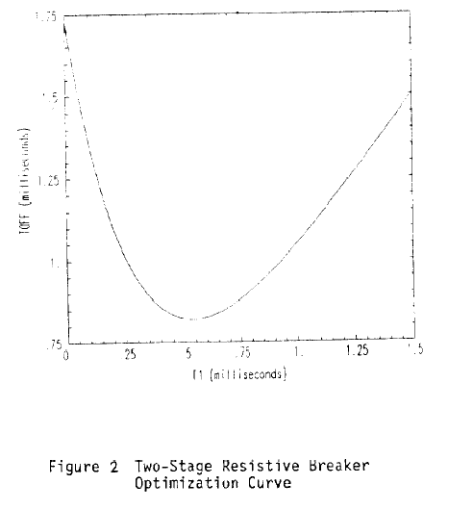

A circuit breaker configuration which combines the favorable features of the switched resistor bank and a commutation circuit is an RC design. The breaker capacitor will provide for fast commutation of load current and the switched resistor bank will allow control of the circuit breaker .voltage, primarily during the initial current interruption. The RC combination can be tuned to provide nearly ideal turn off characteristics and analysis has shown that a series, switched RC design, tuned with the load inductance to exhibit an under damped response, will yield the shortest turn off time.
The optimization of the switched RC circuit breaker is a complex numerical process. The solution chosen here involved computer simulation of various designs and choosing the design with the shortest interruption time. By simulation of possible designs, the non-optimal best RC configuration chosen was a series under-damped circuit because the recovery voltage of this circuit during current interruption is higher than in other configurations such as a parallel circuit.

- Circuit Breaker Characteristic Operation

A typical thermal-magnetic circuit-breaker operates (trips) in two distinct modes; the thermal mode occurs for device currents from 1 up to about 10-15 times the rated setting current, and the magnetic mode occurs for all current levels above the thermal operating region. Characteristic current-time curves for the device operating in the thermal region can be approximated by an equation where I n t equals a constant, whereas in the magnetic region the operating time (typically <20ms) is not well defined in device data curves and specifications, as test circuits are based on rectified AC power sources which have typical rise times exceeding a few milliseconds.
The circuit-breaker model presented in this paper has been developed for a 125A molded device (10kA fault rating), which is commonly used to protect individual battery strings within Telstra's distributed power supplies. For device operation in the thermal region, the characteristic I n t form of the current-time curve can be obtained from the device specification curve as shown in Figure 1. A value of n = 3.5 gives an adequate fit over the range of currents within the thermal operating region.
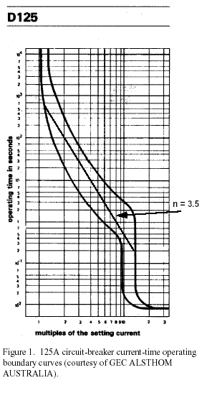

For device operation in the magnetic region, characteristic current-arc voltage-time behavior has been observed for the circuit-breakers operating in a high-current DC test facility over a range of current levels and circuit time constants. At the start of such a fault instance, the current passing through the closed circuit-breaker contacts increases to a level where magnetic activation forces the contacts to open. As the contacts start to open an arc is developed which is inherently unstable and a complex voltage-current characteristic occurs as the arc progresses through to extinction. For the 125A circuit-breaker operating in the magnetic region, the contacts are forced open when the current level typically rises above 2-4kA. Circuit-breaker operation was measured over a range of circuit conditions, such as:
- fast rates of current rise exceeding 10kA/ms, which resulted in short pre-arcing times of about 0.15- 0.2ms (e.g. results from a test circuit with 5.4kA prospective current and 0.26ms time constant are shown in Figure 2).
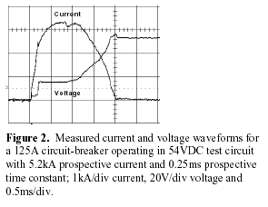
- High prospective current levels exceeding 10kA, which result in pre-arcing times around 0.9ms for circuit time constants of about 1.2ms, as shown in Figure 3. It should be noted that special oscilloscope probing and current shunt techniques are required to record clean waveforms in the high transient noise environment that occurs in a high current test facility.

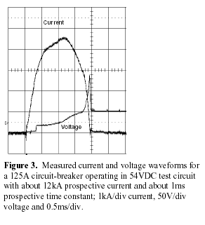

- Circuit-breaker Model

The circuit-breaker model is shown in Figure 4. Current icb through the circuit-breaker flows between I/O pins cb+ and cb-, passing through the voltage source Vsense, voltage-controlled voltage source E (arc) and voltage-controlled switch cbmod1. Vsense acts as an ideal current meter.
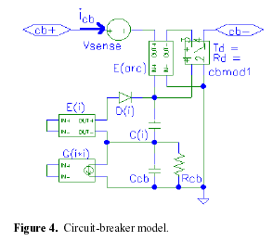

To model the thermal characteristic of the circuit breaker, the current icb measured by Vsense is passed to the current-controlled current source G(i*i), which outputs a current equal to icb raised to the power n, whenever icb exceeds the rated current ir of the circuit breaker. The change in voltage developed across Ccb is then,
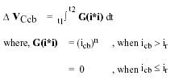
By making the capacitor Ccb value equal to the prearcing it of the circuit-breaker, in As, the voltage developed across Ccb at the end of the pre-arcing time is normalized to 1V. The thermal loss of the circuit breaker is modeled by the resistor Rcb, which discharges the voltage across Ccb.
To model the magnetic characteristic of the circuit breaker observed in Figures 2 and 3, a voltage source E(i), which is controlled by the current icb, outputs a voltage that linearly increases from 0 when the current level exceeds im1, rising to a maximum of 1V when the current level reaches im2. The diode D (i) and capacitor C (i) provide a peak hold function to allow the simulation to proceed in a latching action. The arc voltage initially generated as the contacts break, Va, is modeled by a voltage sourced from E(arc). The voltage-controlled switch cbmod1 models the DC resistance of the circuit-breaker with closed contacts Rd, the resistance increase as the arc extinguishes, and the one-way action of the opening contacts. The input to E (arc) and cbmod1 is the voltage developed across both Ccb and C (i). The switch cbmod1 is a digital subcircuit which switches off when its controlling input voltage exceeds 1V. The change in switch resistance during the off transition is controlled by a time delay factor Td and a resistance factor Rd. Three series connected resistances in cbmod1 model the circuit-breaker arc resistance increase. Model parameter values are given in Table 1, based on typical measured characteristics of a 125A circuit breaker.
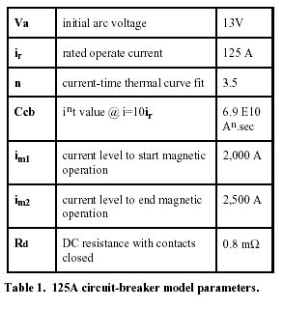
- Model Validation

Measured voltage and current waveforms of a 125A circuit-breaker operating in both a DC high-current test facility and a distributed power system rack were used to validate the model when operating in the magnetic region. Operation in the thermal region is not shown, as this mode is typically of secondary importance when investigating over-current protection in telecommunications power systems.
Figures 5 and 6 show simulated waveforms of the circuit-breaker model operating in circuits with equivalent characteristics to the test circuits used to obtain the measured waveforms shown in Figures 2 and 3 respectively.

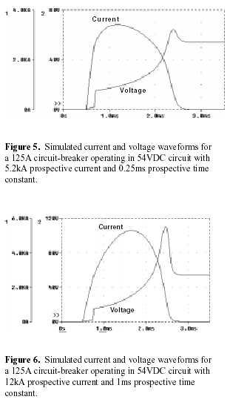

Simulated results show quite good agreement with measured results considering the complex physical arcing process that takes place during circuit-breaker operation. The major area of discrepancy is the overvoltage transient generated as the arc extinguishes. It should be noted that minor waveform variations have been observed with repeated tests under the same test conditions.
The circuit-breaker model has assisted Telstra's power system designers to analyze the operation of a 125A circuit-breaker operating in a Telstra distributed power system battery rack. The measured current waveform of a circuit-breaker interrupting a short circuit from the 48V battery string negative (active) output terminal to the rack frame is shown in Figure 7. No voltage waveforms were taken in this test. Figure 8 shows simulated waveforms of the circuit-breaker model operating in a circuit with equivalent characteristics to that used to obtain the measured waveform shown in Figure 7. Again, quite good agreement is obtained between the simulated and measured current waveform.
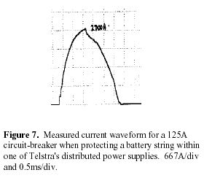
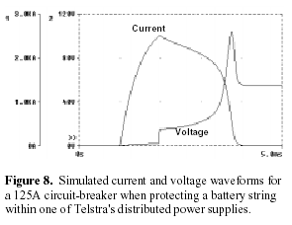

In summary, this describes a new circuit-breaker model that accurately represents circuit-breaker behavior in DC distribution systems over a wide range of over-currents. The circuit-breaker model can be coupled with other distribution component models to simulate the protection performance in telecommunications DC distribution systems.

- DC CIRCUIT BREAKER PERFORMANCE & OPERATION

The circuit breaker has been used as a combined disconnection device and over-current protection device for the DC output of rectifiers for many years. This double function provided by one component has made the circuit breaker the industry standard and many Telecom specifications require their inclusion in rectifier modules.
The advent of the modular switch mode rectifier (SMR) has created an opportunity for alternative devices, particularly because the SMRs can be disconnected from the DC bus at their connector.

- functions required by the system that can be performed by the circuit breaker

- Disconnect device for servicing - it is not safe or desirable to perform servicing operations on live equipment so the rectifier must be capable of being disconnected from the AC and DC power systems.

- No surge at plug-in or at any other time – the electrolytic capacitor on the output of each rectifier can pass a high surge current when the rectifier is first connected to the DC bus. For example a 3000uF output capacitor has an ESR of 15mohm. If this capacitor is connected in a discharged state to a 54Vdc bus, then a brief surge of 3600A can occur. This surge could upset the load by setting off under-voltage alarms, or at least make a loud ‘click’ on the telephone network. By closing the output circuit breaker only after this capacitor is charged, the surge is reduced or eliminated.

- Polarity reversal protection - if the polarity of the output of the rectifier is reversed then the system will pass a large uncontrolled current through the internal secondary diode of the rectifier. It is best to open the circuit in this circumstance with an overcurrent protection device such as a circuit breaker.

- SMR isolation from the DC bus in the event of an SMR secondary circuit failure - if an SMR suffers catastrophic failure in its output circuit then the battery and system should be protected - an overcurrent protection device is required.

- Circuit Breaker Installation and Performance

Designed to be mounted on a vertical surface, the circuit breakers should be mounted on a surface within 10° of the vertical plane. If the circuit breaker is mounted on a horizontal surface or at any angle other than the specified angle, its characteristics will be changed.
A circuit breaker must be easily accessible for the operator to actuate it and this mostly means mounting on the front panel of the SMR. Connectors for AC and DC are now more commonly mounted at the back of each SMR to allow easy module changeover. Since the correct electrical position for the circuit breaker is as near as possible to the live output terminal, cabling or bussing between the back and the front of the SMR needs to be provided, usually going both ways! This cabling creates a significant power loss (it carries full output current) and tends to block airflow in the SMR. It also acts as an antenna picking up noise as it passes across the ‘hot’ power electronics switching circuits.
The circuit breaker self-heats and should be kept cool (or de-rated accordingly), and so uses up valuable cool space. The circuit breaker should be mounted vertically in order to please the eye, which means a minimum case height of 3U (132mm) for most types. When designing for an output circuit breaker in an SMR module there is a considerable overhead of space, especially for smaller modules. The circuit in Fig 1 shows our proposal applied to the output of a rectifier.

- The Circuit Breaker in Operation

Circuit Breakers operate like a solenoid coil. The coil unit consists of an oil-filled tube with a metal core at one end and a pole piece and armature at the opposite end with a spring in between.
When a current load passes through the coil winding, it creates a magnetic field. As long as the current load is either at or below the nominal rating of the breaker, the metal core will remain stationary.
If the current load increases beyond the nominal rating, the strength of the magnetic field causes the core to move toward the pole-end of the tube. The oil viscosity regulates the core’s movement through the tube, thereby regulating the time delay. As the percentage of current load increases, the required trip time of the breaker decreases and vice versa.
When the current reaches the overload rating, the metal core will meet the pole piece at the opposite end of the tube. At this point, the armature is attracted to the same pole piece, tripping the breaker. In case of sudden short circuit, the magnetic field created will instantly trip the breaker.
In the event of a fault the circuit breaker will trip (assuming that the fault current is not excessive) and further damage to the equipment will be prevented - until the operator comes along to investigate the problem. The operator will in many instances test to see if there is a genuine fault or if the breaker has just turned off. The subsequent re-start will create more damage to the module and jeopardize the reliability of the system further. The operator may repeat this process many times before being fully satisfied!

- TYPE OF DC CIRCUIT BREAKERS

The Circuit Breakers have many types. The main classifications of the Circuit breakers are:
- Indoor type Circuit Breakers
- Outdoor type Circuit Breakers
Other classes can be the circuit breakers classified to:
- Dead tank type circuit breaker (grounded enclosure)
- Live tank type circuit breaker (ungrounded enclosure)
The main types of the High Voltage Circuit Breakers are :
- air circuit breakers
- air blast circuit breakers
- air magnetic circuit breaker

- oil circuit breakers
- Bulk oil circuit breakers
- Minimum oil circuit breakers
- SULFURHEXAFLUORIDE (SF6 ) Circuit Breakers
- Vacuum Circuit Breakers
Some types of the DC Circuit Breakers in details:
T-1 Series Circuit Breakers SftMt 25 Amp ~ 150 Amp
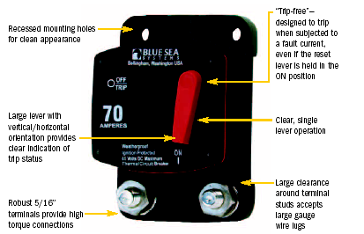
5000 Ampere interrupt capacity meets primary circuit protection requirements for large DC systems.

- Vapor Proof (conforming to SAE J1171)—safe for installation aboard gas-powered boats
- Weatherproof
- Combines switching and circuit breaker functions into one unit
- “Trip Free”—designed to trip when subjected to a fault current, even if the reset lever is held in the ON position.
Agency Specifications
- Meets SAE J553 & J1625 Circuit Breaker Standards for Surface Vehicles.
- Meets SAE J1171 Marine Circuit Breaker Standards Including External Ignition Protection
PN | Description
7120 T-1 | Circuit Breaker 25 Amp
7121 T-1 | Circuit Breaker 30 Amp
7122 T-1 | Circuit Breaker 35 Amp
7123 T-1 | Circuit Breaker 40 Amp
7124 T-1 | Circuit Breaker 50 Amp
7125 T-1 | Circuit Breaker 60 Amp
7126 T-1 | Circuit Breaker 70 Amp
7127 T-1 | Circuit Breaker 80 Amp
7128 T-1 | Circuit Breaker 90 Amp
7129 T-1 | Circuit Breaker 100 Amp
7130 T-1 | Circuit Breaker 110 Amp
7131 T-1 | Circuit Breaker 120 Amp
7132 T-1 | Circuit Breaker 135 Amp
7133 T-1 | Circuit Breaker 150 Amp
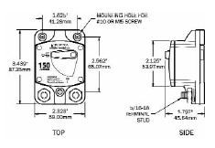
Specifications

Circuit Breaker Class Type III – Switchable /
Manual Reset – Trip Free
Type Thermally Responsive Bi-Metal Blade
Body Material Thermoset Polyester
UL Rated 94V-0, 338°F (170°C)
Amperage Range 25 to 150 Amperes
Voltage Rating 48 Volt DC Maximum
Interrupt Rating DC 5,000 Amperes @ 12 Volts
3,000 Amperes @ 24 Volts
1,500 Amperes @ 42 Volts
Weight 0.50 Lb / 0.23 Kg Panel Mount
0.58 Lb / 0.26 Kg Surface Mount

T-1 Series Circuit Breakers Panel Mount 25 Amp ~ 150 Amp
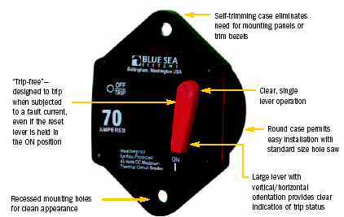

5000 Ampere interrupt capacity meets primary circuit protection requirements for large DC systems

- Vapor Proof (conforming to SAE J1171)—safe for installation aboard gas-powered boats
- Weatherproof
- Combines switching and circuit breaker functions into one unit
- “Trip Free”—designed to trip when subjected to a fault current, even if the reset lever is held in the ON position.
Agency Specifications
- Meets SAE J553 & J1625 Circuit Breaker Standards for Surface Vehicles.
- Meets SAE J1171 Marine Circuit Breaker Standards Including External Ignition Protection
PN | Description
7020 | T-1 Circuit Breaker 25 Amp
7021 | T-1 Circuit Breaker 30 Amp
7022 | T-1 Circuit Breaker 35 Amp
7023 | T-1 Circuit Breaker 40 Amp
7024 | T-1 Circuit Breaker 50 Amp
7025 | T-1 Circuit Breaker 60 Amp
7026 | T-1 Circuit Breaker 70 Amp
7027 | T-1 Circuit Breaker 80 Amp
7028 | T-1 Circuit Breaker 90 Amp
7029 | T-1 Circuit Breaker 100 Amp
7030 | T 1 Circuit Breaker 110 Amp
7031 | T 1 Circuit Breaker 120 Amp
7032 | T 1 Circuit Breaker 135 Amp
7033 | T 1 Circuit Breaker 150 Amp

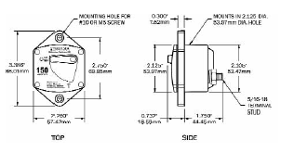
Specifications
Circuit Breaker Class Type III – Switchable /
Manual Reset – Trip Free
Type Thermally Responsive Bi-Metal Blade
Body Material Thermoset Polyester
UL Rated 94V-0, 338°F (170°C)
Amperage Range 25 to 150 Amperes
Voltage Rating 48 Volt DC Maximum
Interrupt Rating DC 5,000 Amperes @ 12 Volts
3,000 Amperes @ 24 Volts
1,500 Amperes @ 42 Volts
Weight 0.50 Lb / 0.23 Kg Panel Mount
0.58 Lb / 0.26 Kg Surface Mount

Push Button Circuit Breaker 3 Amp ~ 40 Amp
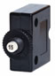
- Lowest cost circuit breaker available
- Compact design enables high density circuit protection configurations
- Can be Waterproof with optional boot
- “Trip Free”—cannot be held closed after trip

Specifications
Interrupt Capacity 1000 Amperes
Circuit Breaker Type Thermal
Body Material Phenolic
Maximum Voltage 28 Volts DC
125-250 Volts AC
Weight 0.24 Lb / 0.11 Kg

PN | Description
7050 | Circuit Breaker Push Button 3 Amp
7051 | Circuit Breaker Push Button 4 Amp
7052 | Circuit Breaker Push Button 5 Amp
7053 | Circuit Breaker Push Button 7 Amp
7054 | Circuit Breaker Push Button 10 Amp
7055 | Circuit Breaker Push Button 12 Amp
7056 | Circuit Breaker Push Button 15 Amp
7057 | Circuit Breaker Push Button 20 Amp
7058 | Circuit Breaker Push Button 25 Amp
7059 | Circuit Breaker Push Button 30 Amp
7060 | Circuit Breaker Push Button 35 Amp
7061 | Circuit Breaker Push Button 40 Amp

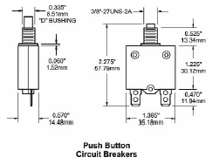

Thermal Circuit Breakers SfcMt
Boot Reset Button Clear, White, Black
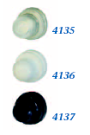

PN | Description
4135 | Boot Reset Button Clear
4136 | Boot Reset Button White
4137 | Boot Reset Button Black
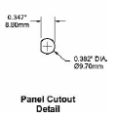

7105 Circuit Breaker, SfcMt 40 Amp ~ 150 Amp
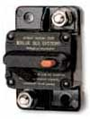
- Vapor Proof (conforming to SAE J1171)—safe for installation aboard gas-powered boats
- Waterproof
- Combines switching and circuit breaker function into one unit
- “Trip Free”—cannot be held closed after trip

Specifications

Interrupt Capacity 3000 Amperes
Circuit Breaker Type Thermal
Body Material Phenolic
Maximum Voltage 30 Volts DC
Weight 0.24 Lb / 0.11 Kg Panel Mount
0.30 Lb / 0.14 Kg Surface Mount

PN | PN
Panel | Surface
Mount | Mount | Description
7005 | 7105 | Circuit Breaker 40 Amp
7000 | 7100 | Circuit Breaker 50 Amp
7001 | 7101 | Circuit Breaker 75 Amp
7002 | 7102 | Circuit Breaker 100 Amp
7003 | 7103 | Circuit Breaker 125 Amp
7004 | 7104 | Circuit Breaker 150 Amp
7198 |  | Mounting Bezel for 700x Circuit Breakers
7199 |  | Mounting Panel for 700x Circuit Breakers

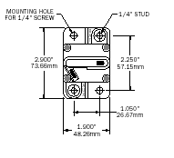

7005 Circuit Breaker, Panel Mount 40 Amp ~ 150 Amp
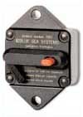
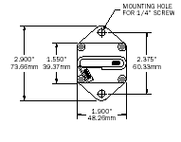
- Vapor Proof (conforming to SAE J1171)—safe for installation aboard gas-powered boats
- Waterproof
- Combines switching and circuit breaker function into one unit
- “Trip Free”—cannot be held closed after trip
Specifications
Interrupt Capacity 3000 Amperes
Circuit Breaker Type Thermal
Body Material Phenolic
Maximum Voltage 30 Volts DC
Weight 0.24 Lb / 0.11 Kg Panel Mount
0.30 Lb / 0.14 Kg Surface Mount
PN | PN
Panel | Surface
Mount | Mount | Description
7005 | 7105 | Circuit Breaker 40 Amp
7000 | 7100 | Circuit Breaker 50 Amp
7001 | 7101 | Circuit Breaker 75 Amp
7002 | 7102 | Circuit Breaker 100 Amp
7003 | 7103 | Circuit Breaker 125 Amp
7004 | 7104 | Circuit Breaker 150 Amp
7198 |  | Mounting Bezel for 700x Circuit Breakers
7199 |  | Mounting Panel for 700x Circuit Breakers

Bezel Mounting Panel
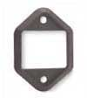

DC Magnetic Circuit Breakers
DC C-Series Single-Pole Circuit Breakers
50 to 300 Ampere range provides overcurrent protection previously only available in fuses for:
• Inverters
• Bow Thrusters • Windlasses
- Combines switching and circuit protection into a single device
- “Trip Free”—cannot be held closed after trip
- LED indicates power “ON” (in panel mounted units)

Specifications

Panel Material 0.125" Aluminum 5052 Alloy
Panel Undercoating Chemical Treatment
Mil-C-5541C or equivalent
Panel Front Coating 2-Part Polyurethane slate gray
Maximum Voltage 65 Volts DC
Rated Switch Cycles 10,000 @ rated amperage and voltage
LED Amperage 5 Milliwatts
Dimensions 5.25" / 133.40 mm high
3.75" / 95.25 mm wide

PN
Panel PN
Circuit Circuit Weight
Breaker Breaker Description Lb/Kg
7272* 7244* Panel DC 50A C-Series 1 pole 0.36/0.17
7273* 7246* Panel DC 60A C-Series 1 pole 0.36/0.17
7274* 7248* Panel DC 80A C-Series 1 pole 0.36/0.17
7259* 7250* Panel DC 100A C-Series 1 pole 0.36/0.17
7262 7267 Panel DC 150A C-Series 2 pole 0.64/0.31
7263 7268 Panel DC 175A C-Series 2 pole 0.64/0.31
7264 7269 Panel DC 200A C-Series 2 pole 0.64/0.31
7265 7270 Panel DC 250A C-Series 3 pole 0.93/0.46
7266 7271 Panel DC 300A C-Series 3 pole 0.93/0.46

*Single Pole units are AC/DC Rated

Some of the DC C-Series Single-Pole Circuit Breakers types:
7244* Circuit Breaker CA1 50 ~ 100 Amp White
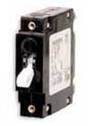

DC C-Series Double-Pole Circuit Breakers 150 ~ 200 Amp
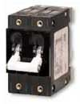

The Internal Circuits of the 1 & 2 Pole
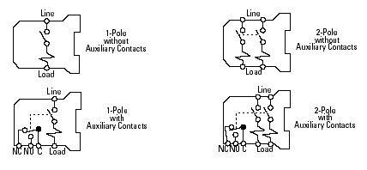
DC C-Series Triple-Pole Circuit Breakers 250 ~ 300 Amp
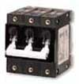

DC C-Series Panel Circuit Breakers 50 ~ 300 Amp
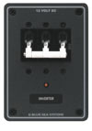

The Delay Curves of the DC Circuit Breaker
Overcurrent — Time Delay Characteristics in Seconds (at 40°C)
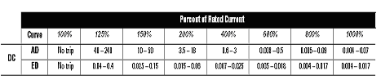
1. All values above are in seconds.
2. Data in this table is equivalent to information presented in following time delay curves.

Time Delay Curves

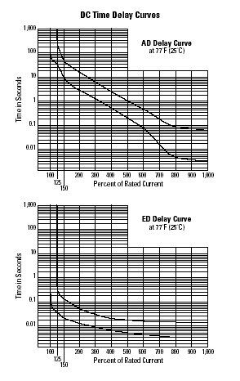

- DC PANELS

Here some of the DC Circuit Breakers Panels
8068 DC 13 Position Circuit Breaker Panel
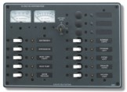

8096 DC 6 Position Circuit Breaker Panel Horizontal
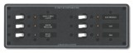
8082 DC 10 Position Circuit Breaker Panel
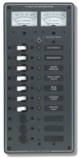
8081 DC 5 Position Circuit Breaker Panel
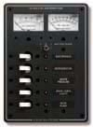
8023 DC 8 Circuit Breaker Panel
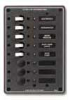

8025 DC 3 Circuit Breaker Panel
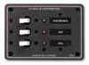
8071 Propane Gas Control System w/Solenoid Valve
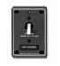
8053 6 Position Waterproof DC Electrical Distribution Panel vertical
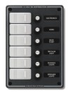
8054 3 Position Waterproof DC Electrical Distribution Panel vertical
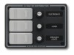
8055 Bilge pump control 12VDC panel (ON)-OFF-AUTO vertical
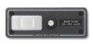
8261 8 Position Waterproof DC Electrical Distribution Panel horizontal


8262 4 Position Waterproof DC Electrical Distribution Panel horizontal

8263 Bilge pump control 12VDC panel (ON) OFF-AUTO horizontal
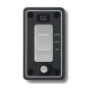

- DC Circuit Breaker Features

- Various models are available with different internal circuits, tripping characteristics, and rated currents
- 1- to 3- multi-pole
- Inertia delay
- Auxiliary contacts and alarm contacts
- The electromagnetic tripping system is not affected by ambient temperature
- Safe trip-free mechanism
- Vibration- and impact-resistant design
- When using accessories such as plug-in bases, flush plates, and colored caps, a variety of mounting styles is possible — such as DIN rail mounting, snap mounting into panel cut-outs, and color-coded arrangement on the panel

- Applications

The DC Circuit Breaker series features superior overload and short-circuit protection. Many combinations of protection mechanisms and internal circuit connections enable wide applications.

- Precision measuring instruments: electronic counters, projection instruments, oscilloscopes, industrial instrumentation, and analytic devices
- Electronic communication devices: facsimile machines, computers, recorders
- Industrial machinery: printers, elevators, cranes
- Chemical and food industry machines: vacuum devices, wrappers, centrifuges, agitators
- Machine tools: mill grinders, drills, presses
- Business machines: automatic vendors, medical equipment, beauty salon equipment, entertainment games
- Other: office equipment, air-conditioners, conveyor belts, and many more

Magnetic circuit breakers operate like a solenoid coil. The coil unit consists of an oil-filled tube with a metal core at one end and a pole piece and armature at the opposite end with a spring in between.
When a current load passes through the coil winding, it creates a magnetic field. As long as the current load is either at or below the nominal rating of the breaker, the metal core will remain stationary.
If the current load increases beyond the nominal rating, the strength of the magnetic field causes the core to move toward the pole-end of the tube. The oil viscosity regulates the core’s movement through the tube, thereby regulating the time delay. As the percentage of current load increases, the required trip time of the breaker decreases and vice versa.
When the current reaches the overload rating, the metal core will meet the pole piece at the opposite end of the tube. At this point, the armature is attracted to the same pole piece, tripping the breaker. In case of sudden short circuit, the magnetic field created will instantly trip the breaker.

- CASE OF STUDY WHERE THE DC CIRCUIT BREAKER OPERATE

The DC Circuit Breakers operate in many places. It can be in electronic counters, projection instruments, oscilloscopes, industrial instrumentation, machines, computers, medical equipment, beauty salon equipment, air-conditioners, Electric vehicles, and many more. Here the DC Circuit breakers in Electric vehicle battery packs will be studied.
Electric vehicle battery packs require DC circuit breakers for safety. These must break thousands of Amps DC at hundreds of Volts. The Sunshark solar racing car has a 140V 17Ahr battery box which needs such a breaker. A static design using 200V MOSFETs to interrupt the fault current is presented. The design specification, decisions and proposed solution circuit are given. The current sensing technique, MOSFET overvoltage protection, and DC bus capacitor recharging scheme are specific focuses. Simulation results are presented and discussed.

- The application

Electric vehicles and Hybrid electric vehicles currently rely on a series string of batteries to provide their motive power and peak power respectively. These battery strings typically have potentials between 72 and 288 Volts, and are capable of supplying hundreds of Amps for several seconds. With internal impedances in the milliOhms, fault currents can be over one thousand Amps.
Specific application was for the Sunshark solar car’s battery box. The Sunshark’s battery box is a sealed carbon fiber box containing ten series connected 12V 17Ah sealed lead acid batteries. The batteries have extremely low internal impedance (0.007 Ohm quoted) and are capable of over 1000A short circuit current. It was desired to place some form of circuit breaker protection within the battery box, since the battery box is disconnected from the car electronics regularly, leaving two shrouded but none-the-less accessible contacts.
The nominal operating current of the batteries in a solar car should actually be zero. All the power from the 1000 to 1500W of solar cells should flow directly to the motor. However, for hill climbing, overtaking, and sprints to the finish line, a peak current determined by the motor and motor controller may be drawn from the batteries. For the Sunshark, a peak continuous current rating of 50A was chosen, allowing a peak power draw of approximately 7kWwith fully charged batteries. The fully charged voltage of the string of ten lead-acid batteries would be about 140V.

- Commercial circuit breakers for DC

Most circuit breakers designed for interrupting large fault currents are designed for the 50Hz AC power network. The presence of current zero crossings greatly ease the circuit breaker’s task by naturally extinguishing the arc which forms when the contacts of the circuit breaker open under load. The inductance of the fault circuit also limits the fault current.
In a DC circuit, the circuit’s inductance in the fault condition can only limit the initial rate of rise of the fault current, but not its final value. Further more, no natural current zero crossings exist to extinguish the arc at the opening circuit breaker contacts. The current can only be driven to zero, and the circuit opened, by forcing the arc voltage to exceed the DC source voltage.
Circuit breakers and contactors specifically designed to break DC are available commercially. A number of schemes often used in combination act to increase the arc voltage. The first method is to use arc chutes, which force the arc to take a convoluted path, and also cool or quench it. In another technique, “magnetic blowout”, the arc traverses a magnetic field. This imposes a force perpendicular to the path of the arc, “blowing” it sideways, and stretching it. The third technique is to form the arc in a vacuum or hydrogen, or other atmosphere which does not favor arcing.
Kilovacs are manufacturers of specialist relays including high voltage and high current DC relays. As an example, their “Czonka II EVX” contactor is rated at 320Vdc, 400A. To operate as a circuit breaker, some extra overload detection circuitry would be required to control the contactor coil.

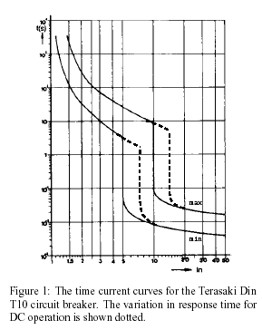

Some AC circuit breakers are rated to break DC at a considerably rated (lower) voltage. This voltage rating may be sufficient for some lower pack voltages. When multiple poles of a multipole breaker are placed in series, a higher DC rating may be allowed. A higher conduction (contact) loss will result, however this is usually small.
For example, of the 240/415Vac Din-T range of circuit breakers manufactured by Terasaki, the T6, T10 and T15 (6kA, 10kA and 15kA interruption capability) series only have a 48Vdc rating, and 110Vdc for two series connected poles. The Din-T10H range is rated for 125Vdc for two poles, and 250Vdc for four poles, which is sufficient for this application.
The thermal trip curves of the circuit breaker define the trip time as a function of the overload current (see Fig. 1). Since these are based on RMS currents, they remain the same for DC operation. At twice the rated trip current, the Din-T10 series may take anywhere between 30 and 300 seconds to trip. The Din-10H would take between 1 and 60 seconds. Since they are designed to limit thermal overloads, the trip time reduces approximately exponentially with increasing current up to the magnetic trip point.
At the magnetic trip point, the current in the breaker is sufficient to unlatch the breaker contacts, via a magnetic coil. This magnetic trip is designed to occur at 5 to 10 times the rated trip current (IEC C curve). It is rapid, taking only 10 to 100ms to trip the breaker. Since it is caused by a magnetic event, the magnetic trip current for DC current flow is 1.4 times the AC trip rating.
The delay in acting inherent in a thermal breaker’s operation is useful for protecting loads such as AC transformer and motor circuits which may draw large surge currents for a short period at turn on. For faults, the magnetic trip rapidly opens the breaker.
In a specific application such as the Sunshark, the maximum current drawn is well defined and controlled by the power electronics. Any current which exceeds this can be immediately identified as abnormal, and should cause a rapid trip of the breaker. For example, any current greater than 75A (150% of 50A) should cause an immediate trip. In a conventional breaker, this would take at least two minutes to trip, and perhaps as long as 30 minutes.
To cause a trip to occur in milliseconds rather than seconds requires a fault current of between 350 and 700 Amps for a DC circuit to activate the magnetic trip. Since the inductances are small, in the several milliseconds it takes the breaker to open, the currents can rise to extremely high values limited only by the circuit's impedances. Although undesirable, extra inductance could be introduced into the circuit to limit the rate of rise of fault current. However, either way, the energy stored in the circuit’s inductances becomes very significant, since.
The power loss in a circuit breaker is small, being 4.5W per pole at 50A. To afford protection to a 50A * 140V = 7000W power flow, a 20W (0.28%) power loss would be considered acceptable.

- Static (semiconductor) DC circuit breakers

An alternative to the mechanical circuit breaker is to use a semiconductor switch to interrupt the DC fault current. A semiconductor switch additionally has the capability of being remotely switched both on and off, in a manner similar to a contactor rather than providing just the fault protection properties of a circuit breaker. This switching cannot be considered to provide isolation in the same manner as a set of open mechanical contacts. If total galvanic isolation is required for safety reasons, a mechanical isolation switch can be installed in series with the semiconductor breaker.
It would appear advantageous to have a contactor arranged to bypass the semiconductor switch under normal operation to achieve low conduction losses. Switch sequencing would ensure that this mechanical breaker does not interrupt the current (ZVS). However, the operation time of the mechanical contactor is still measured in milliseconds. During this time the fault current will ramp quickly to many times its detection level, unless additional inductance is inserted into the circuit. In this application, the semiconductor switch alone is a better solution. At the power levels considered in this circuit, power loss is manageable. Moreover, as discussed earlier, the desired power flow in the battery pack is zero in this solarcar application. The semiconductor switch can limit current as it closes. This “precharge” phase in important for limiting the inrush current into the large filter capacitors in the vehicle’s inverters.

- PREVIOUSWORK

Two papers specifically discussing DC circuit breakers were examined. The first used a forced commutated thyristor circuit, and had a 1000V, 4000A rating. Its voltage and current ratings were much higher than the Sunshark application required. A MOS Controlled Thyristor (MCT) was used for a 300V 75A “Self protecting contactor”. The 600V device had a low voltage drop, and was easily controlled. Thyristors are not a good choice for this lower voltage work, where MOSFETs an offer lower conduction losses, especially at lower currents. At high voltages, IGBTs may be suitable.
In both these papers, the contactor or breaker was required to deal with source inductance as well as load inductance. Interrupting the current causes the voltage at the breaker output contacts to fall towards zero. The energy stored in the inductance of the load circuit can be dissipated in load by commutating it to a freewheeling diode as the output voltage attempts to go negative. Both papers take this approach, as does this design. Interrupting the source current causes the voltage across the breaker input to rise. This input overvoltage must be limited to the rating of the semiconductor switches in a static breaker. There re a number of alternatives for absorbing r dissipating this energy including RC or RCD rubbers, metal oxide arrestors (MOVs), and the series combination of MOVs and spark gaps. If the source inductance is accessible, active devices can short circuit it as the breaker opens. Another alternative is to operate semiconductor switches in their active region o provide well defined over-voltage clamping. Using these techniques, the clamping voltage is usually hosen to be between 1.5 and 2 times the DC supply voltage, which is a compromise between semiconductor breakdown voltages and the energy dissipated in the energy absorption components.
In this application, the inductance inserted on the load side of the breaker is used to set the acceptable rate of rise of fault current. The breaker is located at the source in the battery box itself) and so the source inductance can be reduced to a very low value, which greatly reduces the energy which must be dissipated. It also means that capacitors placed at the switches along with source resistance are enough to reduce the overvoltage to less than 33% of the DC supply voltage. In high voltage high current applications such as the 1000V 4000A breaker developed for the 700V track feeder circuit of a mass-rapid-transit system, thyristors with forced capacitor commutation was appropriate. A 600V 75A MCT (MOS controlled thyristor) was also chosen for its low conduction losses for a 300VDC breaker, with a parallel IGBT to both assist in commutation of the MCT and to perform active clamping. MOSFETs will offer the lowest conduction losses for the Sunshark’s battery voltage of 150V maximum. This is particularly true when the devices are operating well below their current rating for significant periods of time. Avalanche rated devices with a 200V rating were used for the brushless DC motor inverter, and it was hoped they could be used again here. As explained, it is shown that the overvoltage can be kept below this breakdown voltage. The fast turn off of MOSFETs is also advantageous, since it means the fault current can be commutated rapidly to the flyback diode. This will minimize the switch power dissipation during this period.

- BATTERY BOX BREAKER DESIGN

  - Design Specification

To assist in the understanding of the design decisions made, the following design brief is quoted here. The design specifications called for a loss of less than 2W at 10A, and 50W at the maximum rated current of 50A. The breaker should disconnect the source from the load in less than 1ms when the load current exceeds 60A. The maximum source voltage is 150Vdc. To permit battery charging, the breaker should pass current in both directions with low loss. However, the overcurrent trip function is not required to operate when the batteries are being charged, as this source can be assumed to have its own overcurrent protection, or be by nature current limited (as is the solar array). This breaker cannot provide isolation. If isolation is considered necessary, a separate mechanical isolation switch will be placed in series with the breaker. The breaker will only disconnect one terminal of the battery string that is the breaker will be single pole. This is sufficient since the breaker is internal to the sealed, insulated battery box. It would be advantageous if the breaker could also perform the function of a contactor, allowing the battery string to be disconnected electronically from the vehicle electrics. The breaker will also need to be able to be reset or reclosed after being tripped off. An extra set of “coil” contacts will need to be brought out of the sealed battery box. These should preferably be isolated from the batteries, or at least high impedance low voltage connections.
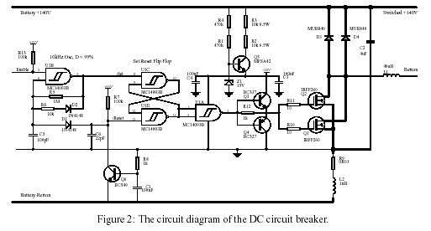

The motor drive and other power supplies have signified- cant filter capacitance on their DC input supplies. This capacitance will require recharging at a current limited rate, before the contactor can be closed. Either a separate recharging circuit or the breaker itself will need to perform this bus capacitor recharging. The breaker circuitry should draw insignificant quiescent current, since it may be left connected to the batteries for long periods. An absolute maximum power consumption of one Watt is initially proposed.

  - High current design

The circuit diagram of the DC breaker is shown in Fig. 2. To better 2W at 10A, the internal on resistance of the contactor must be less than 20m. The IRFP260 200V N-ch MOSFETs used in the motor drive (three in parallel for each switch) have an on resistance of 55m (at 25_C). Four of these in parallel would allow a small margin for a sense resistor and connection losses. The simulations and design here is shown with two of these MOSFETs. Since theMOSFETs are N-ch devices, they are placed in the negative or return path to ease their drive requirements. The flywheel diodes will usually carry no current, but under a fault condition, carry the fault current until it falls to zero. With a loop voltage drop of two volts (possible with a output short circuit) and a 40_H current limiting output inductor, it only takes 1ms for a 0A load current to fall to zero. Two MUR840 400V A fast recovery diodes are shown here. Their single alfwave sinewave pulse rating 10ms) of 100A make hem quite adequate for this duty.

  - Current sensing

Number of methods could be used to sense the load current, and detect an overcurrent condition. The accuracy f the current measurement is not particularly critical, but the speed of detection is fairly important. A mall inductor is used to limit he rate of rise of fault current. With the 40_H inductor shown, and a 150V source and a short circuit load fault, the current can rise 20A (50A to 70A) in approximately 5_s. This is considered sufficient time to sense the fault and commutate the current from the MOSFETs to the flywheel diodes.
Current transformers are immediately unsuitable since the load current is DC. Hall Effect current transducers could be used; however these have significant quiescent power consumption and do not have the required bandwidth for rapid fault detection. A resistive shunt is the simplest solution, and consumes no quiescent power. However, it does incur significant power losses at high load currents, unless the shunt is made very small, which then hinders noise free current measurement. The value chosen of 10m has a voltage drop of 700mV at the 70A, which allows a transistor to set the trip point, and detect the overcurrent.
Rather than try to completely eliminate the parasitic inductance of the sense resistor, it has been assigned a small but significant value. During periods of rapid current increase (such as during a fault condition), it increases the voltage across the sense impedance. By matching the time constant of the RL shunt impedance with an RC filter before the sensing transistor, the actual value of the current is again measured, but with better noise immunity. The RL shunt has 10m of resistance, and 100nH of inductance, and will be formed from an air-cored loop or coil of “Eureka” resistance wire.
A similar technique was suggested for current sensing for short circuit protection of IGBTs. Rather than rely only on IGBT collector voltage for collector current estimation, the voltage across the connecting wire inductance of an IGBT pack was integrated, as seen across the packs power and Kelvin emitter terminals. Sensing the voltage drop across the MOSFETs themselves is attractive. No additional shunt is required, and so conduction power loss is minimized. In the MOSFETs linear region (akin to the BJTs saturation region), the MOSFET does behave as a resistor for a constant gate source voltage. However, this on resistance Ron is not well defined from device to device, so would require calibration after construction, or whenever the MOSFETs were replaced. The on resistance is also very temperature dependent and would require temperature compensation. For the IRFP260, the on resistance doubles as the die temperature rises from 25_C to 125_C.
The final difficulty is that the current can only be sensed while the MOSFET is in its linear region. During the turn on and turn off transients, no meaningful measurement of drain current can be inferred. For these reasons, the much simpler compromise of a separate shunt resistor was chosen.

  - Control Electronics

The control electronics is based around a set-reset flip flop constructed from 4000 series CMOS schmitt input NAND gates. The reset pulse is delivered by the overcurrent sensing transistor and pulls up resistor, with a capacitor to stretch the pulse. The active low flip-flip output is inverted, and drives a pair of emitter followers which control the gate.
In this initial design, a 10 kHz oscillator delivers a regular 1_s active low set pulse. When enabled, it will continually reset the breaker should it trip and so the breaker actually operates more as a current limiter. By operating at a low frequency, the output current becomes discontinuous and the average fault current can be made small a kind of fold back current limiting. The frequency chosen allows the breaker to precharge the distributed 140V bus capacitance with an initial average current of approximately 30A (see Fig. 4). The enable for this oscillator can be taken external to the box using high impedance connections to avoid any shock hazard. However, some protection and filtering of the input would be required, but is not shown in this initial schematic. Since the flip-flip is reset dominant, an alternative method of control would be to place a single switch in parallel with the overcurrent reset transistor (the /reset node). Again since the pull-up is 100k, these connections could be high impedance and diode clamped to limit any fault current which might flow in them. A totally isolated solution could be arranged with an optocoupler, but this requires an external source of power to supply the optocoupler LED on the initial power-up. The control electronics power is supplied by a very crude series regulator (an emitter follower) with a zener diode shunt regulator as a reference. When the circuit is in its quiescent state (either off or on), the transistor won't even be biased on. In this state, the quiescent current draw is under 150μA, or about 20mW.

- SPICE SIMULATION

An estimation of the source inductance of the battery box was required to choose an appropriate snubbing capacitance. Based on a single turn circular loop of wire (admittedly only 28SWG), Ian Hickman offers the rule of thumb of 1nH per millimeter circumferential length. More formally, the inductance per meter of a two wire transmission line is
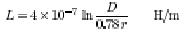
Where the separation of the conductors and τ is the conductor radius. If we estimate the path of the conductors in the battery box to be 0.5m in length, separated by 0.5m, with radius of 5mm, then the inductance L = 0.97 μH.
Using a value of 100mΩ+ 1μH for the 140V battery string impedance and a 4.4μF capacitor snubber across the MOSFETs led to a MOSFET peak voltage of 165V when breaking a 66A load current. Other simulations showed that for any value up to 20μH of source inductance and a 10μF snubber capacitor, the voltage across the MOSFETs remained below 200V. Figure 3 shows a PSpice simulation of the breaker turning on (at 2μs) into the discharged DC bus capacitance essentially a short circuit fault.
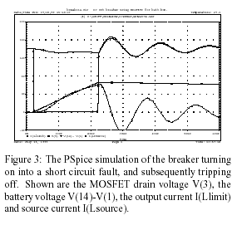

The MOSFET drain voltage falls from the battery voltage of 140V to 0V. The output current and source current rise linearly until they reach 66A. The MOSFET turns off, the battery voltage and current resonate, and the output current begins to slowly fall having commutated to the flywheel diode. By retriggering this cycle at a 10 kHz rate, a simple buck converter is formed which charges up the DC bus capacitance (see Fig. 4). The integral of the switch power dissipation over the 2mS interval shown is 28.6mJ, which suggests a combined MOSFET power dissipation of less than 15W in this current limiting mode. Most of the power dissipation occurs in due to switching rather than conduction losses, due to the relatively slow switching speeds.
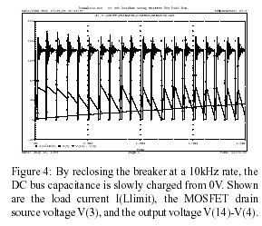

As a conclusion for this study case, Mechanical DC circuit breakers are slow to respond to small overloads, and require large fault currents to trip them quickly (which is still relatively slowly). A static DC circuit breaker using MOSFETs is presented. The MOSFET peak overvoltage is studied, and shown to be limited due to the small source inductance. A small load inductance limits the rate of rise of fault current, and rapid and accurate fault detection is achieved by the use of a separate resistive inductive shunt. By using CMOS circuitry, the quiescent power consumption is very low, 20mW. The switch conduction loss is 2W at 10A.

CONCLUSION

In summary, this project describe and analysis the High Voltage DC Circuit Breakers operation, model, performance, and types. The circuit breakers is very important to protect the from the short circuit fault. It control electrical power network by switching circuits on, by carrying load and by switching circuits off under manual or automatic supervision. They are called on to change from one condition to the other only occasionally, and to perform their special function of closing on to the other only on very rare occasions. They must , therefore, be reliable in the static situations, but be effective instantaneously when they are called on to perform any switching operation, often after long periods without movement.

