CHAPTER 1
INTRODUCTION
1.1 Introduction
The insulation of overhead transmission lines and substations is subjected to several basic types of abnormal conditions that can cause flashovers and outages of long duration. One of these types is the abnormal voltage gradients in the insulation system caused by the contamination of solid insulator surfaces. The number of insulators needed to protect against contamination is uncertain, because there is a wide range in the severity of contamination, and there is considerable uncertainty as to the basic mechanisms by which contamination affects the insulation level of a given configuration. This paper outlines the results of investigations of interfacial breakdown on electrolytic surfaces. Models are used to simulate such polluted insulator problems. Effects of chemical nature of the contaminants and contamination levels on the critical flasher voltage are studied. In order to study such effects, different salts and salt combinations were used on the laboratory model. Single-arc and multiple-arc models are introduced where the phenomena of multiple discharges existing simultaneously on an electrolytic surface is also investigated. Mathematical models are suggested which include the successive formation of multiple arcs. The results obtained based on the new model agree quite well with the experimental values. Power line insulator pollution flashover is usually preceded by the flow of appreciable leakage current. The magnitude of the leakage current depends on the accumulated pollution on the insulator material and the ambient wetting of the pollution layer on the insulator surface. The principal wetting processes are spray wetting, adsorption of moisture from ambient air and condensation. Spray wetting can occur any time of day or night while adsorption depends on the relative humidity of the air and the insulator temperature. While adsorption occurs at a constant temperature, the insulator surface must be cooler than the ambient air for condensation to occur.
1.2 Insulators

General

The type of insulator used in the 132 KV overhead transmission lines is the suspension insulators. The basic parts are the porcelain, pin, and cap as shown in figure 1.

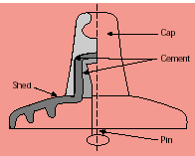
Figure 1.1

Porcelain

The porcelain encased in the cap serves to maintain the insulation between the cap and pin. It simultaneously transmits the mechanical load applied on the insulator from pin to cap. This porcelain parts is very important from both the electrical and mechanical points of view and maybe referred to as the heart of the insulator. The porcelain must be of sufficient thickness to withstand the most power full lighting stroke.

Pin
The pins are normally of hot dip galvanized forged steel, where galvanic corrosion is extreme, the porcelain surface around the pin is usually lea coated. The head is cemented to the inside of the pin hole and the mechanical load applied to the pin is transmitted from the head of the pin to porcelain and cap through the cement.
Cap
The cap encasing the porcelain head is of galvanized blackheart malleable cast iron or drop-forged steel. The mechanical load applied to the pin is transmitted from the head of the pin through the porcelain and cement and is borne by the inside of the cap’s lips.
Insulator Characteristics
The characteristics of the insulator used in the 132 KV transmission lines are shown on table 1.1
Area | Insulator type | Disc Diameter x spacing(mm) | No. of units per string | Length of string (mm)
Asir | Fog/suspension | 254*146 | 9 | 1314
Baha | Fog/suspension | 254*146 | 11 | 1606
Jizan | Aerodynamic/suspension | 330*127 | 18 | 2286
Najran | Long rod | 155*1010 | 2 | 2020
Tihama | Aerodynamic/suspension | 330*127 | 20 | 2540
Bisha | Aerodynamic/suspension | 360*127 | 16 | 2032

Number of Units
The insulator requirement of transmission lines are usually determined by lighting and switching surges rather than the normal frequency voltage. Increasing the number of insulators units under polluted atmospheric conditions should likewise be considered.

In addition to the above criteria, the increase of the number of units should also be considered under the following condition:

- To increase safety in places where it is difficult to inspect the insulators.
- In high altitude regions where flashover voltage decreased due to lower atmospheric pressure.

At the altitude of over 3300 ft (1000m) or in places with temperatures over 40⁰ C , the insulators level or flashover voltage value at normal condition shall be multiplied by the following factor:

For temperature above 40⁰ C:

Multiplying factor = (273+t)/ 313

For altitude above 3300 ft (1000 m):

Multiplying factor = 1+ 0.03(H – 3300) / 1000
The number of suspension insulator units as well as the necessary multiplying factors as applied in the 132 KV transmission lines are shown on table 2.
Table 1.2 (132 KV transmission lines(Number of units)
Area | Altitude(m) | Max No.of units | Max No. of units | Factors altitude
Asir | 2200 | 14 | 9 | 1.1175
Baha | 2400 | 11 | 11 | 1.1372
Bisha | 0-1200 | 16 | 16 | 1.0191
Jizan | 0 | 18 | 18 | -
Najran | 0-1200 | 2 | 2 | 1.0191
Tihama | 0 | 20 | 20 | -

1.3 Insulators type
Pin-type Insulators
Pin-type insulators are applied on medium voltage overhead distribution lines for fixing conductor to tower bodies. Production program process on this type of insulator group comprises Pin-type 11 kV as ANSI norms up to 13 kV maximum service voltage level, Pin-type 20 kV as ANSI norms for 24 kV maximum service voltage level, Pin-type 33 kV as ANSI norms for 36 kV maximum service voltage level. All Pin-type insulators are made of ceramic material IEC 672.
- Pin type 11 kV 2- Pin type 20 kV 3- Pin type 33 kV

Pin type Insulator - 11kV
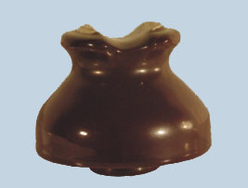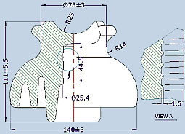
Figure 1.2

Technical Data ( Table 1.3 )
Catalogue Number |  | 0301
Nominal Creepage Distance / mm |  | 230
Low Frequency Withstand Voltage | Wet / kV | 30
Low Frequency Withstand Voltage | Dry / kV | 60
Low Frequency Flashover Voltage | Wet / kV | 40
Low Frequency Flashover Voltage | Dry / kV | 70
Low Frequency Puncture Voltage / kV |  | 95
ANSI Class |  | 55-4

Pin-type Insulator - 20 kV

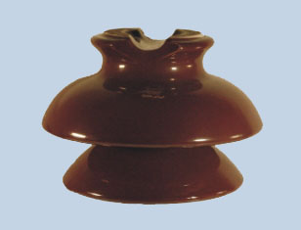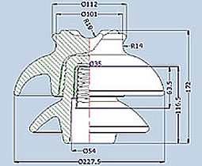
Figure 1.3
Technical Data ( Table 1.4 )
Catalogue Number |  | 0304-1
Leakage Distance / mm |  | 432
Critical Impulse Flashover | Positive / kV | 160
Critical Impulse Flashover | Negative / kV | 225
Low Frequency Flashover Voltage | Wet / kV | 70
Low Frequency Flashover Voltage | Dry / kV | 110
Low Frequency Puncture Voltage /kV |  | 145
Radio Influence Voltage Data | Test voltage to ground /kV | 22
Radio Influence Voltage Data | Max. RIV at 1000kHz /uV | 12000
Cantilever Strangth /kN |  | 13.6

Pin-type Insulator - 33 kV

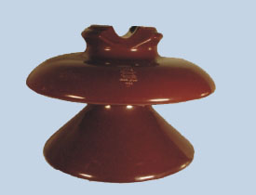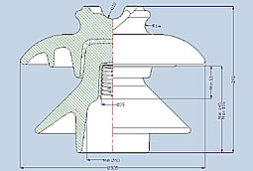
Figure 1.4

Technical Data ( Table 1.5 )
Catalogue Number |  | 0307-1
Leakage Distance / mm |  | 686
Critical Impulse Flashover / kV | Positive / kV | 225
Critical Impulse Flashover / kV | Negative/ kV | 310
Low Frequency Flashover Voltage | Wet / kV | 95
Low Frequency Flashover Voltage | Dry / kV | 140
Low Frequency Puncture Voltage / kV |  | 185
Radio Influence Voltage Data | Test voltage to ground /kV | 30
Radio Influence Voltage Data | Max. RIV at 1000KHz /uV | 16000
Mechanical Failing Load / kN |  | 13.6

Suspension Insulators
All suspension insulators are applied on medium and high voltage overhead transmission and distribution lines and are used for suspension or tension of conductor to tower bodies.
Production program in this insulator group includes: Ball & Socket coupling normal type, Ball & Socket coupling anti-fog type, and Clevis & Tongue coupling normal type.
This type of our insulator's porcelain shell passes routine test such as Thermal shock, Tension proof and Electrical flashover test as well as IEC 383 type and sample test, IEC 797 residual strength, IEC 575 thermal mechanical performance test, IEC 120 dimensions of ball & socket coupling, IEC 372 locking device for ball & socket coupling and ANSI C29.2 impact test.
Other Suspension custom-made insulators can be supplied upon customer's request and specifications.

- Standard Ball & Socket

- Anti-fog Ball & Socket

- Tongue & Clevis

Standard Suspension Insulator - Ball & Socket
Figure 1.5
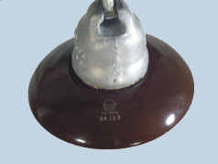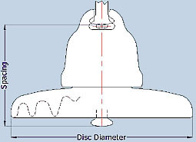
Technical Data |  | (Table 1.6 )
Catalogue Number |  |  | 0201-70 | 0201-80 | 0201-100 | 0201-120
Porcelain Disc Diameter / mm |  |  | 255 | 255 | 255 | 255
Creepage Distance / mm |  |  | 295 | 295 | 295 | 295
Minimum | Power Frequency | Dry / kV | 75 | 75 | 75 | 75
Flashover | Power Frequency | Wet / kV | 45 | 45 | 45 | 45
Voltage | 50 % Impulse | Positive / kV | 125 | 125 | 125 | 125
 | 50 % Impulse | Negative / kV | 130 | 130 | 130 | 130
Withstand | Power Frequency | Dry / kV | 70 | 70 | 70 | 70
Voltage | Power Frequency | Wet / kV | 40 | 40 | 40 | 40
 | Impulse / kV |  | 110 | 110 | 110 | 110

Anti-fog suspension Insulator - Ball & Socket
Figure 1.6
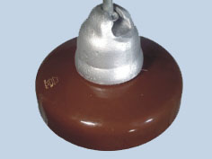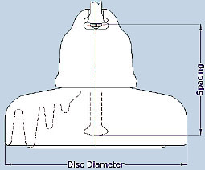
Technical Data |  | (Table 1.7)
Catalogue Number |  |  | 0206-80 | 0206-100 | 0206-120
Porcelain Disc Diameter / mm |  |  | 255 | 255 | 255
Unit Spacing / mm |  |  | 146 | 146 | 146
Creepage Distance / mm |  |  | 432 | 432 | 432
Electromechanical Failing Load / kN |  |  | 80 | 100 | 120
Average |  | Dry / kV | 100 | 100 | 100
Flashover Voltage |  | Wet / kV | 50 | 50 | 50
 | Power Frequency | Dry / kV | 80 | 80 | 80
Withstand | Power Frequency | Wet / kV | 45 | 45 | 45
Voltage | Impulse / kV | Positive / kV | 135 | 135 | 135
 | Impulse / kV | Negative / kV | 145 | 145 | 145
Ball & Socket size |  |  | 16mmA | 16mmA | 16mmA
Locking Device |  |  | R Clip | R Clip | R Clip

Standard suspension Insulator - Tongue & Clevis

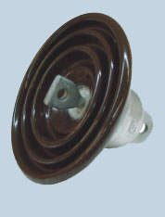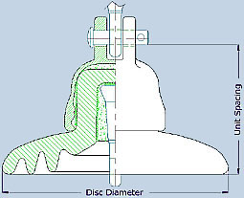
Figure 1.7

Technical Data ( Table 1.8 )

Catalogue Number |  | 0216-70 | 0216-80
Porcelain Disk Diameter / mm |  | 255 | 255
Unit Spacing / mm |  | 146 | 146
Creepage Distance / mm |  | 295 | 295
Electromechanical Failing Load / kN |  | 70 | 80
Standard Coupling According to IEC 471 |  | 16c | 16c

Glass insulator
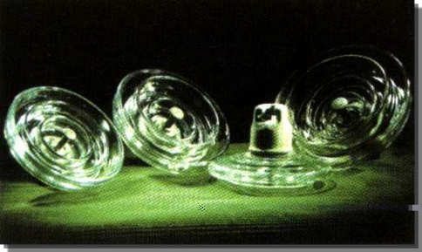
Figure 1.8

Glass Insulator are applied in HV and Extra-HV Transmission lines as dielectirc and use for suspension overhead line.

Main Character:
- Zero-spontaneous Breakage and easy inspection;
- Excellent arc-resistance and vibration-proof performance;
- Good Self-cleaning and less age;
- Large main Electric Capacitance, homogenous distribution of voltage on single string insulators.

Main Types:

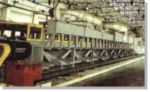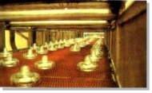
Figure 1.9

Standard Profile Toughened Glass Suspension Insulators --- Ball and Socket Type
From 70 KN, to 300 KN to meet IEC Standard
Standard Profile Toughened Glass Suspension Insulators - Ball and Socket Type

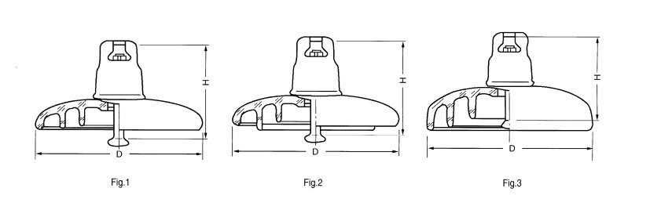
Figure 1.10

