EE417 Term Project

Performance Analysis and Simulation of 16-QAM

Consider the 16-QAM constellation diagram (left) shown in the figure
(the diagram to the right is the 4-ASK (PAM) constellation used for I /Q branches:

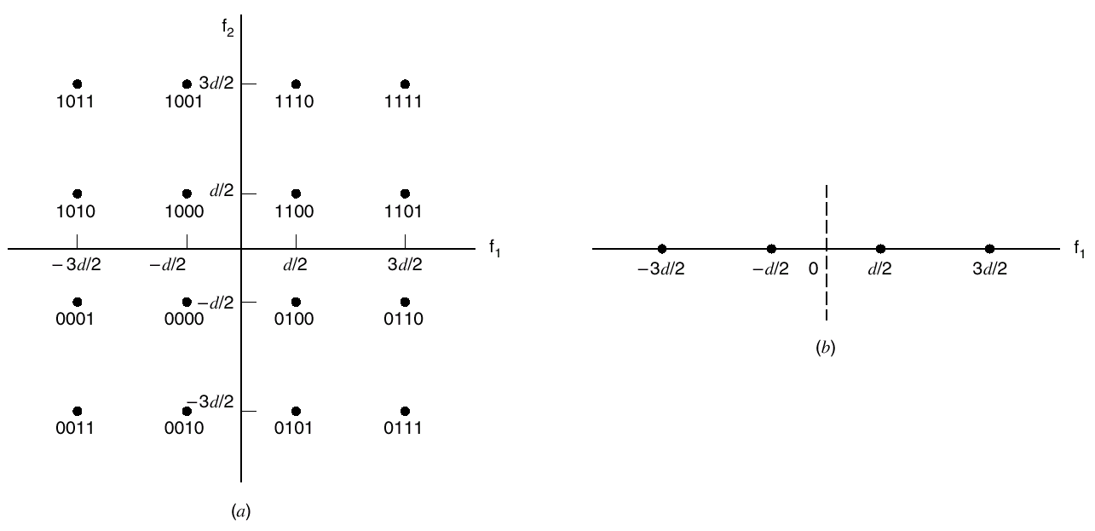

- Derive the (exact) expression of the Symbol Error Probability P_{e} in terms of the minimum distance d.

- Given the Gray mapping used for mapping bits to symbols (shown on the figure), how can you estimate the Probability of Bit Error P_{b}?

- Develop a Matlab program to simulate a 16-QAM Modulator/Demodulator.
Hint: use complex baseband representation of signals (i.e., without carrier)

- Estimate the symbol and bit error probabilities using your Matlab simulation, and compare with the theoretical results.

