KING FAHD UNIVERSITY OF PETROLEUM & MINERALS
DEPARTMENT OF ELECTRICAL ENGINEERING

EE 417: Communications Engineering II

Major Exam I

NAME

ID

Question | Score
1
2
3

TOTAL

Problem #1 (10pts)
The PSD of a Gaussian noise process N(t) is given by S_{N}(f)= rect[(f-f_{c})/2B]+ rect[(f+f_{c})/2B], (expressed in W/Hz), where f_{c} is a high frequency value and B is a constant bandwidth (<f_{c}).

- What type of noise is this? Write its in-phase/quadrature representation (using N_{I}(t) and N_{Q}(t)).
- What is the total average power contained in N(t)?
- Prove that the autocorrelation function of N(t) is R_{N}(τ)=2N_{o}B sinc(2Bτ)cos(2πf_{c}τ).
- If we take samples N(iT_{s}) at any arbitrary sampling period T_{s}, explain whether the samples will in general be correlated or uncorrelated, (and say why?).
- Find a specific sampling rate f_{s}=1/T_{s} that can make the samples N(iT_{s}) uncorrelated? In this case, are the samples also independent (why?)
Hint: use the autocorrelation function!
Problem #2 (10pts)
Consider the AM signal s(t) = A_{c}[1 + k_{a}m(t)] cos(2πf_{c}t) demodulated with envelope detection 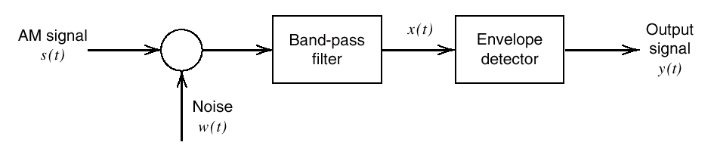
It is known that, for strong signal assumption, the output SNR is given by: , where P and W are the power and bandwidth of the message m(t), and N_{o}/2 is the noise power spectral density.

- Find SNR_{c,} and show that the receiver figure-of-merit is:
- Consider the case of tone modulation where the message m(t)=A_{m} cos(2πf_{m}t). Find the figure of merit, and express it in terms of the modulation index μ=k_{a}A_{m}.
- Find the maximum value of the figure of merit (for part b)), and compare this to the case of DSB-SC with coherent demodulation. What is your conclusion?

Problem #3 (10pts)
  - Explain how FM can allow the communication system designer to obtain a tradeoff between SNR performance and bandwidth consumption
  - Compare FM and AM/DSB with respect to the above factor, and justify your answers.

