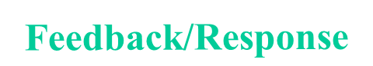
Environment
Sender Receiver
Message Channel
Encode
Decode
NOTE: Barriers can happen here as a result of “Filter of the Mind” and “Monolith of Misunderstanding.”
MODEL OF COMMUNICATION

