Instruction | 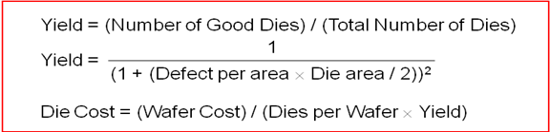  Meaning
add $s1, $s2, $s3 | $s1 = $s2 + $s3
addu $s1, $s2, $s3 | $s1 = $s2 + $s3
sub $s1, $s2, $s3 | $s1 = $s2 – $s3
subu $s1, $s2, $s3 | $s1 = $s2 – $s3
and $s1, $s2, $s3 | $s1 = $s2 & $s3
  Name | Register | Usage
  $zero | $0 | Always 0 (forced by hardware)
  $at | $1 | Reserved for assembler use
  $v0 – $v1 | $2 – $3 | Result values of a function
  $a0 – $a3 | $4 – $7 | Arguments of a function
  $t0 – $t7 | $8 – $15 | Temporary Values
  $s0 – $s7 | $16 – $23 | Saved registers (preserved across call)
  $t8 – $t9 | $24 – $25 | More temporaries
  $k0 – $k1 | $26 – $27 | Reserved for OS kernel
  $gp | $28 | Global pointer (points to global data)
  $sp | $29 | Stack pointer (points to top of stack)
  $fp | $30 | Frame pointer (points to stack frame)
  $ra | $31 | Return address (used by jal for function call)
or $s1, $s2, $s3 | $s1 = $s2 | $s3
xor $s1, $s2, $s3 | $s1 = $s2 ^ $s3
nor $s1, $s2, $s3 | $s1 = ~($s2|$s3)
sll $s1,$s2,10 | $s1 = $s2 << 10
srl $s1,$s2,10 | $s1 = $s2>>>10
sra $s1, $s2, 10 | $s1 = $s2 >> 10
sllv $s1,$s2,$s3 | $s1 = $s2 << $s3
srlv $s1,$s2,$s3 | $s1 = $s2>>>$s3
srav $s1,$s2,$s3 | $s1 = $s2 >> $s3
addi $s1, $s2, 10 | $s1 = $s2 + 10
addiu $s1, $s2, 10 | $s1 = $s2 + 10
andi $s1, $s2, 10 | $s1 = $s2 & 10
ori $s1, $s2, 10 | $s1 = $s2 | 10
xori $s1, $s2, 10 | $s1 = $s2 ^ 10
lui $s1, 10 | $s1 = 10 << 16  Instruction Formats
j label | jump to label
beq rs, rt, label | 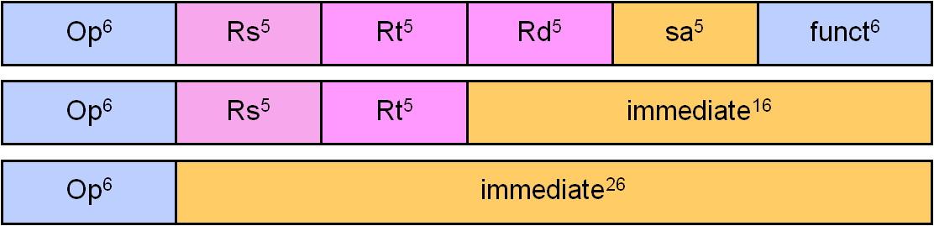  branch if (rs == rt)
bne rs, rt, label | branch if (rs != rt)
blez rs, label | branch if (rs<=0)
bgtz rs, label | branch if (rs > 0)
bltz rs, label | branch if (rs < 0)
bgez rs, label | 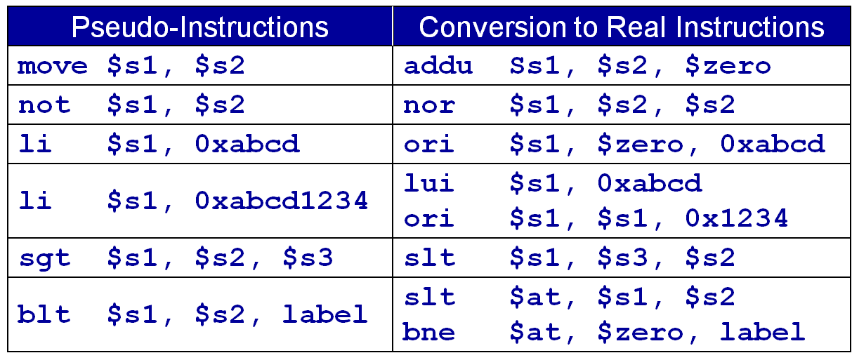  branch if (rs>=0)
slt rd, rs, rt | rd=(rs<rt?1:0)
sltu rd, rs, rt | rd=(rs<rt?1:0)
slti rt, rs, imm16 | rt=(rs<imm?1:0)
sltiu rt, rs, imm16 | rt=(rs<imm?1:0)
lb rt, imm16(rs) | rt = MEM[rs+imm16]
lh rt, imm16(rs) | rt = MEM[rs+imm16]
lw rt, imm16(rs) | rt = MEM[rs+imm16]
lbu rt, imm16(rs) | rt = MEM[rs+imm16]
lhu rt, imm16(rs) | rt = MEM[rs+imm16]
sb rt, imm16(rs) | 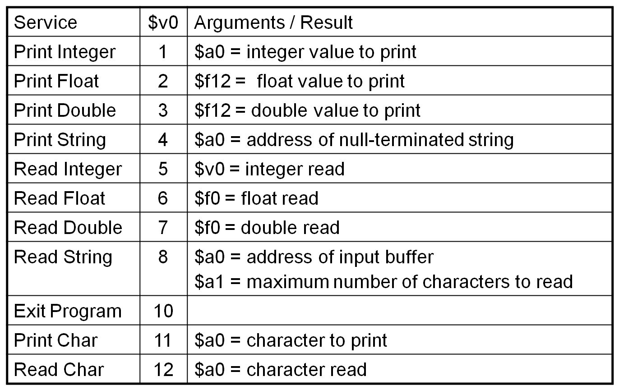  MEM[rs+imm16] = rt
sh rt, imm16(rs) | MEM[rs+imm16] = rt
sw rt, imm16(rs) | MEM[rs+imm16] = rt
jal label | $ra=PC+4, jump label
jr Rs | PC = Rs
jalr Rd, Rs | Rd=PC+4, PC=Rs
mult Rs, Rt | Hi, Lo = Rs × Rt
multu Rs, Rt | Hi, Lo = Rs × Rt
div Rs, Rt | Hi, Lo = Rs / Rt
divu Rs, Rt | Hi, Lo = Rs / Rt
mfhi Rd | Rd = Hi
mflo Rd | Rd = Lo

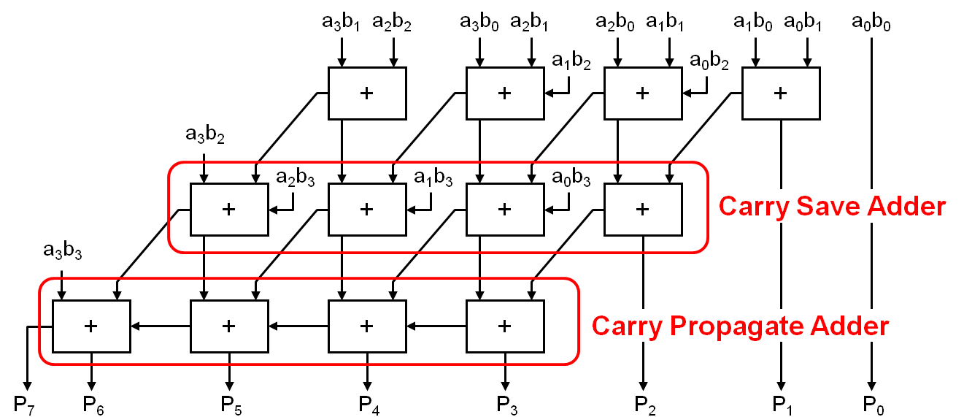
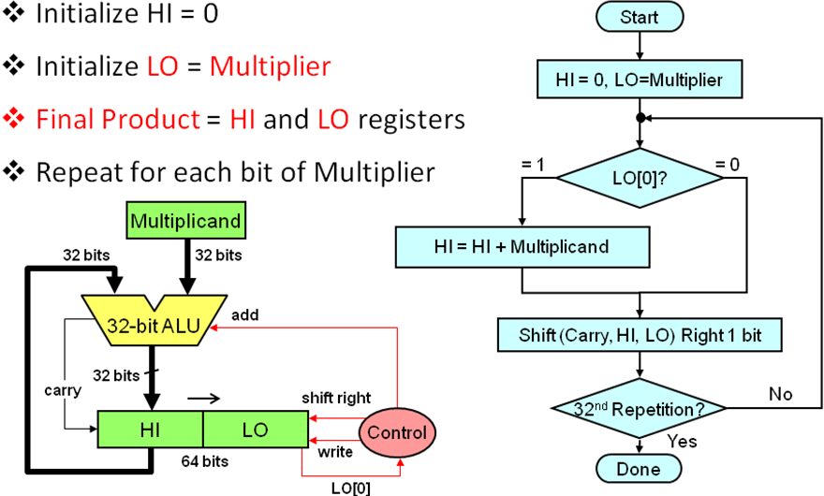
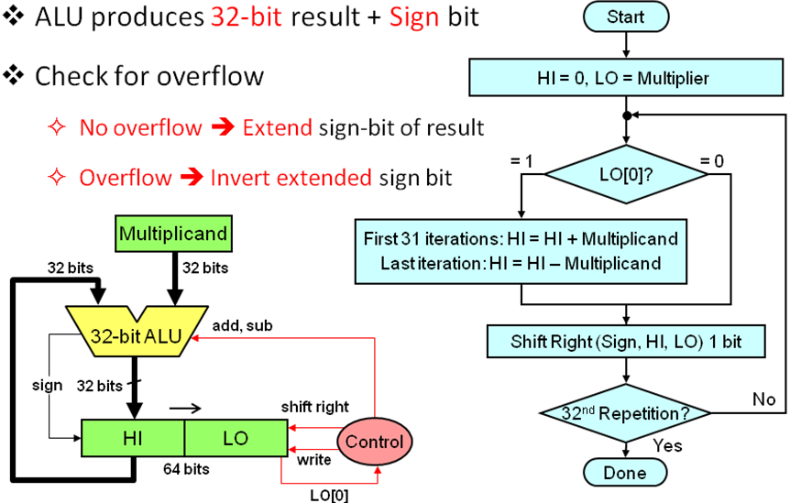
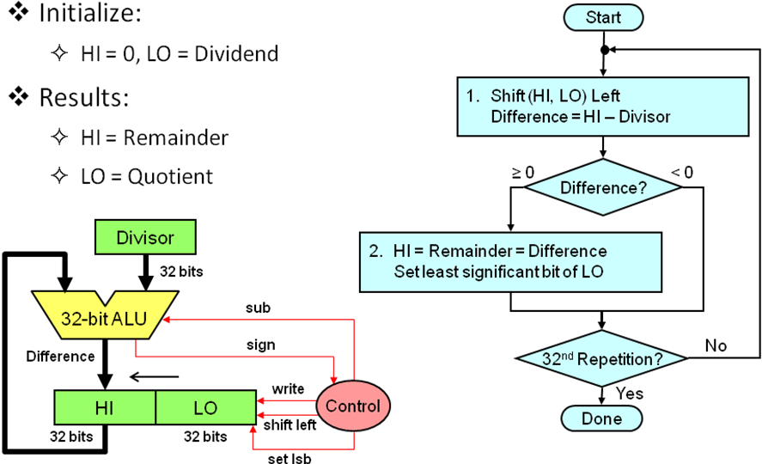
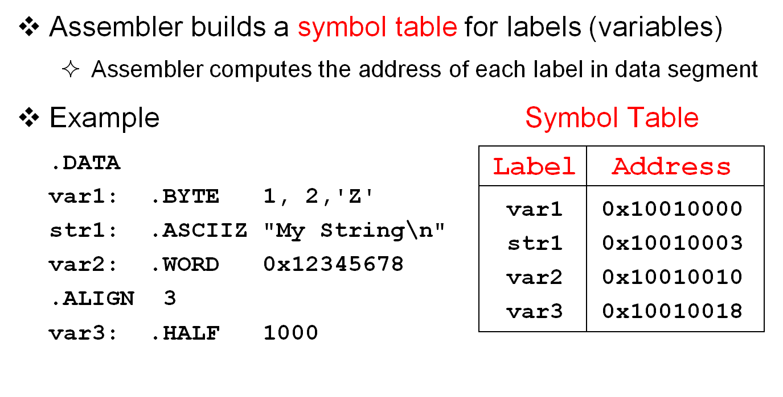
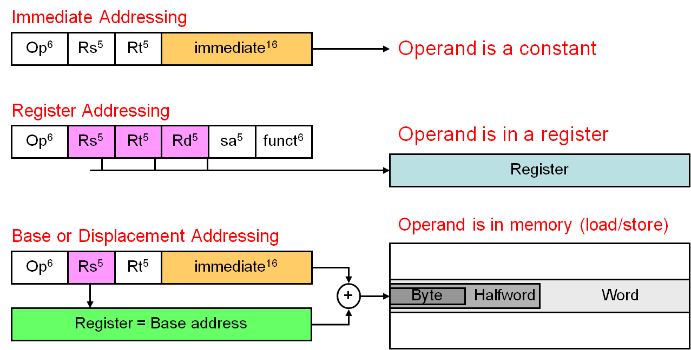
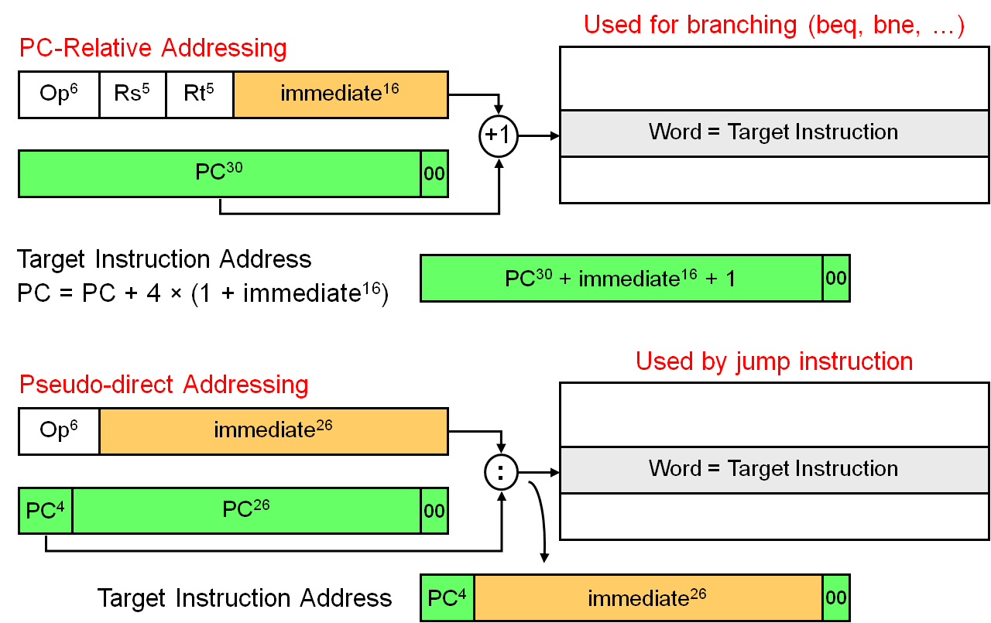
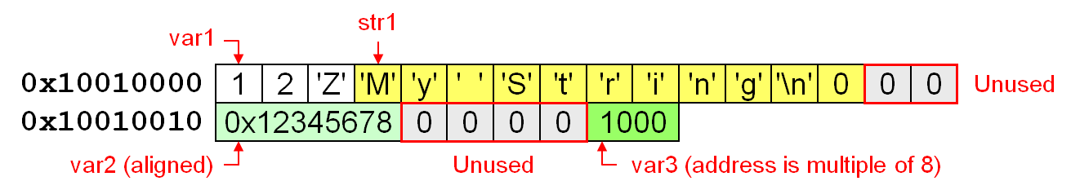
Signed Multiplication
Unsigned Multiplication
Unsigned Division
Wallace Tree Multiplier

