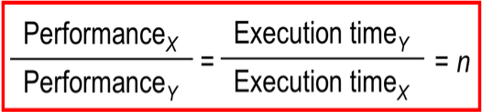
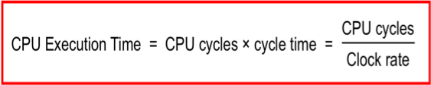
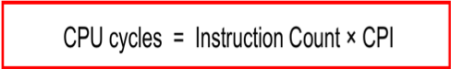
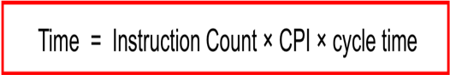
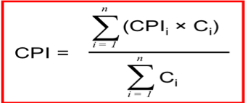
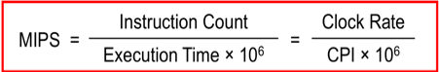
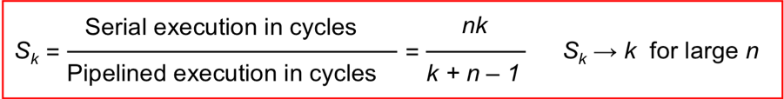
Clock cycle = 1/Clock rate; Clock rate = Cycles per second

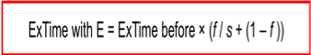
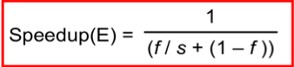

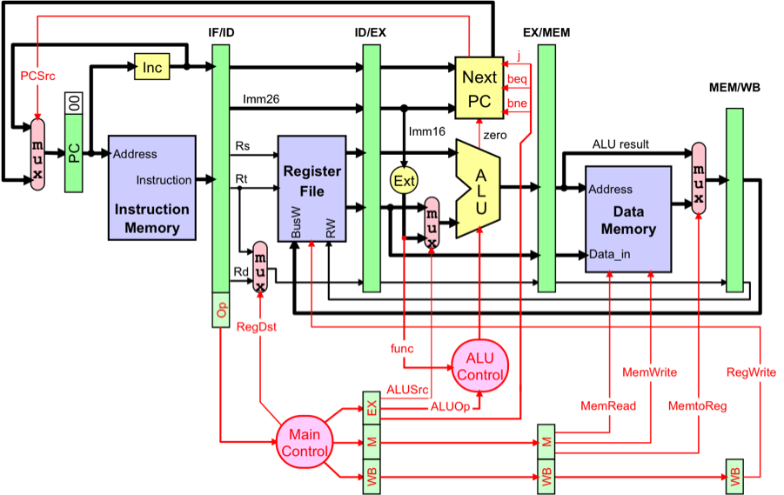

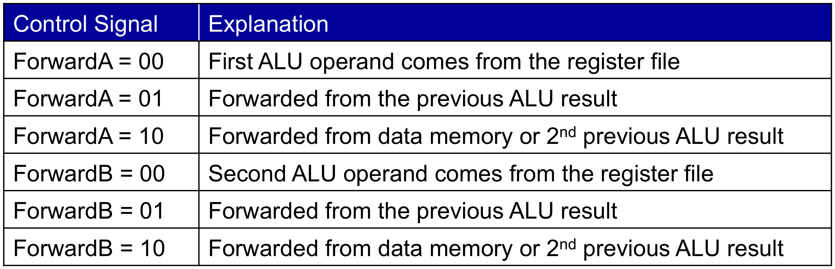

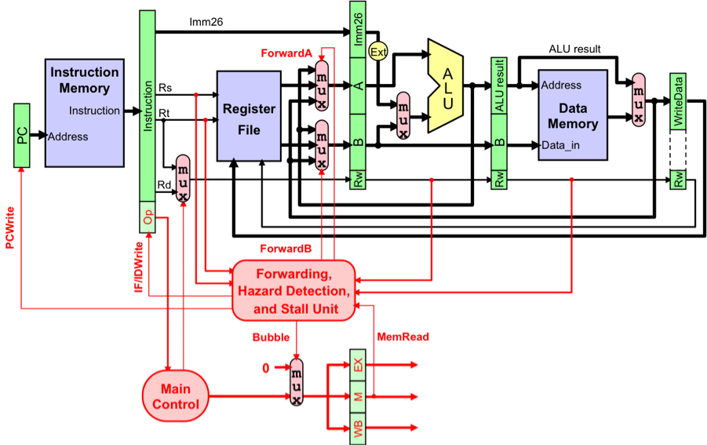
Hit Rate= Hits / (Hits + Misses)
Miss Rate= Misses / (Hits + Misses)
I-Cache Miss Rate = Miss rate in the Instruction Cache
D-Cache Miss Rate = Miss rate in the Data Cache

AMAT = Hit time + Miss rate × Miss penalty

Memory stall cycles = Combined Misses × Miss Penalty
Miss Penalty: clock cycles to process a cache miss
Combined Misses = I-Cache Misses + D-Cache Misses
I-Cache Misses = I-Count × I-Cache Miss Rate
D-Cache Misses = LS-Count × D-Cache Miss Rate
LS-Count (Load & Store) = I-Count × LS Frequency

