

**Information and Computer Science Department**

**Spring Semester 132**

**ICS 103 – Computer Programming in C**

**Midterm Exam key**

**Thursday, April 03, 2014**

**Duration: 120 minutes**

|  |  |
| --- | --- |
| **Name:** |  |

|  |  |  |  |  |  |  |  |  |  |
| --- | --- | --- | --- | --- | --- | --- | --- | --- | --- |
| **ID#:** |  |  |  |  |  |  |  |  |  |

|  |  |
| --- | --- |
| **Section#:** |  |

|  |  |
| --- | --- |
| **Instructor:** |  |

|  |  |  |
| --- | --- | --- |
| **Question #** | **Maximum**  **Grade** | **Obtained**  **Grade** |
| **1** | 4 |  |
| **2** | 12 |  |
| **3** | 36 |  |
| **4** | 15 |  |
| **5** | 10 |  |
| **6** | 8 |  |
| **7** | 15 |  |
| **Total** | **100** |  |

**Question # 1 [4 points]**

Fill in the circles with the software used in developing a high-level language program:

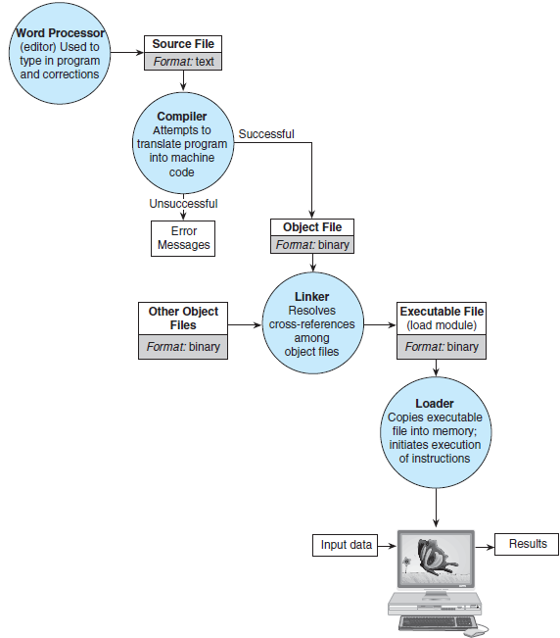

**Question # 2 [12 points]**

Apply the software development method to find the volume and surface area of a sphere given its radius.

$volume=\frac{4}{3}πr^{3}$ $surface area=4πr^{2}$, where r is the radius and π=3.14159

Note: Apply the first four steps ending with a complete C program.

**Problem**:

Find the volume and surface area of a sphere given its radius.

**Analysis**:

Problem Constant

PI 3.14159

Problem Input

double radius

Problem Output

double volume, surface_area

Relevant Formula

$volume=\frac{4}{3}πr^{3}$ $surface area=4πr^{2}$, where r is the radius and π=3.14159

**Design**:

Algorithm

1. Get the radius
2. Compute the volume
   1. Assign 4/3 * PI * radius ^ 3 to the volume
3. Compute the surface area
   1. Assign 4 * PI * radius ^ 2 to the surface area
4. Display the volume and the surface area

**Implementation**:

**/* Calculating the Volume and the Surface Area of a Sphere */**

**#include <stdio.h>**

**#define PI 3.14159**

**int main(void)**

**{**

**double radius; /* input - radius of a sphere */**

**double volume; /* output - volume */**

**double surface_area; /* output - surface area */**

**/* Get the radius */**

**printf("Enter radius> ");**

**scanf("%lf", &radius);**

**/* Calculate the volume */**

**volume = 4.0 / 3.0 * PI * radius * radius * radius;**

**/* Calculate the surface area */**

**surface_area = 4 * PI * radius * radius;**

**/* Display the volume and surface area */**

**printf("The volume is %.2f\n", volume);**

**printf("The surface_area is %.2f\n", surface_area);**

**return (0);**

**}**

**Question # 3 [36 points]**

Identify the error(s), if any, in each of the following code fragments. If a fragment has no errors, write its output. [Note: No explanation of error(s) is required].

| **Code Fragment** | **Output** |
| --- | --- |
| int x = 3;  x = x * x – x / x;  printf("%d", x); | 1 mark  8 |
| int a, b, c, x;  x = 1;  a = 77;  b = 10;  c = 11;  x = a % b;  printf("%d ", x);  x = a / b;  printf("%d ", x);  x = b % a;  printf("%d ", x);  x = b / a;  printf("%d ", x); | 4 marks  7 7 10 0 |
| double x=1234.5678;  int y=77;  printf("%.1f%d\n", x, y);  printf("%1.1f%2d\n", x, y);  printf("%4.2f%3d\n", x, y);  printf("%7.3f%4d\n", x, y);  printf("%9.3f%4d\n", x, y); | 5 marks   |  |  |  |  |  |  |  |  |  |  |  |  |  |  |  | | --- | --- | --- | --- | --- | --- | --- | --- | --- | --- | --- | --- | --- | --- | --- | | 1 | 2 | 3 | 4 | . | 6 | 7 | 7 |  |  |  |  |  |  |  | | 1 | 2 | 3 | 4 | . | 6 | 7 | 7 |  |  |  |  |  |  |  | | 1 | 2 | 3 | 4 | . | 5 | 7 |  | 7 | 7 |  |  |  |  |  | | 1 | 2 | 3 | 4 | . | 5 | 6 | 8 |  |  | 7 | 7 |  |  |  | |  | 1 | 2 | 3 | 4 | . | 5 | 6 | 8 |  |  | 7 | 7 |  |  | |
| double x = 10.4, y;  int m = 2 , n = 7 ;  y = x / m;  printf("%.1f\n", y);  y = n / m;  printf("%.1f\n", y); | 2 marks  5.2  3.0 |
| int x = 12;  if(x > 5)  printf("A");  if(x > 6)  printf("B");  if(x > 12)  printf("C");  else if(x > 8)  printf("D");  else if(x > 4)  printf("E");  else  printf("F"); | 3 marks  ABD |
| int x = 10;  if (x > 15)  x = 0;  printf(“%d”, x);  else  printf(“%d”, x + 5); | 2 marks  Else without if |
| int x;  scanf(“%d”, &x);  switch(x){  case 1: x = x + 1;  break;  case 3: x = x + 2;  case 5: if(x == 4)  x = x + 6;  case 6: x = x + 3;  break;  default: x = x – 1;  }  printf(“%d”, x); | 3 marks  When x is 1  2  When x is 2  1  When x is 3  8 |
| int i, j;  i = 3;  while (i < 7){  for(j = 5; j >= i; j = j-2) {  printf("%d ", i + j);  }  printf("\n");  i = i + 3;  }  printf("%d %d\n", i, j); | 4 marks  8 6  9 5 |
| int i,j,count = 0;  for(i = 3; i != 5; i +=2)  for(j = 3; j > i; j = j-2)  count++;  printf("%d %d %d\n", i, j,count); | 3 marks  5 3 0 |
| int i, j;  for (i = 1; i <= 5; i++){  for (j = 1; j <= i; j++)  printf("%d",j);  for (j = i; j <= 5; j++)  printf("%d",j);  printf("\n");  } | 5 marks  112345  122345  123345  123445  123455 |
| #include <stdio.h>  int f1(int x);  int main()  {  int k = 1,m = 6;  printf("%d %d \n",f1(k),f1(m));  return 0;  }  int f1(int x)  {  if (x <= 2)  return 2;  else  return 2*(x-1);  } | 4 marks  2 10 |

**Question # 4 [15 points]**

In each semester, a private University charges 2000 Saudi Riyals per course for each of the first four courses a student takes. For each course in excess of 4, the charge is 1500 per course. Write a C program that prompts for and reads the number of courses a student takes in a semester; it then displays the total charge to be paid. Your program must display an appropriate error message if the entered number of courses is zero or negative.

Sample program runs:

|  |
| --- |
| 01.jpg |
| 2.jpg |

Note: Your program must be general and not specific to the given sample runs.

**#include <stdio.h>**

**#define CHARGE1 2000**

**#define CHARGE2 1500**

**int main(void){**

**int numCourses, charge;**

**printf("Enter number of courses: ");**

**scanf("%d", &numCourses);**

**if(numCourses <= 0)**

**printf("Error: Invalid number of courses\n");**

**else{**

**if(numCourses <= 4)**

**charge = numCourses * CHARGE1;**

**else**

**charge = 4 * CHARGE1 + (numCourses - 4)*CHARGE2;**

**printf("Total charge = %d Saudi Riyals\n", charge) ;**

**}**

**return 0;**

**}**

**Question # 5 [10 points]**

Write a C program that asks the user to enter an integer number n and displays the multiplication table for numbers 1 to n. Display each number in 3 places. The output of your program should be as follows for n = 5:

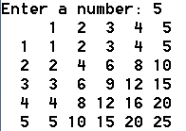

**#include <stdio.h>**

**int main ()**

**{**

**int n, i, j;**

**printf("Enter a number: ");**

**scanf("%d", &n);**

**printf(" ");**

**for (i = 1; i <= n; i++)**

**printf("%3d",i);**

**printf("\n");**

**for (i = 1; i <= n; i++){**

**printf("%3d", i);**

**for (j = 1; j <= n; j++)**

**printf("%3d", i*j);**

**printf("\n");**

**}**

**return 0;**

**}**

**Question # 6 [8 points]**

Write a C program that computes the following sum based on the value of x input by the user.

$$sum=\sum_{i=1}^{i=10}{\frac{x^{i}}{2i-1}}$$

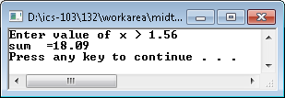

**#include <stdio.h>**

**#include <math.h>**

**int main(){**

**double x, sum, i;**

**sum = 0;**

**printf("Enter value of x >");**

**scanf("%lf", &x);**

**for(i = 1; i <= 10; i = i + 1)**

**sum = sum + pow(x, i) / (2 * i - 1);**

**printf("sum =%.2f\n", sum);**

**return 0;**

**}**

**Question # 7 [15 points]**

The body mass index **(BMI)** is a measure for human body shape based on an individual's weight and height. It is a simple method to assess how much an individual's body weight departs from what is normal. It can be measure by the formula:

**BMI = (weight in kg) / (heightin m)2**

Depending on the value of BMI, a person can be categorized in different weight ranges as given in the table below.

|  |  |
| --- | --- |
| **BMI (kg/m2)** | **Weight Range** |
| Less than 18.5 | Underweight |
| From 18.5 to 24.9 | Normal |
| From 25 to 29.9 | Overweight |
| 30 and more | Obese |

Write a complete C language program using a function **bmi_calc** to calculate BMI. Ask the user about height and weight in the main function. Print a message to the user showing him weight in kg, height in m, BMI and the weight range category as shown in the image.

 

**#include <stdio.h>**

**double bmi_calc (double weight, double height);**

**int main(){**

**double w, h, bmi;**

**/* get the input weight from the user */**

**printf("Enter your weight(in kg):");**

**scanf("%lf", &w);**

**/* get the input height from the user */**

**printf("Enter your height(in m):");**

**scanf("%lf", &h);**

**bmi = bmi_calc (w, h);**

**/* print the result */**

**printf("\nYour Weight: %.2fkg, Your Height: %.2fm, BMI: %.2f\n\n", w, h, bmi);**

**if (bmi < 18.5)**

**printf("Category: Underweight\n\n");**

**else if (bmi < 25)**

**printf("Category: Normal\n\n");**

**else if (bmi < 30)**

**printf("Category: Overweight\n\n");**

**else**

**printf("Category: Obese\n\n");**

**return 0;**

**}**

**double bmi_calc (double weight, double height){**

**/* bmi calculation */**

**return (weight)/(height * height);**

**}**