King Fahd University of Petroleum and Minerals
Information and Computer Science Department
Spring Semester 132
ICS 103 – Computer Programming in C

Final Exam Key

Monday, May 26, 2014

Duration: 120 minutes

Name:

ID#:

Section#:

Instructor:

Question # | Maximum  Grade | Obtained  Grade
1 | 25
2 | 15
3 | 15
4 | 10
5 | 15
6 | 20
Total | 100

Question # 1 [25 points]
Answer the following questions:
Question | Answer
Having the following function prototype:  void calculate(int x, int *y);  and the following declaration  int x, y;  Write a call to the function calculate | 4 marks
Show the output  int A[6], i, n = 6;  for(i = 0; i < n; i++)  if (i % 2 == 0)  A[i] = 5 * i;  else  A[n - i] = -5 * i;  for(i = 0; i < n; i++)  printf("%d\n", A[i]); | 6 marks
Show the output  if(strcmp("B", "Apple") > 0)  printf("hello");  else  printf("world"); | 2 marks
Show the output  char first[10] = "Ahmed", last[10] = "Ali";  strcat(last, first);  printf("%s\n", last);  printf("%s", first); | 2 marks
Show the output  char str1[12] = "Hello";  str1[2] = '\0';  printf("%d", strlen(str1)); | 2 marks
Show the output, if a user inputs the following values:  5 3 1 7 8 6 15 11 2 -1 0 9  #include <stdio.h>  int main () {  int a[3][3], i, j;  for(j = 1; j <= 5; j = j + 2) {  for(i =j; i != j+3; i++) {  scanf("%d", &a[i%3][j%3]);  }  }  for(i = 0; i < 3; i++) {  for(j = 0; j < 3; j++)  printf("%4d", a[i][j]);  printf("\n");  }  return 0;  } | 9 marks

Question # 2 [15 points]
Design the algorithm then write a C function (reverse_array) which reverses the n elements of a given array.
1
2
…
n
n
…
2
1
reverse_array

Algorithm

C function

Question # 3 [15 points]
Apply the problem solving steps to develop a program to check whether a sequence of numbers entered by the user is in the ascending (increasing) order or not.

Analysis

Algorithm

C program

Question # 4 [10 points]
Write a function called addFractions that takes four input parameters which are the numerator (a) and denominator (b) of the first fraction and numerator (c) and denominator (d) of the second fraction. The addFractions function also has two output parameters, which will have the value of the numerator and denominator of the addition of the two input fractions.
$$\frac{a}{b}+\frac{c}{d}=\frac{ad+bc}{bd}$$

Question # 5 [15 points]
Write a function sum_rows_cols that sums all rows and all columns of an integer matrix, which is passed as a parameter. The matrix must have one additional column to sum all rows and one additional row to sum all columns. The matrix, actual number of rows, and actual number of columns should be passed as parameters.
For example, here is a call to sum_rows_cols to take the sum of 3 rows and 4 columns of matrix.
4 | 8 | -2 | 5 |  | sum_rows_cols(matrix, 3, 4); | 4 | 8 | -2 | 5 | 15
1 | 3 | 0 | 6 |  |  | 1 | 3 | 0 | 6 | 10
7 | -1 | 9 | 2 |  |  | 7 | -1 | 9 | 2 | 17
 |  |  |  |  |  | 12 | 10 | 7 | 13 | 42

Question # 6 [20 points]
Write a program that reads the inputs (Student ID, Student Name, Scores of Quiz, Lab and Exam) from a file (data.text) and then computes and outputs the total score of each of the student, to one digit after the decimal point, in another data file named (result.text).

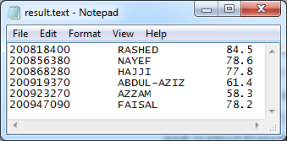
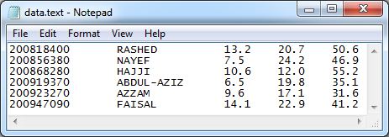
Your Program

