SImRobot is an environment that allows a user to define a Robotic Structure and generates a 3D Graphical Robot (GR) representation on its GUI. The primary task of the GUI is to display the robot workspace called the “Scene” which includes GR and its environment. Also, it allows simulating the Kinematics (motion) of the defined GR which provides the user with a view of the robot motion. This is useful to develop and evaluate robotic algorithms and gaming. It also allows controlling GR using C++. Programming in SimRobot is used to describe the Scene in the matter of initial position, size, shape and color of objects. It can apply physical constrains to object in the scene while providing set of methods to sense and control objects’ movement. Reading from sensors and controlling actuators is done by an external C++ code that is linked and built with SimRobot. Building Scenes in SimRobot requires following a hierarchal approach in describing the scene. The following example shows how to build simple objects.

Example 1: building simple objects in SimRobot:
For each SimRobot scene, an object of type “WORLD” is needed to be created as following:

WORLD "example1" (
QUICKSHADING; //Simplifying sensor data input to speed simulation
AMBIENT (0.1); //define color class
BACKGROUND (0.255,0.255,0.255); // Background color

SURFACE "green" (0.255,1,0.255); // define color green
SURFACE "white" (1,1,1); // define color white
SURFACE "blue" (0,0,1); // define color blue
SURFACE "yellow" (1,1,0); // define color yellow
SURFACE "red" (1,0,0); // define color red

//Header
)[

//Body

].

When defining object “WORLD”, it is important to close the object with “)” and then follow it by “[“. Any other object defined between “)[“ and “].” is considered as a subset of the object “WORLD”. There are many objects in SimRobot that can have several objects defined under them. The purpose of this approach is link objects together when defining them so they can have the same affect when moving or rotating. Let’s define three objects obj1 as cube, obj2 as a cone and obj3 as a ball in the scene.

WORLD "example1" (
QUICKSHADING; //Simplifying sensor data input to speed simulation
AMBIENT (0.1); //define color class

BACKGROUND (0.255,0.255,0.255); // Background color

SURFACE "green" (0.255,1,0.255); // implement color green
SURFACE "white" (1,1,1); // implement color white
SURFACE "blue" (0,0,1); // implement color blue
SURFACE "yellow" (1,1,0); // implement color yellow
SURFACE "red" (1,0,0); // implement color red
SURFACE "orange" (0.57,0.76,0.21); // implement color orange
)[
POLYEDER "obj1" ( // implementation of the cube
MOVETO (0,70,0); //move to location reference to “WORLD” object
BASEPOINTS ((0,0,0),(100,0,0),(100,100,0),
(0,100,0));
// base points define physical layout of object
SWEEP(0,0,100); // using base points, copy object along an axis.
SURFACE "blue"; // specify color of object
);
POLYEDER "obj2" ( // implementation of the cone
MOVETO (170,140,33); // move to location reference to “WORLD” object
BASEPOINTS ((0,100,-100),(0,0,0)); // base points define physical layout of object
ROTATE 16; // use base points and rotate along (0,0,0) of object
SURFACE "yellow"; // specify color of object
);
POLYEDER "obj3" ( // implementation of the ball
MOVETO (-150,140,20); // move to location reference to “WORLD” object
BASEPOINTS ((0,0,0),(19.75,0,4.125),(37.5,0,15.75),
(49.5,0,33.125),(53.75,0,53.75),(49.5,0,84.375),
(37.5,0,91.75),(19.75,0,103.375),(0,0,107.5));
// base points define physical layout of object
// where several points inside a ball are used
ROTATE 40; // use base points and rotate along (0,0,0) of object
SURFACE "red"; // specify color of object
);
].

SimRobot is going to create all of the three objects under the “WORLD” object. The drown image is as following:
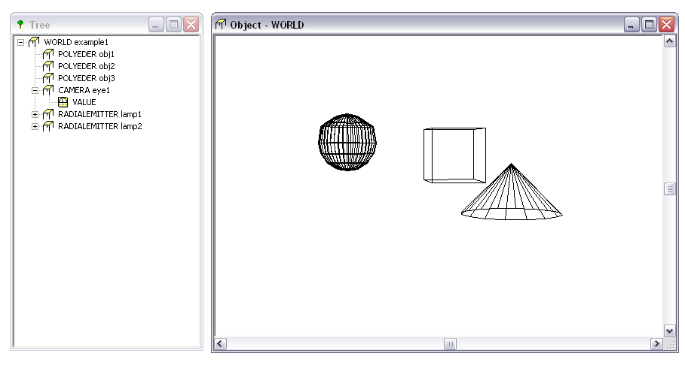

Examining the tree window above, it is shown that obj1, obj2 and obj3 are subset of object “WORLD”. Let’s add a camera and lights to see what the camera sees in the simulation. The following code was added under the “WORLD” object.

CAMERA "eye1" (
TURNX -120; // rotate camera -120 along X-axis
MOVETO (40,-400,300); // move to location reference to “WORLD” object
RESOLUTION (300,300); // input image size
ZBUFFER; // buffer used to create image of environment
CLASS 0; // define displayed color class
CLASS 1; // define displayed color class
CLASS 2; // define displayed color class
);
RADIALEMITTER "lamp1"(
MOVETO (-200,0,340); // move to location reference to “WORLD” object
RADIATION (1,1,1,1); // relative radiation of different classes
FACTOR 100000; // increase factor if called by user
START 1.5; // Starting power of the “RADIALEMITTER”
);
RADIALEMITTER "lamp2"(
MOVETO (540,0,340); // move to location reference to “WORLD” object
RADIATION (1,1,1,1); // relative radiation of different classes
FACTOR 100000; // increase factor if called by user
START 1.5; // Starting power of the “RADIALEMITTER”
);

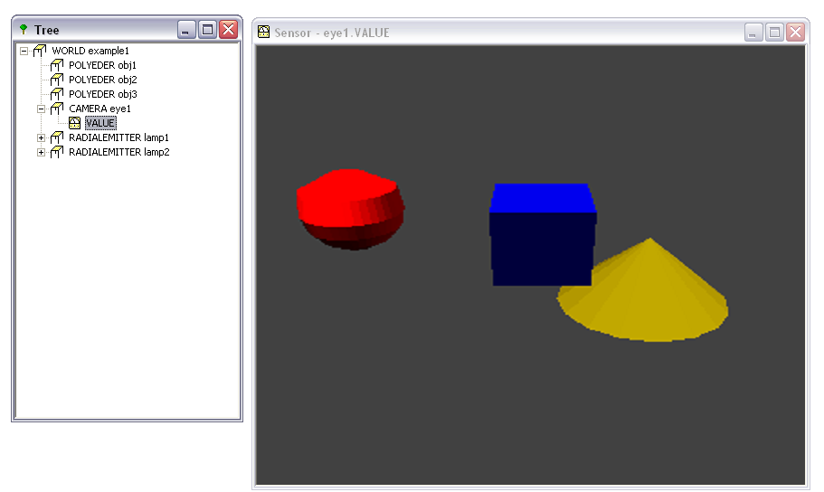

In the previous example, all of the three objects are rigid and unmovable. That is, they don’t have functions that give the user the ability to move or rotate them. There are, however, other objects that can move and to be controlled by the controller such as “EXTENDABLE”, “MANOEUVRABLE”, “TURNABLE” and “VEHICLE”. Each object has its functionality and its methods for controlling movements from the controller. However, those objects have no physical structure and they can’t be seen in SimRobot unless they are represented by a POLYEDER. Let’s start building a robotic arm that can move while testing it inside SimRobot. The Robotic arm will have three objects from type “TURNABLE”, several objects of type “POLYEDER” and two object of type “EXTENDABLE”. The objective of having “TURNABLE” objects is to allow the arm to rotate on a fixed axis at each joint where “POLYEDER” are going to represent their physical structure. “EXTENDABLE” object, however, is used to allow the robot arm to extend along a specific axis. Building order of objects and sub objects are important because of the constrained attachment. That is, if an object moved, all of its subset objects will move because they are attached to the main object. The order of objects, constrained connections and subset objects in the example are shown:
- “WORLD” object named “example1”.
  - “CAMERA” object named “eye1”.
  - “RADIALEMITTER” object named “lamp1”.
  - “RADIALEMITTER” object named “lamp1”.
  - “TURNABLE” object named “dof1”. It is used to create a rotation around Z-axis, which includes all subset objects under “dof1”.
    - “POLYEDER” object named “base”. It defines the physical structure of “dof1”.
    - “POLYEDER” object named “side1”. It is used with “base” to extend the physical description of “dof1”.
    - “POLYEDER” object named “side2”. It is also used with “base” and “side1” to extend the physical description of “dof1”.
    - “EXTENDIBLE” object named “extend1”. It is used to create a limited straight motion along Z-axis, which includes all subset objects under “extend1”.
      - “TURNABLE” object named “dof2”. It is used to create a rotation around X-axis, which includes all subset objects under “dof2”.
        - POLYEDER” object named “arm”. It defines the physical structure of “dof2”.
        - EXTENDIBLE” object named “extend2”. It is used to create a limited straight motion along Z-axis, which includes all subset objects under “extend2”.
          - “POLYEDER” object named “arm_side1”. It defines the physical structure of “extend2”.
          - “POLYEDER” object named “arm_side2”. It is used with “arm_side1” to extend the physical description of “extend2”.
            - “TURNABLE” object named “dof3”. It is used to create a rotation around Y-axis, which includes all subset objects under “dof3”.
