COE 202 – Digital Logic Design
Term 081 – Fall 2008

Project: 8-Bit Magnitude Comparator Implementation
Due Wednesday, Jan 14, 2008 by Midnight
Objectives:
- Using the Logisim simulator
- Designing and testing a 8-bit Magnitude Comparator

Project Details:
In this project, you are required to design a simple 8-bit Magnitude Comparator. A magnitude comparator is a combinational circuit that compares two numbers A & B to determine whether A>B, A<B or A=B.
Circuit Inputs:
First 8-bit number A
Second 8-bit number B

Circuit Outputs:
Only 3 output signals (GT, EQ, LT), where:
1. GT = 1 IFF A > B
2. EQ = 1 IFF A = B
3. LT = 1 IFF A < B

Circuit Block Diagram:
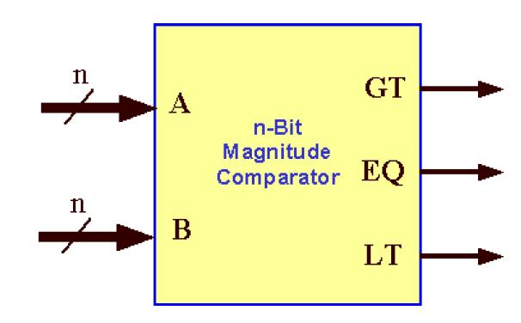
Getting Started with Logisim
You should first download Logisim from the COE 202 course website or Logisim website http://ozark.hendrix.edu/~burch/logisim/. Logisim is very easy to use. To get started, you can read the documentation available under the Logisim website/ Course WebCT.
Submission Guidelines
All submissions will be done through WebCT.
Attach one zip file containing the circuit design, test data, as well as the report document.
Submit also a hard copy of the report during the class lecture.

