

COE ABET COMMITTEE

Activity Report

Term T112

COMPUTER ENGINEERING

Program

at

King Fahd University of Petroleum & Minerals
DHAHRAN, SAUDI ARABIA

10 January 2013

CONFIDENTIAL

The information supplied in this Self-Study Report is for the confidential use of ABET and its authorized agents, and will not be disclosed without authorization of the institution concerned, except for summary data not identifiable to a specific institution.
Table of Contents

Introduction 3
Direct Assessment 3
Indirect Assessment 6
Alumni Survey and Employer Survey 6
COOP Supervisor Survey 12
Exit Survey 15
Summary and Recommendations for the Indirect Assessment 17
Appendix A: Surveys 18

Introduction

According to the ABET Program Assessment Committee the COE Department is expected to carry out a program assessment of all of its POs in T112. This report describes the (1) direct Assessment, and (2) Indirect Assessment that were carried out in T112.

Direct Assessment

The COE Department in its Resolution No COE/4/25/1431-1432H (2010-2011) approved the following Rubric Mapping to the COE Courses.

Approved Rubric Mapping to the COE Courses

Rubric Assessment
The detailed definition of the COE Rubrics is included in the COE Self-Study Report. In addition these can be accessed at:
http://faculty.kfupm.edu.sa/COE/mayez/ABET/Set-of-COE-Rubrics/Set-of-All-COE-Rubrics.docx
The above set of rubrics allows student-by-student rating for each rubric based on the previously defined performance indicators as defined in the Self-Study Report. By referring to the performance criteria for each outcome, it is clear that the rubric data is designed to better reveal how actual learning by students is judged for each Program Outcome.
The Table below shows the Rubrics Assessment Scores for the POs based on the assessment data for T112. The average rubrics score are shown based on Rubric Assessment Mapping to the COE Courses which has been presented in the previous section.
Note that assessment of teamwork (outcome (d)) has two components: assessment by pears (d-I) and by instructor (d-II). Also the outcome on communication skills (g) has two components: (g-O) for oral communications, and (g-W) for written communications.
To analyze outcome achievement based on the rubric assessment data, the ABET committee compared the performance score achieved by each PO to the corresponding performance target (2.5 out of 4) as stated in the overall Assessment process described in the Table titled “Rubrics Assessment Data for T112” which is shown below. Depending on whether the PO meets or does not meet the above performance target the POs have been classified as:

- Achieved (A),
- Marginally Achieved (M), or
- Need Improvement (NI).

Rubrics Assessment Data for T112
Average | Rubrics Assessment Data
Average | A  Math | b  Exp | c  Des | d-I  Team  (Peer-Eva) | d-II  Team  (Instr-Eva) | e  Form | f  Ethics | g-O  Com  (Oral) | g-W  Com  (write) | h  Impact | i  Learn | J  Cont | k  Tool | n  H/S
PO Scores in T112 (out of 4) | 2.53 | 3.23 | 2.4 | 2.89 | 3.75 | 3.3 | 3 | 2.8 | 2.87 | 2.76 | 3.25 | 2.11 | 3.5 | 3.83
Level of achivement | M | A | NI | A | A | A | A | A | A | A | A | NI | A | A

The ABET committee analysis is as follows:

- Outcomes that are achieved (A):

  - The outcomes b(exp), d (team-), e(Exp), f (ethics), g-O (oral-), g-W (write-), h (Eng-sol-), I (learn), k (tools), and n (intg-h/s) are considered as achieved.
  - Outcomes b(exp), e(Exp), f (ethics), I (learn), k (tools), and n (intg-h/s) are achieved with some confidence. However the current B.Sc. program does not properly address the outcome n (intg-h/s). The obtained score is somehow does not reflect the real student performance with respect to this outcome because the outcome is not addressed at all.

  - Outcomes d (team-), g-O (oral-), g-W (writep-), and h (Eng-sol-) are achieved with less confidence. It is clear that the above outcomes are critical to the program and must be closely addressed and improved in the future.

- Outcomes that are marginally achieved (M):

- Outcome a(math) is marginally achieved. Future continuous improvement should consider this outcome and consider strengthening the ability to apply math in some COE courses (like Logic Design, Computer Organization, and Computer Networks).
- Outcomes that need improvement (NI):
- Outcome c(eng-des) and j (contemp) are below the performance target and need improvement (NI).
- Outcome j (contemp) needs improvement. This outcome is not addressed in the current program. It is expected to be addressed in the COE Course Foundation of Computer Engineering of the new B.Sc. program which started in T121.
- Outcome c(eng-des) is about the education of engineering design (ED). It is the most critical outcome in the COE program. This outcome has been subject to Continuous Improvement. The reason this outcome has not improved is that the recommended action has not been applied by the COE Department. Please refer to the Continuous Improvement Section of the COE Self-Study Report for the detailed committee recommendations for improving the above outcome. A progressive plan has been proposed for improving the ED education in the program al all the levels. The plan basically proposed a major change in the way some COE Labs have to operate in order to promote the ED components. We re-iterate the need to revise the way the COE courses and Labs are delivered to improve the ED package in various aspects: organizational and technical, e.g. the use of notebooks in labs, elimination of lab reports, improve the aspects of open-ended problems in both homework, course project, and labs, and the problem solving in the lab experiments as opposed to problem formulation that admit one single solution. The New B.Sc. program has eliminated one of the major courses (COE 400) that represent a culminating deign experience which becomes an elective course in the new program. Therefore, the focus will be in the Design Project Course which will be a major platform to experience the ED education and its practice in the new program. The ABET committee should suggest effective ways to ensure quality ED education at the Senior Design course. This appears to be a more difficult task and very challenging to implement in an effective way.

Indirect Assessment

Alumni Survey and Employer Survey

We have deployed the Alumni Survey and Employer Survey in T112 to get feedback on how the COE program is successful in addressing the PEOs in the views of the COE graduates who completed their COE BSc degree. Unfortunately, we have not received any feedback from the employers despite sending them the survey multiple times. Therefore, we rely in this section on the Alumni Survey only.

The Alumni survey uses the new PEOs which have been approved in T102. And, it reasonably takes no less than 6 years to relate the alumni survey to our current PEOs. For this reason the current alumni survey is useful in relating the success of alumni who graduated prior to establishing our current PEOs. Although this limits the validity of using the survey for PEOs assessment, we use the alumni concerns to point to where curricular corrections should be made.

shows the PEOs in the first column and the survey questions that map to each PEO in second column.

Table ‎1-1: Mapping between PEOs and survey questions
Program Educational Objectives of the Computer Engineering Program at KFUPM | Survey Questions
PEO-1: Produce graduates who, after few years from graduation, will have established themselves as successful professional computer engineers with demonstrated leadership capabilities. | - The COE program has provided me with adequate background to establish myself as a successful professional computer engineer (PEO-1).
 | - The COE program has provided me with adequate background to establish myself with demonstrated leadership capabilities (PEO-1).
 | - The COE program has provided me with adequate background to enable my involvement in innovations and/or entrepreneurial activities (PEO-1).
 | - The COE program has provided me with adequate training for improving my personal skills (e.g., teamwork, leadership, oral and written communication skills) in the work place (PEO-1).
PEO-2: Produce graduates who, after few years from graduation, will have demonstrated an ability to pursue a successful professional and career growth. | - The COE program has provided me with adequate opportunities to help me understand and appreciate the importance of superior work ethics in the practice of my profession (PEO-2).
 | - The COE program has provided me with adequate ability to establish myself in professional activities including professional societies and licensing boards (PEO-2).
 | - The COE program has provided me with an adequate ability and motivation to continuously improve my technical skills (PEO-2).
 | - The COE program has provided me with adequate opportunities for professionally adapting myself to changes in my field (PEO-2).
PEO-3: Produce graduates who, after few years from graduation, will have enrolled and Succeeded in graduate and professional studies/programs if they chose to do so. | - The COE program has provided me with adequate breadth technical programs (PEO-3).
 | - The COE program has provided me with adequate depth technical programs (PEO-3).
 | - The COE program has provided me with adequate background that I can build on to continue and succeed in graduate and professional studies/programs if I chose to do so (PEO-3).

Overall, 29 alumni responded to this survey. Figure ‎1-1 shows, according to the alumni, the degree to which the COE graduate achieved the PEOs. The scores reported show that the alumni satisfaction level for all PEOs exceeds 3.30 out of a scale from 1 to 5. The least rated program aspects questions which received a score below 3.5are as follows with the least rated program aspect being on the top:

- PEO-2-6: The COE program has provided me with adequate ability to establish myself in professional activities including professional societies and licensing boards (PEO-2).
- PEO-1-2: The COE program has provided me with adequate background to establish myself with demonstrated leadership capabilities (PEO-1).
- PEO-1-3: The COE program has provided me with adequate background to enable my involvement in innovations and/or entrepreneurial activities (PEO-1).

We note that two of the above questions fall in PEO-1. Curricular actions need to be taken to address the above concerns.

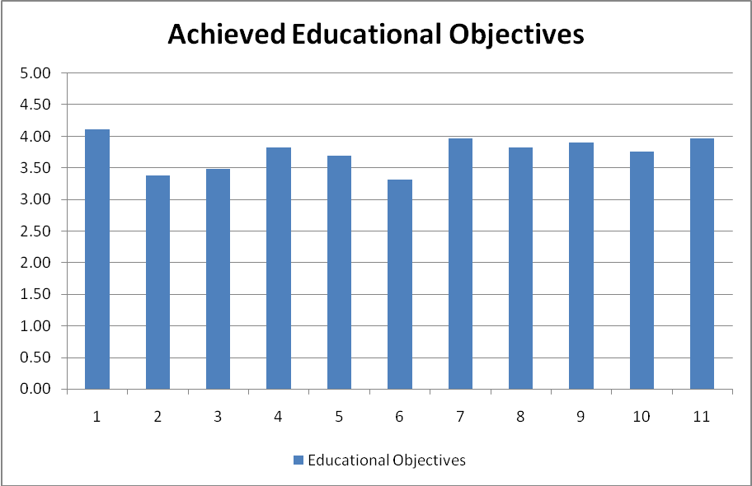
Figure ‎1-1: Degree to which the COE graduate achieved the Educational Objectives

Figure ‎1-2 shows, according to the alumni,the degree to which the COE alumni were expected to meet eachprogram outcome (PO) criterion. The scores reported show that the alumni expectation level for all POs exceeds 3.65. The top rated expectations which received a score of 4.38 are as follows:

- PO(c): Design a system, process, or component to meet desired needs subject to given constraints. Analyze and evaluate alternative solutions.
- PO(g): Use oral, written, and audio-visual techniques effectively for successful communication.

This shows that the surveyed alumni give more importance to the above two POs compared to the others.

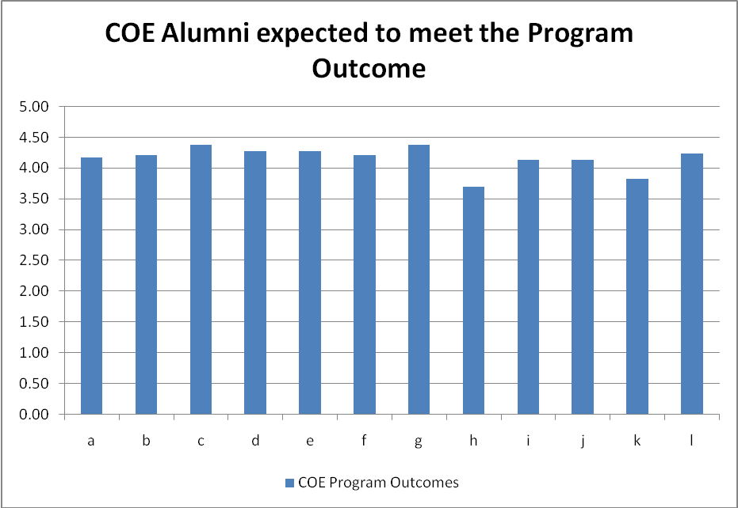
Figure ‎1-2: Degree to which the COE Alumni was expected to meet each PO criterion

Figure ‎1-3shows, according to the alumni, the degree to which the COE alumni met each program outcome (PO) criterion. It is interesting to see that the POs with the top rated expectations are also among the top three in terms of meeting these POs, which received a score of more than 4.05, and are as follows:

- PO(g): Use oral, written, and audio-visual techniques effectively for successful communication.
- PO(c): Design a system, process, or component to meet desired needs subject to given constraints. Analyze and evaluate alternative solutions.
- PO(d): Function on multi-disciplinary and/or diverse teams. Take responsibility, share work, and value other viewpoints.

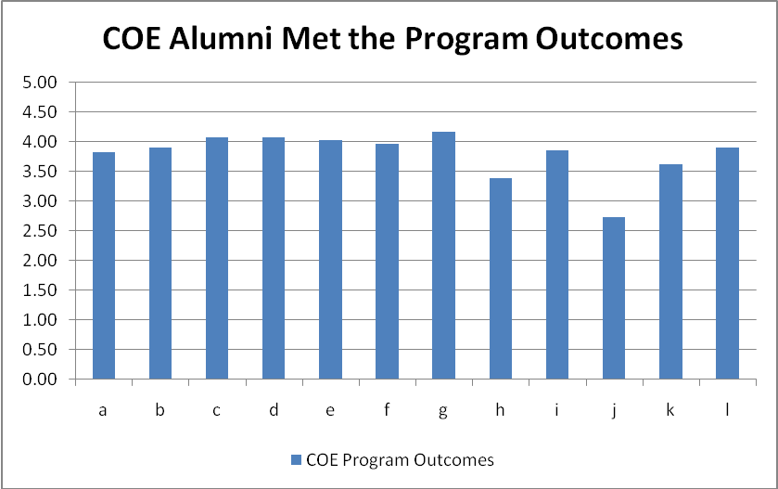
Figure ‎1-3: Degree to which the COE Alumni met each PO criterion

It is also worth noting that the PO that shows the largest difference between what is expected by the alumni and what has been achieved is:
- PO(j): Know about contemporary socio-economic issues relevant to computer engineering.
This outcome received a score of 4.14 in what is expected and 2.72 in whether it was met, which also represents the lowest score over all other POs.

Another outcome that got a score less than 3.5 in whether it was met is:
- PO(h): Understand global effects of practices, products, and events, and the impact of engineering solutions on society.
This outcome received a score of 3.69, which is the lowest, in what is expected and 3.38 in whether it was met, which also represents the lowest score over all other POs. The score of 3.69 also shows that the alumni do not consider this PO to be of high importance.

In summary, PO(j) requires the most attention, and curricular actions need to be taken to address it.
The following are the comments that were received from the Alumni:
The current market in Saudi Arabia is not based on competence and technical qualifications, it is based on cheap labor. period! This note has to be taken into account when making strategic plans on university programs. You should not be following the Saudi Market, because it is fundamentally flawed. All the theory about knowledge-based economy and entrepreneurship has no meaning in the Saudi Market, where closed-business groups which have access to cheap labor drive the whole economy. For the new program, why do you re-invent the wheel, just align it to well-known programs in top universities around the world and you will be doing a great job for our future.
The teaching of the program is competitive;however, there is not enough chances for scientific research at the undergrad level. Please consider providing a scientific research projects as part of the senior project course. Most of the senior design projects focus on applying the knowledge learnt in the program into an industrial context, let say. This of course is very beneficial for the student going to the industry.
It would be nice if you some of the senior design projects are research based. This kind of projects are of interest of student thinking of continuing their graduate study.
I believe that the BSc is powerful but not yet much applicable in KSA
We do not have much of computers or hardwares manufacturing factories as before.
But I still believe that there has to a study line for the Networking as it's much desired in te market
I think COE students should be exposed to solving industry problems by creating a department that looks for partnerships with companies in the industry.
For example, after graduation we found out that many companies like ARAMCO, Sabic, etc do have problems that they ask companies from outside of country to solve and they ask for tremendous amounts of money to provide a solution and to support it after that.
If Half of that amount is invested in partnerships with KFUPM, I am sure that KFUPM Faculty and Students can provide better solutions at a reasonable cost.
Need to be closer to the market

COOP Supervisor Survey

The COE provides an optional COOP program. Very few COE students selected the COOP option in T111 and T112. As a result, only oneCOOP Supervisor Survey was filled, after multiple attempts to get more supervisors participating in this activity.

Figure ‎2-4 shows, according to the COOP supervisor, the degree to which the COE students were expected to meet each program outcome (PO) criterion. The scores reported show that the COOP supervisor expectation level for all POs is 3 or above. The top rated expectations which received the perfect score of 5 are as follows:

  - PO(i): Recognize the need for and demonstrate ability to engage in lifelong learning.
  - PO(j): Know about contemporary socio-economic issues relevant to relevance to computer engineering.

This shows that the surveyed COOP supervisor gives more importance to the above two POs compared to the others.

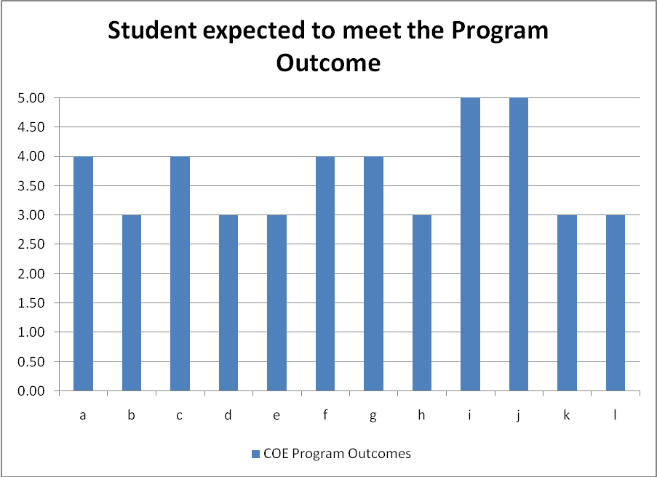
Figure ‎2-4: Degree to which the student was expected to meet each PO criterion

Figure ‎2-5 shows, according to the COOP supervisor, the degree to which the COE students met each program outcome (PO) criterion. It is interesting to see that the PO that received the top score in being met, i.e., PO(e) with the perfect score of 5,is not rated as one of the top expectations by the COOP supervisor, who gave it a score of 3 in terms of expectation. This indicates that the student has achieved much more than what is expected by the supervisor in the following PO:

- PO(e): Identify, formulate, and solve engineering problems. Make appropriate and necessary assumptions. Suggest and evaluate new approaches.

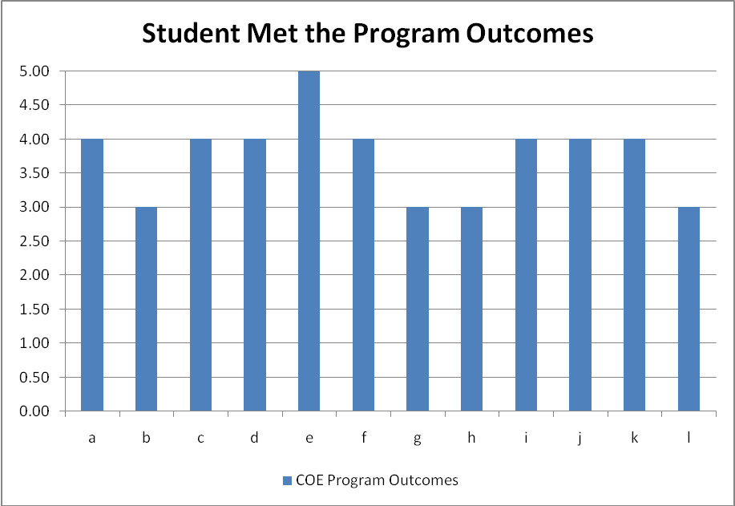
Figure ‎2-5: Degree to which the student met each PO criterion

According to the COOP supervisor, the student has achieved much more than what is expected by the supervisor in the following POs as well, where the expected score was 3 while the score of being met is 4:

  - PO(d): Function on multi-disciplinary and/or diverse teams. Take responsibility, share work, and value other viewpoints.
  - PO(k): Use techniques, skills and modern engineering tools necessary for engineering practice.

It is also worth noting that the POs that show a higher score of what is expected by the COOP supervisorcompared to what has been achieved, and two of which got the perfect score of 5 in what is expected,are:

  - PO(g): Use oral, written, and audio-visual techniques effectively for successful communication.
  - PO(i): Recognize the need for and demonstrate ability to engage in lifelong learning.
  - PO(j): Know about contemporary socio-economic issues relevant to computer engineering.

In summary, PO(g), PO(i), and PO(j)do not meet the expectation of the COOP supervisor, and therefore they require the most attention.Hence, curricular actions need to be taken to address these POs.

Table ‎2-2: shows the comments that were received from the COOP supervisor.

Table ‎2-2:Comments of the COOP Supervisor
Questions | Comments
Other skills required by your organization | Team leading, team playing, service delivery skills
How do you compare KFUPM-COE Coop students with those of other universities? | generic, well oriented
Strengths you see in the KFUPM-COE program and its educational objectives | Integrated courses and materials
Other educational objectives that you believe should be added | Real life scenarios regarding work environments

Exit Survey

Results of deploying the Exit Survey in the terms T111 and T112 are considered here as one of the indirect tools for PO assessment. Figure ‎3-6plots the level of satisfaction of graduating students for the POs. The students acknowledge that the following POs got the highest achievement, with a score of 4.67, and are therefore adequately addressed in the core courses in the curriculum:
- PO(f): Understand professional and ethical responsibilities. Demonstrate ethical practice.
- PO(g): Use oral, written, and audio-visual techniques effectively for successful communication.
The students also gave the following outcome the lowest score of 3.78, and therefore it requires the most attention:
- PO(i): Recognize the need for and demonstrate ability to engage in lifelong learning.

All other POs achieved a score of 4 or higher, and can be considered as satisfactory to the students, and that they are therefore adequately addressed in the core courses in the curriculum.

In summary, the outcome PO(i) requires the most attention, and curricular actions need to be taken to address it.

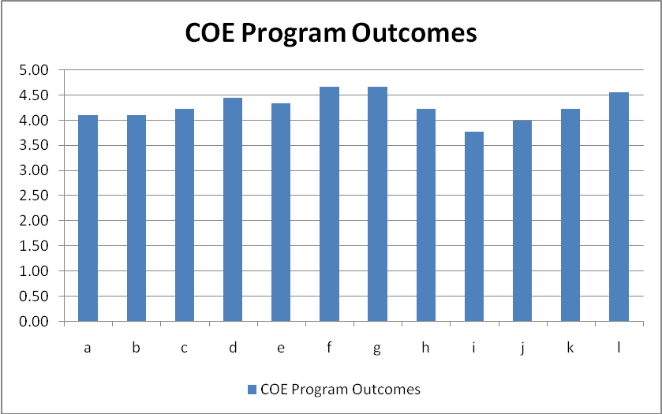
Figure ‎3-6: Level of Satisfaction of Graduating Students for the POs

Figure ‎3-7 shows the level of satisfaction of graduating students for the learning environment. Equity of Treatment by Faculty Members (D.15) achieved the highest score of 4.67. On the other hand, Quality of the Parking (F.28) achieved the lowest score of 2.22, and Quality of Supervision or Advice on Career Planning (C.13) and Quality of the Food Services (F.26) achieved the next lowest scores between 2.5 and 3.All other components achieved a score higher than 3, and therefore can be considered as acceptable.
Overall, Equity of Treatment (D) achieved the highest scores, followed by Quality of Academic Services (E). On the other hand, Quality of the Facilities (F) achieved the lowest scores, and more specifically forParking (F.28) and Food Services (F.26). All other three categories, i.e., Quality of Instruction (A), Quality of Laboratories (B), and Quality of Supervision or Advice (C), achieved an acceptable level of satisfaction except for the Quality of Supervision or Advice on Career Planning (C.13) which got a score of 2.78.
In summary, the quality of facilities needs improvement, and mainly the parking and food services. In addition, the quality of supervision or advice on career planning needs improvement, and necessary actions must be taken by the department to improve it. Faculty members should also be commended for their great work on their fair treatment of all the students.

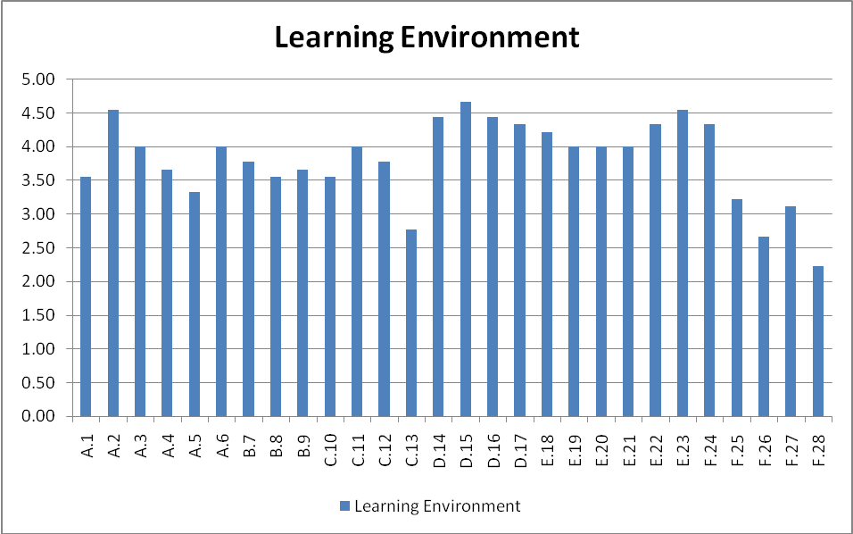
Figure ‎3-7: Level of Satisfaction of Graduating Students for the Learning Environment.

Figure ‎3-8 shows the level of satisfaction of graduating students for the abilities and skills. Statement 9 related to PO(h) achieved the highest score of 4.56. Statement 12 related to PO(i) achieved the lowest score of 3.67. Statements8 and 10related to PO(g) and PO(i), respectively, also achieved scores between 3.5 and 4. All others obtained scores between 4 and 4.5.
In summary, PO(i) requires the most attention, and more specifically the COE department needs to provide an education that will enable the graduating students to pass professional and certificate exams to improve their career opportunities.

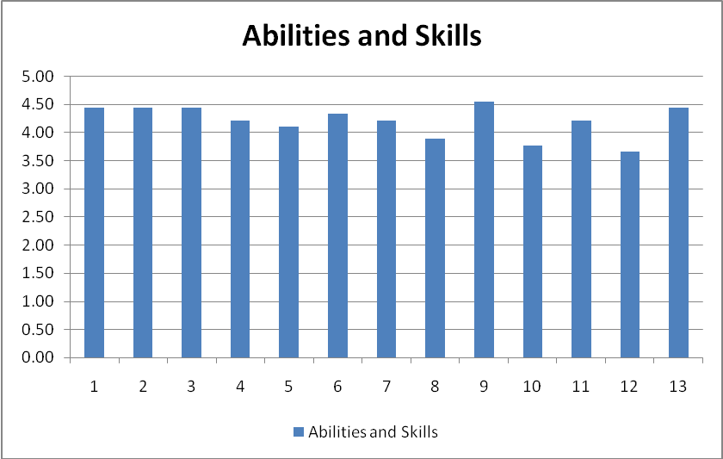
Figure ‎3-8: Level of Satisfaction of Graduating Students for the Abilities & Skills

Summary and Recommendations for the Indirect Assessment
In this section, we present a summary of the results of all the surveys presented in this report. From the alumni’s point of view, PO(j) requires the most attention. From the COOP supervisor’s point of view, PO(g), PO(i), and PO(j) do not meet the expectation of the COOP supervisor, and therefore they require the most attention. From the graduating students’ point of view, PO(i) requires the most attention, and more specifically the COE department needs to provide an education that will enable the graduating students to pass professional and certificate exams to improve their career opportunities. For all these POs, curricular actions need to be taken to address them.
The outcome that requires the most immediate attention is PO(i), followed by PO(j), and then PO(g), all of which are listed below:
  - PO(i): Recognize the need for and demonstrate ability to engage in lifelong learning.
  - PO(j): Know about contemporary socio-economic issues relevant to computer engineering.
  - PO(g): Use oral, written, and audio-visual techniques effectively for successful communication.

Appendix A: Surveys

Computer Engineering Department

Graduating Student Exit Survey

Through this Exit Survey we are asking Computer Engineering graduating students to evaluate their experience as students at King Fahd University of Petroleum and Minerals. All responses will be kept confidential and used as an internal assessment tool to improve our programs. We appreciate your help in filling out this survey.

Thank you in advance.

Name: _________________________________________________________________

Graduation Date: _______________________________________________________

Number of years at KFUPM:______________________________________________

Overall GPA: __________________________________________________________

I - Surveying the Ability and Skills

Abilities and Skills | Excellent | Very Good | Good | Poor | Very Poor
1. My education at KFUPM has given me the ability and confidence to apply general principles of mathematics, science, and engineering to the analysis of computer engineering problems.
2. The quality and variety of COE design projects have been very helpful in developing my engineering design skills.
3. The training and practice I had in my ICS courses at KFUPM has been very helpful to me in the areas of software design and development.
4. The teamwork experience that I had in my COE projects has taught me how to function as an effective team member and has been more productive to me than individual work.
5. My rating of the instruction and guidance I received in teamwork.
6. My education at KFUPM and my oral presentations have improved my ability to communicate my ideas effectively to my audience
7. My education at KFUPM and the technical reports that I wrote for my course projects have improved my writing skills and my ability to communicate my ideas effectively in writing.
8. My rating for the quality of guidance and instruction I received in writing and speaking.
9. My education in the COE department at KFUPM has contributed to my understanding of the impact of computer engineering solutions in my society and in the world.
10. My education in the COE department at KFUPM has prepared me to enter graduate school and to engage in a lifelong learning process.
11. My education in the COE department at KFUPM enabled me to use software and hardware tools needed to solve computer engineering problems.
12. My education in the COE department at KFUPM enabled me to pass professional and certificate exams to improve my career opportunities.
13. The courses I have taken at KFUPM and the COE have given me a good foundation for understanding the contemporary social, political, and technical issues that surround our society.

II - Surveying the COE Program Outcomes (POs)
The Program Outcomes (POs) are statements that describe what the COE graduates are expected to know and be able to do by the time of graduation. They are related to skills, knowledge and behavior that graduate acquired through the COE program.
COE Program Outcomes |  | To what degree the education you received at the COE meet the Program Outcome Criterion:  1: Poor 5: Excellent
 |  | 1 | 2 | 3 | 4 | 5
a | Apply knowledge of mathematics, science, and engineering to obtain solutions and formulate models of processes and systems.
b | Design and conduct experiments, and collect, analyze and interpret data.
c | Design a system, process, or component to meet desired needs subject to given constraints. Analyze and evaluate alternative solutions.
d | Function on multi-disciplinary and/or diverse teams. Take responsibility, share work, and value other viewpoints.
e | Identify, formulate, and solve engineering problems. Make appropriate and necessary assumptions. Suggest and evaluate new approaches.
f | Understand professional and ethical responsibilities. Demonstrate ethical practice.
g | Use oral, written, and audio-visual techniques effectively for successful communication.
h | Understand global effects of practices, products, and events, and the impact of engineering solutions on society
i | Recognize the need for and demonstrate ability to engage in lifelong learning.
j | Know about contemporary socio-economic issues relevant to relevance to computer engineering.
k | Use techniques, skills and modern engineering tools necessary for engineering practice.
l | Design a system that involves the integration of hardware and software

Learning Environment | Excellent | V. Good | Good | Fair | Poor
A. Quality of instruction in:
1. Mathematics, Physics, and Chemistry
2. Computer Engineering courses
3. Information and Computer Science courses
4. English courses
5. Islamic studies and humanities
6. Elective courses
B. Quality of Laboratories:
7. Instruction provided by lab instructors
8. Experiments and lab manuals
9. Computing facilities and equipments
C. Quality of supervision or advice:
10. Summer training or COOP
11. Senior Project
12. Academic planning
13. Career planning
D. Equity of treatment by:
14. Academic administrators: chairman, dean, etc.
15. Faculty members
16. Teaching assistants and lab instructors
17. Secretaries and staff members
E. Quality of Academic Services:
18. Admission process
19. Orientation program
20. Registration process
21. Email, Internet, and Networking infrastructure
22. Library
23. Bookstore
F. Quality of the facilities:
24. Classrooms
25. Recreation and athletics
26. Food services
27. Student housing
28. Parking
III - Surveying the Learning Environment

List positive things about the COE program at KFUPM:

List negative things about the COE program at KFUPM:

What courses were your favorite, and why?

What courses were your least favorite, and why?

What would you suggest to improve the COE major and to make it more useful?

King Fahd University of Petroleum and Minerals
Computer Engineering Department

Alumni survey

Purpose: The objective of this survey is to get feedback from the ALUMNI who graduated from the Computer Engineering Department (COE) of KFUPM. The results of this survey will help KFUPM tune the COE Program to better serve prospective its prospective students. This survey is part of the process for accrediting the COE program by the American Board for Engineering and Technology (ABET).

I Contact Information

The following information is regarding the person who filled-in this survey:

Name: _____________________________________________________
Year of Graduation: ________________
Employer: ____________________________________________________________________________
Job Title: ____________________________________________________________________________
Job Description: _______________________________________________________________________
Mailing Address: ______________________________________________________________________
E-mail: ______________________________________Tel:__________________ Fax: ______________
Advanced Degrees (M.Sc. / PhD if any): ____________________________________________________
University Honors/Recognitions (if any): ___________________________________________________
Employment Honors/Recognitions (if any): _________________________________________________
Membership of professional Societies (if any): _______________________________________________
Have attended a professional/technical society conference(s) since graduation: Yes No
Have participated in continuing education activity since graduation, not including graduate degrees.
Yes No

II - Surveying the COE Program Outcomes (POs)
The Program Outcomes (POs) are statements that describe what the COE graduates are expected to know and be able to do by the time of graduation. They are related to skills, knowledge and behavior that graduate acquired through the COE program.

To what degree was the COE Alumni expected to meet the PO criterion  1: Low 5: High |  |  |  |  | PO Criteria |  | To what degree did the COE Alumni met the PO criterion  1: Poor 5: Excellent
1 | 2 | 3 | 4 | 5 |  |  | 1 | 2 | 3 | 4 | 5
 |  |  |  |  | a | Apply knowledge of mathematics, science, and engineering to obtain solutions and formulate models of processes and systems.
 |  |  |  |  | b | Design and conduct experiments, and collect, analyze and interpret data.
 |  |  |  |  | c | Design a system, process, or component to meet desired needs subject to given constraints. Analyze and evaluate alternative solutions.
 |  |  |  |  | d | Function on multi-disciplinary and/or diverse teams. Take responsibility, share work, and value other viewpoints.
 |  |  |  |  | e | Identify, formulate, and solve engineering problems. Make appropriate and necessary assumptions. Suggest and evaluate new approaches.
 |  |  |  |  | f | Understand professional and ethical responsibilities. Demonstrate ethical practice.
 |  |  |  |  | g | Use oral, written, and audio-visual techniques effectively for successful communication.
 |  |  |  |  | h | Understand global effects of practices, products, and events, and the impact of engineering solutions on society
 |  |  |  |  | i | Recognize the need for and demonstrate ability to engage in lifelong learning.
 |  |  |  |  | j | Know about contemporary socio-economic issues relevant to relevance to computer engineering.
 |  |  |  |  | k | Use techniques, skills and modern engineering tools necessary for engineering practice.
 |  |  |  |  | L | Design a system that involves the integration of hardware and software

III Surveying the COE Program Educational Objectives

ABET defines program educational objectives (PEOs) as “broad statements that describe the career and professional accomplishments that the program is preparing graduates to achieve”. The PEOs are measures of the graduates’ performance3 to 5 years after completing graduation. The Alumni questions sought to find out how the alumni perceive the program and how it satisfies their working environment and needs.
Program Educational Objectives of the Computer Engineering Program at KFUPM |  | To what degree did the COE Graduate achieved the Educational Objectives:  1: Poor 5: Excellent
 |  | 1 | 2 | 3 | 4 | 5
1 | The COE program has provided me with adequate background to establish myself as a successful professional computer engineer (PEO-1).
2 | The COE program has provided me with adequate background to establish myself with demonstrated leadership capabilities (PEO-1).
3 | The COE program has provided me with adequate background to enable my involvement in innovations and/or entrepreneurial activities (PEO-1).
4 | The COE program has provided me with adequate training for improving my personal skills (e.g., teamwork, leadership, oral and written communication skills) in the work place (PEO-1).
5 | The COE program has provided me with adequate opportunities to help me understand and appreciate the importance of superior work ethics in the practice of my profession (PEO-2).
6 | The COE program has provided me with adequate ability to establish myself in professional activities including professional societies and licensing boards (PEO-2).
7 | The COE program has provided me with an adequate ability and motivation to continuously improve my technical skills (PEO-2).
8 | The COE program has provided me with adequate opportunities for professionally adapting myself to changes in my field (PEO-2).
9 | The COE program has provided me with adequate breadth technical programs (PEO-3).
10 | The COE program has provided me with adequate depth technical programs (PEO-3).
11 | The COE program has provided me with adequate background that I can build on to continue and succeed in graduate and professional studies/programs if I chose to do so (PEO-3).

IV Comments

King Fahd University of Petroleum and Minerals
Computer Engineering Department

Assessment Form by Coop Supervisor

Dear Coop Supervisor:

The Department of Computer Engineering (COE) at the King Fahd University of Petroleum and Minerals employs a continuous assessment plan for its program according to the ABET engineering accreditation criterion. We are very much interested to know how our Coop students have met these criteria. Your answers will help us enhance our program and improve the quality of graduates to better serve industry.

Student Name: ___________________________Student KFUPM ID #.: ___________________
Semester: ______________________________ Academic Year:_________________________

I Survey

To what degree was the student expected to meet the criterion during the Coop program  1: Low 5: High |  |  |  |  | Criteria |  | To what degree did the student meet the criterion during the Coop program:  1: Poor 5: Excellent
1 | 2 | 3 | 4 | 5 |  |  | 1 | 2 | 3 | 4 | 5
 |  |  |  |  | a | Apply knowledge of mathematics, science, and engineering to obtain solutions and formulate models of processes and systems.
 |  |  |  |  | b | Design and conduct experiments, and collect, analyze and interpret data.
 |  |  |  |  | c | Design a system, process, or component to meet desired needs subject to given constraints. Analyze and evaluate alternative solutions.
 |  |  |  |  | d | Function on multi-disciplinary and/or diverse teams. Take responsibility, share work, and value other viewpoints.
 |  |  |  |  | e | Identify, formulate, and solve engineering problems. Make appropriate and necessary assumptions. Suggest and evaluate new approaches.
 |  |  |  |  | f | Understand professional and ethical responsibilities. Demonstrate ethical practice.
 |  |  |  |  | g | Use oral, written, and audio-visual techniques effectively for successful communication.
 |  |  |  |  | h | Understand global effects of practices, products, and events, and the impact of engineering solutions on society
 |  |  |  |  | i | Recognize the need for and demonstrate ability to engage in lifelong learning.
 |  |  |  |  | j | Know about contemporary socio-economic issues relevant to relevance to computer engineering.
 |  |  |  |  | k | Use techniques, skills and modern engineering tools necessary for engineering practice.
 |  |  |  |  | l | Design a system that involves the integration of hardware and software

II Comments

A Other skills required by your organization

B How do you compare KFUPM-COE Coop students with those of other universities

C Currently the objective of the COE program is to produce graduates who, after few years from graduation, will have:

- Established themselves as successful professional computer engineers with demonstrated leadership capabilities,
- Demonstrated an ability to pursue a successful professional and career growth, and
- Enrolled and Succeeded in graduate and professional studies/programs if they chose to do so.
Strengths you see in the KFUPM-COE program and its educational objectives

Other educational objectives that you believe should be added

III Contact Information

Information on the person who completed this form:

Name:

Position / Title

Department, Company

e-mail:

Date:

King Fahd University of Petroleum and Minerals
Computer Engineering Department

Employer survey
for Computer Engineering graduates

Purpose: The objective of this survey is to get feedback from organizations which employ graduates of the Computer Engineering Department (COE) of KFUPM. The results of this survey will help KFUPM tune its programs to better serve prospective employers of its graduates. This survey is part of the process for accrediting the COE program by the American Board for Engineering and Technology (ABET).

I Company information

Organization Name

Type of Business

Organization Size
  Small | Medium | Large | Huge

Number of KFUPM-COE Graduates who have been employed in your organization

Nature of work performed by COE graduates in your organization

SalaryRange for KFUPM-COE Graduates

II Contact Information

The following information is regarding the person who filled-in this survey:

Name:

Position / Title

Department, Company& Phone

e-mail:

Date:

III Surveying the COE Program Outcomes (POs)
The Program Outcomes (POs) are statements that describe what the COE graduates are expected to know and be able to do by the time of graduation. They are related to skills, knowledge and behavior that graduate acquired through the COE program.

To what degree was the COE Graduate expected to meet the PO criterion  1: Low 5: High |  |  |  |  | Program Outcome Criteria |  | To what degree did the COE Graduate met the PO criterion  1: Poor 5: Excellent
1 | 2 | 3 | 4 | 5 |  |  | 1 | 2 | 3 | 4 | 5
 |  |  |  |  | a | Apply knowledge of mathematics, science, and engineering to obtain solutions and formulate models of processes and systems.
 |  |  |  |  | b | Design and conduct experiments, and collect, analyze and interpret data.
 |  |  |  |  | c | Design a system, process, or component to meet desired needs subject to given constraints. Analyze and evaluate alternative solutions.
 |  |  |  |  | d | Function on multi-disciplinary and/or diverse teams. Take responsibility, share work, and value other viewpoints.
 |  |  |  |  | e | Identify, formulate, and solve engineering problems. Make appropriate and necessary assumptions. Suggest and evaluate new approaches.
 |  |  |  |  | f | Understand professional and ethical responsibilities. Demonstrate ethical practice.
 |  |  |  |  | g | Use oral, written, and audio-visual techniques effectively for successful communication.
 |  |  |  |  | h | Understand global effects of practices, products, and events, and the impact of engineering solutions on society
 |  |  |  |  | i | Recognize the need for and demonstrate ability to engage in lifelong learning.
 |  |  |  |  | j | Know about contemporary socio-economic issues relevant to relevance to computer engineering.
 |  |  |  |  | k | Use techniques, skills and modern engineering tools necessary for engineering practice.
 |  |  |  |  | l | Design a system that involves the integration of hardware and software
IV Surveying the COE Program Educational Objectives

ABET defines program educational objectives (PEOs) as “broad statements that describe the career and professional accomplishments that the program is preparing graduates to achieve”. The PEOs are measures of the graduates’ performance3 to 5 years after completing the program. The employers' questions are designed to determine how the employers judge COE graduates in meeting job requirements and needs

Program Educational Objectives of the Computer Engineering Program at KFUPM |  | To what degree did the COE Graduate achieved the Educational Objectives:  1: Poor 5: Excellent
 |  | 1 | 2 | 3 | 4 | 5
1 | The COE program has provided me with adequate background to establish myself as a successful professional computer engineer (PEO-1).
2 | The COE program has provided me with adequate background to establish myself with demonstrated leadership capabilities (PEO-1).
3 | The COE program has provided me with adequate background to enable my involvement in innovations and/or entrepreneurial activities (PEO-1).
4 | The COE program has provided me with adequate training for improving my personal skills (e.g., teamwork, leadership, oral and written communication skills) in the work place (PEO-1).
5 | The COE program has provided me with adequate opportunities to help me understand and appreciate the importance of superior work ethics in the practice of my profession (PEO-2).
6 | The COE program has provided me with adequate ability to establish myself in professional activities including professional societies and licensing boards (PEO-2).
7 | The COE program has provided me with an adequate ability and motivation to continuously improve my technical skills (PEO-2).
8 | The COE program has provided me with adequate opportunities for professionally adapting myself to changes in my field (PEO-2).
9 | The COE program has provided me with adequate breadth technical programs (PEO-3).
10 | The COE program has provided me with adequate depth technical programs (PEO-3).
11 | The COE program has provided me with adequate background that I can build on to continue and succeed in graduate and professional studies/programs if I chose to do so (PEO-3).
Comments

