King Fahad University of Petroleum and Minerals

COE Department

COE 451: Design and Analysis of Local Area Networks

COURSE PROJECT

Polling Networks Simulation

Salman Ali Al-Qahtani

927863

Table of Contents

Polling Networks Simulation 3
1 Polling Network and its Operation strategy: 3
1.1 Operation strategy: 3
1.2 Measuring the Performance: 4
2 System Modeling and Assumptions 5
2.1 Assumptions: 5
2.2 Simulation Model 6
2.2.1 Event Generation: 6
2.2.2 Simulation Flow Chart : 7
2.3 Numerical results: 8
2.3.1 Comparing analytical and simulation results 8
2.3.2 Performance Analysis 9
2.3.3 Effects of increasing the total number of stations 9
2.3.4 Effects of increasing the walking time 10
2.3.5 Exhaustive service versus K-limited service 11
2.3.6 Comments on the results 11
2.4 Simulation Form: 12
2.5 Simulation Code : 13
3 References: 13

Table of Figures
Figure ‎1.2-1: Polling Network Model 5
Figure ‎1.2-2: Cycle Time of one Poll (M<=N) 5
Figure ‎2.2-1 : Simulation Flow Chart 7
Figure ‎2.3-1: Mean total delay versus Throughput 8
Figure ‎2.3-2: Average number stored in station buffer versus Throughput 8
Figure ‎2.3-3: Mean delay versus throughput at different number of stations 9
Figure ‎2.3-4: average number of packets stored at a station versus throughput at different number of stations 9
Figure ‎2.3-5: Mean total delay versus throughput at different values of walking time 10
Figure ‎2.3-6: average number of packets stored at a station versus throughput at different values of walking time 10
Figure ‎2.3-7: Transfer delay versus throughputs for Exhaustive and K-limited 11

Polling Networks Simulation

Polling Network and its Operation strategy:

Operation strategy:
The basic feature of a polling network is the action of the central computer in polling each location, or station, on the network in some predetermined order to provide access to the channel. As each location is polled, the connected device, if it has data to transmit, uses the full data rate of the connecting channel to transmit its backlog to the central computer. In between polls, the connected devices accumulate packets, but do not transmit until polled. Transmissions between stations take place through the central computer, which receives all incoming packets and transmits them to the appropriate locations.
In polling, the stations in the network are each given a chance to transmit, one at a time, according to a fixed order or sequence. When the last station in the sequence finishes transmitting based on the service policy, the first station in the sequence is again given the opportunity to transmit. One complete sequence is called a polling cycle or simply cycle. In the form of polling referred to as distributed or hub polling, when one station finishes transmitting its data, it informs the next station in the sequence of its chance by transmitting a special fixed-length packet called a poll. Logically (and perhaps even physically), the stations form a ring, with the polling order determined by the positions of the station in the ring.

When poll arrives to a station, the station will be served based on one of the following service policies:
- Exhaustive Policy: If an Exhaustive policy is in use, the server serves all packets at a queue that it finds upon arrival there, and the new packets that arrive after the server (while serving).
- Gated Policy: If a gated policy is in use, the server serves all packets at a queue that it finds upon arrival there, but no new packets that arrive after the server will be served.
- Limited Policy: If a Limited policy is in use, the server serves a limited number of packets.

Measuring the Performance:

The following parameters will be used to measure the performance:

- Throughput: the ratio of the total average arrival rate to the network to the total capacity of the network (both in packets/second).
$S=\frac{Mλ\overset{\text{__}}{X}}{R}$
- Average cycle time: the total time required to poll each station and return to the starting station in the polling sequence
$T_{c}=\frac{\text{Mw}}{1−S}$
- Average waiting delay: it is divided into to components
- the waiting delay in the station buffer while other station are being served.
- the waiting delay in the station buffer while the particular station is being served.

$W=\frac{\text{Mw}(1−S/M)}{2(1−S)}+\frac{S\overset{\text{__}}{X}}{2R(1−S)}$ Assuming constant packet lengths

- Average number of packets stored in a station buffer: it is divided into two parts
- Those packets that arrive while a station inactive
- Those packets that arrive while the station is being served.
$N=λW=\frac{\text{Mw}λ(1−S/M)}{2(1−S)}+\frac{Sλ\overset{\text{__}}{X}}{2R(1−S)}$

- Average transfer delay: the total average time between packet arrival at station and its delivery to the central computer.
$T=\frac{\overset{\text{__}}{X}}{R}+τ+W$

where $τ$is the end-to-end prorogation delay for the bus.

Figure ‎1.2-1: Polling Network Model

Figure ‎1.2-2: Cycle Time of one Poll (M<=N)

System Modeling and Assumptions

Assumptions:
The polling network model for this simulation uses distributed polling. There are N queues indexed by i, 0 <= i <= N - 1. There is a single server that moves successively from queue i to queue (i + 1) mod N (Figure 1.2-1). The rate at witch packets arrive at a station for transmission on the network is the same for all stations. To simplify the model, we assume all packets except the poll are of the same length (constant packet lengths). A station that has permission to transmit (received the poll) transmits exhaustively, that is, until all massages in its input queue have been transmitted. This includes any packets that might arrive while the station has the poll and is transmitting other packets on the network. Packets arrive at each station according to a Poisson or Bernoulli process, independent of all other arrivals. The arrival rates at the station are identical.
The server has a switchover (Poll) time to go from queue i to queue (i + 1) mod N with fixed delay. This is called walk time (w) and it is required to transfer the poll from one station to another and synchronize the station for transmission to the central computer. We assume that the distance between stations are equals, so that the walks time are equals. The total time required to poll each station and return to the starting station in the polling sequence is called cycle time and the average cycle time is $T_{C}$ (Figure 1.2-2).
Each packet at queue i requires a service time that is related to the packet length, but since the packets size are equally likely then the service time is assumed to be constant time. The packets service times, walk time (Poll) and packets arrival processes are all mutually independent.

Simulation Model

Event Generation:

In our system we have three types of events:
- Packet Arrival event: Packets arrive at queue i according to:
  - A Poisson process with the rate$λ_{i}$. where the inter-arrival time is exponentially distributed, and the Next Arrival Time (Packets) = Clock Time + ( - 1/$λ_{i}$ln(u)) Where 0 <= u <=1
  - Or a Bernoulli process with probability$p_{i}$. The Next Arrival Time (Packets) = Clock Time + (n * one unit time) Where n is the number of first success of Bernoulli process.
- Poll Arrival Event: Next Arrival Time (Poll) = Clock Time + WalkTime(w) where w is small constant value of time. And the sequence of Next station= (current station sequence +1) mod N
- Completion Event: Time of service Completion= Clock Time + Service Time (s) where s is constant value of time.

Simulation Flow Chart :
Figure ‎2.2-3 : Simulation Flow Chart

Numerical results:

Comparing analytical and simulation results
In this section we will compare the simulation model with the analytical equations described in section 4.3. The comparison of simulation results and numerical results obtained from solution of the analytical model is depicted in Figures (5.32-5.33). From the figures, the two results are almost in total agreements.

Figure ‎2.3-4: Mean total delay versus Throughput

Figure ‎2.3-5: Average number stored in station buffer versus Throughput

Performance Analysis

Effects of increasing the total number of stations
In this section, the effect of increasing the number of stations on the performance of polling networks is shown. As we expected, increasing the number of stations will increase the cycle time, and thereby increasing the waiting time of a packet. Consequently, increasing the waiting time will increase the average number of stored packets at station. See figures (2.3-3,2.3-4).
Figure ‎2.3-6: Mean delay versus throughput at different number of stations

Figure ‎2.3-7: average number of packets stored at a station versus throughput at different number of stations

Effects of increasing the walking time
In this section, the effect of increasing the walk time on the performance of polling networks is shown. As we expected, increasing the walk time will increase the cycle time, and thereby increasing the waiting time of a packet. Consequently, increasing the waiting time will increase the average number of stored packets at station. See figures (2.3-5,2.3-6).
Figure ‎2.3-8: Mean total delay versus throughput at different values of walking time

Figure ‎2.3-9: average number of packets stored at a station versus throughput at different values of walking time

Exhaustive service versus K-limited service

In this section the performance of polling networks using exhaustive service policy versus K-limited service policy in terms of average transfer delay are compared. Using the parameters: landa=0.4, M=5,w=0.1 Ts[0.05-0.45], we show how the mean transfer delay vary with parameter K . As shown in figure (2.3-7), the performances of two service policies are the same for the case of low and medium traffic load. For high traffic load, the transfer delay of K-limited service policy is less than exhaustive. However, when the parameter K is large enough, it functions nearly like the exhaustive service.

Figure ‎2.3-10: Transfer delay versus throughputs for Exhaustive and K-limited

Comments on the results

From examination of the equations and plots given in previous sections, we can make some comments on the design of polling networks. In fact, it is important to keep average of transfer delay and average of stored packets per station as small as possible. So, to do that, the number of stations should be restricted when the walking time is large and, correspondingly, if large number of stations is required , we should try our best to keep the walking time as small as possible.

Also, both average of transfer delay and average of stored packets per station increase with throughput. Thus, as throughput increases, the performance in terms of delay will decrease, and more storage is required at the network stations.

In case of low and medium traffic load environments, the exhaustive and k-limited service disciplines are almost the same. However as throughput increases, k-limited service disciplines will provide more fairness than exhaustive. But as K becomes large enough, the performance K-limited discipline approaches the exhaustive.

Simulation Form:
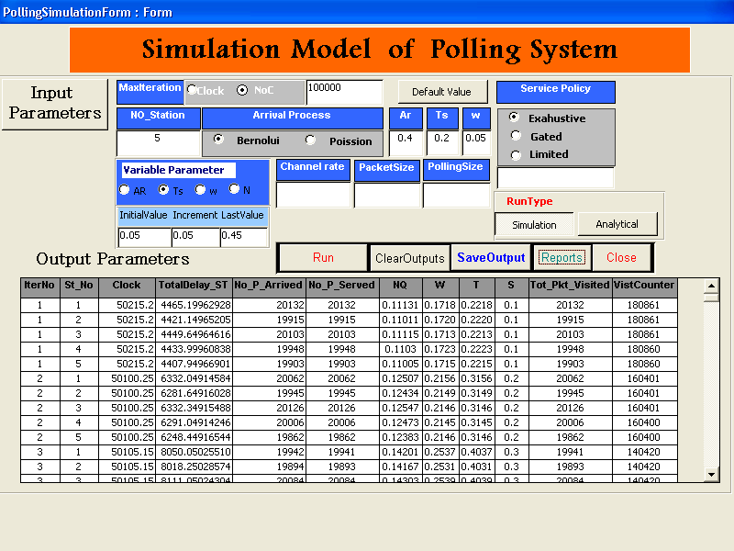

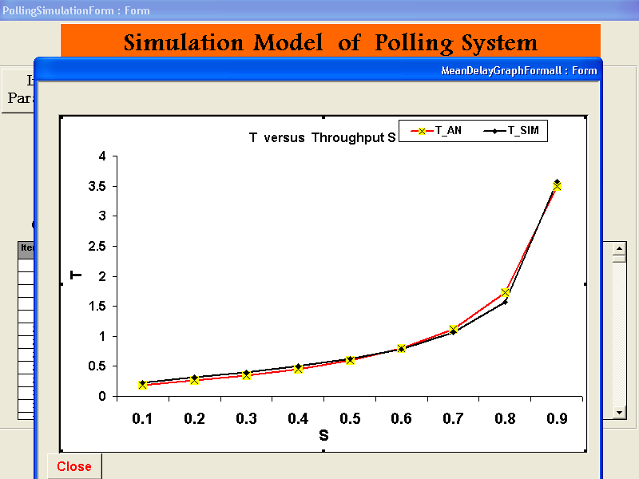
Platform (Microsoft Access 2003)

Simulation Code :

Attribute VB_Name = "poll"
Option Compare Database
' Declare Public constant.
Public Const ST_NO = 100, Q_Limit = 100000, Eevent_NO = 3
Global Landa, P, Meu, Clock, retval, MIAT, WalkTime, ServiceTime, WC, LastEventTime As Double
Global ServedPackets, NoofPacketServedInCurrentStation, MaxPacketToBeServed, NoOfIteration As Long
Global CurrentStation, NextStation, ArrivalType, ServiceType, NextEventType, NoofStations, RunType, TargetStation As Byte
Global PacketsDelay(ST_NO), PacketsDelayInQueue(ST_NO), TotalPaketsDelay, TimeOfArrival(ST_NO, Q_Limit), TotalDelays As Double
Global Qsize(ST_NO), ServedPacketPerStation(ST_NO), QueuedPackets(ST_NO), NumberOfCycle, MaxQ(ST_NO) As Long
Global VisitingCounter(ST_NO), NoofArrivedPackets(ST_NO), TotalPacktsVisited(ST_NO), LimitedParameter, SizeAtArrival As Long
Global TotalofWalkTime, TotalofSerciceTime, NextEventTime(Eevent_NO, ST_NO) As Double

Sub main()

Initialization

While (ServedPackets <= MaxPacketToBeServed) ' Check if simulation Over

ScheduleNewEvent (CurrentStation) ' Find the next event

Select Case NextEventType ' Evaluate TypeOfNextEvent.

Case 1 '"ARRIVAL"
PacketArrival (TargetStation) ' arrival to station i

Case 2 '"POLL"
PollArrival (TargetStation)

Case 3 'COMPLETE
Completion (TargetStation) ' serve queu i
Case Else ' Other values.
Debug.Print "Not between 1 and 3"
End Select

Wend
Report
End Sub

'==================================================================

Sub Initialization()
Dim i As Integer
' initialize all statistical parametrs and the events list
NumberOfCycle = 0
Clock = 0
NextEventType = 0
ServedPackets = 0
SizeAtArrival = 0
TotalDelays = 0
NoofPacketServedInCurrentStation = 0
LastEventTime = 0
TimeSinceLastEvent = 0
TotalofWalkTime = 0
TotalofSerciceTime = 0
If LimitedParameter = 0 Then LimitedParameter = 1000000000#
For i = 1 To NoofStations
PacketsDelay(i) = 0
ServedPacketPerStation(i) = 0
PacketsDelayInQueue(i) = 0
NoofArrivedPackets(i) = 0
Qsize(i) = 0
MaxQ(i) = 0
QueuedPackets(i) = 0
VisitingCounter(i) = 0
TotalPacktsVisited(i) = 0
Next i

For i = 1 To NoofStations
If ArrivalType = 1 Then
NextEventTime(1, i) = 0 'Clock + Bernouli((P))
Else
NextEventTime(1, i) = 0 'Clock + expon((MIAT))
End If
NextEventTime(3, i) = 1E+29
TimeOfArrival(i, 1) = NextEventTime(1, i)
Next i

CurrentStation = 1 'Start polling first station
NextStation = 1
NextEventTime(2, 1) = WalkTime + Clock 'Send poll to first station
WC = 0
End Sub

Sub ScheduleNewEvent(station As Byte)
'the next event is either : (1) Arrival , (2)POLL ,(3) Call Completion
'Return the event with Minimum Time And its type and Station Number
'Calculate Statistics
Dim tempevent, tempstation, j As Integer
Dim TimeSinceLastEvent, MinTimeOfNextEvent, delay As Double
Dim min1, min2 As Double

NextEventType = 0
MinTimeOfNextEvent = 1E+29

' Compair the nearst arrival with the next service time
' of curruent station and with the next poll

' return the nearset one in time with event time and advance

For j = 1 To NoofStations
If NextEventTime(1, j) < MinTimeOfNextEvent Then ' find nearest arrival
MinTimeOfNextEvent = NextEventTime(1, j)
NextEventType = 1
TargetStation = j
End If
Next j
If NextEventTime(3, station) <= MinTimeOfNextEvent Then 'compare with next service time
' of current station
MinTimeOfNextEvent = NextEventTime(3, station)
NextEventType = 3
TargetStation = station
End If
tempevent = NextEventType
tempstation = TargetStation
min1 = MinTimeOfNextEvent

If NextEventTime(2, 1) < MinTimeOfNextEvent Then ' compare with next poll time
MinTimeOfNextEvent = NextEventTime(2, 1)
NextEventType = 2
TargetStation = NextStation
End If

If NextEventType = 2 And WalkTime = 0 Then
j = 0
For i = 1 To NoofStations
If Qsize(i) > 0 Then j = j + 1 ' check if all sations empty
Next i
If j = 0 Then ' if all stations are empty advance to nearst arrival
MinTimeOfNextEvent = min1 '
NextEventTime(2, 1) = min1
TargetStation = tempstation
End If
End If

If NextEventType = 0 Then
ret = MsgBox("\n event list is empty at Clock" & Clock, vbOKOnly, "WARRING")
Exit Sub
End If

Clock = MinTimeOfNextEvent 'Advanced clock time

' calculate Statistics
TimeSinceLastEvent = Clock - LastEventTime
LastEventTime = Clock
TotalDelays = TotalDelays + TimeSinceLastEvent
If NextEventType = 2 Then TotalofWalkTime = WalkTime + TotalofWalkTime
'TotalDelayOfCustomersInQueue = TotalDelayOfCustomersInQueue + NoOfCustomerInQueue * TimeSinceLastEvent
'TotalTimeServerBusy = TotalTimeServerBusy + ServerStatus * TimeSinceLastEvent
' For j = 1 To NoofStations
' PacketsDelay(j) = PacketsDelay(j) + Qsize(j) * TimeSinceLastEvent
' Next j
End Sub

'=================================================================
Sub PacketArrival(station As Byte)
Dim i, j As Byte

Call ScheduleNextEvent(station, "ARRIVAL") ' schedule next event time
NoofArrivedPackets(station) = NoofArrivedPackets(station) + 1
Qsize(station) = Qsize(station) + 1
QueuedPackets(station) = QueuedPackets(station) + 1
TimeOfArrival(station, Qsize(station)) = Clock ' record packet arrival time
If Qsize(station) > MaxQ(station) Then MaxQ(station) = Qsize(station)

End Sub
'=================================================================
Sub PollArrival(station As Byte)
' Check if polled station has packets
' otherwise pass the poll
VisitingCounter(station) = VisitingCounter(station) + 1
TotalPacktsVisited(station) = TotalPacktsVisited(station) + Qsize(station)
SizeAtArrival = Qsize(station)
If Qsize(station) > 0 Then
Call ScheduleNextEvent(station, "COMPLETE") 'start serving current station
NextEventTime(2, 1) = 1E+29 'hold the poll
Else
Call ScheduleNextEvent(station, "POLL") 'pass the poll
End If
End Sub
'==================================================================

Sub Completion(station As Byte)

Dim i As Long
Dim delay As Double
' Collect statistics
If Qsize(station) > 0 Then
delay = Clock - TimeOfArrival(station, 1)
PacketsDelay(station) = PacketsDelay(station) + delay
ServedPackets = ServedPackets + 1
ServedPacketPerStation(station) = ServedPacketPerStation(station) + 1
NoofPacketServedInCurrentStation = NoofPacketServedInCurrentStation + 1
Qsize(station) = Qsize(station) - 1
TotalofSerciceTime = ServiceTime + TotalofSerciceTime
End If
'========= check for service policy type
' 1- exahustive serve all packets
' 2- gated serve SizeAtArrival
' 3- limited serve LimitedParameter
'==========================================
If ServiceType = 3 And NoofPacketServedInCurrentStation >= LimitedParameter Then
NoofPacketServedInCurrentStation = 0
Call ScheduleNextEvent(station, "POLL") 'if limitedfactor exceeded pass poll
Else
If ServiceType = 2 And NoofPacketServedInCurrentStation >= SizeAtArrival Then
NoofPacketServedInCurrentStation = 0

SizeAtArrival = 0
Call ScheduleNextEvent(station, "POLL") 'f limitedfactor exceeded pass poll
Else

If Qsize(station) = 0 Then
NextEventTime(3, station) = 1E+29 ' hold its serving time and move
to next station
TimeOfArrival(station, 1) = 0
Call ScheduleNextEvent(station, "POLL") 'if last packet pass poll
NoofPacketServedInCurrentStation = 0
SizeAtArrival = 0
Else
For i = 1 To Qsize(station) ' advance the packet in queue
TimeOfArrival(station, i) = TimeOfArrival(station, i + 1)
Next i
Call ScheduleNextEvent(station, "COMPLETE")
End If
End If
End If
End Sub

'==================================================================

Sub ScheduleNextEvent(station As Byte, EventType As String)
Dim U As Double

If EventType = "ARRIVAL" Then
If ArrivalProcess = "Poission" Then
NextEventTime(1, station) = Clock + expon((MIAT))
Else

NextEventTime(1, station) = Clock + Bernouli((P))
End If

End If

If EventType = "COMPLETE" Then
NextEventTime(3, station) = Clock + ServiceTime
PacketsDelayInQueue(station) = PacketsDelayInQueue(station) + Clock –
TimeOfArrival(station, 1)

End If

If EventType = "POLL" Then

NextEventTime(2, 1) = Clock + WalkTime
NextStation = (station + 1) Mod NoofStations ' Station Seq 1,2,........,N
If NextStation = 0 Then ' reaching last station
NextStation = NoofStations
NumberOfCycle = NumberOfCycle + 1
End If
CurrentStation = NextStation
End If

End Sub
'==================================================================

Function expon(mean As Double) As Double
Dim U As Double
Randomize
U = Rnd
expon = -mean * Log(U)

End Function
'==================================================================
Function Bernouli(P As Double) As Double
Dim U, i As Double

Randomize
U = Rnd
i = 1

While (U > P) ' search for first success
Randomize
U = Rnd
i = i + 1
Wend

Bernouli = i ' return the next slot time of the next arrival

End Function
'==================================================================
Sub Report()
'Writing OutPut Parameters
Dim str As String
Dim db As Database
Dim rst As Recordset
Dim retval As Integer
Dim i As Integer
str = "SELECT OutPutTable.* FROM OutPutTable;"
Set db = CurrentDb()
Set rst = db.OpenRecordset(str)
For i = 1 To NoofStations
rst.AddNew
rst!Clock = Clock
rst!MaxDelay = 0 'MaxDelay(i)
rst!IterationNo = NoOfIteration
rst!MaxQueueSize = MaxQ(i)
rst!NoOfPacketArrived = NoofArrivedPackets(i)
rst!NoOfPacketServed = ServedPacketPerStation(i)
rst!NoofStations = NoofStations
rst!StationNo = i
rst!ArrivalRate = 1 / MIAT
rst!PacketsInqueue = QueuedPackets(i)
rst!PacketsDelay = PacketsDelay(i)
rst!VisitingCounter = VisitingCounter(i)
rst!ServiceTime = ServiceTime
rst!WalkTime = WalkTime
rst!TotalDelay = TotalDelays
rst!AverageDelay = PacketsDelay(i) / ServedPacketPerStation(i)
rst!TotalPacktsVisited = TotalPacktsVisited(i)
rst!NQ = TotalPacktsVisited(i) / VisitingCounter(i) 'PacketsDelayInQueue(i) / PacketsDelay(i)
rst!NQ2 = TotalPacktsVisited(i) / VisitingCounter(i)
rst!T = PacketsDelay(i) / ServedPacketPerStation(i)
rst!W = PacketsDelayInQueue(i) / QueuedPackets(i)
' rst!S = TotalofSerciceTime / Clock
rst!S = NoofStations * (1 / MIAT) * ServiceTime

rst.Update
Next i
rst.Close
Set db = Nothing
End Sub

References:

[1] Joseph L.Hammond and Peter J.P. O’Reilly “Performance Analysis of Local Computer Networks”, 1986, Addison-wesley publishing company.

[2] Course slides and notes.

