

KING FAHD UNIVERSITY OF PETROLEUM AND MINERALS

COMPUTER ENGINEERING DEPARTMENT

Project Report

Wireless Data Services in CDMA2000

COE- 543 MOBILE AND WIRELESS NETWORKS

Submitted to

Dr. Ashraf S. Hasan Mahmoud

By

Mohammed Yousuf Shareef

ST ID#220326

Table of Contents

1. Introduction 3
2. Evolution Of CDMA2000 3
Cdma2000-1X 3
CDMA2000 1xEV 4
Cdma2000-3X 5
3. Channels Of Cdma 2000 6
CDMA2000 Forward Link 6
4.Packet Data MAC Operation states in Cdma 2000 8
5. Cdma2000 Network Architecture 9
6. Packet Data Call Setup 11
7. Services Of CDMA2000 Networks 12
Short Message Services (SMS) 12
Unified Messaging 13
8. CDMA2000 Packet Core Network 14
9. AAA Services of Cdma2000 Networks 16
Authentication 16
Authorization 17
Accounting 18
10.Advantages of Cdma2000 21
Increased Voice Capacity 22
Higher Data Throughput 22
Increased Battery Life 22
Synchronization 22
Frequency Band Flexibility 22
Power Control 22
Soft Hand-off 23
Transmit Diversity 23
Voice and Data Channels 23
Traffic Channel 24
Supplemental Channels 24
Turbo Coding 24
11.Conclusion 25
12.REFERENCES 26

List of Figures

Figure 1: IMT-2000 Radio Interfaces 3
Figure 2: Cdma2000-1X 4
Figure 3: Cdma2000 Forward Link 6
Figure 4: Cdma2000 Reverse Link 7
Figure 5: MAC Operation states 8
Figure 6: Cdma2000 Network Architecture 9
Figure 7: Packet Data Call Set Up 11
Figure 8: Cdma2000 Packet Core Network 15
Figure 9: Policy System 18
Figure 10: Simple IP 19
Figure 11: Mobile IP 20
Figure 12: IP Policy Management 21

List of Tables
Table 1:Approximate Download time for 3 minute mp3 5
Table 2: Cdma2000 Forward Link………………………………………………………… 7

1. Introduction

The cdma2000 RTT is a wideband, spread spectrum radio interface that uses Code Division Multiple Access (CDMA) technology to meet the IMT-2000 requirements. IMT-2000 requirements are satisfied for the Indoor Office, Indoor to Outdoor/Pedestrian, and Vehicular environments. Cdma2000 operates in both FDD and TDD modes. Cdma2000 meets all of the requirements for the next generation evolution of the current CdmaOne family of standards, including support for voice only, simultaneous voice and data, data only, and location services. Cdma2000 evolves existing CdmaOne services, including speech coders, packet data services, circuit data services, fax services, Short Messaging Services (SMS), and Over the Air Activation and Service Provisioning (OTASP). Cdma2000 is a trademark of the Telecommunications Industry Association (TIA). Code Division Multiple Access 2000 (Cdma2000)- multicarrier- is backwards compatible with IS-95 (CdmaOne), a principle reason for its likely adoption in existing IS-95 networks. Cdma2000, also known as IMT-CDMA Multi-Carrier (1X/3X), is a radio transmission technology for the evolution of narrowband CdmaOne/ IS-95 to 3G by adding up multiple carriers. As its name suggests, multicarrier means many paths are used to and from the terminal for transmitting and receiving data.

2. Evolution Of CDMA2000

3G is the term used to describe next generation mobile services which provide better quality voice and high-speed Internet and multimedia services. While there are many interpretations of what 3G represents, the only definition accepted universally is the one published by the International Telecommunication Union (ITU). ITU, working with industry bodies from around the world, defines and approves technical requirements and standards as well as the use of spectrum for 3G systems under the IMT-2000 (International Telecommunication Union-2000) program. The ITU requires that IMT-2000 (3G) networks, among other capabilities, deliver improved system capacity and spectrum efficiency over the 2G systems and support data services at minimum transmission rates of 144 kbps in mobile (outdoor) and 2 Mbps in fixed (indoor) environments. Based on these requirements, in 1999 ITU approved five radio interfaces for IMT-2000 standards as a part of the ITU-R M.1457 Recommendation. CDMA2000 is one of the five standards. It is also known by its ITU name IMT-CDMA Multi Carrier.

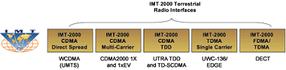

Figure 1: IMT-2000 Radio Interfaces

Cdma2000-1X

The Cdma2000 standard is evolving to continually support new services in a standard 1.25 MHz carrier. The first phase of Cdma2000, or Cdma2000 1X will deliver average data rates of 144 kbps.1X offers approximately twice the voice capacity of CdmaOne, average data rates of 144 kbps, backward compatibility with CdmaOne networks, and many other performance improvements. 1X refers to Cdma2000 implementation within existing spectrum allocations for CdmaOne - 1.25 MHz carriers. The technical term is derived from N =1 (i.e. use of same 1.25 MHz carrier as in CdmaOne) and the 1X means one times 1.25 MHz.

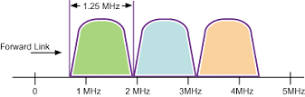

Figure 2: Cdma2000-1X
CDMA2000 1X can be implemented in existing spectrum or in new spectrum allocations. A CDMA2000 1X network will also introduce simultaneous voice and data services, low latency data support and other performance improvements. By migrating from the current IS-95 CDMA air interface technology to 1XRTT, operators double the radio capacity and gain packet data speeds of up to 144 Kbps. 1XRTT will include a new physical layer for 1XRTT and 3XRTT 1.25 MHz channel sizes, support for direct spread and multi carrier forward link 3XRTT options, and twice the current voice capacity. Data services will also be improved with 1XRTT with a full Media Access Control (MAC) framework and packet data MAC definition.

CDMA2000 1xEV

Phase two, labeled Cdma2000 1xEV, will provide for data rates greater than 2Mbps. Cdma2000 represents a family of technologies that includes Cdma2000 1X and Cdma2000 1xEV.

Cdma2000 1xEV includes:

- Cdma2000 1xEV-DO
Cdma2000 1xEV-DO delivers peak data speeds of 2.4Mbps and supports applications such as MP3 transfers and video conferencing.
- Cdma2000 1xEV-DV
Cdma2000 1xEV-DV provides integrated voice and simultaneous high-speed packet data multimedia services at speeds of up to 3.09 Mbps.

1xEV-DO and 1xEV-DV are both backward compatible with Cdma2000 1X and CdmaOne.

The evolution of Cdma2000 beyond 1X is now labeled Cdma2000 1xEV. 1xEV will be divided into two steps: 1xEV-DO and 1xEV-DV. 1xEV-DO stands for 1X Evolution Data Only. 1xEV-DV stands for 1X Evolution Data and Voice. Both 1xEV evolution steps provide for advanced services in Cdma2000 using a standard 1.25 MHz carrier. Evolution with Cdma2000 will therefore continue to be backward compatible with today's networks and forwards compatible with each evolution option.
1xEV-DO will require a separate carrier for data, but this carrier will be able to hand-off to a 1X carrier if simultaneous voice and data services are needed. By allocating a separate carrier for data, operators will be able to deliver peak rates in excess of 2 Mbps (best effort) to their data customers.
IXEV-DV will bring data and voice services for Cdma2000 back into one carrier. A 1xEV-DV carrier will provide not only high-speed data and voice simultaneously, but will also be capable of delivering real-time packet services.

Table 1:Approximate Download time for 3 minute mp3

Network | Max.Data Rate | Download time
GSM | 9.6Kbps | 41 minutes
IS95-A CDMA | 14.4Kbps | 31 minutes
GPRS | 45Kbps | 9 minutes
IS95-B CDMA | 64Kbps | 6 minutes
CDMA 2000-1X | 307Kbps | 1.5 minutes
WCDMA | 384Kbps | 61 seconds
CDMA2000 1XEV-DO | 2.4Mbps | 11 seconds

Cdma2000-3X
3XRTT will support all channel sizes (6x, 9x and 12x) and will use 5 MHz of bandwidth and is expected to allow up to 2 Mbps for stationary applications. 3XRTT will yield up to 1 Mbps for each Traffic or Walsh Channel- by bundling two channels. The 2 Mbps peak data rate targeted by the ITU for IMT-2000 should therefore be achievable

3. Channels Of Cdma 2000
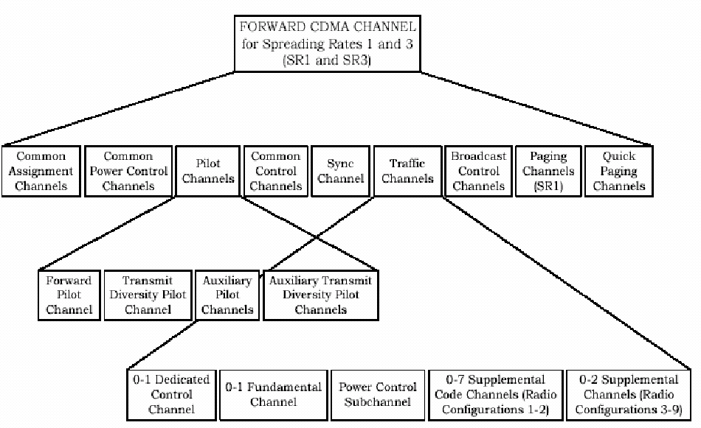

Figure 3: Cdma2000 Forward Link

CDMA2000 Forward Link

Spreading Rates
SR1(1.2288Mcps) and SR3(3XRTT)
Nine Forward link radio configurations
RC1-RC9
Each RC is characterized by physical layer parameters such as different modulation and coding

Table 2: Cdma2000 Forward Link

RC | Max.Data Rate | Code Rate | SR
1 | 9.6kbps | 1/2 | SR1
2 | 14.4kbps | 1/2 | SR1
3 | 153.6kbps | 1/4 | SR1
6 | 307.2kbps | 1/6 | SR1
9 | 1.036Mbps | 1/3 | SR1

New Common Channels:

There are 7 Forward Common Control Channels (F-CCCH). Signaling and MAC messages are 8 Forward Broadcast Control Channels (F-BCCH) and Paging messages, which are specifically used for CDMA2000 mobiles to reduce load on CdmaOne channels. There is a Forward Common Auxiliary Pilot Channel (F-CAICH), which is used to generate spot beams in a particular area (hot spot). There are 3 Forward Quick Paging Channels (F-QPCH) to indicate the mobile to wake up for a message on the paging channel. This helps in conserving battery during idle time. There are 4 Forward Common Power Control Channels (F-CPCCH) which are used to control the reverse access channels.

Dedicated Channels:

CdmaOne has Forward Fundamental Channel (F-FCH) which is primarily used for voice, but may carry data up to 14.4kbps.IS-95B (2.5G): Up to 7 Forward Supplemental Code Channels (F-SCCH) per user Strictly for data traffic supporting either RC1 or RC2.Multiple channel aggregation: 9.6 - 115.2kbps.

New Dedicated Channels:

Forward Dedicated Common Control Channel (F-DCCH) used for high-priority data traffic, such as data re-transmissions. There are 2 Forward Supplemental Channels (F-SCH) per user only for data, but supports RC3 through RC9.

CDMA2000 Reverse Link
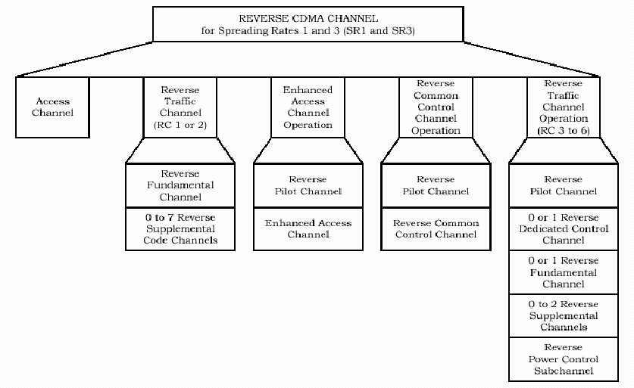

Figure 4: Cdma2000 Reverse Link

New Common Channels:

Reverse Enhanced Access Channel (REACH), Reverse Common Control Channel (RCCCH) is the new common channel added to Cdma2000 which provides more reliable and power efficient access

Dedicated Channels:
CdmaOne has Reverse Fundamental Channel (R-FCH). IS-95B (2.5G) has up to 7 Reverse Supplemental Code Channels (R-SCCH) per user.

New Dedicated Channels:

Reverse Dedicated Control Channel (R-DCCH) is the new dedicated channel. There are 2 Reverse Supplemental Channels (R-SCH) per user. Reverse Pilot Channel (R-PICH), which improves reception at the receiver. Power control bits are multiplexed (at 800Hz) for forward link power control.

4.Packet Data MAC Operation states in Cdma 2000

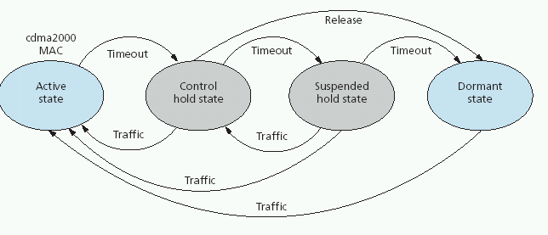
Figure 5: MAC Operation states

In the active state, traffic, power control channels are assigned .In the control hold state, a dedicated control channel is maintained between the user and the base station on which any Mac command can be transmitted with virtually no latency. Power control is also maintained so that a high speed burst operation can begin with no delay due to stabilization of power control. In the suspended hold state, there are no dedicated channels maintained to or from the user. A short data burst is added to the cdma2000 dormant state to support the delivery of short messages without incurring the overhead of a transition from dormant to active state.

5. Cdma2000 Network Architecture

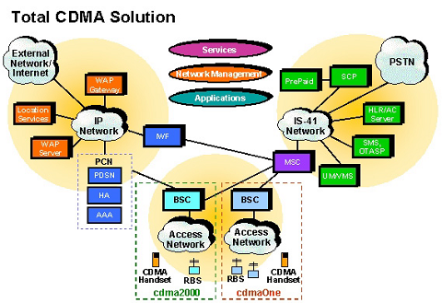
Figure 6: Cdma2000 Network Architecture

Base Station Controller (BSC)
Advanced, packet-based architecture and support for open interfaces provide operators with the flexibility and performance needed to succeed in a competitive wireless market.

Radio Base Station (RBS)
Industry-leading compact design enables operators to deploy the highest performance, most cost-effective networks for all types of scenarios and application needs.

Packet Core Network (PCN)
Always online, always connected functionality and direct access to IP-service networks.

Mobile Switching Center (MSC)
Maximum performance with minimum risk, built upon the highly successful AXE architecture.

Interworking Function (IWF)
The industry's most flexible, scaleable and cost-effective platform for delivering end-to-end mobile solutions over CDMA networks.
Home Location Register (HLR)
Off-switch subscriber database offering flexible dimensioning, telecom-grade performance and profit-generating features.

Authentication Center (AC)
Cost-effective fraud prevention based on the open and flexible JAMBALA™ platform.

Wireless Applications Protocol (WAP)
Merging the convenience of wireless applications and communications with the information access of the Internet.

Network Management Solution (NMS)
Network Management Solutions are designed to:
- Help make managing networks less costly, more effective and better aligned with your business strategies
- Deliver customized solutions and helps to leverage full solution capability
- Support by providing on-going assistance and long-term commitment to better manage of networks

Support for All Key Network and Service Management Functional Areas

- Network Surveillance involves detecting, isolating, and fixing network problems to prevent faults from causing downtime or unacceptable network degradation.
- Performance Management measures and reports network-wide performance statistics enabling management entities to continuously monitor performance variables.
- Trouble Management encompasses the description of occurrences affecting the network and communication of information throughout the operator's organization.
- Configuration Management supports the complex and time-consuming tasks of installation, administration and configuration of the network.
- Asset Management includes the area of network inventory and offers a view of both physical and logical aspects.
- Service Level Management offers proactive monitoring and reporting on the quality of services.
- Traffic Management helps manage the network traffic enabling as many calls as possible to be successfully completed.
- Accounting Management handles the billing mediation to provide collection, processing and distribution of call data records.
- Service Provisioning offers solutions for rapid, automatic activation of services and subscriptions.
- Data Warehousing Solutions analyze and correlate data from various sources and translate information into strategic insights.

Benefits

Improved service deployment Fast response to business opportunities, an enriched service portfolio and increased subscriber satisfaction. Cost savings Centralized control, automated network management and notification of field support personnel, tracking and reporting of maintenance performance Improved Quality of Service (QoS) Reduced problem resolution time, better customer response through automation, proactive maintenance and predictive performance reports Simplified network and service management. An end-to-end network management solution will assist in coping with the increasing network capacity.

6. Packet Data Call Setup
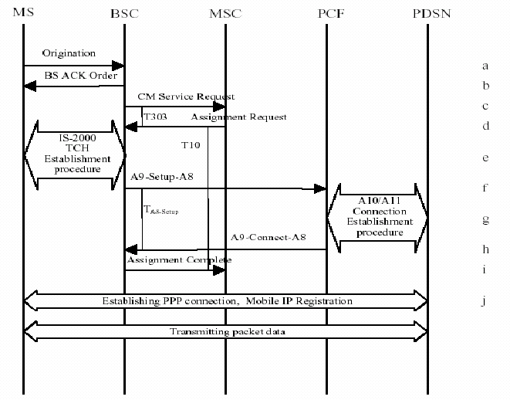
Figure 7: Packet Data Call Set Up

a) In Origination Message, MN requests packet data service (can also request supplementary services like fax over circuit.)
b) BSC acknowledges
c) BSC sends service request message to MSC.
d) After Authentication MSC sends channel assignment request message.
e) Forward and Reverse channel assignment procedures (same as (e) thru (j)).
f) A9-Setup-A8 message to PCF to establish A8 connection.
g) Procedure for establishing A10/A11 connection between PCF and PDSN (R-P interface).
h) PCF transmits A9-Connect-A8 message to BSC.
i) BSC transmits Assignment Complete message to MSC.
j) PPP connection establishment procedure and Mobile IP registration procedure initiated.

7. Services Of CDMA2000 Networks
Powerful network service elements that combine scaleable capabilities, low-ownership costs and new opportunities for business profit and customer loyalty.

Short Message Services (SMS)

Short Message Services (SMS) have the potential to make a significant contribution to the revenues and profits of CDMA wireless network operators. For many end users, SMS could become an essential part of every day life. Messaging-over-IP SMS is a powerful wireless network element for capturing this new market, and turning SMS messaging into a valuable business activity.
Messaging-over-IP SMS increases chargeable network traffic, cuts network management and operational costs, enhances customer care and customer loyalty and gives end users greater control over their personal and business lives. It’s a flexible foundation for the future that can support massive growth in SMS traffic and is able to provide a route into Internet Protocol (IP)-based messaging solutions.
SMS is becoming a part of the growing messaging culture that combines simplicity of use with low cost/high value services that will lead to increased network traffic, higher profits and greater customer loyalty.
Messaging-over-IP SMS not only provides a means to introduce SMS into your CDMA network, but it also provides a reliable migration path to more advanced applications. Messaging-over-IP SMS enhances both today’s and tomorrow’s electronic messaging world. It’s a scalable, highly flexible platform on which to build SMS, using industry-standard and proprietary interfaces that can be tailored for particular end user and network operator needs.
Messaging-over-IP SMS is an open systems platform with a highly adaptable and scalable architecture for CDMA networks. This powerful combination manifests itself in low cost of ownership, open-ended scalability, the flexibility to react quickly to new end user demands and applications, and new opportunities for building profitable, high revenue businesses based on customer loyalty.
Messaging-over-IP SMS uses UNIX-based, commercial, off-the-shelf servers with built-in hardware redundancy and media-independent message software. Open standards and protocols such as TCP/IP, SMTP, SMPP, CAP II and SNMP provide the flexibility to package custom-designed value-added services for competitive market differentiation. It is fully compliant with ANSI and ETSI recommendations and can function as a stand-alone SMS solution or as part of a fully integrated IP-based messaging solution.

Applications:

In addition to enabling short messages to and from hand held wireless terminals, Messaging-over-IP SMS gives you the ability to extend basic SMS functions with other valuable services for end users, network management and customer care.
Applications include:

- Over-the-Air Services: These powerful network management tools allows you to address the wireless terminal to activate and deactivate services and download data, e.g., for service access numbers, prepaid airtime updates and personalized services.

- Black List/White List: This functionality gives you a system-wide capability to include or bar subscribers from sending or receiving SMS messages.

- Live Operator Pools: Human operators can convert voice messages from callers to short SMS messages for transmission as text to recipients.

- Notification: Users receive an SMS message whenever voice or fax mail has been deposited.

- E-Mail Distribution: Short e-mails can be passed directly to a wireless terminal.

- Information Services: Push-pull services can be implemented allowing users access to any information provider – such as news headlines, stock prices, weather, travel, sports results, and bank statements at any time. Or, subscribers can choose to receive certain information, such as the price of a defined stock, at given times

- Remote Machine Interface (telemetry): An end-user can send and receive SMS messages to and from remotely located systems such as burglar or vehicle alarms, vending machines or weather stations.

Unified Messaging

Unified Messaging is an advanced messaging product for network operators that need to target high-end messaging users with state-of-the-art technology. It helps the network operator to differentiate services and reduces churn.
Unified Messaging offers a suite of services to the end-users. The end-user can send, retrieve and manage e-mail, voice mail and fax mail with one subscription, to one service, provided by one operator. In addition, messages may be managed from various terminal types including phones, web-browsers and standard e-mail clients such as Microsoft Outlook or Netscape Messenger. Unified Messaging offers the operator the ability to create different service levels for different end-user groups. The system supports a service differentiation through multiple classes of service definitions, enabling different tariffs for different service levels.
By deploying messaging as a network rather than with service nodes, several advantages can be drawn. The messaging network does not have a theoretical capacity limit since more nodes can be added, as more capacity is needed. Increased capacity is achieved by adding or extending the components that need extra capacity, rather than adding complete service nodes.
The system architecture is platform independent. This means that the network operator has multiple choices when choosing a platform for the system. Platforms can be based on any commercial hardware certified for use with the software application. Existing resources can be re-used minimizing the capital investment.

Supported Protocols:

- FTP – File Transfer Protocol
- H. 323 – ITU-T recommendation that specifies components, protocols and procedures used for transmission of real-time audio, video and data over IP-based networks
- WSP – WAP Gateway Proxy
- HTTP – Hyper Text Transfer Protocol
- IMAP – Internet Message Access Protocol
- ISUP – ISDN User Part
- LDAP – Lightweight Directory Access Protocol
- RADIUS-MA – Remote Authentication Dial-In User Services for Messaging Accounting
- SMPP – Short Message Peer to Peer Protocol
- SMTP – Simple Mail Transfer Protocol
- SNMP – Simple Network Management Protocol
- MIME – Multipurpose Internet Mail Extension

Features

  - Message deposit
  - Multiple-message retrieval methods (e-mail client, WEB browser, WAP browser, fax machine, telephone)
  - Message forwarding
  - Message inventory
  - Notification services
  - Message count notification
  - Single number reach
  - Personal mailbox administration
  - Text to speech conversion
  - Call handling

8. CDMA2000 Packet Core Network

The standards for a Cdma packet core network developed by the TR45.6 working group of the TIA. These standards are using existing standards from the IETF (Internet Engineering Task Force) on Mobile IP. 3GPP2 is also busy defining the evolution of a Cdma2000 network to All-IP. The Cdma2000 PCN will be the first step in this evolution. The PCN network is comprised of the PDSN (Packet Data Serving Node) and AAA (Authentication, Authorization and Accounting). The HA (Home Agent) can be added to provide Mobile IP based packet data services.

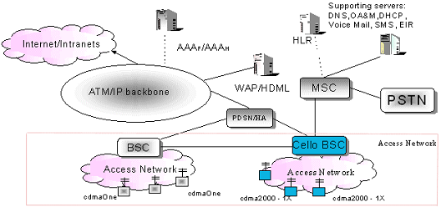

Figure 8: Cdma2000 Packet Core Network

Benefits

- Backward-compatibility with cdmaOne deployments

- Protects operator investment in existing cdmaOne networks
- Provides simple and cost-effective migration to 3G services Voice Improvement

  - Voice Improvement

- Voice Quality Improvement
- Voice Capacity Improvement (1X offers one and a half to 2 times the capacity of cdmaOne; 1xEV-DV offers even greater capacity increases)

- High Speed Data Services Support

- Higher Data Rates (144 kbps to 2 Mbps and beyond)
- Low Latency Data Support

- Multimedia Services Support

- Simultaneous Voice/Data Support for multi-service
- Quality of Service (QoS) Support for multimedia applications

- Special Applications

- Hot Spot Coverage (Spot Beams) and Follow-Me Service (Smart Antennas)
- Access Reliability and Extended Battery Life

The CDMA2000 subscriber terminal product will offer:

- Tri-mode: 800/1900 CDMA and 800 Analog
- Improved capacity and coverage, navigation and info presentation
- Packet Data Capability of 144 kbps
- Simultaneous voice and data support
- Blue tooth/WAP Enabled
- Backwards compatibility with cdmaOne
- Longer standby times

Policy-based authentication, authorization and accounting (AAA) lies at the heart of an end to- end CDMA2000 solution. It is the key to deploy differentiated mobile data services for specific market segments, such as consumer, youth and business.

9. AAA Services of Cdma2000 Networks

Advantages of the AAA Services are:

• Migrate from a “one size fits all” model to personalized services
• Package premium services for both residential and corporate users
• Collect detailed usage information for flexible billing options
• Track resource usage in real time for guaranteed access and access control.

AAA means moving beyond basic user authentication to policy-based authentication, authorization and accounting (AAA) for users’ access to network and application services.

AAA consists of three key functions:

• Authentication – recognize the user
• Authorization – enforce access controls and deliver services
• Accounting – track users’ usage of network resources

Today, network access control for both wire line and wireless Internet access is based on Remote Authentication Dial User Service (RADIUS), an IETF standard. Additional emerging standards, such as the Wireless IP Network Standard from the TIA, define support in third-generation wireless systems for wireless packet data networking. AAA can be more than just the RADIUS protocol. A policy-based AAA system can offer dynamic IP address management, network access controls, differentiated service delivery and comprehensive session-based accounting. Other standards, such as DIAMETER, are evolving for Mobile IP.

Authentication

When a wireless subscriber requests a data service, the mobile device – such as a cell phone, lap top or PDA – sends the request over the radio network to a Packet Data Serving Node (PDSN). The PDSN provides internetworking between the radio and IP networks.

The PDSN sends an Access-Request message to the AAA Server to authenticate the user. The AAA Server should have a centralized database of network, service and user policies, which it evaluates to decide what to do with the access request. For example, the AAA Server must determine whether the subscriber belongs to this network or to another service provider’s network and then either authenticate the user locally or forward the request to the AAA Server in the user’s home network. The AAA Server authenticates the user based on any number of attributes, such as the Network Access Identifier (NAI) username@realm, or Mobile Station Identifier (MSID).

Authorization

If the AAA Server authenticates the user successfully, it must authorize and deliver the appropriate type of service, based on network, service and user policies.

Authorization includes two main steps:

• Enforcing access controls
• Delivering services

The AAA Server can provide some level of authorization for a roaming user even when another AAA Server in the user’s home network performs the authentication. Service providers can maintain control over users who roam into their networks, for example, by enforcing access controls, such as time-of-day controls and quality of service (QOS) parameters, or applying attribute filtering for connection services.

Access controls

Access control policies control when, where and how the user can access the IP network:

• Day and time –Internet access control based on day and time; for example, users with a basic plan might only have access to certain services during peak periods
• Location –Restrict some users from roaming outside of specific geographical areas and give other users full mobility
• Guaranteed access –Reserve a certain number of data sessions for specific corporate customers to enforce service level agreements
• Session quotas – Control the number of users that can be logged in at any time from a specific user group; for example, you could restrict the number of subscribers from one operator who can roam into your network at any one time
• Fixed duration or pre-paid services – Restrict some users to a certain number of Hours of Internet access, based on pre-paid service packages

Flexible policies – Applicable for specific users, user groups, domains or organizations. To target services for specific corporate customers or restrict mobility for users in a given domain.

Service delivery

Service delivery means returning to the PDSN, the appropriate type and level of service for the user session, including an IP address. For example, one user may be allowed a standard PPP session to the Internet; another user may require a secure L2TP tunnel to a corporate network. Users’ policies determine what type of access they are allowed, based on criteria such as location, user preferences, and time of day.
The AAA Server must return service attributes to the PDSN to define the type of network session that it should establish. Connection services may include standard RADIUS and vendor-specific attributes, as well as 3GPP2 attributes.
For Simple IP, the AAA Server must return tunnel setup parameters. For Mobile IP, the AAA Server must return 3GPP2 attributes for the PDSN to establish secure communication with the Home Agent (HA). It allows certain users to request a connection type; for example, mobile users could request a secure tunnel to their corporate networks. It also delivers a tunnel automatically based on attributes in the Access-Request; for example, it could provide an L2TP tunnel for all users dialing a certain number. The AAA Server can manage both static and dynamic IP address allocation on a session basis. The AAA Server can manage dynamic pools of IP addresses to provide users with seamless mobility, while at the same time using IP addresses efficiently.

Accounting

A key challenge for wireless providers is the billing of data services based on more than airtime, especially in packet-based networks. Accounting records include information on session type, session duration, number of packets, bytes or messages sent, and so on. The AAA Server must be extensible to accommodate new data as the accounting requirements evolve. Accounting data is invaluable for flexible billing options – including prepaid services and usage-based charges for premium services – as well as for network planning, reporting and marketing purposes. In order to minimize the complexity of downstream processing, the AAA Server should be interoperable with revenue collection software that can provide real-time accounting correlation to produce a single, comprehensive accounting record for each session. It must also support partitioned data streams, in customized formats, for multiple downstream systems, including inter-working with roaming partners and corporate customers. Revenue collection should back up accounting records in a high-performance database for complete reliability of this important data.

The AAA Server acts as the Policy Decision Point in a wireless data implementation.
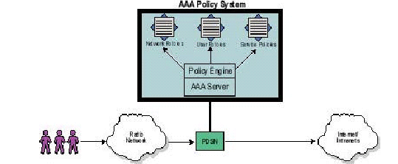
Figure 9: Policy System

The AAA Server enforces network, service and user policies for users’ Internet access and for all mobile data services.

Simple IP

Simple IP provides a very basic level of mobility. Users are restricted to roaming in a few cells within the same geographical area. Users can only maintain an IP address within cells connected to a single PDSN, served by a single wireless operator. There is no standardized hand-off of the user between PDSNs or between operators. Despite these restrictions, Simple IP is useful in both 2G and 3G networks. For example, by using AAA you can provide VPN tunneling from the service provider’s backbone to a corporation or ISP. Also authentication of users by proxying to a Home AAA Server for the user’s corporation or ISP is possible.
Depending on the relationships between service providers, users can roam between networks, but it is not seamless. In other words, as the user moves between different regions or networks, they must disconnect and then reconnect. This also requires more coordination between service providers.

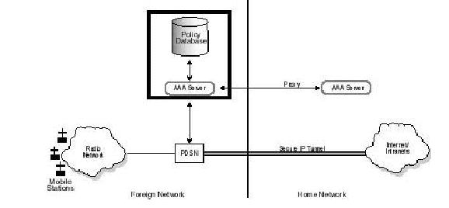
Figure 10: Simple IP

Mobile IP

Mobile IP enables full mobility by providing an IP handoff mechanism as the user moves within a wireless service provider’s regions and between providers’ networks. Mobile IP provides full mobility for users across geographical areas served by different wireless providers. The user’s service provider maintains a Home Agent (HA), which assigns the IP address and routes all the user’s IP traffic. The users’ mobile device connects to the nearest PDSN, which acts as a Foreign Agent (FA). The Foreign Agent contacts the home AAA Server to authenticate the user and retrieve tunneling parameters and an IP address. The Home Agent provides tunnel encryption keys to enable the establishment of a secure tunnel. Users can roam seamlessly between service providers’ networks. In each provider’s network, the AAA Server communicates with the AAA Server in the user’s home network to obtain tunneling parameters and IP addresses.

Figure 3 shows the role of AAA in 3G wireless networks. This figure shows an arrangement where the visited service provider provides access services for another service provider’s roaming users. The seamless hand-off of information between wireless providers ensures transparent mobility for users – the service they get on the road is the same as when they are at home.
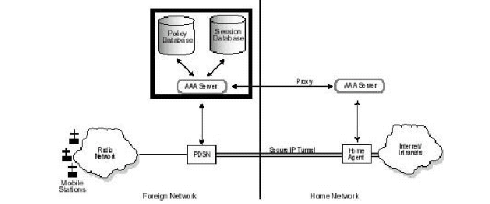
Figure 11: Mobile IP

Operational Integration

The AAA Server does not operate in isolation – It integrates seamlessly into the network and the operational environment. Simple and proven integration with provisioning, customer care, systems management and billing systems are critical to operational success. This not only allows ease of deployment, but also ensures customer information can be synchronized across systems, and new services can be introduced quickly and easily. The AAA Server must be open and support standard and published APIs for seamless inter-working with these systems, as well as allowing extensibility to application and content services. Multi-vendor and standards support ensures a future-proof solution, and one that not only works with any equipment you have in the network, but also provides for consolidated management into your existing operational systems environment.

The Power of Policies

Policy-based authentication, authorization and accounting (AAA) is the key to enabling differentiated mobile data services for the residential and corporate markets in both circuit switched and next-generation packet-switched (3G) IP networks. Figure 12 shows a complete IP policy management system provides AAA services for both network access and application services in 2G, 2.5G and 3G networks.

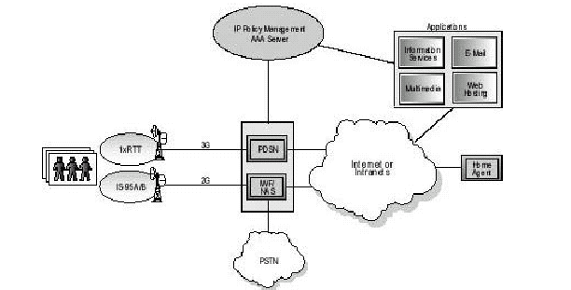
Figure 12: IP Policy Management
To take advantage of the exponential growth in demand for wireless services, the provider need to provide personalized service packages to the customers . At the same time shorten time-to-market for new services and manage all the customers and services efficiently to keep costs down.
AAA services are bundled together with customized services for specific organizations or domains, user groups and even individual users to deploy these services quickly. There is a need to move beyond basic IP connectivity to offer differentiated, competitive service packages, such as:
• Various degrees of mobility support
• Internet applications, including WAP-based applications
• Corporate outsourcing, with managed wireless VPNs and guaranteed access
• Dynamic session-based IP address management
• Access controls based on time of day, location, user policies, and network availability
• Comprehensive accounting for flexible session and traffic billing options

10.Advantages of Cdma2000

Cdma2000 benefited from the extensive experience acquired through several years of operation of cdmaOne systems. As a result, Cdma2000 is a very efficient and robust technology. Supporting voice and data, the standard was devised and tested in various spectrum bands, including the new IMT-2000 allocations.
There is tremendous demand for new services and operators are looking to provide these to many more subscribers at reasonable prices.
The unique features, benefits, and performance of Cdma2000 make it an excellent technology for high-voice capacity and high-speed packet data. The fact that CDMA2000 1X has the ability to support both voice and data services on the same carrier makes it cost effective for wireless operators.
Due to its optimized radio technology, CDMA2000 enables operators to invest in fewer cell sites and deploy them faster, ultimately allowing the service providers to increase their revenues with faster Return On Investment (ROI). Increased revenues, along with a wider array of services, make CDMA2000 the technology of choice for service providers.

Increased Voice Capacity

CDMA2000 1X supports 35 traffic channels per sector per RF (26 Erlangs/sector/RF) using the EVRC vocoder, which became commercial in 1999.
Voice capacity improvement in the forward link is attributed to faster power control, lower code rates (1/4 rate), and transmit diversity (for single path Raleigh fading). In the reverse link, capacity improvement is primarily due to coherent reverse link.

Higher Data Throughput

Today's commercial CDMA2000 1X networks (phase 1) support a peak data rate of 153.6 kbps. CDMA2000 1xEV-DO, commercial in Korea, enables peak rates of up to 2.4 Mbps and CDMA2000 1xEV-DV will be capable of delivering data of 3.09 Mbps.

Increased Battery Life

CDMA2000 significantly enhances battery performance. Benefits include:
  - Quick paging channel operation
  - Improved reverse link performance
  - New common channel structure and operation
  - Reverse link gated transmission
  - New MAC states for efficient and ubiquitous idle time operation

Synchronization

CDMA2000 is synchronized with the Universal Coordinated Time (UCT). The forward link transmission timing of all CDMA2000 base stations worldwide is synchronized within a few microseconds. Base station synchronization can be achieved through several techniques including self-synchronization, radio beep, or through satellite-based systems such as GPS, Galileo, or GLONASS. Reverse link timing is based on the received timing derived from the first multipath component used by the terminal.

Frequency Band Flexibility
CDMA2000 can be deployed in all cellular, PCS or new IMT-2000 spectrum. CDMA2000 networks have already been deployed in the 450 MHz, 800 MHz, 1700 MHz, and 1900 MHz bands. CDMA2000 can also be implemented in other frequencies such as 900 MHz and 1800 MHz. The high spectral efficiency of CDMA2000 permits high traffic deployments in any 1.25 MHz channel of spectrum.

Power Control
The basic frame length is 20 ms divided into 16 equal power control groups. In addition, CDMA2000 defines a 5 ms frame structure, essentially to support signaling bursts, as well as 40 and 80 ms frames, which offer additional interleaving depth and diversity gains for data services. Unlike IS-95 where Fast Closed Loop Power Control was applied only to the reverse link, CDMA2000 channels can be power controlled at up to 800 Hz in both the reverse and forward links. The reverse link power control command bits are punctured into the F-FCH or the F-DCCH (explained in later sections) depending on the service configuration. The forward link power control command bits are punctured in the last quarter of the R-PICH power control slot.

Soft Hand-off

In addition to intrasystem, intrafrequency monitoring, the network may direct the terminal to look for base stations on a different frequency or a different system. CDMA2000 provides a framework to the terminal in support of the inter- frequency handover measurements consisting of identity and system parameters to be measured. The terminal performs required measurements as allowed by its hardware capability.
In case of a terminal with dual receiver structure, the measurement can be done in parallel. When a terminal has a single receiver, the channel reception will be interrupted when performing the measurement. In this instance, during the measurement, a certain portion of a frame will be lost. To improve the chance of successful decoding, the terminal is allowed to bias the FL power control loop and boost the RL transmit power before performing the measurement. This method increases the energy per information bit and reduces the risk of losing the link in the interval. Based on measurement reports provided by the terminal, the network then decides whether or not to hand-off a given terminal to a different frequency system. It does not release the resource until it receives confirmation that hand-off was successful or the timer expires. This enables the terminal to come back in case it could not acquire the new frequency or the new system.

Transmit Diversity
Transmit diversity consists of de-multiplexing and modulating data into two orthogonal signals, each of them transmitted from a different antenna at the same frequency. The two orthogonal signals are generated using either Orthogonal Transmit Diversity (OTD) or Space-Time Spreading (STS). The receiver reconstructs the original signal using the diversity signals, thus taking advantage of the additional space and/or frequency diversity.
Another transmission option is directive transmission. The base station directs a beam towards a single user or a group of users in a specific location, thus providing space separation in addition to code separation. Depending on the radio environment, transmit diversity techniques may improve the link performance by up to 5 dB.

Voice and Data Channels
The CDMA2000 forward traffic channel structure may include several physical channels:
The Fundamental Channel (F-FCH) is equivalent to functionality Traffic Channel (TCH) for IS-95. It can support data, voice, or signaling multiplexed with one another at any rate from 750 bps to 14.4 kbps.
The Supplemental Channel (F-SCH) supports high rate data services. The network may schedule transmission on the F-SCH on a frame-by- frame basis, if desired.
The Dedicated Control Channel (F-DCCH) is used for signaling or bursty data sessions. This channel allows for sending the signaling information without any impact on the parallel data stream.
The reverse traffic channel structure is similar to the forward traffic channel. It may include R-PICH, a Fundamental Channel (R-FCH), and/or a Dedicated Control Channel (R-DCCH), and one or several Supplemental Channels (R-SCH). Their functionality and encoding structure is the same as for the forward link with data rates ranging from 1 kbps to 1 Mbps (It is important to note that while the standard supports a maximum data rate of 1 Mbps, existing products are supporting a peak data rate of 307 kbps).

Traffic Channel
The traffic channel structure and frame format is very flexible. In order to limit the signaling load that would be associated with a full frame format parameter negotiation, CDMA2000 specifies a set of channel configurations. It defines a spreading rate and an associated set of frames for each configuration.
The forward traffic channel always includes either a fundamental channel or a dedicated control channel. The main benefit of this multichannel forward traffic structure is the flexibility to independently set up and tear down new services without any complicated multiplexing reconfiguration or code channel juggling. The structure also allows different hand-off configurations for different channels. For example, the F-DCCH, which carries critical signaling information, may be in soft hand-off, while the associated F-SCH operation could be based on a best cell strategy.

Supplemental Channels
One key CDMA2000 1X feature is the ability to support both voice and data services on the same carrier. CDMA2000 operates at up to 16 or 32 times the FCH rate-also referred to as 16x or 32x in Release 0 and A, respectively. In contrast to voice calls, the traffic generated by packet data calls is bursty, with small durations of high traffic separated by larger durations of no traffic. It is very inefficient to dedicate a permanent traffic channel to a packet data call. This burstiness impacts the amount of available power to the voice calls, possibly degrading their quality if the system is not engineered correctly. Hence, a key CDMA2000 design issue is assuring that a CDMA channel carrying voice and data calls simultaneously do so with negligible impact to the QoS of both.
Supplemental Channels (SCHs) can be assigned and deassigned at any time by the base station. The SCH has the additional benefit of improved modulation, coding, and power control schemes. This allows a single SCH to provide a data rate of up to 16 FCH in CDMA2000 Release 0 (or 153.6 kbps for Rate Set 1 rates), and up to 32 FCH in CDMA2000 Release A (or 307.2 kbps for Rate Set 1 rates). Note that each sector of a base station may transmit multiple SCHs simultaneously if it has sufficient transmit power and Walsh codes. The CDMA2000 standard limits the number of SCHs a mobile station can support simultaneously to two. This is in addition to the FCH or DCCH, which are set up for the entire duration of the call since they are used to carry signaling and control frames as well as data. Two approaches are possible: individually assigned SCHs, with either finite or infinite assignments, or shared SCHs with infinite assignments.
For bursty and delay-tolerant traffic, assigning a few scheduled fat pipes is preferable to dedicating many thin or slow pipes. The fat-pipe approach exploits variations in the channel conditions of different users to maximize sector throughput. The more sensitive the traffic becomes to delay, such as voice, the more appropriate the dedicated traffic channel approach becomes.

Turbo Coding

CDMA2000 provides the option of using either turbo coding or convolutional coding on the forward and reverse SCHs. Both coding schemes are optional for the base station and the mobile station, and the capability of each is communicated through signaling messages prior to the set up of the call. In addition to peak rate increase and improved rate granularity, the major improvement to the traffic channel coding in CDMA2000 is the support of turbo coding at rate 1/2, 1/3, or 1/4. The turbo code is based on 1/8 state parallel structure and can only be used for supplemental channels and frames with more than 360 bits. Turbo coding provides a very efficient scheme for data transmission and leads to better link performance and system capacity improvements. In general, turbo coding provides a performance gain in terms of power savings over convolutional coding. This gain is a function of the data rate, with higher data rates generally providing more turbo coding gain

11.Conclusion

Mobile Internet services will become a major application in the next generation of mobile communications. To make costs reasonable, it will be very important in a data rich network to separate voice traffic and data traffic. Among several proposals for a data dedicated air interface, CDMA2000 1xEV-DO is the most advanced from technical maturation point of view. The evaluation of the HDR system, which is going to be a base of CDMA2000 1xEV-DO, is being developed in downtown Tokyo.
A mobile IP network utilizing CDMA2000 1xEV-DO is developed The network does not need telephone switches but only needs Internet routers for user data and signaling information exchange. A combination of Home Agents (HAs) and Packet Data Service Nodes (PDSNs) will allow location management of mobile terminals. Mobile Internet services can be applied to home use, outdoor mobile, and high-speed vehicle environments. For these applications, various kinds of network equipment and terminals are being developed. Data-oriented mobile Internet services are getting developed.

12.REFERENCES

1. Wireless Network Evolution by Vijay K. Garg
2. “Cdma2000: A Third generation radio transmission technology”, Bell Labs technical
Journal, sept.1998.
3. TIA/EIA IS-2000-3 “Medium Access Control Standard for cdma2000 Spread Spectrum
Systems,”Nov.1999.
4. Douglas N.Kinsley, Sarath Kumar, Subhasis Laha, and Sanjiv Nanda,“Evolution
Of Wireless Data Services IS-95 to cdma2000”.
5. Technology Primer AAA Services for Cdma2000 Networks, Bridge Water Systems

