Performance Evaluation of Routing Algorithms in Wireless Mobile Ad-Hoc Networks

Itrat Rasool Quadri
King Fahd University of Petroleum & Minerals
Dhahran, Saudi Arabia
E-mail: iquadri@ccse.kfupm.edu.sa
Tel: 8605926

Abstract

This decade will see an exponential increase in the use of advanced wireless mobile computing technology centered round the IP protocol suite. MANETs (Mobile Ad-Hoc Networks) support, robust and efficient operation by incorporating routing functionality into mobile nodes. These networks have a dynamic rapidly changing topology that is bandwidth constrained. Different protocols are available today that support the network infrastructure but adaptation is required in order to be useful within a network no longer connected to the Internet infrastructure. Protocols that build routes “on demand” minimize control traffic overhead whereas Table driven protocols produce extra control traffic, which is required to constantly update antiquated route entries. This paper evaluates the performance of such protocols under different circumstances.

1 Introduction

MANET consists of a set of mobile nodes, which communicate over radio regardless of the presence of infrastructure. Such networks are suitable for several kinds of applications and are very flexible. Communication has to be relayed over intermediate nodes most of the time due to limited transmission range of wireless interfaces, thus each node has to behave as a router in such multi-hop networks.

Mobile Ad-hoc networks have huge potential for use in several areas like conferencing, home networking, emergency services in case of failure of wired communication infrastructure due to power outage, PAN (Personal Area Networks) and Bluetooth, sensor dust etc.

To find a route between mobile nodes in a mobile multi-hop wireless network is a major problem. Many approaches have been proposed to solve this problem but so far no routing algorithm has shown to be suitable for all situations. The following sections give a detailed evaluation of routing algorithms such as DSDV (Destination-Sequenced Distance-Vector) which has been proposed to overcome large message penalties of DBF, DSR (Dynamic Source Routing) in which nodes communicate along paths stored in source routes carried along with the data packets, AODV (Ad Hoc On-Demand Distance Vector) routing protocol that gives an on-demand version of the distance-vector protocol, ZRP (Zone Routing Protocols) which hybridize protocols like DSDV with on-demand protocols, TORA (Temporally Ordered Routing Algorithm) which is the latest descendent of link-reversal protocols and STAR that is one such example of a partial link-state algorithm that is not table driven.

2 MANET Routing Protocols

2.1 DSDV (Destination Sequenced Distance Vector) Routing Protocol

DSDV, models mobile computers as routers cooperating to forward packets to each other as needed. DSDV is quite suitable for scenarios in which almost all nodes are mutually involved in communication with almost all other nodes and in which the mobility factor is medium.

2.2 DSR (Dynamic Source Routing) Protocol

DSR gives rise to a completely self-organizing and self-configuring network without the need for any existing network infrastructure or administration. ‘Route Discovery ‘ and ‘Route Maintenance’ are two of its mechanisms that discover and maintain source routes to arbitrary destinations in MANETs.

2.3 AODV (Ad Hoc On-Demand Distance Vector) routing protocol

AODV is capable of unicast and multicast routing. It builds routes between nodes when desired by source nodes. It maintains these routes as long as they are needed by the source. It uses trees to connect multicast group members. It is self-starting, loop free and highly scalable.

2.4 ZRP (Zone Routing Protocol)

ZRP combines the advantages of pro-active and reactive approaches to implement a routing protocol into a hybrid scheme taking advantage of the node’s local neighborhood based on former and communicates with these neighborhoods based on latter.

2.5 TORA (Temporally Ordered Routing Algorithm)

TORA has minimal reaction to topological changes. A packet is routed on the basis of information at each node in the network, and routes are selected through evaluation of a sophisticated height function for a DAG (Directed Acyclic Graph) used in determining the route between nodes.

2.6 STAR (Source Tree Adaptive Routing) protocol

Routers in star communicate their source routing trees to their neighbors either incrementally or in atomic updates. It performs efficient routing in packet radio networks using link-state information.

3 Simulation Based Performance Evaluation

This section provides details of simulation parameters used in simulation of protocols in various simulators like OPNET, NS-2, GloboSim, etc. mentioned earlier. The description consists of simulation parameters, effect of mobility, workload and performance results.

3.1 DSDV

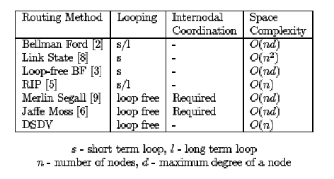

Figure 1

With the exception of link-state approach, all routing methods mentioned in Fig 1 are different varieties of distance-vector algorithm. The most desirable features that a routing algorithm should possess, is the comparison criteria to determine the usefulness in a dynamic ad hoc routing environment. Communication bandwidth is the most prized commodity in the wireless media. Routing loops are undesirable. They are the major cause of bandwidth consumption in infrared LANs that employ CSMA protocol and are also responsible for collisions in the medium. Internodal coordination is a technique to prevent loops with the imposition of constraints on update ordering among nodes. Resulting internodal protocols are complex. Obtaining alternate paths quickly becomes a major problem due to their update co-ordination where topology changes are frequent. One other method of comparison is the space requirement of the routing methods. The memory that backbone routers have at their disposal is much greater than what the laptops and the hand-held notebooks have. This points towards the importance of economy of space.

DBF algorithm is susceptible to routing loops and counting-to-infinity problem. RIP also suffers from this problem. Nodes make uncoordinated modifications to their route tables on the basis of possible incorrect information, which shows why loops are a major cause of concern in DBF algorithms. Merlin and Segall proposed a method to alleviate this problem through an internodal coordination mechanism followed by Jaffe and Mosse with better convergence results. It is not known if any of the routing protocols achieve elimination of loops through the use of these complex coordination mechanisms, which automatically brings us to the conclusion that, the usefulness of these complex methods is greatly reduced from the deployment point of view.

Link-state algorithms are free from routing to infinity problem, however an up-to-date version of the entire network topology has to be maintained at every node resulting in excessive communication and storage overhead in a rapidly changing network. However, temporary routing loops still have not been eliminated during implementation or in any proposed algorithm.

The DSDV approach has several desirable features. One such is its memory requirement that is O(n). Loop free paths are guaranteed at all instants without the implementation of complex update coordination protocol among nodes. Even though its worst-case convergence behavior is not optimal but still is quite rapid in the average case.

.

3.2 DSR

DSR was evaluated using discrete event simulation. The simulation environment consisted of wireless and mobile networking extensions [2]. ns-2 network simulator from the University of California at Berkeley and the VINT Project was used for the simulation. The extensions mentioned above provided a detailed model of the physical and link layer behavior of a wireless network, which allowed for the arbitrary movement of nodes within it. Free space, ground reflection propagation, transmission power, antenna gain, receiver sensitivity, propagation delay, carrier sense and capture effect were the realistic modeling factors provided at the physical layer [11]. Complete Distributed Coordination Function (DCF) MAC protocol of the IEEE

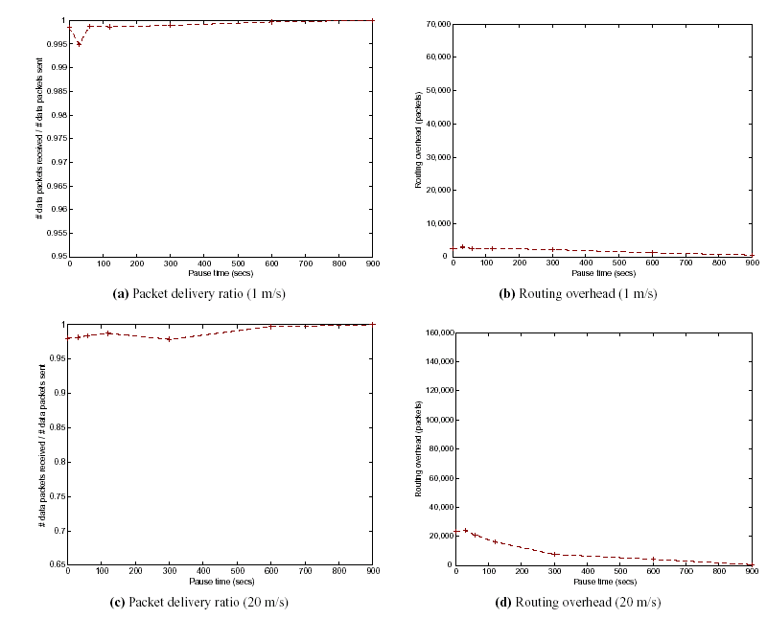
Figure 2

802.11 wireless LAN protocol standard and the standard Internet ARP were modeled at the link layer.

50 mobile nodes were modeled in the network moving according to the random waypoint mobility model [12] within a flat rectangular (1500 m * 300 m) area; simulations were run for 15 minutes. (CBR) UDP was used to generate traffic with 10, 20 or 30 mobile nodes acting as traffic sources, which generated 4 packets per second. The results for 20 sources were observed.
According to the random waypoint mobility model each mobile node begins at a random location and moves independently during the simulation. The node remains stationary for a specified period of time called the pause time and then moves straight to a new random location at a random speed up to some maximum speed. Upon reaching the new location the node again remains stationary for a pause time, again proceeds to a random location after that at a random speed. This behavior continues throughout the simulation.

The figure shows the performance of DSR as a function of pause time for different maximum node movement speeds. Fig 2 (a) and (b) represent the performance at 1 m/sec and figure (c) and (d) show the performance at 20 m/sec. The packet delivery ratio as represented in (a) and (c) is the overall percentage of the UDP data packets originated by nodes that were successfully delivered by DSR. The routing overhead as shown in (b) and (d) is the number of routing overhead packets generated by DSR to achieve this level of data packet delivery. A point in the graph represents the average of 10 random movements and communication scenarios for the given pause time. All nodes in the network are in constant motion at pause time 0. With the increase in pause time the average node movement rate in the network decreases. All nodes are stationary at pause time 900, which represents the time for which the simulation was run. The vertical scales for the two speeds differ in order to make the details more apparent.

At movement speeds of 1 m/sec and 20 m/sec, DSR delivered all data packets regardless of pause time with the ratio reaching 100% at a pause time of 900. Routing overhead turned out to be low at all pause times, 0 at pause time 900. It rose slowly as the pause time decreased. At the speed of 1 m/sec DSR was able to deliver 99.5% of all packets, which reached 99.8% on most occasions. At the speed of 20 m/sec DSR delivered 98% of the packets including pause time of 0.

3.3 AODV

The model environment was similar to that of GloboSim. The mobility model used is known as random direction [13].

3.3.1 Unicast Simulations

Unicast simulations were performed using 50, 100, 250 and 500 nodes. Sessions between randomly chosen sources and destinations were created. Data packets were sent at a rate of four packets per second once the session started until the simulation terminated or the maximum number of packets for that session was reached. Twenty such data sessions were created. The communication range (Rmax) determines the interconnection pattern of an adhoc network. Rmax was kept constant at 250 meters. Node density was approximately constant in different simulations as shown in Fig 3.1.

The main purpose of the simulation was to show that AODV can find routes quickly and accurately and can maintain them for as long as required. The packet delivery ratio was found to be similar to throughput in that it represented the number of data packets received as compared to number sent as shown in Fig 3.2. Because of the mobility of nodes and constant breakage of routes the ratio was not likely to be 100%. AODV does not retransmit data packets that are lost because of node mobility and therefore does not guarantee packet delivery. It is however able to find good route's for IP's best effort delivery and the ratio for packet delivery is high. It was observed that for stationary networks the ratio was approximately constant for networks of varying sizes. With the increase in node mobility the packet delivery rate rapidly decreased at a quicker rate for large networks than for smaller networks. It is due to longer path lengths required for connectivity maintenance between sources and destinations in the larger networks.

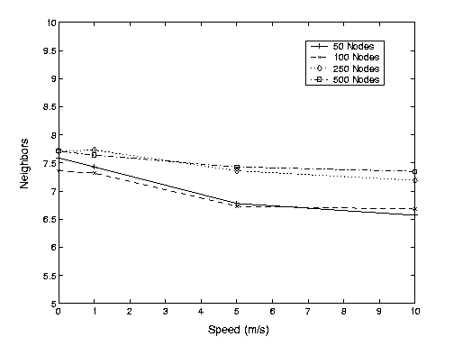
Figure 3.1
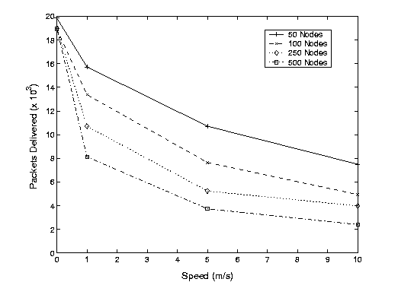
Figure 3.2

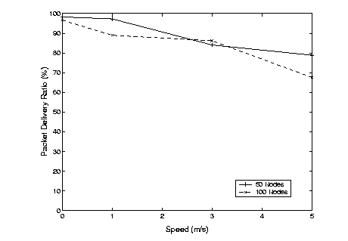
Figure 3.3

3.3.2 Multicast Simulations

For this scenario there was one multicast group that nodes could join. Ten randomly selected nodes joined the group at the simulation initiation and remained members for the entire duration. With the joining of all the members a node began sending data to all the members of the group until the simulation ended. Data packets were considered to be of 64 bytes and were sent at a rate of four per second.100% can be achieved if each node receives all the packets destined for it by the source. Fig 3.3 shows the packet delivery ratio for the simulations. It was found that the number of received data packets was between 95-100% for zero mobility. Packet delivery of 100% was not achieved for zero mobility because of probable collisions. The packet delivery ratio decreased with the increase in node mobility due to difficulty in maintaining multicast tree links. The protocol however performed well for slow node mobility achieving 87-97% packet delivery. The smaller networks outperformed larger networks with the increase in node mobility by a comprehensive margin.

3.4 ZRP

OPNET simulator from OPNET Technologies™, an event-driven simulation package was used to evaluate the performance of ZRP over a range of routing zone radii (p), from reactive flood search routing (p=1) to proactive link-state routing (p->∞).

The simulated RWN (Reconfigurable Wireless Network) consisted of 200 mobile nodes, whose initial positions were chosen from a random distribution over an area of 1,000m by 1000m. The duration of each simulation was 125 seconds. During the transient period of first five seconds no data was collected to ensure stability of the route discovery
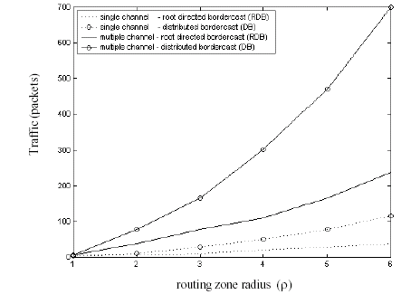
Figure 4.1

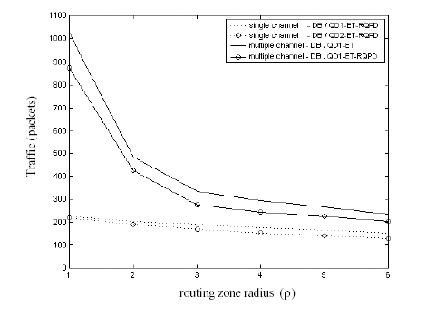
Figure 4.2
process. According to the assumption made, the background channel interference and receiver noise limited the transmission range of packets and busy tones to a physical radius of 500m in the absence of a packet collision.

In the model neighbor discovery was based on the reception of Hello Beacons that were broadcast at the MAC layer. These beacons were transmitted at random intervals. It was observed that all else being equal the rate at which the network reconfigured increased with the mobility of the nodes as shown in Fig 4.1. Reactive IERP (Interzone routing Protocol) performance was demonstrated by the average traffic produced by each route query as shown in Fig 4.2. In the case of p=1, the peripheral nodes are neighbors. This means that IERP route query operates as a basic flood search. As the routing zone radius increased the reactive route discovery operated with increased efficiency. The improvement was due to QD (Query Detection) and ET (Early Termination) query control mechanisms, which combined to guide the route requests outward from previously queried regions. IERP can control which nodes can relay route requests along with the outgoing links on which the requests are forwarded in case of multiple channel networks. The amount of control traffic depended on node mobility as well as route query rate. The relative traffic can be characterized on the basis of call to mobility ratio (CMR). As the CMR increased the ZRP configuration favored larger zone radii. In the simulated networks, a ZRP configuration of p = 1 was appropriate for a CMR below 15 [query/km]. An improvement in the overall amount of routing traffic was provided by routing zones in case of a larger CMR.

The performance of ZRP was measured against the average route query-response time. The delay characteristics appeared to be heavily influenced by the traffic generated by the particular route query when employing low network load. ZRP control traffic grows and begins to have a noticeable impact on the instantaneous network load which is more reactive than the average network load with the increase in volatility of the network topology and demand for new routes.

3.5 TORA

TORA was originally compared to ILS. The MAC layer was considered out of the equation because no multiple access layer could be assumed and both the protocols require the same underlying network support. Both protocols performance were found to be dependent on the network size and the average rate of topological changes. With the bandwidth constant, either the network size increased or the rate of network topological changes increased whereby the performance of TORA exceeded that of ILS in both situations. The control overhead for ILS increased much more rapidly than TORA in both scenarios. TORA thus provided lower end-to-end message packet delay on average for a given available bandwidth.

The minimum amount of control overhead to permit computation of the shortest path increases more rapidly than the amount of overhead for TORA with the increase in network size / rate of change of topology. If this is the case then any shortest path routing protocol must perform poorly relative to TORA at some threshold for network size / rate of change of network topology.

Broadcast reliability is required by TORA for routing information to its one-hop neighbors set even though it is an expensive requirement but not uncommon. It was shown that [2] TORA performed poorly relative to DSR and AODV when implemented over 802.11-based link layers because of this requirement.

TORA was intended for applications in large scale, dynamic heterogeneous networks that have more than form of multiple access, possibly TDMA based. LMR, TORA, DSR, AODV and many other on demand approaches are algorithms that are supportive of shortest-path computations. They conserve network bandwidth by avoiding reaction to many topological changes.

The TORA approach is convergent in connected as well as partitioned portions in the absence of route building and vice versa in the presence of route building. TORA is stable by the definition of stability in a distributed algorithm. TORAs reaction to link failure is optimistic, re-orienting the DAG through reversing links as a way for alternate path searching. TORA may be suitable for dense topologies although this is just an intelligent guess.

3.6 STAR

The link layer implements a MAC protocol similar to the IEEE 802.11 standard, and the
Physical layer is based on a direct sequenced spread spectrum radio with a link bandwidth of 1 Mbit/sec. The simulation experiment used 20 nodes forming an ad hoc network, which moved over a flat space of 5000m * 7000m and randomly distributed initially at a density of 1 node/km². Nodes moved in the simulation according to the random waypoint model. Each after pause time seconds began the simulation. It then selected a random destination and moved towards it at a speed of 20 m/sec for uniformly distributed period of time between 5 and 11 seconds. The node paused at the destination for pause time seconds and after selecting another destination at random proceeded as previously mentioned. The simulation study was conducted in the CPT (C++ Protocol Toolkit) simulator environment

STAR was compared with ALP (Account, Login, Password) and the traditional link-state approach [14]. For the simulations STAR used ORA (Optimum Routing Approach) as ALP and TOB (Topological Broadcast) attempted to provide paths that were optimal with respect to a defined metric.

The simulation was run for 5 pause times: 0, 30, 45, 60 and 90 seconds. Continuous motion was represented by a pause time of 0. The simulation time was defined to be 900 seconds. The performance of STAR, ALP, and TOB were observed in terms of the number of packets generated as a function of simulation time for four pause times. The behavior of the protocols according to the node pause times was noted. It showed the number of link connectivity changes and the total number of update packets generated by the routing protocols. It was found that ALP generated four times on average the update packets that STAR generated whereas TOB generated 10 times as much.

STAR using LORA (Least-Overhead Routing Approach) was compared with DSR as it has been shown to be one of the best performing on-demand routing protocols. To run DSR in the simulation environment DSR code was ported from ns-2 into the CPT simulator. Both STAR and DSR can buffer 20 packets awaiting discovery of route through the network. The purpose of the simulation was to test the routing ability of routing protocols to react to topology changes while delivering packets to destinations. To measure this ability, two communication patterns corresponding to 8 and 20 data flows were applied to the simulated network. The workload consisted of 32 data packets per second in both scenarios. Each continuous (CBR) bit rate generated 4 packets per second in the scenario with 8 flows and 1.6 packets per second in the scenario with 20 sources. The packet size was 64 bytes and 8 unique destinations were considered in both scenarios. The data flows started at times between 20 and 120 seconds that were uniformly distributed.

The protocol evaluation was based on the simulation of 20 wireless nodes in continuous motion for a simulated time of 900 and 1800 seconds. The total number of update packets transmitted by the nodes and the total number of data packets delivered to the applications for the two simulated networks was noted. Routers running STAR transmitted data packets at varying intervals based on changes in link connectivity whereas DSR generated packets on the basis of variation in connectivity changes and the workload inserted in the network.

4 Performance Evaluations of Routing Protocols in Real Environment

Some important experiments were carried out [19] to determine the limitations of simulators in effective evaluation of ad hoc mobile routing protocols and the following conclusions were drawn. The mobility models are not accurate enough, metrics not advanced enough to capture needed properties like high mobility and low-route change, the propagation models are too simple and with the increase in complexity become computationally intensive and resource consuming and last but not the least, frequency related modeling is required to accommodate objects that absorb signals.

An ad hoc sensor network was evaluated [20] to observe the performance of DSDV. The sensor network deployed had a network topology, which used the single-destination form of the DSDV protocol. Blind selection of DSDV parents based on minimum number of hops under the changing node interconnectivity may have resulted in poor route choices as a node might have received a route update from a node 4 hops from the destination which was 7 hops away from the specified node. This means that packet losses would
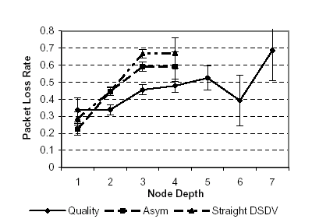
Packet loss rates in a 24-node network with straight DSDV, DSDV with link quality detection, and DSDV with asymmetric link detection.

Figure 5
have certainly increased with increase in physical distances. In the 24-node experiment the use of straight DSDV resulted in moderate packet loss. The 48 node experiment resulted in less dramatic results whereas the 91 node experiment resulted in an improvement of 2-4%.

DSR behavior was studied in a real network by implementing it in the FreeBSD version of UNIX. The testbed consisted of five mobile nodes implemented as cars driving at 25 MPH plus two stationary nodes separated by a distance of 700 meters. The cars moved in a loop throughout the duration of the testbed along a specified route. GPS was used to tell the nodes of their locations in real time. It was observed that the protocol had very low routing overhead and was able to deliver almost all originated data even with continuous mobility of nodes within the network. The reason for this is the on-demand behavior of the protocol with no periodic activity required within the network.

Because of difficulty in implementing AODV in real world environment it had to be modified along with the kernel of the Linux Operating System due to the incompatibility of the Linux kernel with the IP-Layer to routing in a mobile environment. Work is still in progress on this task. Realistic scenario based simulations [10] have been performed on DSDV, AODV and DSR to judge their comparative performance. Scenarios taken into consideration were Conference, with low mobility, Event Coverage, with fairly high mobility and Disaster Area, with some fast and some slow nodes. The simulation results are depicted in figure 6. DSDV had difficulties in almost all the scenarios whereas DSR slightly outperforming AODV. The load overheads were low thereby not bringing into consideration the low overhead of DSR. The Disaster Scenario exhibited frequent partitioning of the network and hence challenged all the protocols.

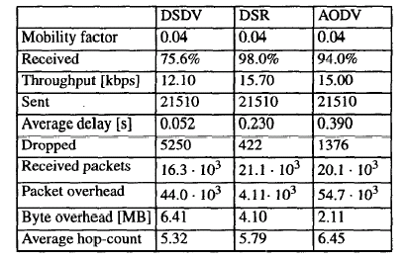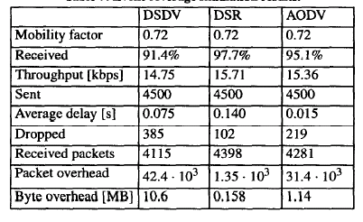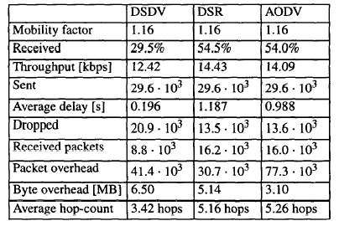

Conference Simulation result Event Coverage Simulation result Disaster Area Simulation Result

Figure 6

So far no study has come up with the real world evaluation of ZRP because of the enormity of the network on which it operates, which is difficult to setup in real world. The suitability of TORA for any particular application will be dependent on the characteristics of the intended networking environment however its performance has not been tested completely. Physical implementation of STAR is not known to this point.

5 Related Works

U.S Defense Advanced Research projects Agency (DARPA) had started research on multihop wireless ad hoc networks since 1973 with the start of the PRNet (Packet Radio Network) project. Design details of DSR were published in 1996 produced by Johnson. The motivation for the design of DSR came from the ARP used in TCP/IP suite of protocols in the Internet. IEEE 802 SRT Bridge standard is similar in approach to DSR. SSA (Signal Stability Based Adaptive) routing protocol and ABR (Associativity Based Routing Routing) protocol discover routes on demand similarly to the route discovery in DSR. AODV uses mechanisms similar to DSR’s route discovery and maintenance. ZRP uses DSR for routing between zones.

6 Future Work

An alternative to DSDV design may be the one, which performs route discovery on a need to know basis. AODV has to be remodeled to be able to establish asymmetric routes given its importance. Routing control traffic can be minimized to allow ZRP to provide routes 1.5 to 2.0 times faster than flood search routing protocols. TORA does not support shortest path computation, which gives it a possible room for improvement. Least overhead routing for ad hoc networks is a possible area of research. The areas that remain open to further investigation include scalability, QoS, Security, Interoperation with the Internet, power control etc.

7 Conclusion

It has been noticed that quick route maintenance is important as it affects all the metrics including delivery rate at high workload and increased speed. No protocol is designed to be power aware with the exception of AODV that is power efficient for bi-directional traffic. DSDV provided the least processing for route maintenance and highest throughput with TORA providing the opposite. TORA had to generate a large amount of control messages to manage DAGs. AODV distributed the load over the network in the least efficient way as it used a lot less control messages limited to the nodes that were involved in routing. The success of DSR is related to generation of control messages and frequency of data packet transmissions. It can be easily deduced that AODV is the choice for high speed networks while DSDV for low speed networks.

References

[1] E. Royer, S. Barbra, C. Toh, A review of Current Routing Protocols for Ad-Hoc Wireless Mobile Networks, IEEE Personal Communications, April 1999, pp. 46-59.

[2] Josh Broch, David A. Maltz, David B. Johnson, Yih-Chun Hu, Jorjeta Jetcheva: A Performance Comparison of Multi-Hop Wireless Ad Hoc Network Routing Protocols. MOBICOM 1998: 85-9
[3] S. Corson and J. Macker, Mobile Ad hoc Networking (MANET): Routing Protocol Performance Issues and Evaluation Considerations, Internet draft, draft-ietf-manet-issues-01.txt.
[4] Charles Perkins, Pravin Bhagwat: Highly Dynamic Destination-Sequenced Distance Vector Routing for Mobile Computers. ACM SIGCOMM, 1994
[5] Charles Perkins, Ad hoc On Demand Distance Vector (AODV) Routing, (This Internet-Draft is also available in PostScript format [134519 bytes].)
[6] V. Park, S. Corson: Temporally-Ordered Routing Algorithm (TORA) Version 1 Functional Specification, Internet draft.
[7] Zygmunt J. Haas, Marc R. Pearlman, The Zone Routing Protocol (ZRP) for Ad Hoc Networks, Internet draft.
[8] J.J. Garcia-Luna, Marcelo Spohn, SOURCE TREE ADAPTIVE ROUTING (STAR) PROTOCOL, Internet draft

[9] David A. Maltz, Josh Broch, Jorjeta Jetcheva, David B. Johnson: The Effects of On-Demand Behavior in Routing Protocols for Multi-Hop Wireless Ad Hoc Networks, IEEE Journal on, Selected Areas in Communications special issue on mobile and wireless networks. August 1999.

[10] Per Johansson, Tony Larsson, Nicklas Hedman, Bartosz Mielczarek, and Mikael Degermark. Scenario-based Performance Analysis of Routing Protocols for Mobile Ad hoc Networks, In Proceedings of MobiCom'99. Seattle WA, August 1999. (This was also an MSc. thesis by Tony Larsson and Niklas Hedman.)

[11] T.S. Rappaport. Wireless Communications: Principles and Practice. Prentice Hall, Englewood Cliffs, N.j., 1996.

[12] D.B. Johnson and D.A. Maltz. “Dynamic Source Routing in Ad Hoc Wireless Networks” In Mobile Computing, T. Imielinski and H. Korth, eds., Kluwer Academic Publishers, Norwell, Mass., 1996, 153-181.

[13] Elizabeth M. Royer, P. Michael Melliar-Smith, and Louise E. Moser. "An Analysis of the Optimum Node Density for Ad hoc Mobile Networks." Proceedings of the IEEE International Conference on Communications, Helsinki, Finland, June 2001.

[14] J.J. Garcia-Luna-Aceves and M. Spohn, ``Scalable Link-State Internet Routing,'' Proc. ICNP '98: Sixth IEEE International Conference on Network Protocols, Austin, Texas, October 14--16, 1998.

[15] Charles E. Perkins, Pravin Bhagwat: Highly Dynamic Destination-Sequenced Distance-Vector Routing (DSDV) for mobile computers. SIGCOMM 1994: 234-244

[16] David B. Johnson, David A. Maltz, and Josh Broch, "DSR: The Dynamic Source Routing Protocol for Multihop Wireless Ad Hoc Networks," Ad Hoc Networking, edited by Charles E. Perkins, Chapter 5, Addison-Wesley, (2001): 139-172. Invited chapter.

[17] Elizabeth M. Royer. "Routing in Ad hoc Mobile Networks: On-Demand and Hierarchical Strategies." Ph.D. Dissertation, December 2000.

[18] M.R. Pearlman, Z.J. Haas, Determining the Optimal Configuration of the Zone Routing Protocol. IEEE journal on Selected Areas of Communications (Special Issue, Ad-Hoc Networks) 17(8), August 1999.

[19] David Lundberg, Ad hoc Protocol Evaluation and Experiences of Real World Ad Hoc Networking, Masters Thesis

[20] Mark D. Yarvis, W. Steven Conner, Lakshman Krishnamurthy, Alan Mainwaring Jasmeet Chhabra, and Brent Elliott. “Real-World Experiences with an Interactive Ad Hoc Sensor Network”, International Conference on Parallel Processing Workshops (ICPPW'02), August 18 - 21, 2002 Vancouver, B.C., Canada.

[21] Elizabeth M. Royer and Charles E. Perkins. "An Implementation Study of the AODV Routing Protocol." Proceedings of the IEEE Wireless Communications and Networking Conference, Chicago, IL, September 2000.

