King Fahd University Of Petroleum and Minerals
Department Of Computer Engineering
COE 543
Wireless & Mobile Computing
Spring 2003 (022)

Instructor: Dr. Ashraf S. Hasan Mahmoud

Term Project

On

“Performance Evaluation Study & Simulation for IEEE 802.11 WLAN Protocol”

Date: May 20th, 2003

Submitted by

Mohammad Abdur Razzaque
ID#: 220308
Khawar Saeed Khan
ID#: G220514

TABLE OF CONTENTS

1.Introduction 4
2.Overview of IEEE 802.11 5
2.1 Features of 802.11 6
2.2IEEE 802.11 Requirements 7
3.IEEE 802.11 Topology 8
3.1 Independent Basic Service Set (IBSS) Networks 8
3.2 Extended Service Set (ESS) networks 9
3.3 Mobility types 10

4. IEEE 802.11 services 11
4.1 Station service (SS) 11
4.2 Distribution system service (DSS) 11
5. 802.11 operation modes 12
5.1 Infrastructure mode 12
5.2 Ad-Hoc Mode 13
6.Variants of 802.11 13
6.1 802.11a 13
6.2 802.11b 13
6.3 802.11d 14
6.4 802.11e 14
6.5 802.11g 14
7. IEEE 802.11 Logical Architecture 14
7.1Carrier Sensing in 802.11 15
7.1.1 PHY Sensing: 15
7.1.2Virtual carrier sensing 16
7.2 IEEE802.11 MAC Layer 16
7.3 Accessing the Wireless Medium 17
7.3.1 IFS (Inter Frame Spacing) 17
7.3.2CSMA/CA access Scheme (DCF-Distributed Coordination Function) 18
7.3.3 RTS/CTS 21
7.3.4 PCF Access Method 22
7.4 MAC frame format 22
8.Physical Layer Architecture 23
8.1 Physical Layer Operations 24
8.2 Physical Layer Technologies 24
8.2.1 IEEE 802.11 FHSS 24
8.2.2 IEEE 802.11 DSSS 25
8.2.3 IEEE 802.11 DFIR 26
9. Simulation Of IEEE 802.11 MAC 27
9.1Model 27
9.2 Algorithm 27
9.3 Random motion 28
9.4 Distance Matrix 28
9.5 Medium Sensing 28
9.5 Contention Window 29
9.6 Station States 29
9.7 Simulation Results 31
10.Conclusion 34
References:………………………………………………………………………………36
Appendix A……………….……………………………………………………………..37

ABSTRACT

Our project is the study of IEEE 802.11 WLAN protocol and the simulation of its MAC DCF operation. This project consists of two parts, a survey part and a simulation part. For the survey part we have studied the MAC operation of IEEE 802.11 in detail including all of its access mechanisms and the services it provide. Also we have studied some physical technologies that this protocol employees. All of this literature survey is presented in the form of report below. The other section of this report describes the simulation done in MATLAB. Simulation is done for the DCF function only. Algorithm is described and also the results derived from the simulation have been presented. At the end we have presented our conclusion based on our literature survey and simulation results that has also been verified with the simulation result.

1.Introduction

A wireless local-area network (WLAN) provides the features and benefits of traditional LAN technologies such as Ethernet and Token Ring without the limitations of wires or cables. By using WLAN technology, you are able to surf the web, to check e-mail or to take an online course without being confined to your desk. WLANs can be used to replace wired LANs or to be an extension of the wired network; they can provide the final few meters of connectivity between a wired network and the mobile user. Arguments for WLANs are of course mobility, scalability and especially for temporary networks, the speed of installation.
The user having an adapter connected to his system, for example a PCI card for desktops or a PC Card for notebooks usually establishes a wireless connection. A WLAN system is different from a traditional wired LAN in many ways: the destination address is not equivalent to a physical location, WLANs deal with fixed, portable and mobile stations and of course, the physical layers used here are fundamentally different from wired media.
IEEE 802.11 has variants like 802.11b, 802.11a, 802.11e, and 802.11g. The IEEE 802.11 specifications are wireless standards that define an "over-the-air" interface between a wireless client and a base station or access point, as well as among wireless clients.
In our project we will study the Performance Evaluation of IEEE 802.11 WLAN Protocol. As the MAC layer is same for all the variants of 802.11 then in terms MAC they are same but varies in Physical layers
In WLANs, the medium access control (MAC) protocol is the main element that determines the efficiency of sharing the limited communication bandwidth of the wireless channel. The fraction of channel bandwidth used by successfully transmitted messages gives a good indication of the protocol efficiency, and its maximum value is referred to as protocol capacity. In this context we will study the details of the MAC layer including the physical layer. There are two operation modes defined in IEEE 802.11: Infrastructure Mode and Ad Hoc Mode.

We will do a literature survey including simulation of some performance parameters like capacity, packet error rate etc. In our literature survey we will provide an overview of 802.11, including its topology, logical architecture, all variants, operation modes of IEEE 802.11etc.

2.Overview of IEEE 802.11

The importance of standards is very high and they solve many problems like vendor dependency, interoperability etc. Standards could two types: official (IEEE) and public (TCP/IP). An official standard is published and know to the public, but controlled by an official standard organization, such as IEEE. For the Wireless LAN we have a standard defined by IEEE and it is IEEE 802.11.

IEE 802 decided a new working group in 1990, IEEE 802.11, specifically devoted to wireless LANs. In 1997 the first IEEE802.11 standards (1 and 2Mb/s) was completed. After that a number of its variants are evolving gradually.

The aim of the 802.11 standard was to develop a MAC and PHY layer for wireless connectivity for fixed, portable and moving stations within a local area. The higher OSI-layers are the same as in any other 802.X standard; this means that at this level there is no difference perceptible between wired and wireless media.

The standard defines the MAC procedures to support the asynchronous MAC service data unit (MSDU) delivery services; several PHY signaling techniques and interface functions that are controlled by the IEEE802.11 MAC.

2.1 Features of 802.11

The 802.11 standard provide MAC and PHY functionalities for wireless connectivity of fixed, portable, and moving stations moving at pedestrian and vehicular speeds within a local area.
Specific features of the 802.11 standard include the following:
- Support of asynchronous and time-bounded delivery service
- Continuity of service within extended areas via a distribution system, such as
Ethernet.
- Accommodation of transmission rates of 1 and 2- Mbps
- Support of most market applications
- Multicast (including broadcast) services
- Network management services
- Registration and Authentication services
Target environments for use of the standard include the following:
- Inside buildings, such as offices, banks, shops, malls, hospitals, manufacturing
plants, and residences.
- Outdoor areas, such as parking lots, campuses, building complexes, and out-door plants
The 802.11 standard takes into account the following significant differences between wireless and wired LANs:

Power Management
Because most wireless LAN NIC are available in PCMCIA Type II format, obviously yon can outfit portable and mobile handheld computing equipment with wireless LAN connectivity. But the problem is the battery power. The addition of a wireless LAN NIC to a portable computer can quickly drain batteries.
The solution to conserve battery power enable wireless NICs to switch to lower-power standby modes periodically when not transmitting, reducing the drain on the battery. The MAC Layer implements power management by functions putting the radio to sleep when no transmission activity occurs for some specific or user defined time period. But the problem is that sleeping station can miss critical data messages and 802.11 solve this problem by incorporating buffers to queue messages. The standard calls for sleeping stations to awaken periodically and retrieve any applicable messages.

Bandwidth
The ISM spread spectrum bands do not offer a great deal of bandwidth, keeping data rates lower than desired for some applications. That’s why the 802.11 Working Group, dealing with methods to compress data, making the best use of available bandwidth. Efforts are also underway to increase the data rate of 802.11 to accommodate the growing need for exchanging larger and larger files.

Security
The wireless LANs transmits signals over much larger areas than that of wired media, such as twisted-pair, coaxial, and optical cable and it causes a much larger area to protect. To employ security, the 802.1'l Working Group coordinated their work with the IEEE 802.10 Standards Committee responsible for developing security mechanisms for all 802 series LANs.

Addressing
The topology of a wireless network is dynamic; therefore the destination address does not always correspond to the destination's location. This raises a problem when routing packets through the network to the intended destination. Mobile IP is a solution to the problem.

2.2IEEE 802.11 Requirements

To be IEEE 802.11 standard compatible a device has fulfill the following requirements:
- Single MAC supporting multiple PHYs
- Mechanism to allow multiple overlapping networks in the same area
- Provisions to handle the interface from other
- ISM band radios and microwave ovens
- Mechanism to handle “hidden” terminal problem
- Options to support time-bounded services
- Provisions to handle privacy and access security

3.IEEE 802.11 Topology

The IEEE 802.11 topology consists of components, interacting to provide a wireless LAN that enables station mobility transparent to higher protocol layers, such as the LLC. A station is any device that contains functionality of the 802.11 protocol (that is, MAC Layer, PHY Layer, and interface to a wireless medium). The functions of the 802.11 standard reside physically in a radio NIC, the software interface that drives the NIC and access point. The 802.11 standard supports the following two topologies:
• Independent Basic Service Set (IBSS) networks
• Extended Service Set (ESS) networks
These networks utilize a basic building block the 802,11 standard refers to as a BSS, providing a coverage area whereby stations of the BSS remain fully connected. A station is free to move within the BSS, but it can no longer communicate directly with other stations if it leaves the BSS.

3.1 Independent Basic Service Set (IBSS) Networks

The smallest building block of a wireless LAN is a basic service set (BSS), which consists of some number of stations executing the same MAC protocol and competing for access the to the same shared medium. An IBSS is a stand-alone BSS that has no backbone infrastructure and consists of at least two wireless stations (Figure 1). This type of network is often referred to as an ad hoc network because it can be constructed quickly without much planning.
A basic service set may be isolated or it may connect to a backbone distribution system through an access point (AP)(figure 2). The access point functions as a bridge. The MAC protocol may be fully distributed or controlled by a central coordination function housed in the access point.
Figure 1: An Independent BSS (IBSS) is the most basic type of 802.11 WLAN
Figure 2: An Extended Service Set (ESS) 802.11 WLAN consists of multiple cells interconnected by APs and Distribution system (Ethernet)

3.2 Extended Service Set (ESS) networks
An extended service set (ESS) consists of two or more basic service sets inter-connected (figure 2) by a distribution system. Typically, the distribution system is a wired backbone LAN.

3.3 Mobility types

No-transition
This type of mobility refers to stations that do not move and those that are moving within a local BSS.

BSS-transition
This type of mobility refers to stations that move from one BSS in one ESS to another BSS within the same ESS.

ESS-transition
This type of mobility refers to stations that move from a BSS in one ESS to a BSS in a different ESS.
The 802.11 standard clearly supports the no-transition and BSS-transition mobility types. The standard, however, does not guarantee that a connection will continue when making an ESS-transition.
The 802.11 standard defines the distribution system as an element that interconnects BSSs within the ESS via access points. An access point is an addressable station, providing an interface to the distribution system for stations located within various BSSs. The independent BSS and ESS networks are transparent to the LLC Layer.
Within the ESS, the 802.11 standard accommodates the following physical configuration of BSSs:

Partially overlapped BSS
This type of configuration provides contiguous coverage within a defined area, which is best if the application cannot tolerate a disruption of network service.

Physically disjointed BSS
For this case, the configuration does not provide contiguous coverage. 802.11 does not specie a limit to the distance between BSSs.

Physically collocated BSS
This may be necessary to provide a redundant or higher-performing network.
The 802.11 standard does not constrain the composition of the distribution system; therefore, it may be 802-conipliant or some nonstandard network. If data frames need transmission to and from a non-IEEE 802.11 LAN, these frames, as defined by the 802.11 standard, enter and exit through a logical point called portal. The portal provides logical integration between existing wired LANs and 802.11 LANs.

4. IEEE 802.11 services

The IEEE 802.11 architecture allows for the possibility that the DS (Distribution System) may not be identical to an existing wired LAN. A DS may be created from many different technologies including current IEEE 802 wired LANs. IEEE 802.11 does not constrain the DS to be either data link or network layer based. Nor does IEEE 802.11 constrain a DS to be either centralized or distributed in nature.

IEEE 802.11 explicitly does not specify the details of DS implementations. Instead, IEEE 802.11 specifies Services. The services are associated with different components of the architecture. There are two categories of IEEE 802.11 service—the station service (SS) and the distribution system service (DSS). Both categories of service are used by the IEEE 802.11 MAC sublayer[6].
This set of services is divided into two groups: those that are part of every station, and those that are part of a DS.

4.1 Station service (SS)

The service provided by stations is known as the station service. The SS is present in every IEEE 802.11 station (including APs, as APs include station functionality). The SS is specified for use by MAC sublayer entities. All conformant stations provide SS.The SS is as follows:
a) Authentication
b) Deauthentication
c) Privacy
d) MSDU delivery

4.2 Distribution system service (DSS)
The service provided by the DS is known as the distribution system service. These services are represented in the IEEE 802.11 architecture by arrows within the APs, indicating that the services are used to cross media and address space logical boundaries. This is the convenient place to show the services in the picture. The physical embodiment of various services may or may not be within a physical AP. The DS provides the DSSs. They are accessed via a station that also provides DSSs. A station that is providing
access to DSS is an AP.
The DSSs are as follows:
a) Association
b) Disassociation
c) Distribution
d) Integration
e) Reassociation
DSSs are specified for use by MAC sublayer entities.

5. 802.11 operation modes

There are two operation modes defined in IEEE 802.11: Infrastructure Mode and Ad Hoc Mode. (Figure3)

5.1 Infrastructure mode

In infrastructure mode, the wireless network consists of at least one access point (AP) connected to the wired network infrastructure and a set of wireless end stations. An access point controls encryption on the network and may bridge or route the wireless traffic to a wired Ethernet network (or the Internet).
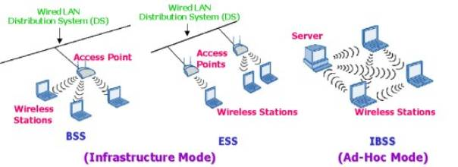

Figure 3: 802.11 modes

5.2 Ad-Hoc Mode

Ad-Hoc mode is a set of 802.11 wireless stations that communicate directly with each other without using an access point or any connection to a wired network. Ad-Hoc Mode is also called peer-to-peer mode or an Independent Basic Service Set (IBSS) as mentioned earlier.

6.Variants of 802.11

To meet the future challenges and requirement IEEE 802.11 Working group working actively for revision of the IEEE 802.11standards.Upto present following are the variants of 802.11 and they all are same in MAC layer view but different PHYs. The existing standard and its amendments [5] describe WLAN PHY (Physical layer): Spread spectrum, OFDM, Infrared and MAC layers.

6.1 802.11a

- The 802.11a Task Group (TG a) operates in the 5GHz band same as HIPERLAN-2
- The OFDM system provides 8 different data rates between 6 to 54 Mbit/s.
- Uses BPSK, QPSK, 16-QAM and 64-QAM modulation schemes coupled with forward error correcting coding.
- Using more power and more efficient data encoding schemes than 802.11b.

6.2 802.11b

- 2.4GHz ISM band Wi-Fi standard ratified in the second half of 1999.
- Rates up to 6.5 and 11 Mb/s
- Support CCK
- Same PLCP as IEEE802.11 DSSS

6.3 802.11d

The IEEE 802.11d Task Group (TG d) describes a protocol that will allow a 802.11 device to receive the regulatory information required to configure itself properly to operate anywhere on earth.

6.4 802.11e

The 802.11e Task Group (TG e) is proceeding to build improved support for quality of service (for example for voice transmission). The aim is to enhance the current 802.11 MAC to expand support for LAN applications with Quality of Service requirements, to provide improvements in security, and in the capabilities and efficiency of the protocol.

6.5 802.11g

- IEEE 802.11 Task Group G (TG g) approved its first draft during the month of November 2001
- Supporting PBCC (packet binary convolution coding, a single carrier technique) and OFDM.
- It is a natural speed extension for the 802.11b standard.
- Data rates up to 54 Mbps in the 2.4 GHz band.

7. IEEE 802.11 Logical Architecture

A topology provides a means of explaining necessary physical components of network, but the logical architecture defines the network’s operation. The logical architecture of 802.11 is layered protocol architecture as shown in figure 4[8].

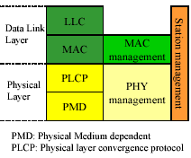

Figure 4: Protocol Entities for IEEE 802.11

As we mentioned 802.11 only defines the MAC and PHY layers, as the higher layers are same for all standards. The traditional simple MAC and PHY layers definitions in the IEEE 802 sub standards are broken into other sub layers to make the specification process easier. The MAC layer is divided into MAC sub layer and MAC management sub layer entities. In addition IEEE 802.11 specifies a station management sub layer that is responsible for coordination of the interactions between MAC and PHY layers.

7.1Carrier Sensing in 802.11

The carrier sensing mechanism in IEEE802.11 is more complicated than the IEEE802.3.Here it is performed in two ways:
- Physically (in the PHY layer)
- Virtually (in the MAC layer)

7.1.1 PHY Sensing:

It is done through the Clear Channel Assessment (CCA) signal produced by PLCP in PHY layer of 802.11.This CCA is generated based on real sensing of the air interface by sensing the detected bits in the air or by checking the RSS (received signal strength) of the carrier against a threshold.

- Decision using detected bits slow but reliable
- Decision using RSS of carrier against threshold – fast but many false alarms due to interference.

7.1.2Virtual carrier sensing

It is based on the Network Allocation Vector (NAV) signal supported by the RTS/CTS and PCF mechanisms at MAC – indicates the medium is occupied for a given (length field) time duration Used for RTS/CTS and PCF based schemes only.

7.2 IEEE802.11 MAC Layer

Each station and access point on an 802.11 WLAN implements the MAC layer service, which provides the capability for peer LLC entities to exchange MAC service data units (MSDU’s) between MAC service access points (SAPs).

As we mentioned MAC has two sub layers and all the responsibilities are divided between them.

- MAC sub layer
- MAC layer management sub layer

Major responsibilities of MAC sub layer
- Define access scheme
- Define packet formats

Major responsibilities of management sub layer
- Support ESS
- Power management
- Security

7.3 Accessing the Wireless Medium

Before transmitting a frame, the MAC coordination must first gain access to the network.
To access the medium, IEEE 802.11 provides different access schemes:
- CSMA/CA – contention data
- RTS/CTS – contention-free
- PCF – contention-free, intended for time-bounded traffic
First two modes are used by DCF function for channel accessing.
Before going to the description we need to know access spacing or Inter Frame Spacing (IFSs) between the transmissions of the packets.

7.3.1 IFS (Inter Frame Spacing)

To allow coordination of a number of options for the MAC operations, IEEE 802.11 recommends three inter-frame spacings (IPSs) between the transmissions of the packets. These IFS's periods provide a-mechanism-for assigning priority, which is used for implementation of QOS support for time-bounded or other applications. After completion of each transmission, all terminals having information packets wait for one of the three IFS periods according lo the level of priority of their information packet.

DIFS

PIFS
SIFS

Medium
Busy
Time

Figure: 5: Different IFS in MAC access protocol

DIFS: DCF-IFS (DIFS) is used for contention data spacing that has the lowest priority and longest duration (as shown in figure 5).

SIFS: Short IFS (SIFS), used for highest priority packets such as ACK and CTS (clear to send), that has the lowest duration of time.

PIFS: The PCF IFS (PIFS), designed for PCF operation, has the second priority rate with duration between DIFS and SIFS.

7.3.2CSMA/CA access Scheme (DCF-Distributed Coordination Function)

It is an asynchronous and contention-based access scheme, which is also known as a DCF, and it is the basic access scheme.
In CSMA/CA, as soon as the MAC has a packet to transmit, it senses the channel to see if the channel is available both physically and virtually. If the channel is virtually busy because a NAV signal is turned on, the operation is delayed until the NAV signal has disappeared. When the channel is virtually available, the MAC layer senses the PHY condition of the channel (as shown in figure 6)[1].

If the channel is detected idle, the DIFS interval (i.e., 50 µs for 802.11b networks) starts, after waiting for the DIFS time the station starts packet transmission. Otherwise, the station continues to monitor the channel for busy or idle status. After finding the channel idle for a DIFS interval, the station [3]:
- Starts to treat time in units of slot time.
- Generates a random backoff interval in units of slot time depending on the contention window.
- Continues to monitor whether the channel is busy or idle.

Figure 6: The Operation of CSMA/CA contention based 802.11 DCF access protocol
In the latter step, for each slot time where the channel remains idle, the backoff interval is decremented by one. Here the slot time duration is at least the time reqired for a station to detect an idle channel plus the time required switching from listening mode to transmission mode. When the interval value reaches zero, the station starts packet transmission. During this backoff period, if the channel is sensed busy in a slot time, the decrement of the backoff interval stops (i.e., is frozen) and resumes only after the channel is detected idle continuously for the DIFS interval and the following one slot time.

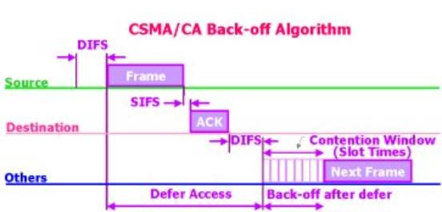

Figure 7: CSMA/CA (DCF protocol)

Again, packet transmission is started when the backoff interval reaches zero. The backoff mechanism helps avoid collision since the channel has been detected to be busy recently. Further, to avoid channel capture, a station must wait for a backoff interval between two consecutive new packet transmissions, even if the channel is sensed idle in the DIFS interval (see figure 8).
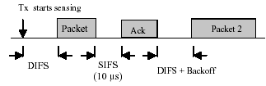
Figure 8: DCF with channel capture avoidance

The choice of the random number for the backoff timer is based on the binary exponential backoff algorithm, where a station chooses any of the numbers between 0 and CW-1 randomly with equal probability. The Contention Window (CW) is set to be CWmin for every new data frame transmission. CW is doubled each time when the transmission is unsuccessful, until it reaches CWmax, then it remains at CWmax. To determine whether a data frame transmission is successful, a positive Acknowledgement (ACK) is transmitted by the receiver. ACK is transmitted after a short interframe space (SIFS) period when successfully receiving the entire data frame. If ACK is not detected within a SIFS period after the completion of the data frame transmission, the transmission is assumed to be unsuccessful, and a retransmission is required [4].

7.3.3 RTS/CTS

It is the four-way handshaking access method, which is generally used for solving the hidden terminal problem. A Request To Send (RTS) frame is sent by a potential transmitter to the receiver and a Clear To Send (CTS) frame is sent from the receiver in response to the received RTS frame. Executing a backoff algorithm retransmits if the CTS frame is not received within a certain time interval the RTS frame. After a successful exchange of the RTS and CTS frames the data frame can be sent by the transmitter after waiting for a SIFS. RTS and CTS include a duration field that specifies the time interval necessary to transmit the data frame and the ACK. This information is used by stations, which can hear the transmitter or the receiver to update their Net Allocation Vector (NAV), a timer that is always decremented. The drawback of using RTS/CTS is an increased overhead which may be very important for short data frames, the efficiency of RTS/CTS depends upon the length of the packets. RTS/CTS is typically used for large-size packets, for which retransmissions would be expensive from a bandwidth viewpoint [5].
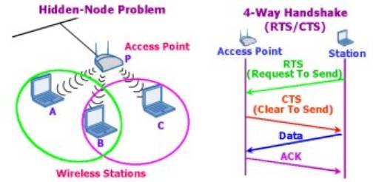
Figure9: RTS/CTS
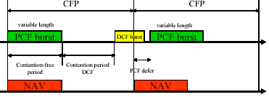
Figure 10: PCF access scheme

7.3.4 PCF Access Method

A contention free and priority based access protocol usable on infrastructure network configurations containing a controller called a point coordinator within the access points. The AP, playing the point coordinator, stops all other terminals and polls other stations in a semi-periodic manner. Figure 10 illustrates the operation of the PCF. The AP organizes a periodical contention-free period (CFP) for the time-bounded information. It coordinates time-bounded data to be transmitted at the beginning of each CFP, and during those periods it arranges an NAV signal for all other terminals. The length of the PCF period is variable, and it only occupies a portion of the CFP. The rest of the CFP is released for contention and DCF packets. If a DCF packet occupies the channel and does not complete before the start of the next CFP the starting time of the CFP will defer (figure 10). However, the NAV signal for all other terminals goes to operation at the beginning of the CFP.

7.4 MAC frame format

The IEEE 802.11 standard specifies an overall MAC frame format, as shown in Figure 11 This frame structure is found in. all frames that stations transmit, regardless of frame type. After forming the applicable frame, the MAC coordination passes the frame's, bits to the physical layer convergence procedure sublayer (PLCP), starting with the first bit of the Frame Control Field and ending with the last bit of the frame check sequence (FCS)[1].

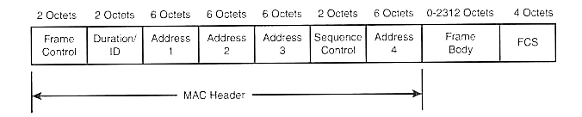
Figure11: MAC frame Format of 802.11
Frame Control: This field carries control information being sent from station to station.
Duration/ID: In most frames, this field contains a duration value, depending on the type of frame sent.
Address 1, 2, .3,and 4: The address fields contain different types of addresses, depending on the type of frame being sent. These address types may include the Basic Service Set Identification (BSSID), source address, destination address, transmitting station address, and receiving station address.
Sequence Control: The sequence control is used for fragmentation numbering to control the sequencing.
Body Field: This field has a variable length payload and its range is 0-2312 bytes.
Frame Check Sequence (FCS): The MAC layer at the sending station calculates a 32 bits FCS using CRC and place the result in this field.

8.Physical Layer Architecture

The architecture of the Physical Layer consists of the following three components for each station (Figure 4)

Physical Layer management

The Physical Layer management works in conjunction with MAC Layer management and performs management functions for the Physical Layer.

Physical Layer convergence procedure (PLCP) sub layer

The MAC Layer communicates with the PLCP via primitives through the Physical Layer service access point (SAP). When the MAC Layer instructs, the PLCP prepares MAC protocol data units (MPDUs) for transmission. The PLCP also delivers incoming frames from the wireless medium to the MAC Layer.The PLCP appends fields to the MPDU that contain information needed by the Physical Layer transmitters and receivers. The 802.11 standard refers to this composite frame as a PLCP protocol data unit (PPDU). The frame structure of a PPDU provides for asynchronous transfer of MPDUs between stations. As a result, the receiving station's Physical Layer must synchronize its circuitry to each individual incoming frame.

Physical medium dependent (PMD) sub layer
Under the direction of the PLCP, the PMD provides actual transmission and reception of Physical Layer entities between two stations via the wireless medium. To provide this service, the PMD interfaces directly with the wireless medium (that is, the air) and provides modulation and demodulation of the frame transmissions. The PLCP and PMD communicate via primitives to govern the transmission and reception functions.

8.1 Physical Layer Operations

The general operation of the individual physical layers is very similar. To perform PLCP functions, the 802.11 standard specifies the use of state machines. Each state machine performs one of the following functions

- Carrier Sense: To determine the state of the medium
- Transmit: To send individual octets of the data frame
- Receive: To receive individual octets of the data frame

8.2 Physical Layer Technologies

Two main technologies are used for wireless communications: Radio Frequency and Infrared. RF in this case is located in the 2.4GHz ISM-band. RF is capable of being used for 'not line of sight' and longer distance situations. IR is not a useful technology for use in a WLAN system since it is used for short distance communications.
There are two methods of spread spectrum modulation used within the unlicensed 2.4-GHz frequency band: frequency hopping spread spectrum (FHSS) and direct sequence spread spectrum (DSSS). Spread spectrum is ideal for data communications because it is less susceptible to radio noise and creates little interference. A brief idea of the each technology is given below [5].

8.2.1 IEEE 802.11 FHSS

FHSS allows for a less complex radio design than DSSS but FHSS is limited to a 2-Mbps data transfer rate. It has the following features [1][2]:

- FHSS PMD hops over 78 channels of 1 MHz each in the centre of the 2.44 GH ISM band
- Modulation is GFSK: 1 bit/symbol   1 Mb/s or 2bit/symbol   2 Mb/s
- BSS selects (PHY management sub layer) one of three hopping patterns:
(0,3,6,9…75),
(1,4,7,10…76), or
(2,5,8,11…77)
- Hopping rate: 2.5 hop per second
- Therefore three APs can coexist in the same area  which means maximum throughput of 6 Mb/s
- Maximum transmit power = 100 mW
- Scrambling (whitening) of MPDU – randomization and elimination of DC component
- Lowest cost and Power consumption
- Most tolerant to signal interference

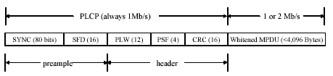
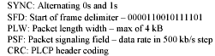
Figure 12: PLCP frame for the FHSS of 802.11

8.2.2 IEEE 802.11 DSSS

The Direct Sequence Spread Spectrum (DSSS) has the following properties [1][8]:

- DSSS PMD uses 26 MHz chunks to transmit 11 Mc/s (as shown in figure 13)
- Modulation: DBPSK for 1 Mb/s and DQPSK for 2 Mb/s
- ISM band at 2.4 GHz   11 overlapping channels with 5 MHz spacing
- Coexisting – 5 choices per BSS
- Max tx power = 100 mW
- Wider range the FHSS
- Highest cost and Power consumption
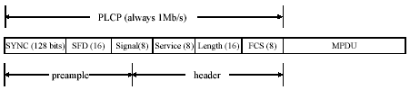
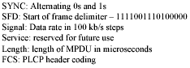
Figure 13: PLCP frame for the DSSS of 802.11

8.2.3 IEEE 802.11 DFIR
The Diffused Infrared has the following features [1][8]:
- DFIR PMD utilizes 250 ns pulses
- Pulse Position Modulation (PPM)
- 16-PPM for the 1 Mb/s option
- 4-PPM for the 2 Mb/s option
- Low cost
- Higher tolerance to RF signal interference
- Lower range compare to spread spectrum
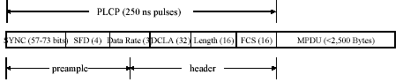
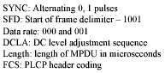
Figure 14: PLCP frame for the DFIR of 802.11

9. Simulation Of IEEE 802.11 MAC
There are two ways to validate any research. Either the conclusion of research is based on any analytical model through which certain equations are derived or by simulating the whole environment by any simulation tool and deriving the results from that simulation. We have opted for the second option and that is the simulation of IEEE 802.11 through which we have derived the results for our project. We have simulated an operation of the IEEE 802.11 MAC layer according to the standard specifications defined by IEEE. The IEEE 802.11 standard specifications are illustrated in [temp]. The simulation is based on the algorithm used in [7].

9.1Model

IEEE 802.11 MAC implies two contention-based methods for medium access. Distributed coordination function (DCF) and Request to Send/Clear To Send (RTS/CTS). We have simulated the DCF function of the MAC layer that uses Carrier Sense Multiple Access/Collision Avoidance (CSMA/CA) and the simulation is done in Matlab. In this simulation some assumptions that have been made are listed below

- Perfect channel conditions have been assumed.
- The packet propagation delays between the communicating stations are assumed to be zero.
- As described, only DCF function is simulated.
- Only basic access is employed, no RTS/CTS messages are exchanged.

9.2 Algorithm

The algorithm implemented for the simulation has been taken from the established work in [temp]. The random movement of mobile stations in that code is dependent on some parameter Beta that defines the dependence of the stations on their previous positions. In our implementation, we have developed the random motion of stations that is the function of some random variable with mean zero and variance one. This variance dictates the motion of the station and it is further subjected to the variance given by the user in the form of motion scale that becomes the final variance of mobile stations. The code for our simulation is provided in Appendix A and the algorithm is explained here.

9.3 Random motion
First of all the random motion of the stations is calculated as described above. The change in the coordinates of the station is added to the previous position coordinates to define a new position.

9.4 Distance Matrix
In each simulation cycle when the stations have taken their new random positions, a distance matrix is generated. Distance matrix is an N x N matrix, where N is the number of stations. The values in this matrix are either zero or one. Value one indicates that the two stations are in range whereas value zero indicates the out of range situation. Since the matrix is symmetric thus each row or each column corresponds to the distances of one station from the others. For example, in an N x N matrix the value ‘00’ indicates the distance of station one from itself that is always one, whereas the value ‘01’ indicates the distance between station one and station two that may be zero or one depending on their distance and so on.

9.5 Medium Sensing
If a station becomes ready for transmission that is when the station’s back off counter expires or the SIFS counter expires in case of replying with acknowledgement then a vector of length N, equal to the Number of stations, is initialized named ‘sending’. In the ‘sending’ vector the value for each station that is described above is set to one and for others it is set to zero. This sending vector is then multiplied with the distance matrix and the resultant vector of length N is named ‘busy medium’. Looking at the station’s state and the ‘busy medium’ vector it becomes clear if there are any two stations transmitting at the same time. If a station in transmission state has a value one in its ‘busy medium’ vector then there is no other station transmitting at the same time, but if it has value two in the ‘busy medium’ vector then there are 2 stations that are transmitting simultaneously and it is accounted as collision.

9.5 Contention Window

Contention window has two extreme values. In our simulation program the minimum value is 3 and the maximum value is 10. Initially, the contention windows are set to minimum for all stations but as the collision happens, the value for contention window is increased by one. The contention window value directly affects the back off counters of the stations. The back off counter is the function of contention window [7].

9.6 Station States
The whole operation is divided in states. Each station depending on its current status either jumps to a higher state or a lower state. These states are as

State – 0

  - Stations in this state do not transmit or receive.
  - If a station wants to transmit it sets high it’s transition signal to state – 1.
  - Frame lengths are chosen randomly for the stations that have turned their transition signal to state – 1 high.
  - Destination is chosen randomly for all the transmitting stations.
  - Back off counter (BC) value is chosen depending on the contention window.
  - Finally jump is made to state – 1.

State – 1

  - ‘Sending’ and ‘busy medium’ vectors are generated.
  - If the medium is found idle after Medium sensing, the station turns its transition signal to state – 2 high.
  - Jump is made to state – 2.

State – 2

  - The timer for the stations in this state is set equal to DIFS.
  - DIFS = SIFS + 2 * slot time.
  - Medium is sensed once again. If the medium is found busy the station goes into state – 1.
  - If medium is found idle, the DIFS timer decrements in each simulation cycle.
  - When DIFS timer expires, the station turns high its transition signal to state – 3.
  - Jump is made to state – 3.

State – 3

  - If no transmission detected, the station decrement its back off counter.
  - When BC counter expires, station sets high its transition signal to state 5.
  - Jump is made to state 5.

State – 4

  - This state corresponds to the ACK transmissions.
  - The SIFS timer is decremented by one in each simulation cycle.
  - When SIFS timer expires the transition signal to state - -1 is turned high.
  - Timer is set equal to the ACK length.
  - Jump is made to state - -1.

State – 5

  - If there are more than one station in state – 5 at a time that is if more than one station are transmitting at the same time, the station enters into state – 6.
  - If the destination station is not in range, the station enters into state – 7.
  - Transmission starts and the frame length is decremented in each simulation cycle
  - When frame length expires, the station turns high its transition signal to state – 0.
  - If collision has occurred that is state – 6 or destination is out of range that is state – 7, the contention window is incremented by one.
  - If the contention window becomes greater than the maximum value that is 10 it is again reduced to its maximum value
  - If transmission occurs successfully, the contention window is set equal to its minimum value.
  - Total transmissions, collision and out of range situations are calculated.
  - For the destination station that is the receiver timer is set to SIFS and its ACK destination evaluated.
  - Station turns high its transition signal to state – 4.
  - Jump is made to state – 4.

State - -1

  - Looking at the ‘sending’ vector and busy medium, if there are more than one stations transmitting ACK at the same time the station jumps into state - -2 (ACK collision).
  - If the ACK destination is out of range the station jumps into state - -3 (ACK unreachable).
  - The timer equal to the ACK length is decremented by one in each simulation cycle.
  - When the timer expires, the station turns its transition signal to state – 0 high
  - ACK collisions and ACK unreachable are calculated.

9.7 Simulation Results

Based on the above-described algorithm we developed the code in MATLAB. Using the simulation we have determined the performance of the WLAN 802.11 under the different load conditions and for different transmission ranges of mobile stations. Also we have determined the collisions and unreachable packet situations under different loads. Our simulation calculates the following parameters

- Total Transmissions.
- Successful Transmissions.
- Total Collisions.
- Unreachable Packets.
- Total Acknowledgments.
- Successful Acknowledgments.
- Acknowledgment Collisions.
- Unreachable Acknowledgments.

Based on the above parameters we have calculated the efficiency of the system subjecting it to different conditions. The results are shown below.

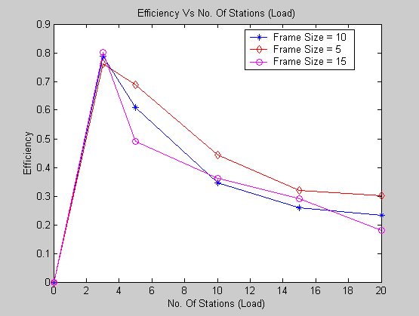

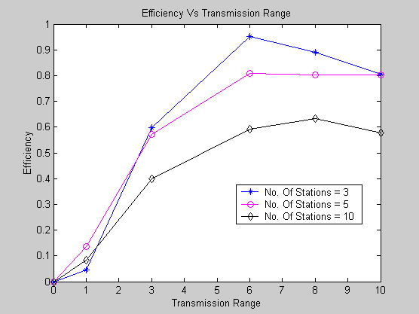

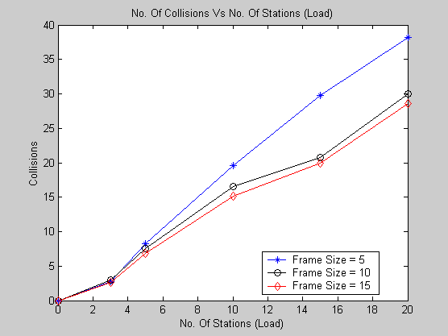

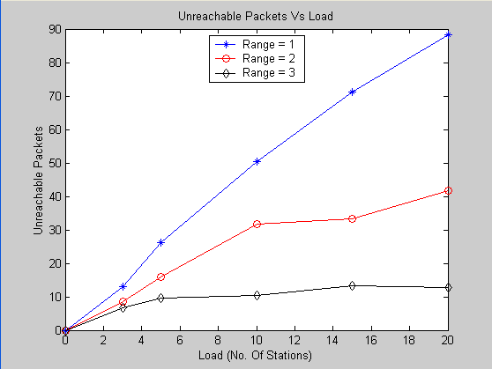

10.Conclusion
Based on the simulation results it is clear that increasing the load in a WLAN system drastically reduces the efficiency of the network. After scrutinizing the results, we propose to increase the transmission range for stations. Increasing the transmission range would improve the efficiency better for the heavy load. For the validation of our conclusion we present the following proof.

- Proof

For the frame size 5, range 3 and No. Of Stations 10, the efficiency of network is 0.4423. If we increase the transmission range from 3 to 10, keeping the frame size 5 and No. Of Stations 10, the network efficiency comes close to 0.6. That is 15.77% improvement in efficiency.

Increasing the range for stations will require some kind of power control mechanism. It is not possible to increase the range of stations or in other words power transmitted by stations to a very large value but this trade off has much area for optimization as the interference factor in not present.

References

[1]. Jim Geier, Wirless LANs, Implementing Interoperable Networks, Macmillan Technical Publishing, 2001

[2].Kaveh Pahlavan, Prashant Krishnamurthy, Principles of Wireless Networks – A unified Approach, Prentice Hall, 2002

[3] Kin K. Leung, Bruce McNair, Leonard J. Cimini, Jr., and Jack H. Winters”Outdoor IEEE 802.11 Cellular Networks: MAC Protocol Design and Performance,” AT&T Labs – Research Middletown, NJ 07748

[4]. Chuan Heng Foh and Moshe Zukerman ARC Special Research Center for Ultra–Broadband Information Networks EEE Department, The University of Melbourne “Performance Analysis of the IEEE 802.11 MAC Protocol”

[5]. http://www.esat.kuleuven.ac.be/~h239/reports/2001/wlan/index.php

[6.] International Standard ISO/IEC 8802-11: 1999(E) ANSI/IEEE Std 802.11, 1999 Edition
[7] http://netlab1.bu.edu/~staro/546projects/wirelesslan/index.htm
[8] http://www.ccse.kfupm.edu.sa/~ashraf/COE022_543/COE543_IEEE80211.pdf

APPENDIX – A

n = input('1. Number of stations : ');
if(length(n) == 0)
n = 5;
end

simul_time = input ('2. Simulation time(slot time = 2) : ');
if(length(simul_time) == 0)
simul_time = 600;
end

fsize = input('3. Frame Size : ');
if(length(fsize) == 0)
fsize = 5;
end

motion_scale = input('4. Time Scale for random motion (0 - 10):' );
if(length(motion_scale) == 0 | motion_scale > 10)
motion_scale = 5;
end

range = input('5. Range of each station : ');
if (length(range) == 0)
range = 3;
end

count = 0;
state = zeros(1,n);
traffic = 0.1;
CWmax = 10;
CWmin = 3;
CW = CWmin * ones(1,n);
frame_length = zeros(1,n);
frame_dest = zeros(1,n);
ack_dest = zeros(1,n);
ack_length = 4;
sifs = 2;
slot_time = 2;
BCounter = zeros(1,n);
difs = sifs + 2*slot_time;
timer = zeros(1,n);
stimer = zeros(1,n);
total_transmissions = 0;
successful_transmission = 0;
total_collisions = 0;
unreachable_packets = 0;
total_acks = 0;
ack_collisions = 0;
unreachable_acks = 0;
successful_acks = 0;

Eb2=0.0001 * motion_scale;
pos_x = randn(1,n);
pos_y = randn(1,n);

distance_matrix = ones(n,n);
sending = zeros(1,n);
busy_medium = zeros(1,n);

pos_x_change = sqrt(Eb2) * randn(1,n);
pos_y_change = sqrt(Eb2) * randn(1,n);

for i = 1:simul_time

%%%%%%%%%%%%%%%%%%%%%%%%%%%%%

% Random Motion

if (count == 0)
pos_x_change = pos_x_change + randn(1,n) * sqrt(Eb2);
pos_y_change = pos_y_change + randn(1,n) * sqrt(Eb2);
pos_x = pos_x + pos_x_change;
pos_y = pos_y + pos_y_change;
end

if (count == 1)
pos_x_change = pos_x_change + randn(1,n) * sqrt(Eb2);
pos_y_change = pos_y_change + randn(1,n) * sqrt(Eb2);
pos_x = pos_x + pos_x_change;
pos_y = pos_y - pos_y_change;
end

if (count == 2)
pos_x_change = pos_x_change - randn(1,n) * sqrt(Eb2);
pos_y_change = pos_y_change - randn(1,n) * sqrt(Eb2);
pos_x = pos_x - pos_x_change;
pos_y = pos_y - pos_y_change;
end

if (count == 3)
pos_x_change = pos_x_change + randn(1,n) * sqrt(Eb2);
pos_y_change = pos_y_change + randn(1,n) * sqrt(Eb2);
pos_x = pos_x - pos_x_change;
pos_y = pos_y + pos_y_change;
end

count = count + 1;

if(count > 3)
count = 0;
end

distance_matrix = ones(n,n);

for i = 1:n
for j = 1:n

if ((pos_x(i)-pos_x(j))^2 + (pos_y(i)-pos_y(j))^2 > range^2)

distance_matrix(i,j) = 0;

end
end
end

%%%%%%%%%%%%%%%%%%%%%%%%%%%%%%

%%%%%%%%%%%%%%%%%%%%%%%%%%%%%

% State - 0

transition_0to1 = zeros(1,n);
to_send = rand(1,n);

transition_0to1(state == 0 & to_send < traffic) = 1;

temp_vec = sifs + rand(1,n) * 2 * fsize;
frame_length(state ==0 & transition_0to1 > 0) = temp_vec(state ==0 & transition_0to1 > 0);

temp_vec = ceil(rand(1,n) * n);
frame_dest(state == 0 & transition_0to1 > 0) = temp_vec(state ==0 & transition_0to1 > 0);

for i = 1:n
while ( frame_dest(i) == i | frame_dest(i) == 0)
frame_dest(i) = ceil(rand * n);
end
end

temp_vec = floor(rand(1,n) .* (2.^CW));
BCounter(state == 0 & transition_0to1 > 0) = temp_vec(state == 0 & transition_0to1 > 0) * slot_time;

state(transition_0to1 > 0) = 1;

%%%%%%%%%%%%%%%%%%%%%%%%%%%%%%%%%%%%%%%

% State - 1

% Medium Sensing
sending = zeros(1,n);
sending(state <= -1 | state >= 5) = 1;
%sending
busy_medium = sending * distance_matrix;

transition_1to2 = zeros(1,n);
transition_1to2(state == 1 & busy_medium < 1) = 1;

%%%%%%%%%%%%%%%%%%%%%%%%%%%%%%%%%%%%%%%%%

% State - 2
% Difs Timer

timer(transition_1to2 > 0) = difs;
transition_2to1 = zeros(1,n);
transition_2to1(state == 2 & busy_medium > 0) = 1;

timer(state == 2) = timer(state == 2) - 1;

transition_2to3 = zeros(1,n);
transition_2to3(state == 2 & timer<0) = 1;

%%%%%%%%%%%%%%%%%%%%%%%%%%%%%%%%%%%%%%%%%%

% State - 3

BCounter(state == 3 & busy_medium < 1) = BCounter(state == 3 & busy_medium < 1) - 1;

transition_3to5 = zeros(1,n);
transition_3to5(state == 3 & BCounter<0) = 1;

%%%%%%%%%%%%%%%%%%%%%%%%%%%%%%%%%%%%%%%%%%%

% State - 5

for i = 1:n

if (state(i) == 5 & busy_medium(frame_dest(i)) > 1)

state(i) = 6;

end

if (state(i) == 5 & distance_matrix(i,frame_dest(i)) < 1)

state(i) = 7;

end

end

frame_length(state >= 5) = frame_length(state >= 5) - 1;

transition_5to0 = zeros(1,n);
transition_5to0(state >=5 & frame_length < 0) = 1;

CW(state > 5 & transition_5to0 > 0) = CW(state > 5 & transition_5to0 > 0) + 1;
CW(CW > CWmax) = CWmax;
CW(state == 5 & transition_5to0 > 0) = CWmin;

total_transmissions = total_transmissions + length(state(state >= 5 & transition_5to0 > 0));
successful_transmission = successful_transmission + length(state(state == 5 & transition_5to0 >0));
total_collisions = total_collisions + length(state(state == 6 & transition_5to0 > 0));
unreachable_packets = unreachable_packets + length(state(state == 7 & transition_5to0 > 0));

transition_5to4 = zeros(1,n);

for i = 1:n
if(state(i) == 5 & transition_5to0(i) > 0)

transition_5to4(frame_dest(i)) = 1;
timer(frame_dest(i)) = sifs;
ack_dest(frame_dest(i)) = i;

end
end

%state(transition_5to4 > 0) = 4;
timer(state == 4 & busy_medium > 0) = sifs;

timer(state == 4 & busy_medium < 1) = timer(state == 4 & busy_medium < 1) - 1;

%timer(state == 4) = timer(state == 4) - 1

transition_4tom1 = zeros(1,n);
transition_4tom1(state == 4 & timer < 0) = 1;
timer(transition_4tom1 > 0) = ack_length;

%%%%%%%%%%%%%%%%%%%%%%%%%%%%%%%%%%%%%%%%%%%%

% State - -1

for i = 1:n

if (state(i) == -1 & busy_medium(ack_dest(i)) > 1)

state(i) = -2;

end

if (state(i) == -1 & distance_matrix(i,ack_dest(i)) < 1)

state(i) = -3;

end

end

timer(state <= -1) = timer(state <= -1) - 1;

transition_m1to0 = zeros(1,n);
transition_m1to0(state <= -1 & timer < 0) = 1;

total_acks = total_acks + length(state(state <= -1 & transition_m1to0 > 0));
successful_acks = successful_acks + length(state(state == -1 & transition_m1to0 > 0));
ack_collisions = ack_collisions + length(state(state == -2 & transition_m1to0 > 0));
unreachable_acks = unreachable_acks + length(state(state == -3 & transition_m1to0 > 0));

%state
%%%%%%%%%%%%%%%%%%%%%%%%%%%%%%%%%%%%%%%%%
% States Conversion

state(transition_0to1 > 0) = 1;
state(transition_1to2 > 0) = 2;
state(transition_2to3 > 0) = 3;
state(transition_3to5 > 0) = 5;
state(transition_2to1 > 0) = 1;
state(transition_5to0 > 0) = 0;
state(transition_5to4 > 0) = 4;
state(transition_4tom1 > 0) = -1;
state(transition_m1to0 > 0) = 0;

%state
end
total_transmissions
successful_transmission
total_collisions
unreachable_packets
total_acks
successful_acks
ack_collisions
unreachable_acks
eff = successful_transmission/total_transmissions



