King Fahad University of Petroleum & Minerals
Collage of Computer Sciences & Engineering
Computer Engineering Department

COE-543
Mobile & Wireless Networks

Bluetooth Protocol: Tutorial & Simulation

Final Report

Prepared by

Louai Al-Awami
970728

Prepared for

Dr. Ashraf Mahmoud

May 20, 2003

Table of Contents
Table of Contents 2
List of Figures 3
Introduction 4
Bluetooth Technology 4
Bluetooth Technology Specifications 4
Bluetooth Network Topology 6
Bluetooth Modes of Operation 7
Device Discovery and Network Creation 8
Bluetooth Protocol Stack 12
Radio [‎1][‎8] 13
Baseband & Link Control [‎1][‎8] 13
Link Manager [1][‎8] 15
Host Controller Interface (HCI) [‎1] 17
Logical Link Control & Adaptation Protocol (L2CAP) [‎1][‎8] 18
RFCOMM [‎1][‎8] 20
Service Discovery Protocol (SDP) [‎1][‎3][‎8] 22
Bluetooth Profiles [‎8] 23
The Network Simulator 2 (NS-2) 24
NS-2 Components [‎11] 25
NS-2 Installation 27
Bluehoc [‎12] 27
Bluehoc Installation 28
Conclusion 28
References 32

List of Figures
Fig 1: Bluetooth Device Address (BD_ADDR). 6
Fig 2: a) Single-slave piconet. b) Multi-slave piconet c) Scatternet. 7
Fig 3: Comparison between modes on power saving and responsiveness. 8
Fig 4: Transition states of a Bluetooth device. 9
Fig 5: Example of a SCO and ACL connection. 11
Fig 6: OSI Stack vs. Bluetooth Stack. 12
Fig 7: Bluetooth Protocol Stack. 12
Fig 8: Bluetooth Protocol Stack. 15
Fig 9: LMP massages exchange during ACL link setup. 16
Fig 10: Structure of L2CAP Packet. 19
Fig 11 : Structure of L2CP Command. 19
Fig 12: L2CAP State Machine. 20
Fig 13: Structure of an RFCOMM Frame. 21
Fig 14: Example of Cellular Phone SDP Browsing Hierarchy. 23
Fig 15: NS Architecture. 25
Fig 16: Example of NAM GUI. 26
Fig 17: NS components interaction. 26
Fig 18: Flow chart for inquiry phase.: a) inquirer b)inquered. 28
Fig 19: Flow chart for paging phase: a) pager b) paged. 29

Introduction
Bluetooth is an open standard for low power, low cost, short range, ad-hoc, secure Pico-Cellular, voice and data, wireless radio technology. The technology targets the replacement of cables between devices such as PCs, laptops, mobile phones and PDAs, to construct a Personal Area Network (PAN). It also can serve in WLAN access points, cordless computers, three-in-one-phones, interactive conference, speaking laptops, automatic synchronizer, instant postcard, ad-hoc networking and hidden computing. The Bluetooth standard deals with all the specifications form the physical to the application layer.[2][3]
The Bluetooth was first introduced through a study made by Ericsson in 1994. It was named after the Harald Blaatand “Bluetooth“ II, king of Denmark (940-981) who united Denmark and Norway, in analogy to the unity that the Bluetooth will create between different devices from different vendors.
The Bluetooth Special Interest Group (SIG) which develops the standard for this technology has been formed in 1998 to include Ericsson, Intel, IBM, Toshiba and Nokia. Later, more than 2000 members joined the Bluetooth SIG. [2]

Bluetooth Technology
In this section we will talk about the Bluetooth technology. We will describe the specifications and the operation.

Bluetooth Technology Specifications
The Bluetooth utilizes the unlicensed 2.4 GHz (ISM) band for its operation. And it can work in a range of 10m with no need for line-of-sight (LOS) connection. The data rate supported by the Bluetooth is 780 kbps. This rate can be either used as unidirectional, with 721 Kbps and 57.6 Kbps for the return direction, or as 432.6 Kbps symmetric data transfer. It is also capable of simultaneous data and voice transfer, ad-hoc networking and automatic device discovery. [3]
Since Bluetooth operates in the unlicensed ISM band, it uses frequency hopping spread spectrum (FHSS) to help it co-exists with other devices living in the same band. Each piconet within one site moves through 1600 different hops per second (or one hop per 625 us), where each hop occupies two time slot. A summary of the features
 | Technology
 | Bluetooth | HomeRF | WLAN 802.11b | HyperLAN | WLAN 802.11a | HyperLAN2
Frequency Band | 2.4 GHz | 2.4 GHz | 2.4 GHz | 2.4 GHz | 5 GHz | 5 GHz
Multiple Access Technology | FHSS | FHSS | DSSS | GMSK | OFDM | ODFM
Data rate | 780 Kbps | 1.6 Mbps | 11 Mbps | 23 Mbps | 50 Mbps | 50 Mbps
Range | 10m | 50m | 100m
Power | Very Low | Medium | Medium | Medium | Medium High | Medium High
Cost | Very Low | Medium Low | Medium | Medium | High | High
Applications | Cable Replacements Wireless Data Wireless Voice Personal Networks | Wireless Data Wireless Voice | Wireless Data | Wireless Data | Wireless Data | Wireless Data
Network Support | PPP, Ethernet |  | Ethernet | Ethernet | Ethernet | Ethernet, IP, ATM, PPP, 1394, UMTS
Key Features | Very Low Power Voice & Data Roaming  Low Cost  Good Noise Immunity | Voice & Data  Moderate Cost | Good Performance | Good Performance | High Performance | High Performance
Promoters | 2000+ | <50 | <100 | <50 | <100 | <50
Regional Support | Worldwide | US | US/Asia | Europe | US | Europe
Table 1: A comparison between Bluetooth and other wireless technologies.
discussed above in addition to a comparison with other wireless technologies is presented in Table 1.[1][3]
Each Bluetooth device has a special address that is internationally unique called the Bluetooth Device Address (BD_ADDR). This is standardized and distributed through an international authority to Bluetooth manufacturers. BD_ADDR is 48-bit long, and is similar in role to the MAC address of the IEEE802. As shown in Fig 1, the BD_ADDR is divided into three parts, the Least Address Part (LAP), the Upper Address Part (UAP) and the Non-significant Address Part (NAP) as shown in Error: Reference source not found. Bluetooth devices also have a standard clock with frequency of 3.2 kHz, which is equivalent a period of 312.5 us. The BD_ADDR and the clock play major role in the selection of the frequency hopping sequence as we will see later. [1]
24-bits
8-bits
16-bits
LAP
UAP
NAP
Fig 1: Bluetooth Device Address (BD_ADDR).[ ]

Bluetooth Network Topology
A Bluetooth network is an ad-hoc network. This means that there is no fixed infrastructure to serve the network, and hence the members that form the network serve each other. When a mobile station (MS) first wakes up, it searches for neighboring MS’s by sending what is called a page or an inquiry. Up on receiving this page, any MS within the coverage area of the paging MS will replay to indicate its existence and that it is willing to communicate. The paging MS becomes a master and all other MS’s are slaves, and the formed network is called a piconet. 1]
A master can communicate at most with 7 active slaves and up to 255 parked slaves. However, an entity can be a member of more than one piconet but a master of only one. The latter configuration is called a scatternet which is a group of piconets. The two configurations are shown in Error: Reference source not found. The master has no privileges over others, except that it governs the synchronization between the members by
- Determining the frequency hopping sequence used.
- The timing of the frequency hopping.
- Deciding the current frequency.
- The addresses (sequence) of each slave to transmit.[2]
Piconets and scatternets can be static or dynamically formed as MS moves in and out of nets.
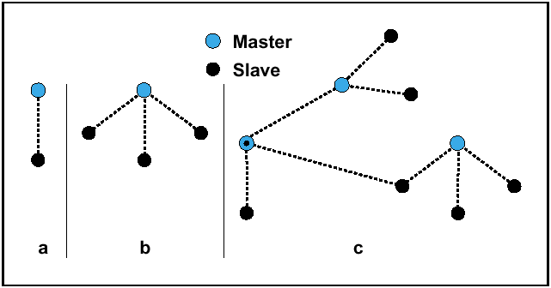
Fig 2: a) Single-slave piconet. b) Multi-slave piconet c) Scatternet.[6]

Bluetooth Modes of Operation
A member of a Bluetooth network can operate in one of five modes, active, sniff, hold, park and standby. The first four modes can be during connection while the last is assumed when the member is not participating in any connection. Note that all the states apply for a slave, but a master must be always active. The purposes of these modes are power conservation and capacity expandability. [2]
When a slave is not participating in any connection, it is in standby mode. However, when a slave is active, the slave listens for the packets coming from the master. In this way the slave responds quickly, but since it is always listening, it consumes more power. On the other hand, in sniff mode the slave listens to the master during predefined interval, and sleeps the rest of the time. This can reduce the power consumed by the slave. In the hold mode, the slave and master agree on a period of time during which the slave stops listening to the packets coming form the master. After the period expires, the slave resumes listening. The slave is not necessarily idle during the holding time, but it can communicate with other masters or establish another connection. Finally, a parked slave keeps synchronized with the master by listening to the packets coming from the master on periodic basis, but it is not considered an active member, i.e. it can not transmit any data since it is not assigned a time slot. Note that in the other three modes (active, sniff and hold) a slave is considered active, which means it is assigned a time slot. We will illustrate this more when we discuss the communication mechanism in the next section.[2]
The reader can notice that there is a compromise between the responsiveness and the power consumption between modes. Error: Reference source not found compares the four modes with respect to power conservation and responsiveness.

Parked
Sniff/hold
Active
Responsiveness
Power saving
Fastest
Slowest
Most
Least
Fig 3: Comparison between modes on power saving and responsiveness.

Device Discovery and Network Creation

The establishment of a Bluetooth network goes through four stages, we will discuss them in the following lines. Initially, all devices within the standard range (10m) are in the standby mode, and they do not know about each other. To know about its neighbors, the device initiates an inquiry as a request for information about other devices in its vicinity. The inquired devices respond by sending an inquiry response to the inquiring devices. After this phase, the inquiring device becomes aware of other devices in its range, but no connection is yet established. Note that there may be devices within the range but will not be discovered, this is major security threat.[1]
To start a connection, the device sends a page to the intended device. The paged device will respond and starts a connection procedure and the two get connected. Fig 4 shows these transitions. Note that a device in the connected state can also inquiry and page, this is used to establish scatternets. In what follows, I will give detailed description of each of these procedures. Note also that the operation is not two-way, i.e. that to collect information about other devices, each device should do an inquiry operation itself. [1]

Standby
Connected
Paging
Inquiry
Fig 4: Transition states of a Bluetooth device.[2]
Inquiry Operation
Bluetooth devices can do two operations with respect to device discovery that are inquiry and inquiry scanning. These services are provided by the link control layer and performed upon request of the higher layers. There are two problems here, since the two devices are not aware of each other, how can they synchronize in terms of timing and frequency hopping sequence. For timing, the inquiring device sends inquiries at the full rate, i.e. 3200 inquiries per second. The scanning device however, scans at half the rate, i.e. 1600 scans per second. For the frequency hopping sequence, the devices use a standard hopping sequence that is called inquiry-hopping sequence. In this way, it is guaranteed that the two will catch in time and frequency.[1][2]
When an inquired device hears the inquiry, it does not respond directly to avoid collision, since there may be more than one device in the range. Instead, the device waits a random time period (between 0 and 1023 slots) and scans again, and responding by sending a Frequency Hopping Synchronization (FHS) packet. The FHS packet includes the BD_ADDR of the scanning device and the clocking information and the hopping channel. Due to error of reception or possibility of collision, the inquiry phase may as long as 10.24 s.[2]
The goal of the inquiry phase is to gather information about other devices in the vicinity. If this information is already known, from previous connection for example, then this phase can be ignored, and the device can go directly to the paging phase as shown in Fig 4.

Paging Operation
To start a connection with other devices, the initiating device sends a series of paging requests to the intended device. These requests include the address of the intended device and its timing is estimated using the clocking information gained from the FHS packet received during the inquiry phase. On the other side, the paged device does a paging scan. When it hears the paging request from the pager, it will respond by sending ID packet as an acknowledgement. The pager then sends an FHS that includes the BD_ADDR, hopping sequence, CLK of the pager and the assigned AM_ADDR (Active Member Address), which is used as a sequence number to reference this member within the piconet. Upon receiving the FHS packet, the paged device replies by sending an ID packet. At this time the paging device becomes the master, whereas the paged device becomes a slave. The slave uses this information in the FHS packet to calculate the frequency hopping sequence of the master. [1][2]
After the frequency hopping has been calculated, the master sends a POLL packet to check if the frequency hopping transition has been correctly done. The slave then replies by sending any thing. After that, a sequence of Link Management Protocol (LMP) packets is sent to configure the link.[1]

Piconet Operation
During a connection state, two types of packets can be exchanged between a master and slave devices. The Asynchronous Connection-Less (ACL) packets are used to exchange asynchronous data which resembles a packet-switching link. On the other hand, Synchronous Connection Oriented (SCO) packets resembles a symmetric circuit-switching link, and used mainly for time sensitive applications like voice transmission. Form their names we can deduce that the SCO connection will have fixed slot(s), but the ACL will not.[1]
Then connection between a slave and a master consists of slots of 625 us each (half the frequency of operation). The master can send on the even slots and slaves use the odd slots. For the ACL connection, the master transmits only when it has data to send. Correspondingly, the slave sends only on the slot following the slot it receives at. This means that slave can not send unless it is sent to.[1]
For the SCO link, a pair of consecutive slots is reserved per connection. In this case, the master can send during the first (even) slot, and the slave can send during the next slot. Moreover, the slave can send even if it receives nothing for the master.
Fig 5 shows an example where the connection between the master and slave 1, 3 and 4 are ACL, whereas the connection with slav2 is SCO. You can notice the following:
- The master transmits during the oven slots only, but the slaves use the odd ones.
- Slave 1 and 4 can not transmit unless when they receive something from the master.
- When the master has nothing to send to slave 3, it moves to next slave (slave 4 in this case).
- The each second pair of slots is reserved for a SCO connection with slave 2.
- Slave 2 can transmit even if does not receive anything form the master.[1]

Fig 18 and Fig 19 show a flow chart of the inquiry and paging phases respectively.
Master
Slave 1
Slave 2
Slave 3
Slave 4
625 us
0
1
2
3
4
5
7
6
SCO
SCO
Fig 5: Example of a SCO and ACL connection.

Bluetooth Protocol Stack
The preceding discussion was meant to get the reader familiar with the terminology and the operation of the Bluetooth network, in order to start the discussion of the conceptual protocol stack in this section.
Application
Application

Presentation
HCI
Link Manager
Network
Physical
Data Link
Link Controller
L2CAP
RFCOMM/ SDP
Session
Transport
Radio
Baseband
Fig 6: OSI Stack vs. Bluetooth Stack.[1]

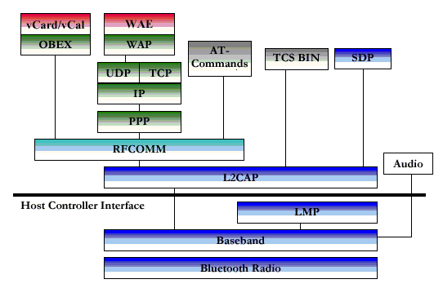
Fig 7: Bluetooth Protocol Stack.[7]

Error: Reference source not found and Error: Reference source not found show two different views of the Bluetooth protocol stack. In comparison with the OSI model, the Bluetooth has 8 layers rather than 7. In Error: Reference source not found you can see that most of the layers in Bluetooth overlap with more than one layer in the OSI. Regardless of this mismatch, we will use the OSI model to compare to since most people are familiar with it. In this section, I will go through the protocol layer by layer and explain briefly the functions and the issues of concern in each layer.

Radio [1][8]
The radio layer implements many functions from the OSI physical layer. It works as the air interface for receiving and transmitting the signals. It also does the required signal processing for modulation and channel encoding.
The Bluetooth radio specifications define the use of frequency hopping to cope with the interference that exists in the ISM band. It uses 79 hops (23 in some countries like France), each of which is 1MHz wide. This covers the spectrum from 2.402 GHz to 2.4855 GHz this is if we add to it the guard bands that are used to reduce the interference between neighboring channels.
The modulation technique used is Gaussian Frequency Shift Keying (GFSK). In addition, three transmission power classes are defined, 20dBm, 10dBm and 0dBm for operating ranges of 100m, 10m and 10cm respectively.
The receiver sensitivity should be -70dBm or better. The transceiver can optionally have a power control facility through the use of Receiver Signal Strength Indicator (RSSI), by which the receiver measures its received signal and determine wheither the transmitter should increase or decrease its transmitted power.
As mentioned earlier, each Bluetooth device uses a 3.2 KHz clock (or 312.5 us period), and each slot lasts for 2 clocks (or 625 us). Using these numbers you can find that each device will span 1600 frequency hops per second.

Baseband & Link Control [1][8]
The Baseband and the link controller (LC) are treated in some references as one layer. I will follow the same approach to maintain consistency with the OSI model.
Each Bluetooth device has an international identity which is called the Bluetooth Device Address (BD_ADDR) as discussed earlier (see Error: Reference source not found). In addition, there are 3 addresses that are used for different purposes during network operation. The Active Member Address (AM_ADDR) is a 3-bit address that is assigned to each different active member within a piconet. As we say earlier, there can be a maximum of seven active members at a time; they are numbered from 0 to 7.
The Parked Member Address (PM_ADDR) is an 8-bit address assigned to parked members within a piconet only during their parking period. The Access Request Address (AR_ADDR) is used by a parked member to determine the access window in which it can send an imparking request to the master.
The Bluetooth Baseband defines two types of connections that are Asynchronous Connectionless (ACL) for data and Synchronous Connection-Oriented (SCO) for voice, which were already discussed. The SCO packets are neither acknowledged nor retransmitted. Moreover, one master can handle three simultaneous point-to-point symmetric SCO connections with data rate of 64Kbps each. The ACL is point-to-multipoint link that implements retransmission and can apply also to those slaves participating in SCO connections to provide simultaneous voice/data services.
A general structure of packets maintained by Bluetooth Baseband is shown in -a. The access code identifies packets from different piconets, and is derived from the master (BD_ADD). Since each piconet has only one master, then all the packets exchanged within a piconet will have the same unique access code which is called Channel Access Code (CAC). There are two more access codes that are used for paging and inquiry called Device Access Code (DAC) and Inquiry Access Code (IAC).

The header field contains the following fields as in Error: Reference source not found-c:
- AM_ADDR: The active member address as mentioned earlier.
- Packet Type: To identify wheither it is a SCO, ACL or NULL or POLL.
- Flow: For flow control and set when receiver is overwhelmed.
- ARQN: Used for acknowledgement.
- SEQN: Sequence number (0 or 1).
- Header Error Check (HEC): A CRC for header error control.
Note that the payload for ACL packets is not fixed as in Error: Reference source not found-d, it can go up to 2744 bits. For SCO packets however, the payload is fixed with 240-bits, since it is meant fro time-sensitive applications.

Fig 8: Bluetooth Protocol Stack.[1]

All what has been discussed so far is the responsibility of the Baseband layer. The Link control (LC) deals with the state of the link and modes of operation. As discussed earlier, a Bluetooth device can switch between 5 modes: standby, active, sniff, hold and park. In addition, the devices have to go through a sequence of states (actions) in order to establish a connection. The details of this have been covered in the “Network Operation Section”.

Link Manager [1][8]
The Link Manager carries out link setup, authentication, link configuration and other protocols. It also utilizes the underlying services provided by the LC to communicate with the LM on the destination device using the Link Management Protocol (LMP). Among the functions that are done by the LM:
- Attaching and detaching slaves to a piconet and allocating their AM_ADDR.
- Link configuration and master-slave roles switching.
- Establishing ACL and SCO links.
- Controlling test modes.
- Carrying the transition between different modes (hold, park, sniff, .etc).

To do the above functions, the two communicating LM’s exchange a set of Protocol Data Units (PDU’s) within certain procedure. Each of these PDU’s spans no more than one slot. I will not describe all the procedures here, but I will describe the role of the LM during the connection establishment.
Error: Reference source not found shows the PDU’s exchanged by two LM’s on a master and a slave device during link setup of an ACL connection. Note that after the LC completes the paging procedure, the LM takes over to complete the connection establishment.

Fig 9: LMP massages exchange during ACL link setup. [1]

Once the paging is done, the LM on the master sends an LMP_host connection_req. The slave replies with LMP_accepted. After that the two negotiate the link options and finally send connection completeness indication with acknowledgment. In case of an SCO connection, first an ACL connection is established, and then the SCO link is established on top of the already established ACL link. Note that the default connection is of ACL type, and both the master and the slave can initiate a request for an SCO connection.

Host Controller Interface (HCI) [1]
The normal implementation of Bluetooth devices separates the upper and lower layers (usually the lower layers are Radio, Baseband, LC and LM, and the upper layers are the rest of the stack.). For example, a PC Bluetooth card includes the four lower layers and the rest are implemented in software on the PC as a program or a driver.
A standard firmware interface that interfaces the two sets of layers is called the Host Controller Interface (HCI). The use of the HCI brings the following advantages to the Bluetooth implementation:
- It minimizes the memory requirements and complexity on the Bluetooth module and hence reduces its cost.
- The Host device (e.g. a PC) can sleep and be awoken by the Bluetooth module when a connection comes.
The HCI consists of three components that are the HCI Firmware, HCI Driver and Host Controller Interface Layer. The HCI firmware is located on the Bluetooth module. It maintains a set of standard commands for the interaction between the higher and lower layers. Through these commands, the HCI firmware can provide the layers with the state of different state and event registers.
The HCI Driver lies on the Host device as a software unit. It notifies the host of any event when it receives notifications from the HCI firmware. The Host Controller Transport Layer provides the connection between the HCI firmware and the HCI Driver. Three standard interfaces have been standardized for Bluetooth Host Controller that are the USB, UART and RS232.
From the discussion above, you should have noticed that the HCI firmware deals with commands, the HCI Driver deals with events and the Host controller transport layer deals with interfaces. Table 2 lists those entities that each HCI component can deal with. Note that in host-less systems, the higher layers and LM will interact directly.

Components | Entities
HCI Firmware | - HCI-specific information exchange  - Link control commands  - Link Policy Commands  - Host Controller and Baseband commands  - Information parameters  - Status parameters  - Testing commands
HCI Driver | - Flow Control  - HCI events  - HCI error codes
Host Controller Transport Layer | - UART Transport Layer  - USB Transport Layer  - RS232 Transport Layer
Table 2: Entities under Each HCI Component.

Logical Link Control & Adaptation Protocol (L2CAP) [1][8]
The L2CAP comes on top of the LM layer. For systems with no host, i.e. where the Bluetooth is one module and hence no HCI is needed, the L2CAP talks directly with the LM, otherwise, it has to go through the HCI. The L2CAP layer has many functions that are:
- Protocol Multiplexing: L2CAP allows different packets of different protocols to be multiplexed over single link since the lower layers do not distinguish between packets of different protocols.
- Segmentation & Reassembly: Bluetooth allows higher layer to deliver large packets which can not be supported by the lower layer protocols such as in the case of LAN access points. The L2CAP segments the coming packets and pass them to the lower layers in the sending node. On the receiver node however, the L2CAP reassembles the coming packets and passes them to the higher layers.
- Group Management: L2CAP allows higher layer to use group addressing, in which more than one device is addressed. In such a case, a Channel Identifier (CID) is assigned to each group, and all what the higher layers have to do is to use this CID to address the corresponding group. L2CAP then duplicates the packets to each destination.
- QoS: L2CAP allow higher layer to request certain QoS for their connection. Then each connection will be treated according to its QoS promised.

In contrast with the Baseband, the L2CAP supports only one type of connections. It supports the ACL connections but not SCO. This is why you see in the protocol stack (Error: Reference source not found) that the Audio interacts directly with the Baseband.
Length
Channel Identifier
Data (0-65535 bytes)
0
16
32
Fig 10: Structure of L2CAP Packet. [1]
Two L2CAP layers on two different Bluetooth devices communicate through a virtual (logical) channel that is established between them. The two L2CAP layers exchange packets. Error: Reference source not found shows the format of a L2CAP Packet. The Channel Identifier (CID) field is used to address different connection, wheither a single or a group connection. The data field will contain what is called a command that instructs the target L2CAP.
OpCode
Identifier
Length

Data
0
8
16
32
Fig 11 : Structure of L2CP Command.
Fig 11 shows the structure of L2CAP command. The OpCode identifies the content of the command. There can be more than one command within one packet. And in order to distinguish the responses of these commands, which might come on different packets, the identifier field is used.
In order for two L2CAP’s to establish a logical connection, we said they should exchange a set of packets. These packets are used to configure this connection which is established in a series of steps as shown in Error: Reference source not found. The request for initiating the connection comes for the higher layers. The requesting side sends a connection request and waits for reply. The disconnection request can also be initiated by the applications in either side.

RFCOMM [1][8]
The RFCOMM is a simple transport protocol that emulates the serial RS-232 standard that is used to interface devices of different types. The protocol is based on the TS 07.10 standard that is used by the GSM cellular phones to multiplex several streams of data onto one physical serial cable. This way, the RFCOMM allow for many different simultaneous connections between two machines. The RFCOMM depends on the L2CAP to handle the multiplexed steams coming from different connections. There can be up to 60 simultaneous connections between two Bluetooth devices; each of these connections has a Data Link Connection Identifier (DLCI). On the other hand, the RFCOMM relies on the Baseband to do the error control, in sequence delivery and flow control.
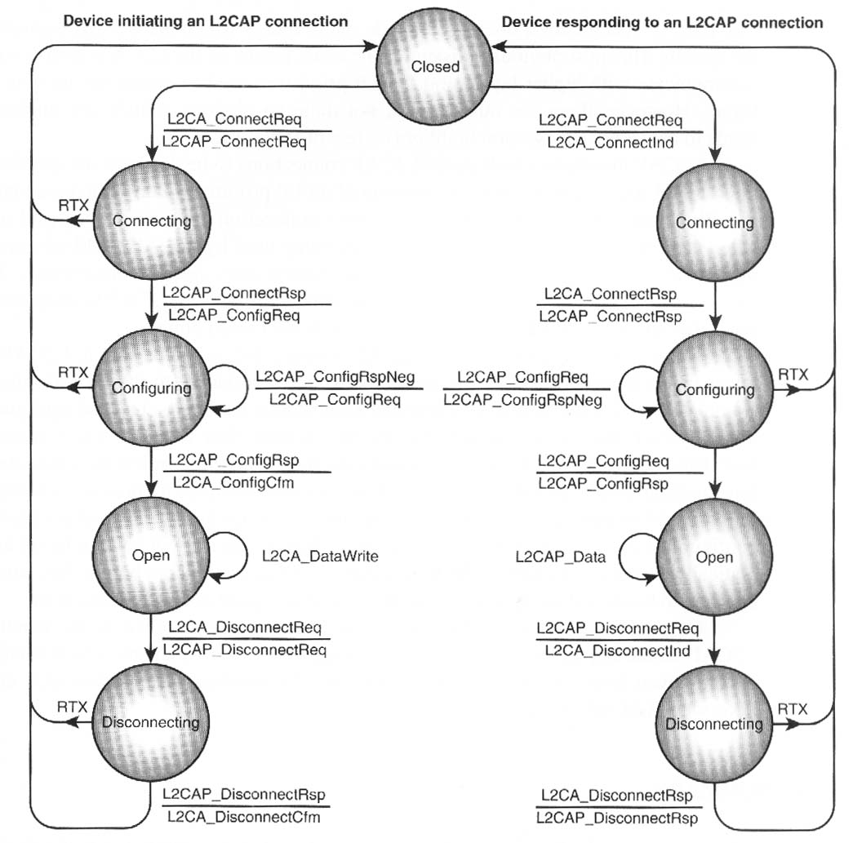
Fig 12: L2CAP State Machine. [1]

RFCOMM communicates through frames. There are 5 types of frames that are sent through the L2CAP layer:
- SABM: Start Asynchronous Balanced Mode.
- UA: Unnumbered Acknowledgment.
- DISC: Disconnect
- DM: Disconnected Mode.
- UIH: Unnumbered Information with Header check.
These frames are used to start and end connections (or channels). In addition, the UIH is used to send control massages or data. The RFCOMM is capable of emulating the 9 circuits that are used in the RS-232 standard as shown in Table 3.
In the context of RS-232, two types of devices are defined; these are the Data Circuit-terminating Equipment (DCE) such as a modem and a Data Terminal Equipment (DTE) such as a PC. RFCOMM does not distinguish between these two types and implicitly emulates a null modem if two devices of the same type are interfaced.
Pin Circuit Name
102 Signal Common
103 Transmit Data (TD)
104 Received Data (RD)
105 Request to Send (RTS)
106 Clear to Send (CTS)
107 Data Set Ready (DSR)
108 Data Terminal Ready (DTR)
109 Data Carrier Detect (CD)
125 Ring Indicator (RI)

Table 3: The 9 Control Signals of RS-232.[8]

Address
Control

Data (0-32767 bytes)
Length or Data
Length
FCS
0
8
16
24
32
Fig 13: Structure of an RFCOMM Frame.[1]
Fig 13 shows the structure of and RFCOMM frame. The address field identifies the channel among many other multiplexed channels. The control field identifies the type of the frame. We mentioned earlier that RFCOMM have 5 types of frames, SABM, UA, DISC, DM and UIH. The Frame Check Sequence (FCS) is used for error control.
RFCOMM also has a flow control capability. There are 4 types of flow control mechanism that is supported by the RFCOMM.

- L2CAP Flow Control: In this case the RFCOMM depends on the L2CAP to provide the flow control.
- Wired Serial Port Flow Control: This may be software flow control using characters such as XON/XOFF or hardware flow control using circuits such as RTS/CTS or DTR/DSR.
- RFCOMM Flow Control: Using RFCOMM flow control command which effects all ongoing connections on RFCOMM entity. Alternatively, the modem status command can operate on one single connection.
- Port Emulation Entity, Serial Flow Control: In this case the driver can do the flow control upon receiving requests from the applications requesting to do so. The driver can use the flow control supported by the RFCOMM, or do its own flow control.
- Credit-Based Flow Control: In this case, the receiving entity provides a credit describing how many frames it’s willing to accept before its buffer is full. When the credit reaches zero the sending entity stops until it receives a new credit.

Service Discovery Protocol (SDP) [1][38][8]
The SDP provides a mean for Bluetooth devices to discover, identify but not access the services that are offered by another Bluetooth device. The device that requests the service is called SDP client. Whereas the device that provides the service is called the SDP server which maintain a catalog of the available services in form of records. Each service record includes the service type, name, ID, protocol and description.
The SDP utilizes the services provided by the L2CAP layer as seen in Error: Reference source not found. In order for two devices to exchange SDP services, a L2CAP connection must be established and the SDP will run on top of it.
Two services are supported by SDP, searching and browsing. Each service is defined by its Universal Unique Identifier (UUID). The searching uses this UUID to search for services. The server can decide which of the services is browsable and which is not. The services will be arranged in a hierarchical manner, Fig 14 shows an example of a possible cellular phone SDP browsing hierarchy. To browse, the SDP client examines the root of the hierarchy. Then it traces the way out till it reaches the service in the leaf.

Public Brows Root
Audio
Organizer
Cellular
Vcal
Alarm
Intercom
Fig 14: Example of Cellular Phone SDP Browsing Hierarchy.[1]

The SDP client can use three types of transactions regarding SDP, service search transaction, service attribute transaction and service search attribute transaction. Following is a description of each.
- Service Search Transaction: used to request a list of service records.
- Service Attribute Transaction: used to request a specific attribute value from a record.
- Service Search Attribute Transaction: this combines both previous transactions.

Bluetooth Profiles [8]
If you look to the upper part of the protocol, you will see a set of Bluetooth profiles. These are not protocol as it may appear from a quick glance. Profiles describe how a particular user service will be provided using the previously described protocols. Profiles also define what features are mandatory and which are not for a particular service.
I will not describe these profiles since they have a strong relation with implementation which may vary from one manufacturer to another. Table 4 lists those profiles.

Main Profiles |  | Additional Profiles
GAP | Generic Access Profile | ESDP | Extended Service Discovery Profile (for Universal Plug and Play)
SDAP | Service Discovery Application Profile | A2DP | Advanced Audio Distribution Profile
CTP | Cordless Telephony Profile | AVRCP | Audio Video Remote Control Profile
IP | Intercom Profile | BIP | Basic Imaging Profile
SPP | Serial Port Profile | BPP | Basic Printing Profile
HS | Headset Profile | CIP | Common ISDN Access Profile
DNP | Dial-up Networking Profile | GAVDP | Generic Audio Video Distribution Profile
DP | Fax Profile | HFR | Hands-Free Profile
LAP | LAN (Local Area Network) Access Profile | HCRP | Hardcopy Cable Replacement Profile
GEOP | Generic Object Exchange Profile | HID | Human Interface Device Profile
OPP | Object Push Profile | PAN | PAN (Personal Area Networking) Profile
FTP | File Transfer Profile | SAP | SIM Access Profile
SP | Synchronization Profile | SAP | SIM Access Profile

Table 4: Bluetooth Profiles.[8]

The Network Simulator 2 (NS-2)
NS is a very powerfull open-source, event-driven, research-targeted simulator that simulates most of the existing network protocols such as TCP, UDP, CPR, VBR, FTP, Telnet, etc. NS-2 has been developed since 1989 and was supported by DARPA. Later, it went under development by many scientific organizations and companies such as Berkeley, Xerox, USC, USC/ISI and LBL. [10]
As I am writing these words, the latest versions so far is v.2.26. In this section I will provide an introduction of NS-2 in terms of components and installation. Note that Bluetooth is not implemented in the above mentioned versions, but it comes in a separate extension called Bluehoc. Moreover, the only versions of NS that Bluehoc currently supports are NS-2.1b7a and NS-2.1b8a. In order to run Bluehoc on V2.26 or any other version you will need to do some modifications to the corresponding files.

NS-2 Components [11]
NS-2 is implemented using two languages, which are C/C++ and Tool Command Language (TCL). NS-2 consists of many components NS, NAM, TCL, OTCL, TCLCL and Xgraph. In what follows, I will mention each component and give a brief description about it and who the components fit together.
TCL (Tools Command Language): This is a simple script language that is used to make simulation scenarios. This language is very simple and easy to use and learn. For more information about this language refer to http://www.neosoft.com/tcl/.
OTCL (Object-oriented Tools Command Language): This is an object oriented extension of TCL. Actually, the simulation scenarios are written using this language, but OTCL barrows many services from TCL.
TCLCL (TCL & C Linkage): This is a module to do the linkage between each TCL or OTCL object and its C++ correspondent. For efficiency reasons, objects are implemented in C++ and passed to OTCL through TCLCL.
NS (Network Simulator): This is the core of the simulator which does the actual implementation of the simulation scenarios and produces the results. It is implemented with OTCL and C/C++.
NAM (Network Animator): This is a tool that takes the output of NS and generates a graphical representation of the simulation scenario. An example of NAM is shown in Fig 16Error: Reference source not found.
Xgraph: This is a tool that analyzes the output data of NS and generates graphs and statistics for different analysis purposes.
Error: Reference source not found shows how different components of NS-2 fit together. Error: Reference source not found shows how the different components interact to genrate the final results.

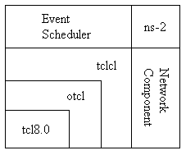
Fig 15: NS Architecture.[11]
Fig 16: Example of NAM GUI.[11]

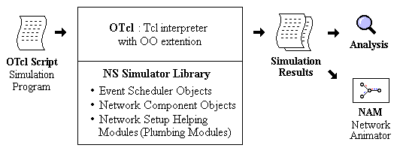
Fig 17: NS components interaction.[11]

NS-2 Installation
NS-2 is originally designed to work on UNIX and Linux platforms. But it also works for Windows but not directly. I will try to illustrate the main steps for different case, but the details of the installation are included with the package itself.
As we mentioned earlier, NS-2 is open source and hence can be acquired for free from the fallowing URL, http://www.isi.edu/nsnam/dist, the whole package size is about 45MB- depending on the version. You can either download the whole package at one time using the package ns-allinone-2.26.tar.gz or download it file by file and arrange them hierarchically.
To install the package on UNIX and Linux platforms, you just need to extract the compressed folder and execute the “./install” file in the main directory of the folder. After the installation is complete, you need to edit the PATH variable to include the directories that contains the executable files of NS-2. Detailed description of those modifications can be found in http://www.cs.virginia.edu/~nc2y/ns-cygwin.shtml.
On the other hand, for windows the best way is to install NS-2 on Cygwin which is a Linux-like environment for Windows. Cygwin can be downloaded for free from http://www.cygwin.com/. Cygwin comes with a very beautiful setup wizard that allows the user to select the packages to download and the preferred FTP server. After you install Cygwin, run it and it will have a UNIX-like command prompt in which you can do the pervious steps as with Linux or UNIX. In order to have a GUI instead of the command prompt with Cygwin, you need to install a package called XFree that comes with Cygwin.
After the installation is completed, a good tutorial about running and using NS-2 can be found in http://nile.wpi.edu/NS/. The site has a very good tutorial on NS-2 and complete set of examples and their explanations.

Bluehoc [12]
Bluehoc is an open source extension designed by IBM that runs over NS-2 to simulate the Bluetooth standard. Unfortunately, the current versions support only NS-2.1b7a and NS-2.1b8a. The current version of Bluehoc is V3.0. Bluehoc simulates the following protocols of the Bluetooth:
- Bluetooth radio.
- Bluetooth Baseband.
- Link Manager Protocol.
- Logical Link Control and Adaptation Protocol (L2CAP).
The key issues that the Bluehoc addresses are:
- Device Discovery performance of Bluetooth.
- Connection Establishment and QoS negotiation.
- Medium access control scheduling schemes.
- Radio characteristics of Bluetooth system.
- Statistical modeling of the indoor wireless channel.
- Performance of TCP/IP based applications over Bluetooth.
Note that the previous protocols do not include scatternet operation. The latter has recently been added to Bluehoc but as a separate extension called Bluescat0.6.

Bluehoc Installation
You need to download Bluehoc form http://www-124.ibm.com/developerworks/projects/bluehoc. The package includes a clear installation procedure in a file called “INSTALL”. One thing to note is that Bluehoc can be installed in two different ways, depending on NS-2 being installed or not.
Note also that Bluehoc2.0 is designed for NS-2.1b7a, but Bluehoc3.0 is designed for NS-2.1b8a. For any problem on the installation or using Bluehoc, there exists a mailing list at http://www-124.ibm.com/pipermail/bluehoc-discussion. There is also a similar list for NS-2 at http://www.isi.edu/nsnam/ns/ns-lists.html.

Conclusion
We discussed in the report the Bluetooth working model and the network operation. The protocol of Bluetooth was also discussed. I gave also a brief overview of NS-2 and the Bluehoc and their installation.
Bluetooth gained a worldwide acceptance. Yet, there still many issues that need improvements. One of these issues is security flaws, like the one we highlighted during the discussion of the operation of paging and inquiry. Another issue is the efficiency of scheduling. For the latter issue we saw that the slots allocated for slaves are always reserved even if there is no communication, this reduces the efficiency of communication.
Due to instillation problem I could not achieve the simulation part although I has benefited a lot by involving into Unix, Linux and Windows Systems details. On the other hand, I went through a good tutorial about NS-2 and acquired a good introduction that motivated me to look for further study and implementation of the simulator in the future. I would like to express my willing to resume my research into Bluetooth and Wireless networking.

Stop
Send inquiry
Start inquiry
Any response?
Receive FHS and record info.
Discover all ?
Y
N
Y
N
Start inquiry scan
Any inquiry?
Send FHS
Wait random time
Any inquiry?
Y
Y
N
N
b)
a)
Fig 18: Flow chart for inquiry phase.: a) inquirer b)inquered.
Start paging

Sends a Page with slave ID
Send FHS
Wait
Send POLL
Send LMP
STOP

Y
N
Start paging scan

Sends ID packet
Receive FHS and Sends ID packet

Any Page?
Sends ID packet

Configure Link
STOP

Y
N
a)
b)
Fig 19: Flow chart for paging phase: a) pager b) paged.

References

- Bray, J, Sturman C, ”Bluetooth Connect Without Cables “
Prentice Hall, Upper saddle River, 2001.
- Miller B. , Bisdikian C. , ”Bluetooth Revealed, The insider Guide to an Open Specification for Global Wireless Communications”,
Prentice Hall, Upper saddle River, 2001.
- Sairam K. et al., “Bluetooth in Wireless Communication”, IEEE comm., June 2002.
- Yujin Lim et al., “Performance Evaluation of the Bluetooth-based Public Internet Access Point”, IEEE, 2001.
- Rodriguez B., Fernandez M. and Armada A., “Discrete Channel Simulation of Bluetooth Piconets”,
- Bluetooth Special Interest Group: http://www.bluetooth.com
- Bluetooth Tutorial: www.xilinx.com/esp/bluetooth/tutorials/
- Bluetooth Tutorial: http://www.palowireless.com/infotooth/tutorial.asp
- Bluetooth Official Web Site: http://www.bluetooth.net/
- NS Home Page: http://www.isi.edu/nsnam/ns
- NS by Example http://nile.wpi.edu/NS/

The BlueHoc Project Home Page: http://oss.software.ibm.com/developerworks/opensource/bluehoc/

