Name: Id#

COE 202, Term 141

Digital Logic Design

Quiz# 6

Date: Thursday, Dec. 25

Q1 The sequential circuit shown below has a single output Z, an input x together with a Reset input to initialize the circuit. Note that the used D-FFs have direct/asynchronous Clear and Set inputs (shown in the figure as CLR and SET).
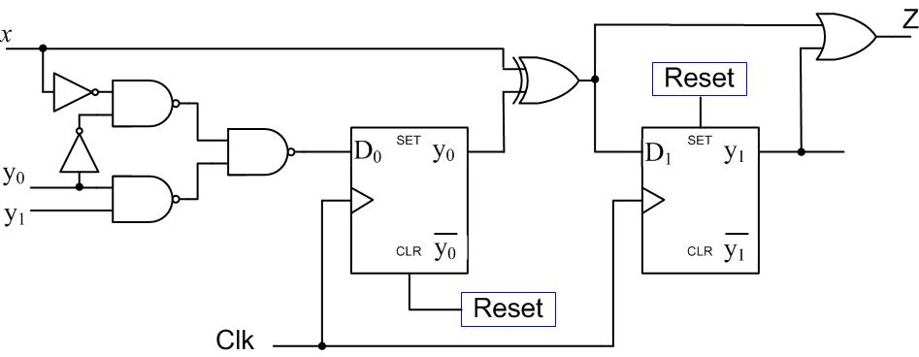

- Is the circuit type Mealy or Moore? Why? ( 2 point)

- Derive expressions for the D₀ and D₁ flip flop inputs and the external output Z. (3 points)

$$D_{0}=y_{1}y_{0}+\overline{x} \overline{y_{0}}$$
$$D_{1}=y_{0}⊕x$$
$$Z=y_{1}+D_{1}$$

- Derive the state transition table of the circuit. (4 points)

- What is the circuit initial state? (1 points)

$$y_{1}y_{0}=10$$
Q2 It is required to design a synchronous sequential circuit that receives a serial inputs x and produces a serial output z that computes the equation z=x-2. Draw the state diagram of this circuit assuming a Mealy model. Assume the existence of an asynchronous reset input to reset the machine to a reset state. Two samples of input/output data are given below.
(NOTE: You are only required to draw the state diagram Nothing MORE) (6 points)

t = 0
time
Examples:

Input | x | 0 1 0 1
Output | z | 0 0 0 1

time
t = 0
Examples:

Input | x | 1 1 1 0
Output | z | 1 0 1 0

