Name: KEY Id#

COE 202, Term 151

Digital Logic Design

Quiz# 5

Date: Thursday, Dec. 10

Q1. The sequential circuit shown below has a single output Z, an input x together with a Reset input to initialize the circuit. Note that the used D-FFs have direct/asynchronous Clear and Set inputs (shown in the figure as CLR and SET).
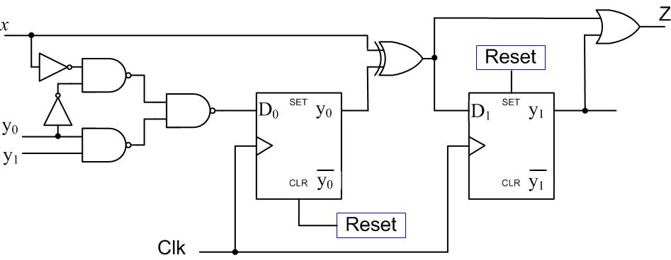

- Is the circuit type Mealy or Moore? Why?

Mealy since Z depends on the input x.

- Derive expressions for the D₀ and D₁ flip flop inputs and the external output Z.
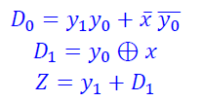$D_{1}=y_{0}⊕xZ=y_{1}+D_{1}$

- Derive the state transition table of the circuit.
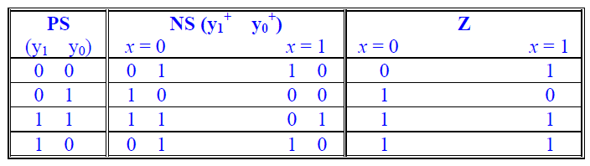

- What is the circuit initial state?
y₁y₀=10
Q2. Consider the following state transition table for a synchronous sequential circuit that multiplies a binary number by 3 i.e. Z=3*X. The circuit has a single input X, a single output Z, and two state variables Y₀, and Y₁. The states are encoded using binary codes 00, 01, 10.

PS (Y₁ Y₀)^{t} | NS (Y1 Y₀)^{t+1} | Z
 | X = 0 X = 1 | X = 0 X = 1
0 0 | 0 0 0 1 | 0 1
0 1 | 0 0 1 0 | 1 0
1 0 | 0 1 1 0 | 0 1

Using D-FFs and minimal combinational logic, determine the equations for the D-FF inputs and the output Z for this circuit and draw the resulting circuit. State 00 is the reset state.

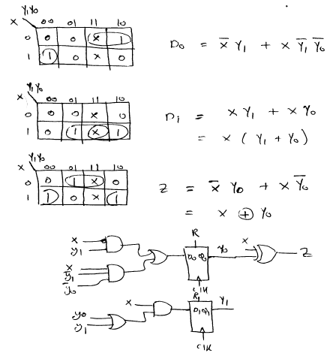

Q3. It is required to design a synchronous sequential circuit that receives a serial sequence of 3-bit codes through input X and produces 1 through output Y when the received 3-bit code equals either 010 or 110 (i.e., either 0 followed by 1 followed by 0, or 1 followed by 1 followed by 0). Assume the availability of an asynchronous reset input to reset the machine to a reset state. Draw the state diagram of the circuit assuming a Mealy model with minimum number of states. You are not required to derive the equations and the circuit. The following is an example of an input and output sequence:
Example:
Time

Input | X | 0 1 0 0 0 1 0 0 1 1 0 1 1 1 0
Output | Y | 0 0 1 0 0 0 0 0 0 0 0 0 0 0 1

