Name: KEY Id#

COE 202, Term 131

Digital Logic Design

Quiz# 5

Date: Thursday, Nov. 28

Q1. Fill in all blank cells in the two tables below. All binary representations use 7 bits
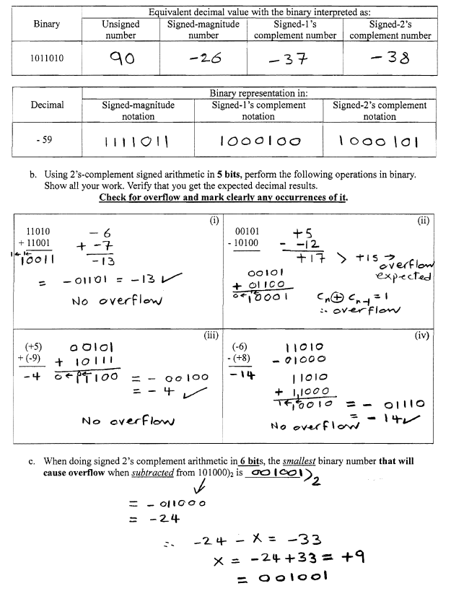

Q2.
