Name: KEY Id#

COE 202, Term 112

Digital Logic Design

Quiz# 5

Date: Wednesday, April 25

Q1. Design a rising edge-triggered D flip-flop using a rising edge-triggered JK flip flop.

State Table:

Current State (Q) | Input (D) | Next State (Q) | J | K
0 | 0 | 0 | 0 | X
0 | 1 | 1 | 1 | X
1 | 0 | 0 | X | 1
1 | 1 | 1 | X | 0

J= D K=D’

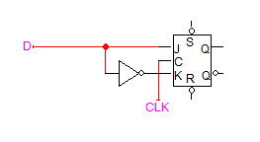

Q2. A sequential circuit with two D flip-flops A and B, two inputs X and Y, and one output Z is specified by the following equations:

D_{A} = X` Y + X A D_{B} = X` B + X A Z = B

- Draw the logic diagram of the circuit.

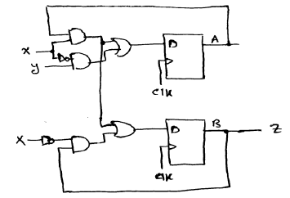

Derive the state table.

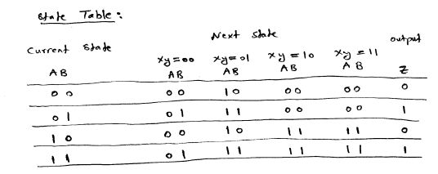

Derive the state diagram.

