Name: Id#

COE 202, Term 132

Digital Logic Design
Quiz# 5

Date: Tuesday, May 6

Question 1. (13 points)
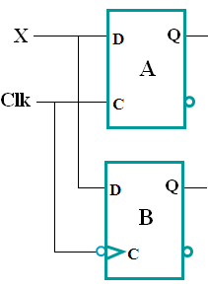
- In the circuit shown, A is a D-type latch and B is a D-type flip flop. For the input waveforms given for the clock signal (Clk) and the input X, accurately draw the resulting waveforms at outputs Q_{A} and Q_{B}.

Assume that both Q_{A} and Q_{B} are initially at 0.

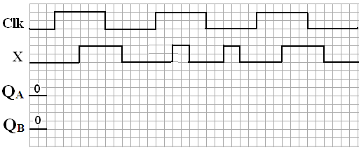
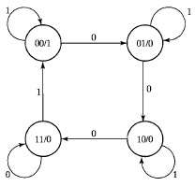

- The state diagram shown is for a sequential circuit that has a single input X and a single output Y. The circuit uses two positive edge triggered D-type flip flops Q1 and Q0.

- Starting with the circuit in state Q1Q0=11, complete the missing waveforms in the timing diagram below.
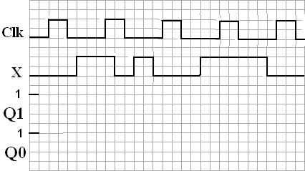

- Let the circuit be in state 00 with input X held permanently at 0. The circuit will end up being stuck at state _______. With the circuit operating at a clock frequency of 2 KHz, this state transition takes a minimum time duration of _______ ms.
Question 2. (12 Points)
Consider the sequential circuit opposite and then answer the following questions:

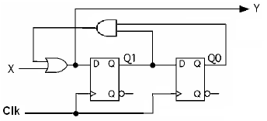
a. Is the circuit Mealy or Moore?

b. Provide logical expressions for the flip flop D inputs and the external output

c. Give both the state table and the state diagram. Use the layout given below for the state diagram. Note: Q0 represents the LSB of the binary value of the state.

