Name: KEY Id#

COE 202, Term 131

Digital Logic Design

Quiz# 4

Date: Tuesday, Nov. 25

Q1. Design a circuit that accepts two 2-bit unsigned numbers A = A₁A₀ and B = B₁B₀. The circuit produces A – B when A > B, and produces A + B otherwise. Find the following:
- The number of outputs produced by the circuit.

A – B result is at most 2 bits, A + B result is at most 3 bits ⇒ # outputs = 3

- The truth table of the circuit.

A₁ | A₀ | B₁ | B₀ | O₂ | O₁ | O₀
0 | 0 | 0 | 0 | 0 | 0 | 0
0 | 0 | 0 | 1 | 0 | 0 | 1
0 | 0 | 1 | 0 | 0 | 1 | 0
0 | 0 | 1 | 1 | 0 | 1 | 1
0 | 1 | 0 | 0 | 0 | 0 | 1
0 | 1 | 0 | 1 | 0 | 1 | 0
0 | 1 | 1 | 0 | 0 | 1 | 1
0 | 1 | 1 | 1 | 1 | 0 | 0
1 | 0 | 0 | 0 | 0 | 1 | 0
1 | 0 | 0 | 1 | 0 | 0 | 1
1 | 0 | 1 | 0 | 1 | 0 | 0
1 | 0 | 1 | 1 | 1 | 0 | 1
1 | 1 | 0 | 0 | 0 | 1 | 1
1 | 1 | 0 | 1 | 0 | 1 | 0
1 | 1 | 1 | 0 | 0 | 0 | 1
1 | 1 | 1 | 1 | 1 | 1 | 0

- The minimal product-of-sums expression for each output.

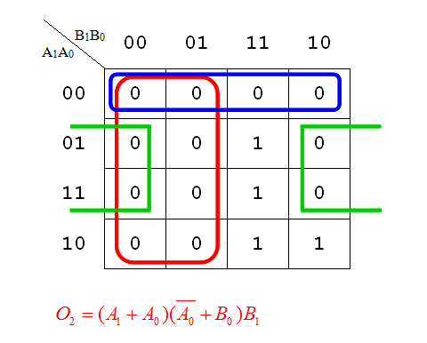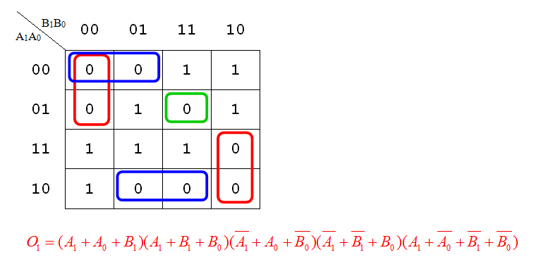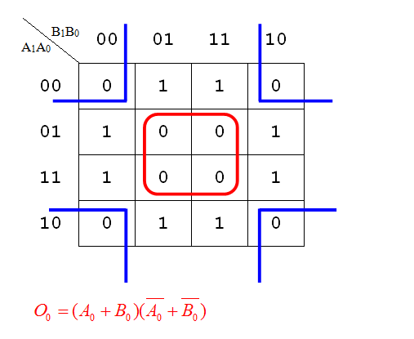

Q2. Convert the AND/OR/NOT logic diagram shown below to a NAND logic diagram:

