Name: KEY Id#

COE 202, Term 122

Digital Logic Design

Quiz# 4

Date: Monday, April 8

Q1. We would like to design an adder to add the 8-bit constant 10101010 to an arbitrary 8-bit number. The adder is to be designed using four identical adder modules, each of which will add 2 bits of the number to the constant (10) and a carry from the next lower pair of bits and produce 2 bits of the sum and the carry to the next bits. A block diagram of part of this design is shown below:

The problem each 2-bit adder solves is:

c
a b
+ 1 0
y s t

  - Show a truth table for the 2-bit adder (it has three inputs: a, b, and c, and it has three outputs: y, s, and t), and find minimal SOP expressions for each output.
  - Compute the delay from the c-input of each module to the y output of that module and the total delay for the 8 bits. Assume that the delay of a gate is related to the number of inputs i.e. the delay of an inverter is 1, the delay of a 2-input gate is 2, etc.

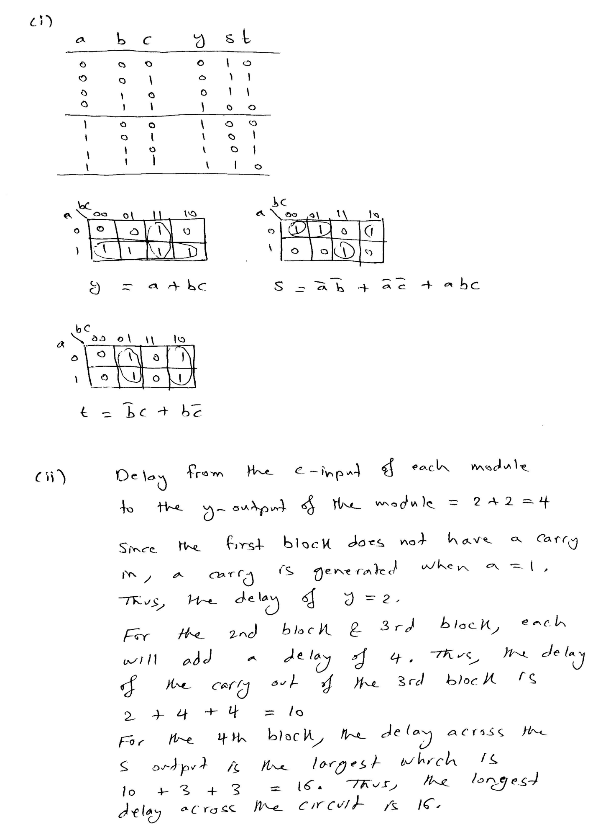

Q2.

- Determine the decimal value of the 7-bit binary number (1011010) when interpreted as:

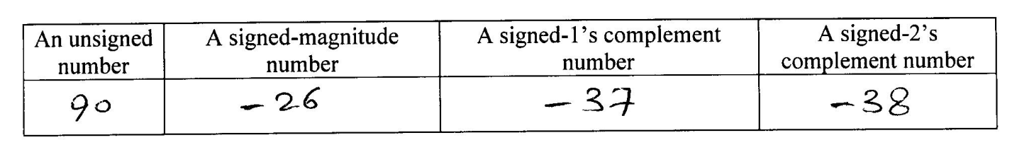

- Represent the decimal value (- 21) in binary using a total of 7 bits in the following notations:

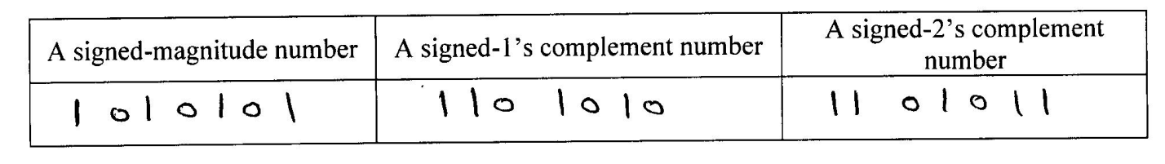
- Perform the following signed-2’s complement arithmetic operations in binary using 5 bits.
All numbers given are represented in the signed-2’s complement notation. Indicate clearly the carry values from the last two stages. For each of the three operations, check and indicate whether overflow occurred or not.

