Name: KEY Id#

COE 202, Term 102

Fundamentals of Computer Engineering

Quiz# 4 (Take Home)

Due date: Monday, April 18, 2011

Q.1. Using logic works, you are required to do the following:

Model a full adder circuit, verify its correct functionality by simulation. Add delay attributes to the gates by making the delay of a 2-input AND gate 2, the delay of a 2-input OR gate 2 and the delay of an XOR gate 4. Then create a device symbol for it.

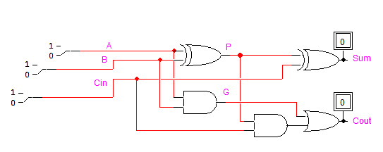 | 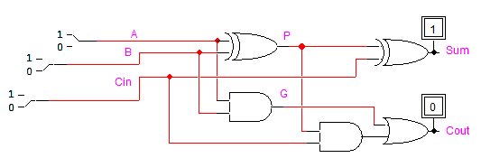
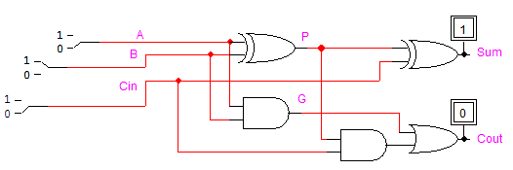 | 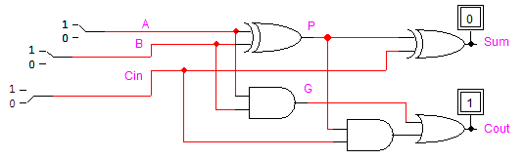
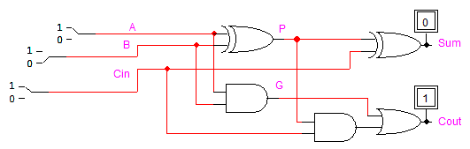 | 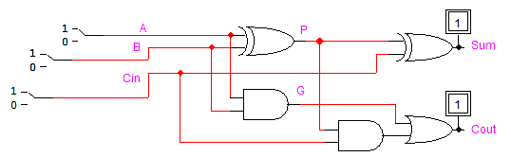
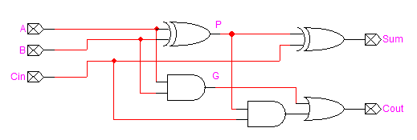 | 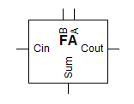

Using the full adder created in (a) construct a 4-bit Ripple Carry Adder (RCA). Verify its correctness by simulation and determine the longest delay. Then, create a device symbol for it.

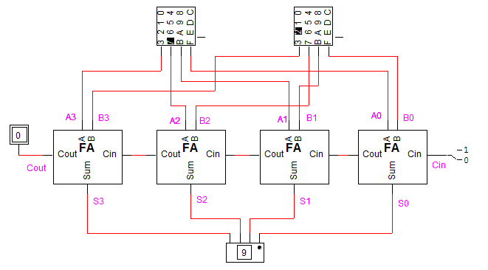
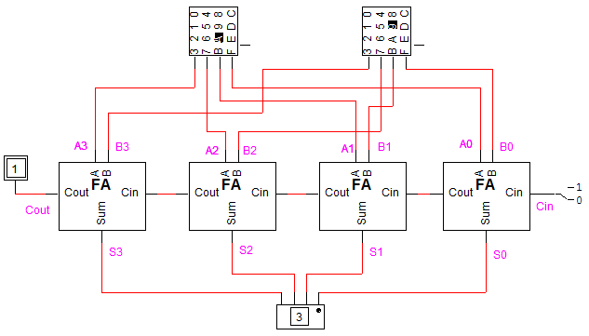
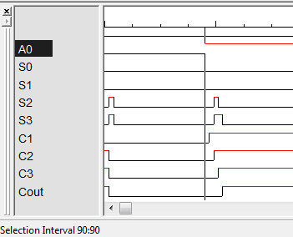 | 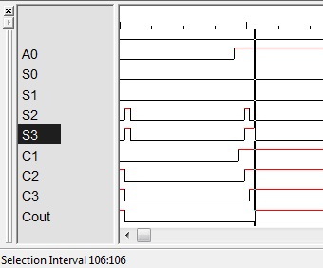
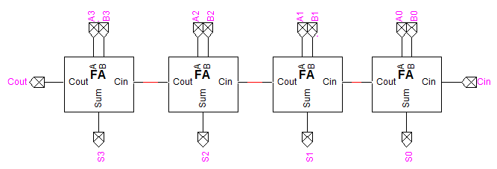
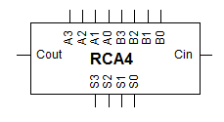

To measure the longest propagation delay, we set B₃B₂B₁B₀=0000 and A₃A₂A₁A₀=0000 and then change them to B₃B₂B₁B₀=1111 and A₃A₂A₁A₀=0001 to generate a carry in the first cell and propagate it to the last cell. To measure the longest delay we need to find the time difference between the time when A₀ has changed (time=90) to the time when Cout or S₃ have changed (time=106)= 106-90=16 ns. This is as expected as the generate AND gate in the first cell has a delay of 2ns and the carry is propagated after additional 2ns through the OR gate resulting in a total delay of 4ns from the first cell. Then, the AND and OR gates add a 4ns delay in each cell to propagate the carry which results in a delay of 16 ns.

Model a 4-bit Carry Look-Ahead Adder (CLA) using the same gate delay attributes specified in (a). Verify its correctness by simulation and determine the longest delay. Compare its delay to the 4-bit RCA in (b). Then, create a device symbol for it.

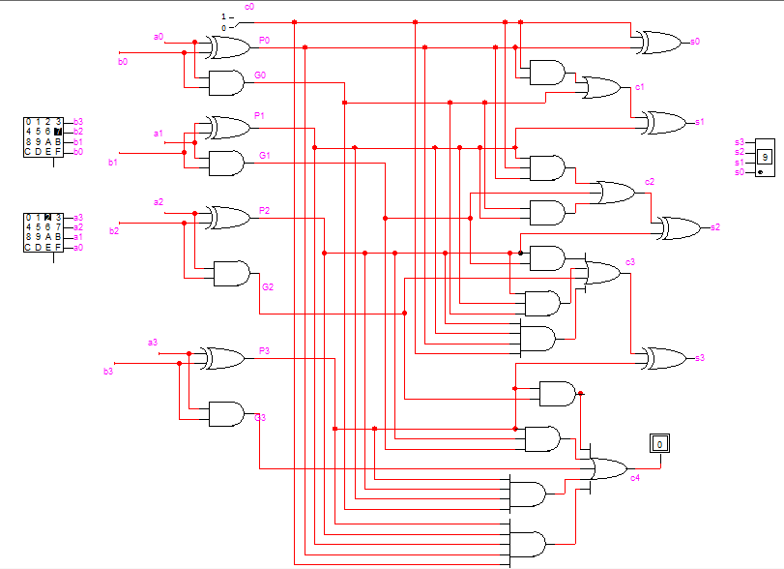
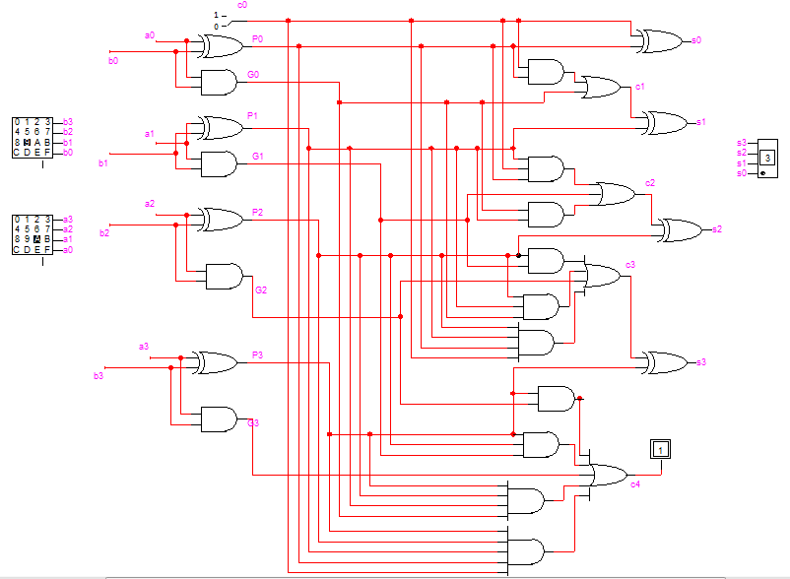
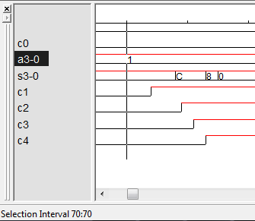 | 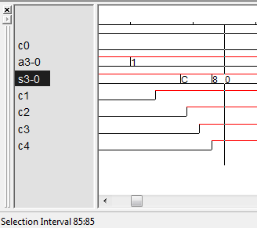
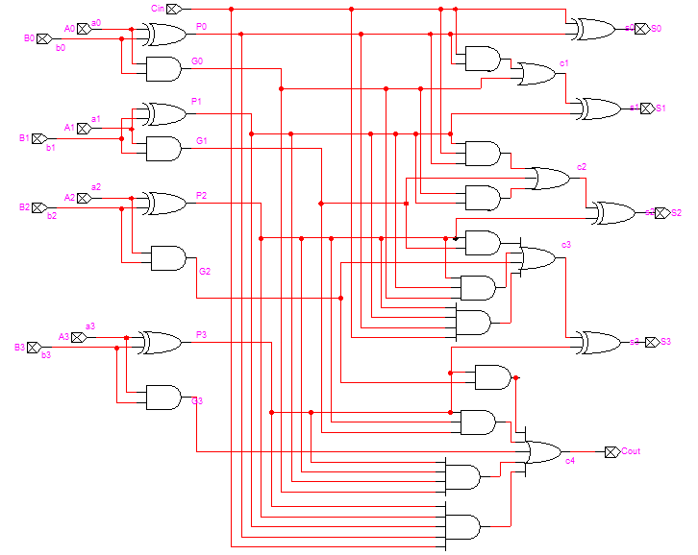
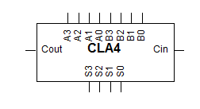

To measure the longest propagation delay, we set B₃B₂B₁B₀=0000 and A₃A₂A₁A₀=0000 and then change them to B₃B₂B₁B₀=1111 and A₃A₂A₁A₀=0001 to generate a carry in the first cell and propagate it to the last cell. To measure the longest delay we need to find the time difference between the time when A₀ has changed (time=70) to the time when S₃ has changed (time=85)= 85-70=15 ns. We have the set delay of each AND & OR gate equal to the number of its inputs. Hence the delay for the carry signals is as follows: C1=4 ns; C2=9 ns; C3=11 ns; C4=13 ns. The delay for S4=11+4=15ns. Note the delay compared the 4-bit RCA has improved only by 1 ns because we have set the delay of the XOR to 4ns. Usually the delay of the XOR is smaller and hence we get better delay improvements.

Model a BCD adder using the 4-bit RCA in (b) and verify its correctness by simulation.

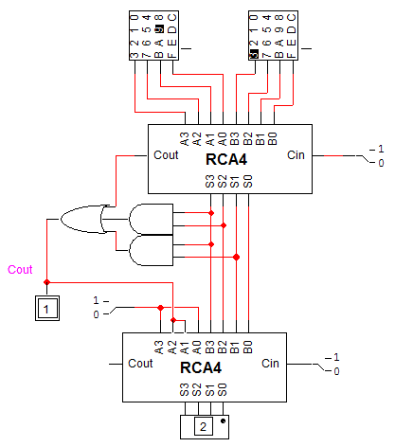
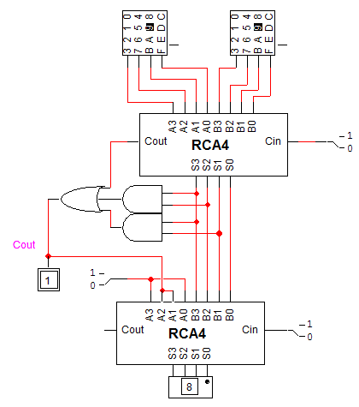
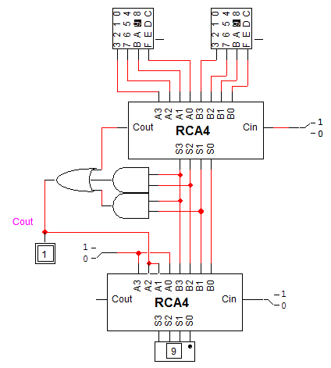

Model a 4-bit by 4-bit multiplier using the 4-bit CLA adder in (c). Verify its correctness by simulation.

