Name: Id#

COE 202, Term 201

Digital Logic Design

Quiz# 3 Solution

Date: Tuesday, Sep. 29, 2020

Question 1: (12 points)

- (5 points) Given that F(x,y,z) = (x + y’)(x’ + z) + x’ z.
- (2 points) Fill the given truth table for function F.

x | y | z | F
0 | 0 | 0 | 1
0 | 0 | 1 | 1
0 | 1 | 0 | 0
0 | 1 | 1 | 1
1 | 0 | 0 | 0
1 | 0 | 1 | 1
1 | 1 | 0 | 0
1 | 1 | 1 | 1

- (1 point) List all the Minterms of function F(x,y,z) using the ∑ notation.

F(x,y,z) = ∑(0, 1, 3, 5, 7)

- (2 points) Write function F(x,y,z) as a product of Maxterms using algebraic form.

F = (x + y’ + z) (x’ + y + z) ( x’ + y’ + z)

- (4 points) Given the two Boolean functions F and G as:
F (x,y,z) =∑(0, 2, 6)
G (x,y,z) = ∏(1, 3, 6, 7)

- (2 points) List the Maxterms of (F.G) using the ∏ notation.

G(x,y,z) = ∏(1, 3, 6, 7) = ∑ (0, 2, 4, 5)
F.G = ∑ (0, 2) = ∏(1, 3, 4, 5, 6, 7)

- (2 points) List the Minterms of (F+ G’) using the ∑ notation.

F(x,y,z) = ∑(0, 2, 6)
G (x,y,z) = ∑ (0, 2, 4, 5); G’(x,y,z) = ∑ (1, 3, 6, 7)
F + G’ = ∑(0, 1, 2, 3, 6, 7)

- (3 points) Given the following implementation of function F. Assume that the delay of each gate is equal to the number of inputs (i.e., the delay of an inverter is 1ns, the delay of a 2-input AND/OR gate is 2ns). Calculate the propagation delay of F and determine the critical path.
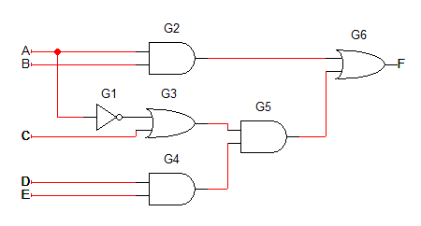

The propagation delay of F is 7 ns.
The critical path is G1 – G3 – G5 – G6.

