Name: KEY Id#

COE 202, Term 151

Digital Logic Design

Quiz# 3

Date: Sunday, Oct. 25

Q1. Assuming the availability of all variables and their complements, simplify the following two Boolean functions F and G subject to the given don’t care conditions d1 and d2 using the K-Map method:

Implement F using only NOR gates:
 |  | C D
 |  | 00 | 01 | 11 | 10
A B | 00 |  |  | X
 | 01 | 1 | 1 | X | 1
 | 11 | 1 | 1
 | 10 |  | X |  | 1

F(A, B, C, D) = ∑(4, 5, 6, 10, 12, 13)
d1(A, B, C, D) = ∑(3, 7, 9)

To get a 2-Level NOR-NOR implementation, we use the simplified POS expression (Groups of 0’s) given by:

F= (A+B) . (B+C). (A’+B’+C’).{(C’+D’) or (B+D’)}

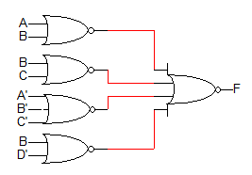
 |  | C D
 |  | 00 | 01 | 11 | 10
A B | 00 | 1 |  | X | 1
 | 01 |  |  | X | X
 | 11 | X | 1 | 1
 | 10 | 1 | X | 1

Implement G using only NAND gates:
G(A, B, C, D) = ∑(0, 2, 8, 11, 13, 15)
d2(A, B, C, D) = ∑(3, 6, 7, 9, 12)

Simplified SOP expression directly maps into a 2-Level NAND-NAND implementation.

G = A D + A' B' D' + A C' OR G = A D + B' C' D' + A' C

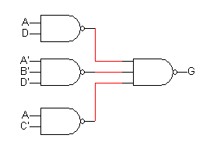

Q2. Implement the following circuit using only 2-input XOR gates with minimal number of gates:

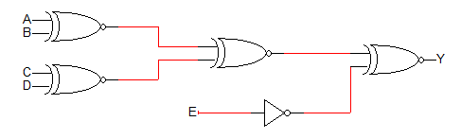

Solution:
