Name: Id#

COE 202, Term 122

Digital Logic Design

Quiz# 3

Date: Monday, March 11

Q1. For the Boolean function F(W, X, Y, Z)=Σ m(0, 1, 2, 3, 7, 8, 10), d(W, X, Y, Z)=Σ m(5, 6, 11, 13, 15) shown in the k-map below:
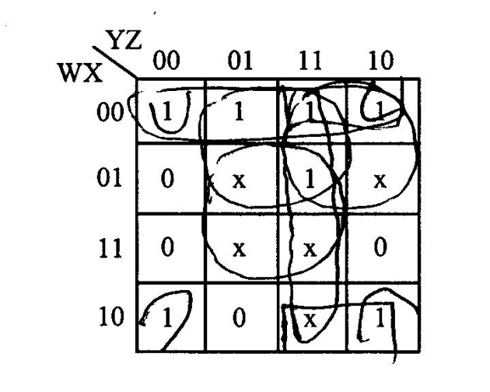

Identify all the prime implicants and the essential prime implicants of F.

Simplify the Boolean function F into a minimal sum-of-products expression.

Simplify the Boolean function F into a minimal product-of-sums expression.

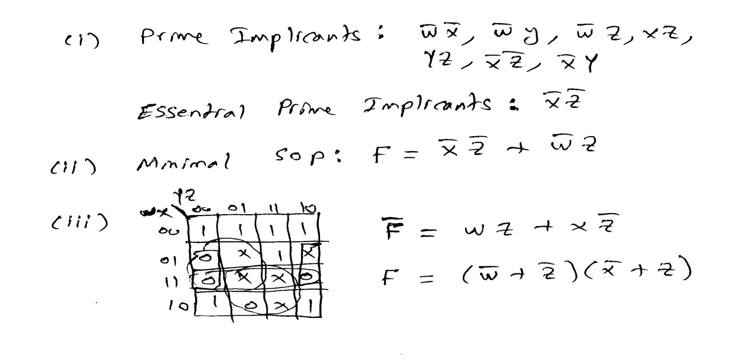

Q2. The following Boolean expression: BE + B`DE` is a simplified version of the expression: A`BE + BCDE + BC`D`E + A`B`DE` + B`C`DE`. Are there any don`t care conditions? If so, what are they?

