Name: KEY Id#

COE 202, Term 121

Digital Logic Design

Quiz# 3

Date: Saturday, Nov. 10

# 

# **Q1**. For the Boolean function F(W, X, Y, Z)= m(0, 1, 2, 3, 7, 8, 10), d(W, X, Y, Z)= m(5, 6, 11, 15) shown in the k-map below:

WX

10

11

01

00

YZ

1

1

1

1

00

0

x

1

x

01

0

0

x

0



11

1

0

x

1

10

# Identify all the *prime implicants* and the *essential prime implicants* of F.

# Simplify the Boolean function **F** into a minimal sum-of-products expression.

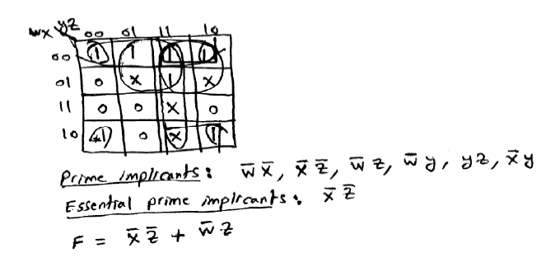

# **Q2**. Implement the logic circuit given below using only NOR and NOT gates

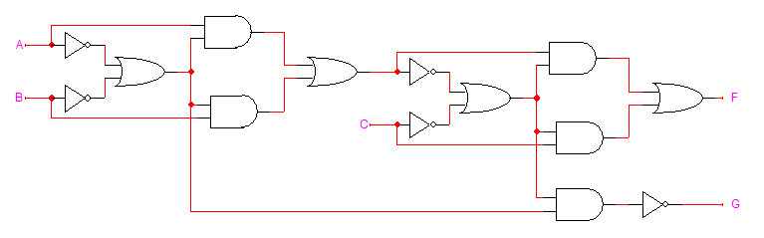

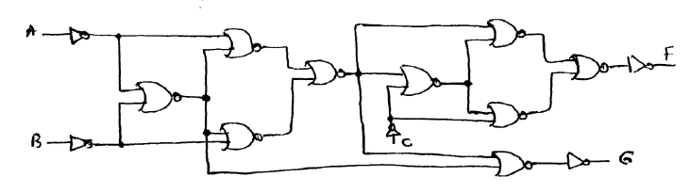

**Q3**. Design a 3-bit decrementer using only basic gates (AND, OR, and NOT). The circuit takes a 3-bit unsigned number **I=I2I1I0** as input and generates a 3-bit output number **Z =** **Z2Z1Z0** and a **Valid** output **V.**  Whenever **I > 0** the output **Z = I-1** and **V=1**. If **I=0**, the output is invalid which is indicated by an output **V=0.** Derive the simplified Boolean expressions of all outputs.

