Name: KEY Id#

COE 202, Term 131

Digital Logic Design

Quiz# 2

Date: Thursday, Oct. 3

Q1. Simplify the following Boolean functions to the minimum number of literals sum-of-product expressions using algebraic manipulation:

x’ y’ z’ + x’ y’ z + x’ y z + x y’ z + x y z

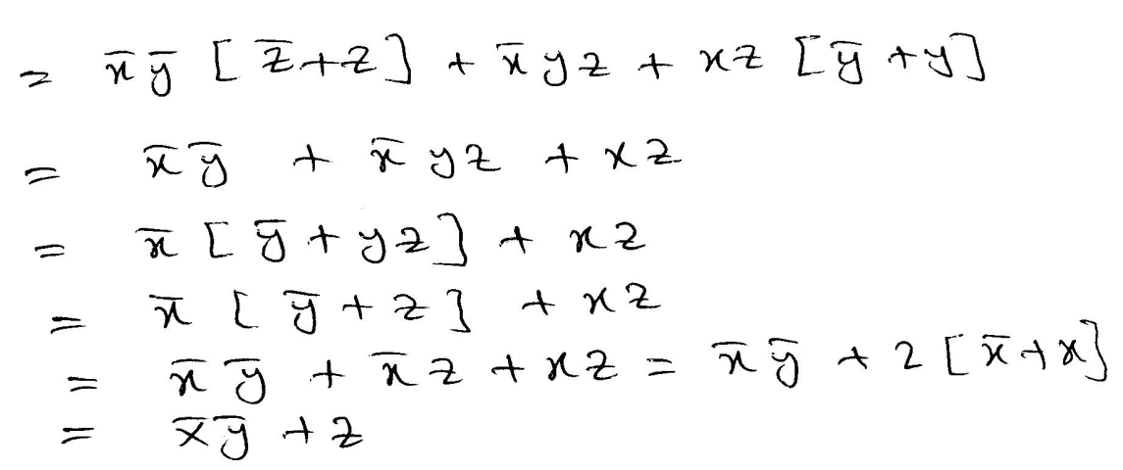

A B C’ + A’ C’ D + A B’ C’ + B C’ D + A’ D

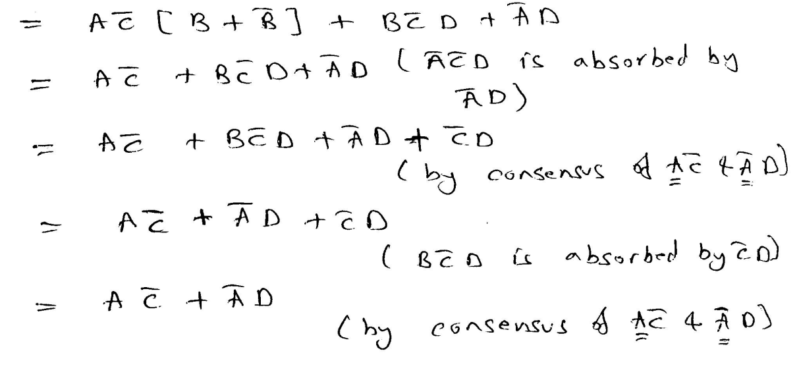

Q2. Express the function $F\left(A, B, C, D\right)= A B+\overline{C}+ D$as:

Sum of minterms $F(A, B, C, D)= \sum{m( )}$

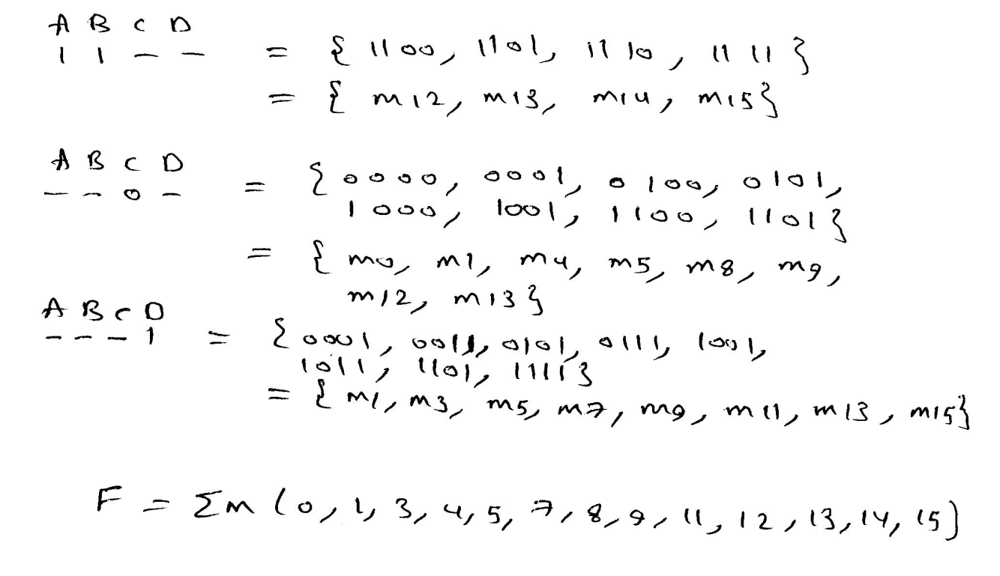

Product of maxterms $F\left(A, B, C,D\right)= \prod{M( )}$

